Galaxy Morphology Analysis
1. Project Overview
This project analyzes galaxy morphology and classification participation using data from the Galaxy Zoo 2 project. The goal is to explore patterns in galaxy classifications, examine the distribution of morphological features, and investigate how classification and vote volume carry across the dataset.
2. Dataset Summary
- Rows: 239,695
Columns: 231
A smaller dataset was created for the analysis, retaining nine relevant columns.
Column Description
galaxy_id Unique identifier for each galaxy
consensus_class Galaxy Zoo 2 classification label
classification_count Number of classification associated with the galaxy
vote_count Total vote volume associated with the galaxy
smooth_fraction Debiased smooth morphology fraction
features_or_disk_fraction Debiased features-or-disk morphology fraction
spiral_fraction Debiased spiral morphology fraction
one_arm_fraction Debiased one-arm morphology fraction
two_arm_fraction Debiased two-arm morphology fraction

3. Exploratory Data Analysis using Python
We began with data preparation and cleaning in Python:
- Data Loading: Imported the dataset using pandas.
- Initial Exploration: Used df.info() to check structures and .describe() for summary statistics
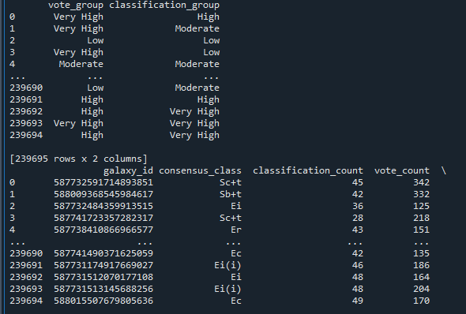
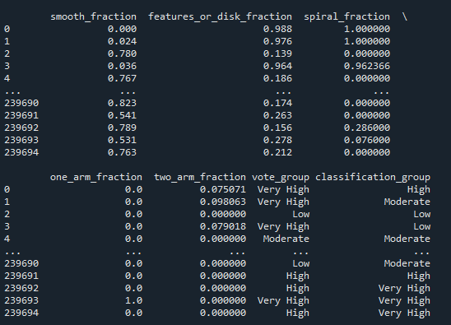
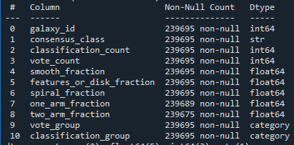
- Missing Data Handling: Check for null values and interpreted meaning behind missing values. Missing values were retained because Galaxy zoo questions were skipped depending on responses from earlier questions. Therefore, a missing value does not necessarily indicate an error or a zero fraction.
- Column Standardization: Renamed columns for better readability and documentation.
- Feature Engineering:
  - Created vote_group column by categorizing the amount of votes per group
  - Created classification_group column from classification count
- Data consistency Check: Verified if any columns were redundant and dropped any that seemed unnecessary for the report.
- Database integration: Connect Python script to PostgreSQL and coaded the cleaned DataFrame into the database for SQL analysis.
4. Data Analysis using SQL
We performed structured analysis in PostgreSQL to answer key business/astrophysics questions:
1. Theoretical Classification Reduction – Hypothetical maximum of 20 classifications per galaxy were evaluated to estimate how much total classification volume could be reduced under that limit.

2. Participation Distribution – Galaxies were grouped according to their vote participation levels
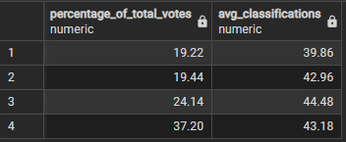
3. Primary Morphology Fractions Below 60% -- Identified galaxies where both smooth fraction and features/disk fractions were below 60%

4. Morphology Distribution Using a 70% Threshold – Calculated galaxy counts and population percentages from a threshold.
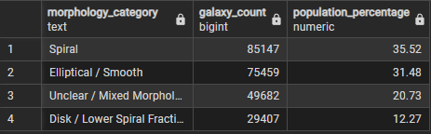
5. One-Arm and Two-Arm Fractions – Compared one-arm and two-arm fractions using averages, medians, and nonzero-value coutns.
6. Classification and Vote Distribution – Identified descriptive statistics for classification and vote counts.

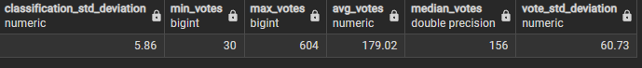
7. High Debiased Morphology Fractions – Identified galaxies with 90% in either primary morphology fraction.
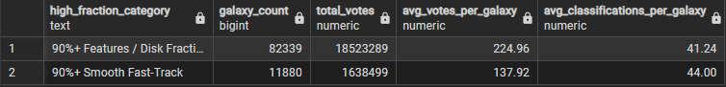
8. Comparison of 60% and 85% Thresholds – Examine how stricter threshold requirements affect the size of a hypothetical unresolved classification queue.
5. Dashboard in Power BI
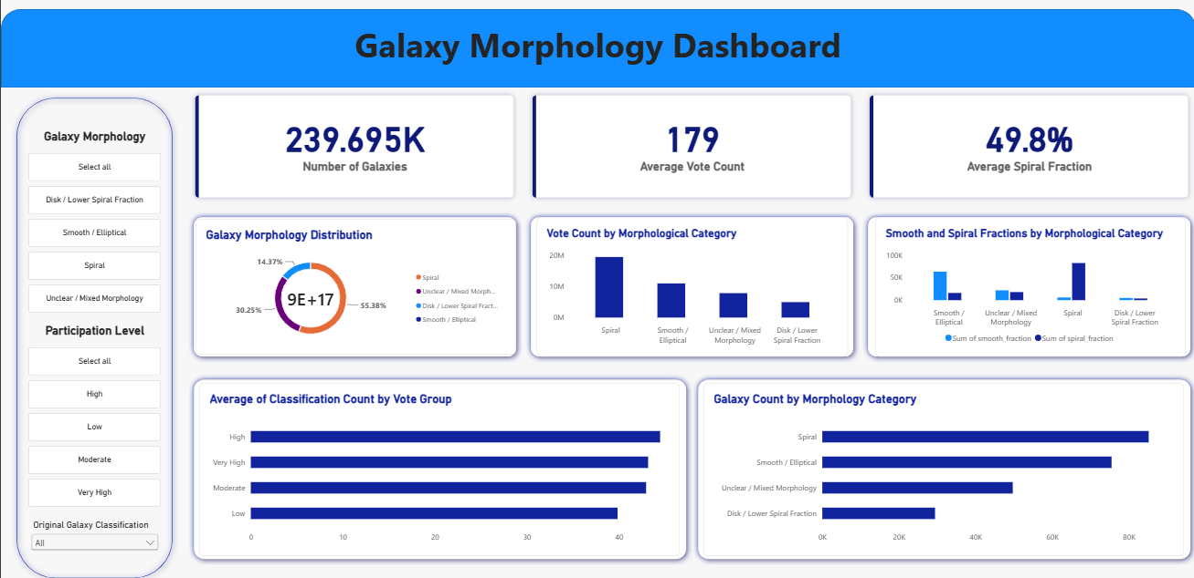
6. Business/Astrophysics Recommendations
- Optimize classification volume – Evaluate classification limits to reduce unnecessary classification volume while maintaining reliable galaxy classiciations.
- Monitor participation levels – Track vote and classification distributions to identify galaxies that consistently receive higher participation volumes and may require additional resources.
- Improve morphology classification – Use morphology fraction patterns to identify galaxies
- Expand morphological analysis – Investigate one-arm, two-arm, smooth, and spiral fraction patters to understand the distribution of galaxy morphological features.
- Develop a data-driven classification workflow – Combine participation metrics and morphology fractions to prioritize galaxies for further review while exploring opportunities to make the classification process more efficient.

