R Notebook

Katie Adnams

This is an [R Markdown](http://rmarkdown.rstudio.com) Notebook. When you execute code within the notebook, the results appear beneath the code.

Try executing this chunk by clicking the *Run* button within the chunk or by placing your cursor inside it and pressing *Ctrl+Shift+Enter*.

plot(cars)

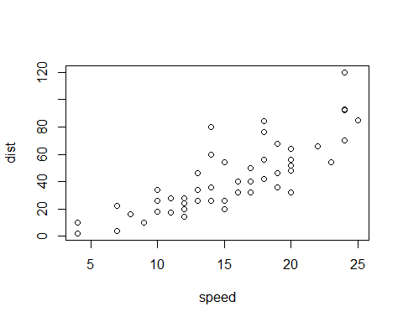

Add a new chunk by clicking the *Insert Chunk* button on the toolbar or by pressing *Ctrl+Alt+I*.

When you save the notebook, an HTML file containing the code and output will be saved alongside it (click the *Preview* button or press *Ctrl+Shift+K* to preview the HTML file).

The preview shows you a rendered HTML copy of the contents of the editor. Consequently, unlike *Knit*, *Preview* does not run any R code chunks. Instead, the output of the chunk when it was last run in the editor is displayed.

Let’s try this out then, using GIS code from last week. Inserting a chunk below:

library(tidyverse)

## -- Attaching packages --------------------------- tidyverse 1.2.1 --

## v ggplot2 3.0.0 v purrr 0.2.5  
## v tibble 1.4.2 v dplyr 0.7.6  
## v tidyr 0.8.1 v stringr 1.3.1  
## v readr 1.1.1 v forcats 0.3.0

## -- Conflicts ------------------------------ tidyverse_conflicts() --  
## x dplyr::filter() masks stats::filter()  
## x dplyr::lag() masks stats::lag()

library(geojsonio)

##   
## Attaching package: 'geojsonio'

## The following object is masked from 'package:base':  
##   
## pretty

library(sf)

## Linking to GEOS 3.6.1, GDAL 2.2.3, PROJ 4.9.3

library(tmap)  
library(tmaptools)  
#read some data attributes  
LondonData <- read_csv("https://files.datapress.com/london/dataset/ward-profiles-and-atlas/2015-09-24T14:21:24/ward-profiles-excel-version.csv", na = "n/a")

## Parsed with column specification:  
## cols(  
## .default = col_double(),  
## `Ward name` = col_character(),  
## `Old code` = col_character(),  
## `New code` = col_character()  
## )

## See spec(...) for full column specifications.

#read some geometries  
EW <- geojson_read("http://geoportal.statistics.gov.uk/datasets/8edafbe3276d4b56aec60991cbddda50_2.geojson", what = "sp")  
#pull out London  
LondonMap <- EW[grep("^E09",EW@data$lad15cd),]  
#convert to a simple features object  
LondonMapSF <- st_as_sf(LondonMap)  
#append the data to the geometries  
LondonMapSF <- append_data(LondonMapSF,LondonData, key.shp = "lad15cd", key.data = "New code", ignore.duplicates = TRUE)

## Data contains duplicated keys: E09000001

## Over coverage: 626 out of 659 data records were not appended. Run over_coverage() to get the corresponding data row numbers and key values.

#plot a choropleth  
qtm(LondonMapSF, fill = "% Not Born in UK - 2011")

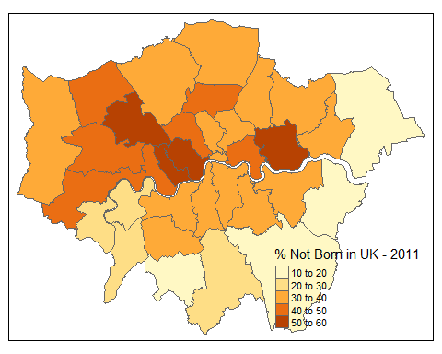 Zotero bibliography helpful stuff is below

#install.packages("citr")  
library (citr)

Lets try adding a citation: I got my reference from here Katie So the citations don’t seem to work which is annoying…we’ll have to come back to that[@noauthor_hello_nodate].