LAB #11 — REPORT

EAPS 577

40 points possible

NAME: Kris Laferriere

(1) For each of the following spectral indices, compare the spectral index to the RGB image of the cube. Does the spectral index correlate with a geologic feature? This is a good indication that you’re seeing a real spectral signature and not just noise. If so, describe the geologic feature that exhibits strong values of the index (e.g., sand dunes, red capping unit, pink ovoid, green bedrock, etc.)? If not, how would you describe the pattern?

1. LCPINDEX – can indicate low-Ca pyroxene (e.g., orthopyroxene) (3 pt)  
     
   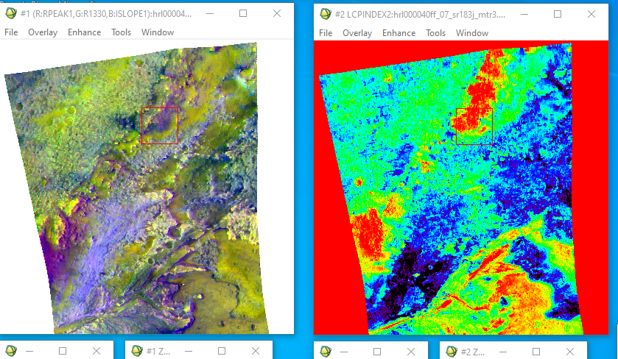
2. HCPINDEX – can indicate high-Ca pyroxene (e.g., clinopyroxene) (3 pt)

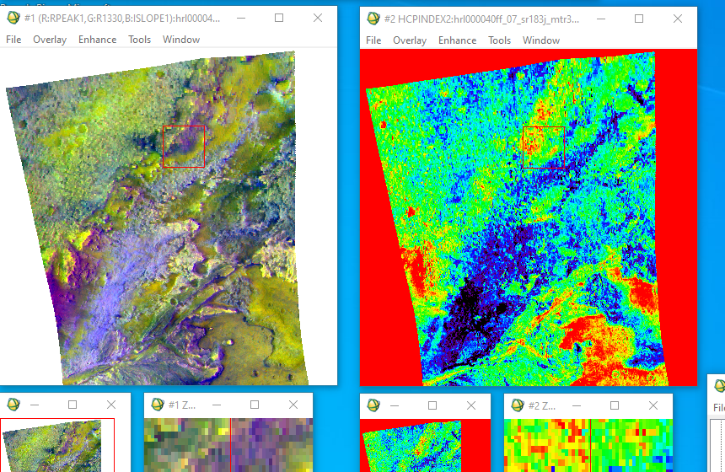

(c) BD1300 – can indicate olivine or Fe-bearing carbonate (3 pt)

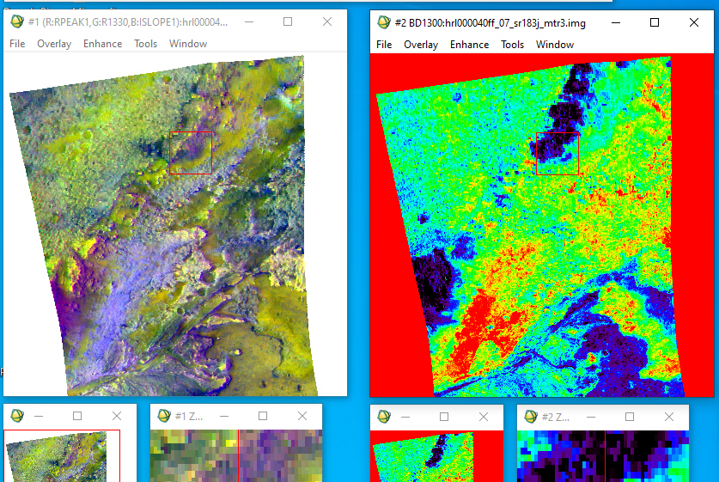

(d) BD2230 – can indicate clay minerals with both Al and Fe (3 pt)

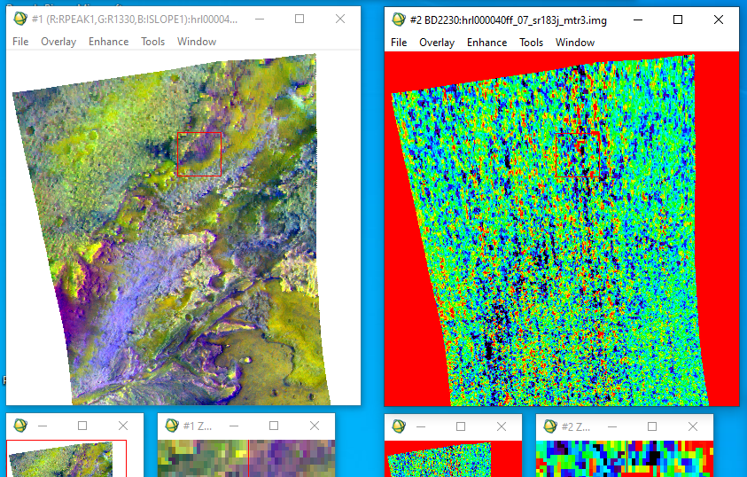

(e) D2300 – can indicate Fe/Mg-bearing clays (3 pt)



(f) BD2500_2 – can indicate carbonates (3 pt)

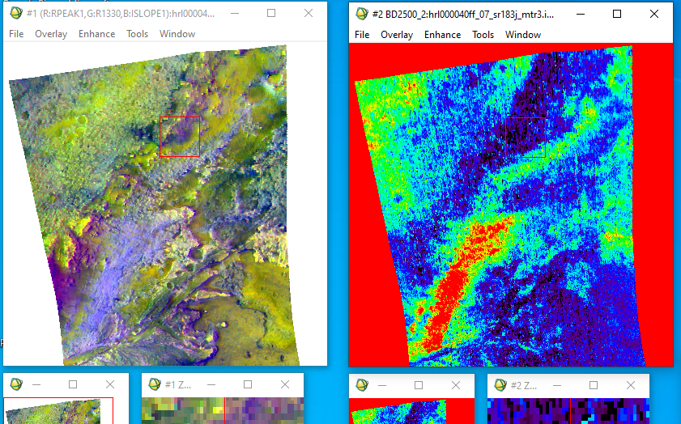

(2) (a) Paste the RGB combo image below. (1 pt)

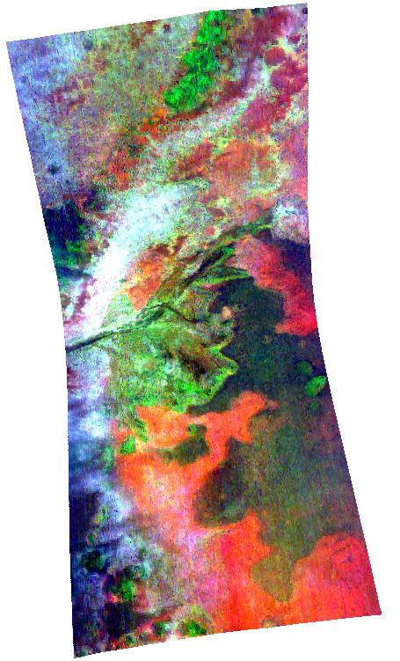

1. Can you see variations that were not apparent just by looking at the individual images? (1 pt)

(3) (a) What geologic feature is dominating the topography? (1 pt)

The crater

(b) Was your original dusty location at a similar elevation to most of the image? (1 pt)

It is in the green, which is ~-2280 m, where as the darkest is -2680 and the highest is -1982, so this is a bit below average, but the image is dominated by the lowland.

(c) Why might choosing a different elevation affect the severity of one of the effects above, keeping in mind that Mars’ atmosphere gets much thicker at lower elevations? (1 pt)

More atmosphere to go through/scatter light.

(4) (a) Paste your stacked extracted spectra below, including your dusty spectrum (1 pt)

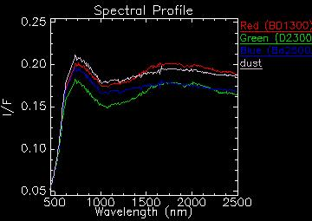

(b) Paste your stacked ratio spectra below (1 pt)

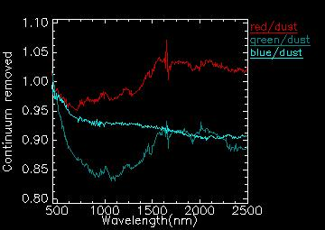

(c) Paste your stacked lab spectra below (1 pt)

(d) Compare your extracted spectra to the lab spectra. Do you see similarities? (3 pts)

green is olivine, with something added.

Not sure red, maybe magnesit, olibine.

Blue is feature less,

(e) Would you feel comfortable making a compositional interpretation based on those similarities? (1 pt)

(5) Lastly, use these or any other maps to propose a route for the Perseverance rover, in order to achieve the following objectives related to mineralogy:

* Investigate biosignatures associated with fine-grained clay-rich materials
* Investigate biosignatures associated with carbonate lake precipitates
* Sample lava flows to date and calibrate the crater chronology

Identify at least one stop to achieve each objective. You can draw a route on the map in Figure 4. Compare your route to the actual route to date of the rover in Figure 3, what did we miss that you think might have been important? (10 pts)