LAB #12 — REPORT

EAPS 577

40 points possible

NAME: Kris Laferriere

**Part 1: Topographic eye candy in ENVI**

(1) What geologic/geographic features are associated with the low parts of the scene? (2 pts)

The low parts of the scene (dark in the DEM grayscale), is the bright features in RGB, maybe a river bed? Looks like delta end it in. lots of sediments.

(2) Use the relief map to identify and investigate volcanic features to the north of the lake.

(a) Do you see evidence for a caldera collapse? How can you tell? (2 pts)

Yes, there is evidence of a caldera collapse as there is a circular pit north of the lake

(b) Use the X or Y profile tool on the DEM to generate a profile across the caldera, and paste an image of your profile below. (1 pt)

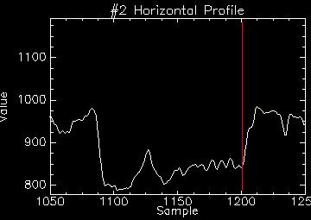

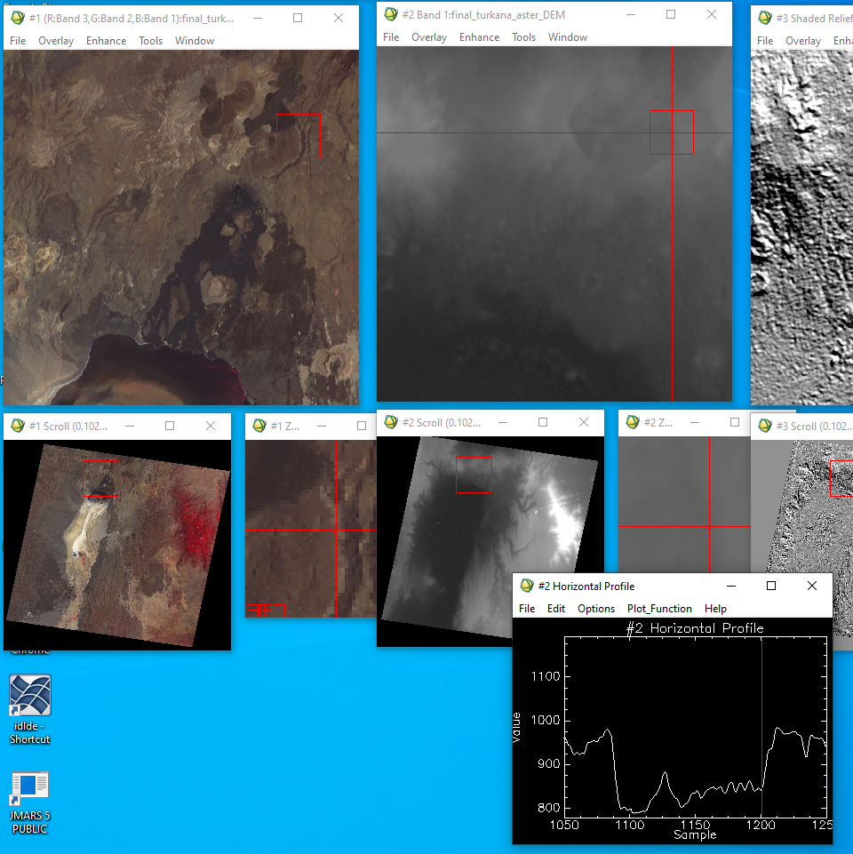

(c) Assuming that one pixel (sample) is 30 m wide, what is the depth and width of the caldera? (2 pts)

1000 – 1208 (x30m)

884 – 791 and 997 – 791 (m)

(3) Use the slope map to identify the typical slopes of the following features (in degrees):

(a) the large alluvial fan complex (bajada) along the left side of the valley (1 pt)

0-10 range of degree slopes

(b) the sides of the volcanic cone to the upper right of the lake. (1 pt)

30-50 degrees

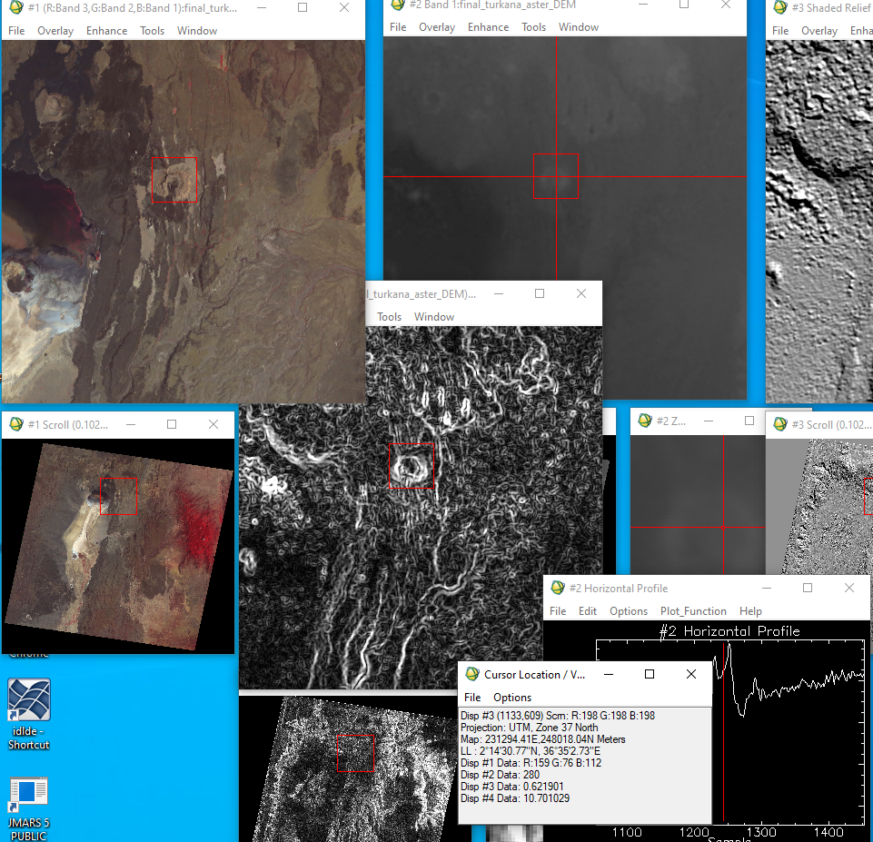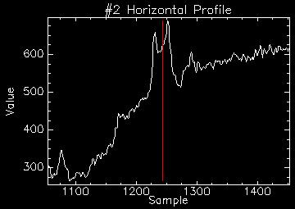

(4) Use the 3D view to determine the order of geologic events in the scene, including rifting, volcanism (multiple episodes?), and fluvial incision. Describe how you can tell which came first, and use screenshots or saved images from the 3D view to support your arguments. (3 pts)

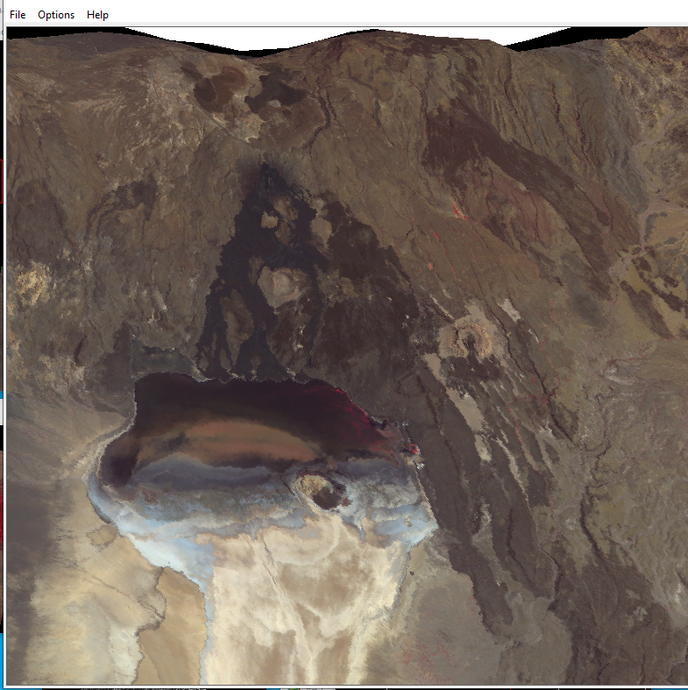

The order of it spatially

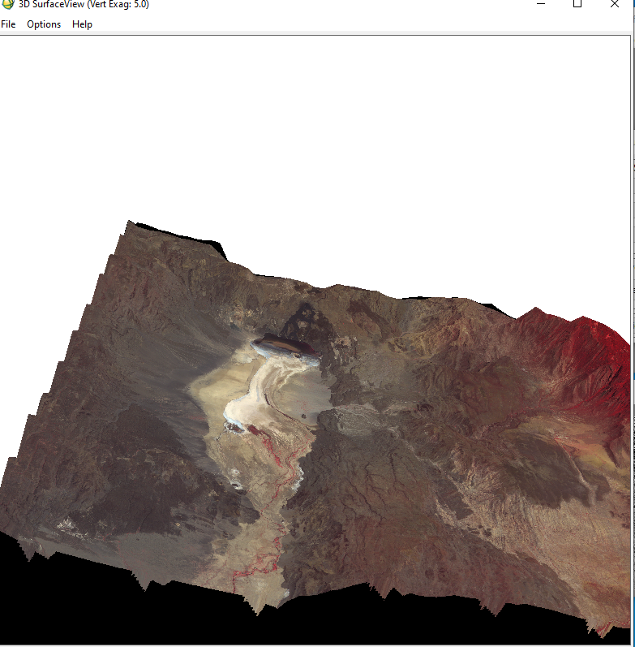

**Part 2: Lunar Crater Morphometry with LOLA in JMARS**

(5) (a) Paste an LROC WAC image of an example **fresh** crater that is 5 to 10 km in diameter here. Don’t forget to include an appropriate scale bar. Include the lat/lon coordinates of the crater (shown in the bottom left corner when the mouse is over the crater). (1 pt)

(b) Paste the topographic profile of your crater that is 5 to 10 km in diameter. (1 pt)

(c) What is the height of the rim above the surrounding terrain? (1 pt)

(d) What is the depth of the floor below the surrounding terrain? (1 pt)

(e) How wide is your crater? (1 pt)

(6) (a) Paste an LROC WAC image into your lab report of an example **fresh** crater that is > 20 km in diameter. Don’t forget to include an appropriate scale bar. Include the lat/lon coordinates of the crater. (1 pt)

(b) Paste the topographic profile of your crater that is > 20 km in diameter. (1 pt)

(c) What is the height of the rim above the surrounding terrain? (1 pt)

(d) What is the depth of the floor below the surrounding terrain? (1 pt)

(e) Can you constrain the thickness of the ejecta blanket? (1 pt)

(f) How wide is your crater? (1 pt)

(7) What major morphologic differences do you notice between these two craters (both map view and profile view)? Make sure to discuss the rim, continuous ejecta blanket, and any interior structures. (4 pts)

If you collaborated with other students for the crater morphometry section, please list their names here:

(8) Paste your plot of the crater depths and diameters below (don’t forget to label your axes) (6 pts)

(9) (a) The data will have some scatter, but what is the general trend in the depth to diameter data? (1 pt)

(b) Note that there is a significant break in slope in the trend, what is the approximate diameter range where you see this? (1 pt)

(c) What is the typical depth:diameter ratio for lunar craters below the break? (1 pt)

(d) Hypothesize why this break in the slope occurs – what might be limiting the depth of impact craters above a certain size? (its ok if you don’t know the answers here, just think of possible reasons). (2 pts)

(e) What factors might be responsible for the scatter in the data? (2 pts)