**Lab 5: Where there's smoke there's fire**

*37 points possible*

A PDF of the lab report must be uploaded to Gradescope by 10 am on Tuesday, March 1, 2022 (see submission instructions on Brightspace, and check Brightspace for due date updates).

NAME: Kris Laferriere

———————————————————————————————————————————

PART 1: DARK PIXEL SUBTRACTION (14 pts)

1. (a) Fill in the table below with reasonable average path radiance DN values for each band, and then plot these values in a graph of DN vs. **wavelength** (you can use IDL, Excel, Google Spreadsheets, whatever works for you) and paste it below. [5 pts]:

Using 1% as significant

Band 1 path radiance: 76

Band 2 path radiance: 26

Band 3 path radiance: 22

Band 4 path radiance: 12

Band 5 path radiance: 5

Band 6 path radiance: 118

Band 7 path radiance: 1

Graph:

b) Explain the method you used to find path radiance. What features in the scene do these values correspond to? How close to “dark” are these areas in reality? [3 pts]:

To determine the path radiance, I used the histograms. I chose from the table of values the first time that 1% of the pixels were represented by a DN value. The features in the scene that correspond to these dark regions differently depending on which band. In bands 4 and 5, the dark regions correspond to the water in the cape. In all other bands, the dark corresponds to dark regions on the surface, specifically a cloud shadow is where I looked. The cloud shadow is probably closer to dark than the ocean, but it is dependent on wavelength.

c) What happens to path radiance as a function of wavelength? Based on this and investigating the scene, what atmospheric radiative processes (scattering, emission, absorption) can you identify contributing to the atmospheric path radiance in the image? Identify at least two and describe which wavelengths they affect the most strongly. [3 pts]:

As a function of wavelength, the path radiance varies based on if the atmosphere is scattering, emitting, or absorbing. Rayleigh scattering occurs at shorter wavelengths, and is contributing to the higher DN values at the lowest wavelengths. Around 2 microns, the atmosphere is absorbing (thanks to OH/H2O), which leads to the low DN values. At longer, thermal wavelengths ~11 microns, the atmosphere is emitting, leading to the highest DN values.

Remake in python so its correctly spaced.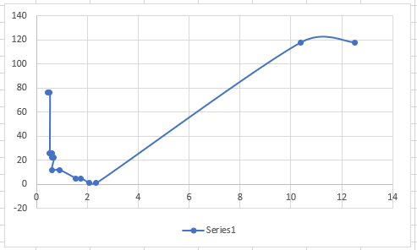

1. Scattering varies depending on environmental locale. Relative to this Cape Cod scene, what types of scattering might you expect to observe more or less of for these areas and why? :

(i) a cold, high altitude plateau in the Himalayas? [2 pts]

(ii) a smoggy day in Los Angeles? [2 pts]

————————————————————————————————————————

PART 2: ESTIMATING FIRE CHARACTERISTICS (23 pts)

1. Are the bright white spots in visible light in the scene fires? How can you tell? If not, what are they? [3 pts]:

The bright white spots in band 7 are fires, which we can tell from the smoke in band 2. Maybe ?

1. (a) Using either blink or animations as described above, can you detect all fires with just the visible wavelengths of light? Why or why not? [3 pts]:

The visible (1, 2, 3) really just show smoke. Band 7, has thermal emission at 2.2 because fires are hot so we need that.

(b) The smoke particles in the scene are on the order of a micron of a few hundred nanometers. What type of scattering will they create and why? [2 pts]:

(c) Collect some spectra over different fires, with different thermal vs. visible/near-infrared brightnesses, and paste an image of the spectra below. [3 pts]:

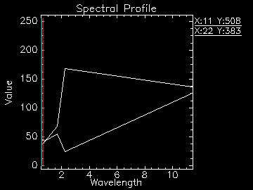

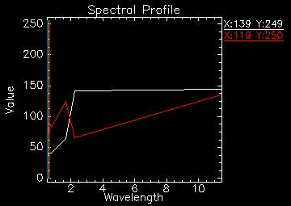

(d) Describe the spectral shape of the hottest fires you can find. What bands are saturated? Picture what the actual Blackbody emission curve would look like if you could fill in the data gaps - what wavelength would the peak of the curve occur at? [3 pts]:

Fire emits in the thermal and atmosphere doesn’t absorb enough, or full thermal at 11 saturated? Where does bb for 1900 k peak?

(e) If fires are too hot, it is extremely dangerous for firefighters to fight them on the ground. Using Wien’s Law, what do you estimate to be the temperature of these Yellowstone fires, and are they all the same temperature? Are there some areas that you would not advise firefighters to enter? [3 pts]

Wiens: peak wavelength = b/T. solve for T, T =b/wavelength. Fire temp maxes 2.2 micron band to 170 ish DN. Falls above 600 K below 1900 K. can find exact temp from model.

1. (a) Paste images of each band combination below. [2 pts]

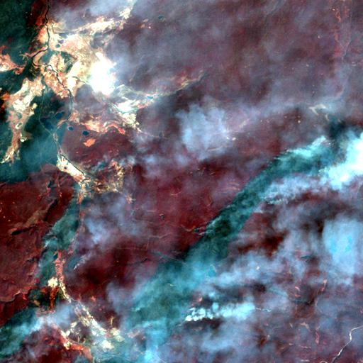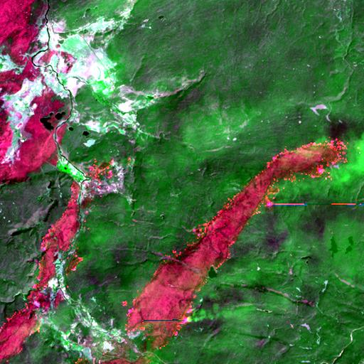

745.

(b) You want to generate a map of the damage caused by the fire. Which of these two combinations of spectral bands best distinguishes burned from unburned areas and why? How do you recognize an unburned area? [2 pts]

745, more clear color distinction, less affect of clouds. Shows on fire/recently burned as brighter red.

(c) Does the fire appear to be under control? Why or why not? [2 pts]

No, theres pixels extending out from the red into the green which look fresh and not a totally burned region yet.