LAB #6 — REPORT

EAPS 577

40 points possible

*A PDF of the lab report must be uploaded to Gradescope by 10 am on Tuesday, March 22, 2022 – this is after spring break (see submission instructions on Brightspace, and check Brightspace for due date updates).*

NAME: Kris Laferriere

**Counting Area #1:**

1. Take a look at the crater counting area #1.
   1. Describe the geology of the boxed area to the best of your ability. (2 pts)

The geology in the boxed area in highly cratered (for mars).

* 1. Do you see evidence for modification of craters here (infill, erosion, ghost craters, tectonic disruption, etc.), and if so, please describe? (1 pt)

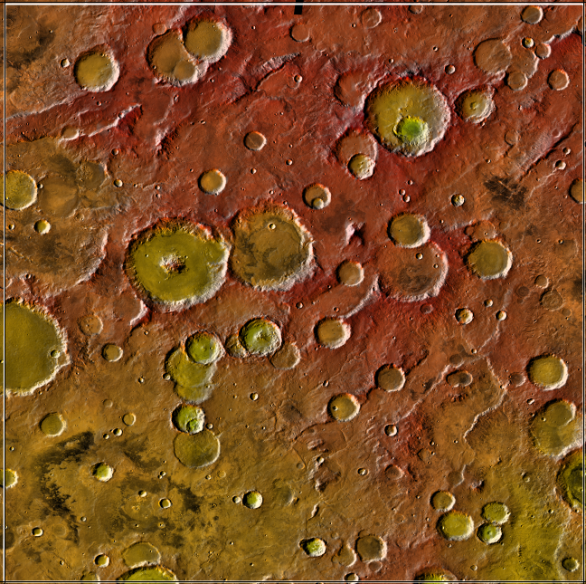

* 1. Do you see any evidence for a change in age of the surface across the area, and if so, how can you tell? (1 pt)

The north eastern portion of Region 1 is higher in elevation.

* 1. Paste a screenshot of your counted area with the craters on it below. (1 pt)

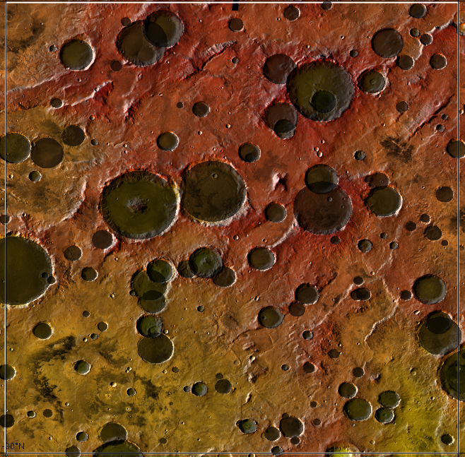

1. Try to fit your data in area #1.  
   1. Paste a screenshot of your plot, including your best fit line(s), below. (1 pt)

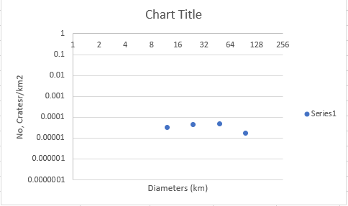

* 1. What best fit age did you determine for the surface? (1 pt)
  2. What range of ages would be plausible for your data? That is, for each surface, what are the oldest and youngest ages that fit your data? Be quantitative (i.e. ± 1 billion years). (1 pt)
  3. What geologic epoch does your age estimate assign to this data? (1 pt)

1. Evaluate your fit in area #1.  
   1. Is there any evidence for surface modification/resurfacing in the shape of the trend? (1 pt)
   2. What do you believe was your greatest source(s) of error for the uncertainties in the ages? Things to think about: Were there any circular features in the scene that you weren’t sure if they were primary craters (volcanoes or secondary craters)? Did you observe any really degraded craters, and did you end up including them in your count? Were you able to accurately count down to ~8 km? Please be as specific and as quantitative as possible. [Please note that the following are not adequate explanations: human error, bad eyesight, classmates talking, etc.] (2 pts)

**Counting Area #2:**

1. Take a look at the crater counting area #2.
   1. Describe the geology of the boxed area to the best of your ability. (2 pts)
   2. Do you see evidence for modification of craters here (infill, erosion, ghost craters, tectonic disruption, etc.), and if so, please describe? (1 pt)
   3. Do you see any evidence for a change in age of the surface across the area, and if so, how can you tell? (1 pt)
   4. Paste a screenshot of your counted area with the craters on it below. (1 pt)

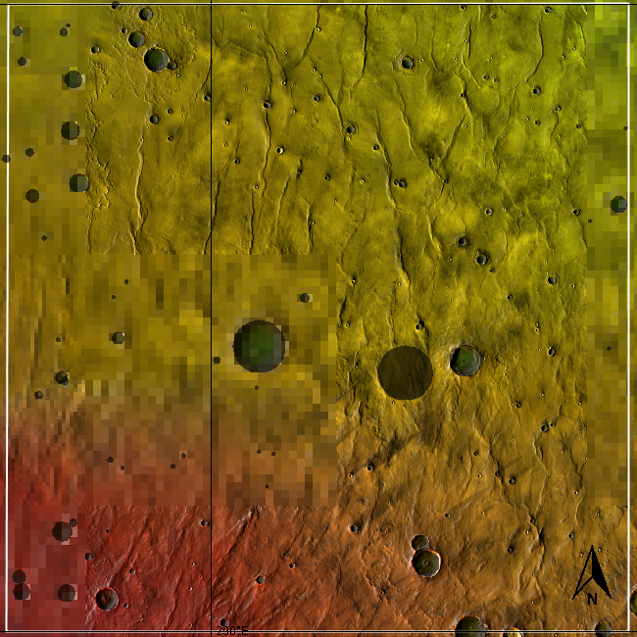

1. Try to fit your data in area #2.
2. Paste a screenshot of your plot, including your best fit, below. (1 pt)
3. What best fit age did you determine for the surface? (1 pt)
4. What range of ages would be plausible for your data? That is, for each surface, what are the oldest and youngest ages that fit your data? Be quantitative (i.e. ± 1 billion years). (1 pt)
5. What geologic epoch does your age estimate assign to this data? (1 pt)
6. Evaluate your fit in area #2.
7. Is there any evidence for surface modification/resurfacing in the shape of the trend? (1 pt)
8. What do you believe was your greatest source(s) of error for the uncertainties in the ages? See the question above for details. (2 pts)

**Counting Area #3:**

1. Take a look at the crater counting area #3.
   1. Describe the geology of the boxed area to the best of your ability. (2 pts)
   2. Do you see evidence for modification of craters here (infill, erosion, ghost craters, tectonic disruption, etc.), and if so, please describe? (1 pt)
   3. Do you see any evidence for a change in age of the surface across the area, and if so, how can you tell? (1 pt)
   4. Paste a screenshot of your counted area with the craters on it below. (1 pt)
2. Try to fit your data in area #3.
3. Paste a screenshot of your plot, including your best fit, below. (1 pt)
4. What best fit age did you determine for the surface? (1 pt)
5. What range of ages would be plausible for your data? That is, for each surface, what are the oldest and youngest ages that fit your data? Be quantitative (i.e. ± 1 billion years). (1 pt)
6. What geologic epoch does your age estimate assign to this data? (1 pt)
7. Evaluate your fit in area #3
8. Is there any evidence for surface modification/resurfacing in the shape of the trend? (1 pt)
9. What do you believe was your greatest source(s) of error for the uncertainties in the ages? See the question above for details. (2 pts)
10. Wrap up.
    1. Which of the areas you examined gave you the least precise date and why? Use the plot of crater frequency versus age of the surface in the instructions to explain your answer. (2 pt)
    2. Imagine you get to choose one surface with a specific crater density to try to quantify the ages more precisely using radiometric age dating. Again using the plot of crater frequency versus age of the surface, which era would be most useful to sample to pin down the ages and why? (2 pts)