LAB #9 — REPORT

EAPS 577

25 points possible

NAME: Kris Laferriere

(1) Ratioing the spectra

1. Describe the overall shape of the VNIR/SWIR portion of the spectrum at this processing stage. In what visible color does the peak reflectance occur? (2 pts)

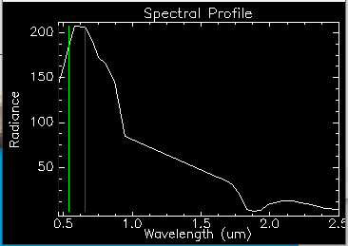

The spectrum peaks between green and red. This is reflected light. Absorption at 1.9 microns

1. What is causing this spectral shape and a peak at this position? (1 pt)
2. Do you observe any large absorption bands? What is their position, and what are they caused by? (2 pts)

(2) Red areas

1. Based on lecture, what is the likely cause of this absorption feature? (1 pt)

Whatever absorbes at 0.87 but not at 1.9, also at green (0.542?)

1. What type of mineral is it most likely to correspond to? (1 pt)

(3) Minerals in Figure 2

1. Use the web to learn more about these four minerals and the environments that they form in. Describe the origin of each mineral briefly. (4 pts)

b. What is the common environment that they all form in? (1 pt)

(4) Spectral library

1. Paste your spectral library plot zoomed in on the 2-2.5 micron region and showing all four minerals below. Check your units! (1 pt)

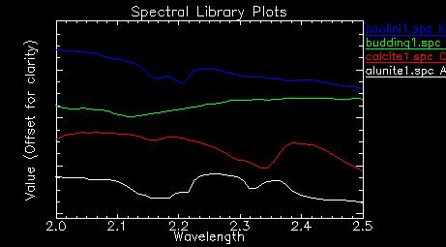

1. Will you be able to easily distinguish between all four minerals based on this region of the spectrum alone? Which ones may look similar? (1 pt)

Kaolini and alunite, but alunite should have features longwards.

1. Which three wavelengths would best help you discriminate between these four minerals? (2 pts)

Best three wavelengths: 2.34 for calcite. 2.2 for kaolinite.

Ratio, budding needs 2.12 and 2.3 or >. Kaolini needs 2.1, 2.2, 2.3 >

Alunite needs 2.15, 2.25, 2.45. calcite needs 2.12, 2.34, 2.4.

So all three need

2.12-2.15, 2.34, 2.4.

So bands: 21, 24, 25.

No 20, 22, 24

1. What color will each mineral be in the decorrelation stretch? (2 pts)

Kalonite will be red.

Budding should be equally red and green, more blue

Calcite should be equaly red and green, not very blue

Alunite should be equally red and blue, not very green.

1. Paste the DCS image below. (1 pt)

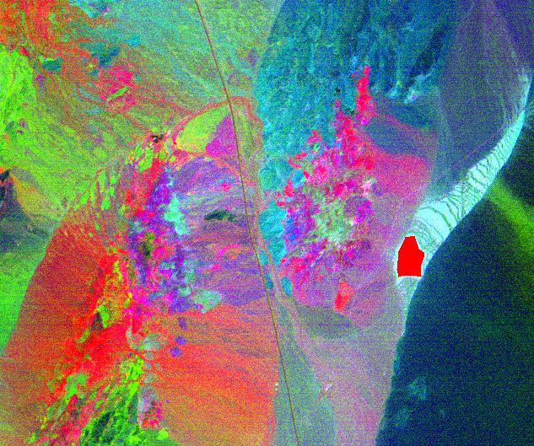

(5) Surface spectra

Alunite:

1. Paste the stacked 2-2.4 μm plot of all four spectra below. (check your units!) (1 pt)
2. Paste all four of your comparison plots to lab spectra below. (4 pts)
3. How well do the image spectra compare to the library spectra? Again, note the absorption features near 2.2 and 2.3 μm. (1 pt)