LAB #3 — REPORT

38 points possible

All materials must be uploaded to Gradescope by 10 am on Thursday, February 10, 2022 (see submission instructions in lab instructions).

NAME: Kris Laferriere

At the end of the lab, you should have created the following items in your working directory:

- This report, edited and filled out

- Copies of your journal files

- imp_cal.pro (must also be pasted at the end of this report)

- rover_raw.tif + sky_raw.tif

- rover_nobadpixels.tif + sky_nobadpixels.tif

- rover_nodark.tif + sky_nodark.tif

- rover_final.tif + sky_final.tif

**1. Raw images**

(a) Paste “rover_raw.tif” and “sky_raw.tif” below [2 pts]:



(b) What potential problems do you observe in these images? List at least two. [2 pts]:

There are some clear bright pixels that should be removed. In the Sky image, it is clear that there is darkening to the right side and stripping. The rover image also shows darkening to the right side of the image. The darkening is probably due to dark current affecting the detector, while the stripping is related to responsivity, and needs to be removed by a flat field.

**2. Bad pixel correction**

(a) Evaluate the quality of your corrected image. Did your program fix the obvious bad pixels? Did it overcorrect the image? [1 pt]:

Yes, my program fixed the obvious bad pixels, and did not over correct the image. It replaced 4063 pixels or 6% of the image.

(b) Paste “rover_nobadpixels.tif” and sky_nobadpixels.tif” below [2 pts]:



(c) How many "bad" pixels did you replace in each of the six raw images? [2 pts]:

Rover_red: 4063

Rover_grn: 3679

Rover_blu: 2643

Sky_red: 7917

Sky_grn: 6799

Sky_blu: 7835

**3. Dark current correction principles**

1. What are typical DN values for the raw images, and how does the bias value compare to these values? [1 pt]:

The typical DN for the raw images is:

Sky red: 2500-6500, mean: 4700

Sky blu: 2500-6500, mean: 4500

Sky grn: 2500-6500, mean: 4675

Rover red: 500-5500, mean: 3405

Rover blu: 500-5000, mean: 3176

Rover grn: 500-5000, mean: 3350

The bias value should be much lower than the observations, otherwise the exposure time is not long enough to make reasonably high SNR for scientific observations.

1. For this filter wheel system, why is there only one dark_lab image, and not one for each R/G/B image? [1 pt]

For this filter wheel system, there is only one dark lab image because you cannot have a filter on the instrument with the shutter closed, which is how the dark is taken. Thus, the dark needs to cover the full wavelength range of the instrument, and is not able to be limited to the filter ranges.

(c) What do you think might cause the dark current to increase toward the top of the image? [1 pt]:

The dark current increases towards the top of the image due to heating of the instrument internally.

(d) Do you detect any evidence of frame transfer smear (i.e., "electronic shutter effect") across the raw images, and in which direction (horizontally or vertically)? [1 pt]:

The image of the shutter from lab clearly shows frame transfer smear, horizontally across the image. This is not as obvious on the raw images.

(e) What is the average percent increase in DN across the image due to frame transfer smear? [1 pt]

The average percent increase in DN across the image due to frame transfer smear is

**4. Remove the dark current**

1. Paste rover_nodark.tif and sky_nodark.tif below. [2 pts]:

(b) Did the dark model correct the frame transfer smear that you measured in the last part? How can you tell? [2 pts] :

The dark model corrected the brightness change across the frame.

(c) Describe any residual patterns or artifacts that remain in the images after this step in the processing (experiment with stretching on the sky images). [2 pts]:

There is still a dark spot in the corner of the rover image. The sky still has cross hatches (needs flat).

**5. Flatfield correction**

1. Why is the flatfield image divided out of the scene while the dark current is subtracted? [1 pt]:

(b) Paste rover_noflat.tif and sky_noflat.tif below. [2 pts]:

(c) Take a look at your flat-field corrected images. Describe some of the improvements. Was anything made worse? If so, please elaborate. [3 pts]:

Using hist eq, flat divided still has a feature.

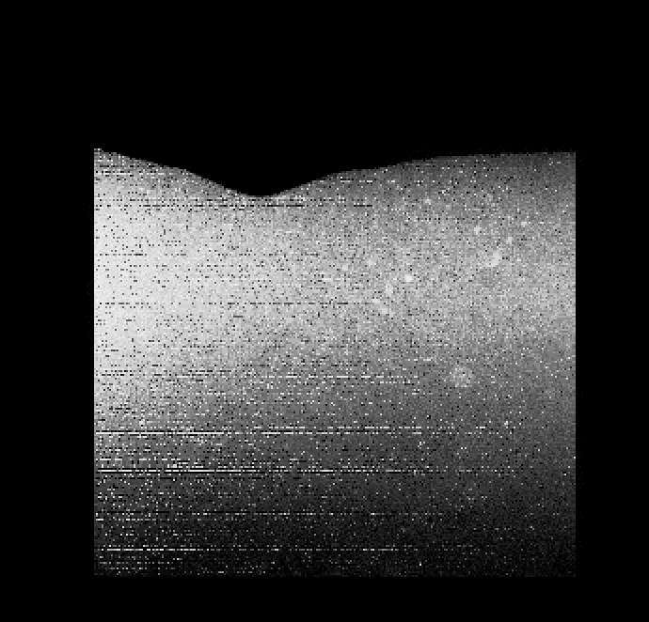

Old – no dark

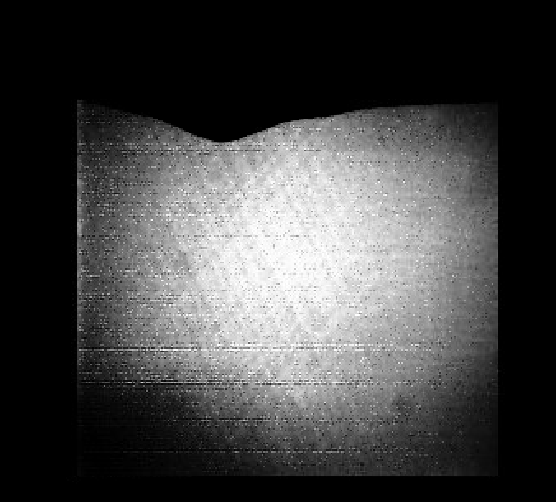

**6. Responsivity correction**

(a) Thinking back to lecture, why is the responsivity at blue wavelengths so much less than at red wavelengths? [1 pts]

(b) Paste rover_final.tif and sky_final.tif below. [2 pts]

7. The reveal!

(a) What color is the Martian sky? [1 pts]

(b) What color are the rover wheels (and why)? [2 pts]

8. Paste the text from your final version of imp_cal.pro below. [6 pts]   
***This step is required to receive points on this lab.***