On Demand Home Repair Services

Group Name: wAtErFaLl 4 lYfE

Team members: Khyber Lahori, Osama Al Mazloum, Riyanson Alfred , Abdullah Khalid

**Introduction:**

When we first came to our Introduction to Software engineering class we were all excited. Our professor was showing us examples of android apps his students had made in the past and they all looked amazing. We had always wanted to make android app but we didn’t know where to start nor did we have to time to learn how to use android studio being engineering students we already had enough work on our plates from school so we couldn’t wait to get this project stated. We were tasked to make an on demand home repair app and when we first read the details on what kind of app we had to make we thought this was way too difficult especially compared to the kind of projects we were shown by the professor those seemed so much simpler so we were a little intimidated by the project to begin with. During the first few weeks since we had been given the project we didn’t do much if any work on the project simply because we didn’t know how to do it however as the class progressed we learned more about the tools we need to use as well as how to use them and with that knowledge we were able to only complete the basics that we needed to implement onto our android app but we were a lot able to teach our selves new concepts which we didn’t learn in our class such as firebases authorization and implement that onto our android app.

**Table with the roles in the team and contributions of team members for each deliverable.**

|  |  |
| --- | --- |
| Name | Contribution |
| Khyber Lahori | 25% |
| Osama Al Mazlo | 25% |
| Riyanson Alfred | 25% |
| Abdullah Khalid | 25% |

We feel like we divided the work very evenly everyone would help each other whenever someone needed help however for the most part we divided the deliverable so Khyber did Deliverable 3 while Osama did Deliverable 2, Riyanson did Deliverable 4 and Abdullah did Deliverable 1

**All the screenshots of our app**

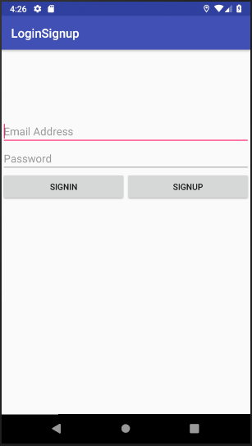

Figure 1 Login Page (first page user sees)

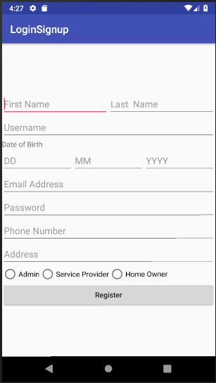

Figure 2 Sign up page(after hitting sign up button)

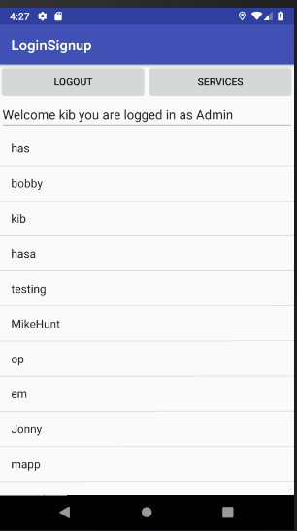

Figure 3 Admin welcome page

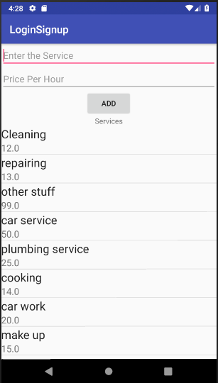

Figure 4 Admin add service page

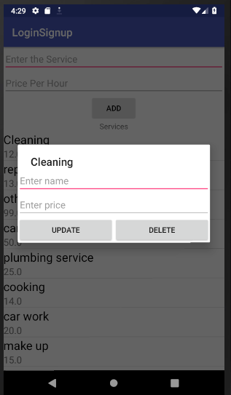

Figure 5Admin update/delete services

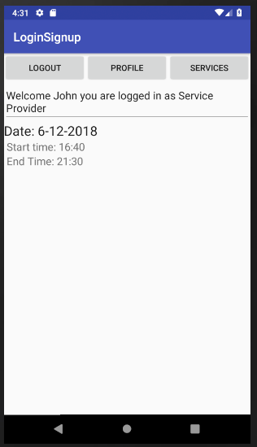

Figure 6 Service Provider Welcome page

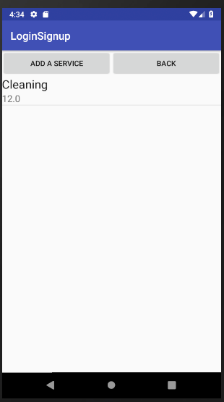

Figure 7 Service Provider services he has

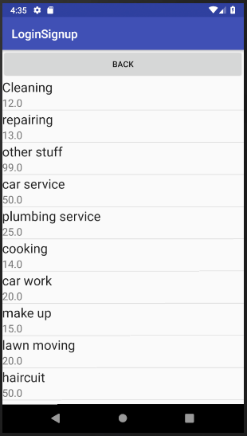

Figure 8 List of all services from admin that service provider can add

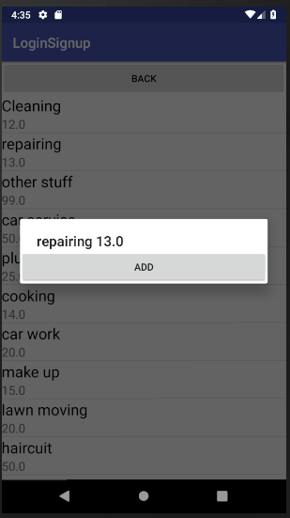

Figure 9 Service provider adding services

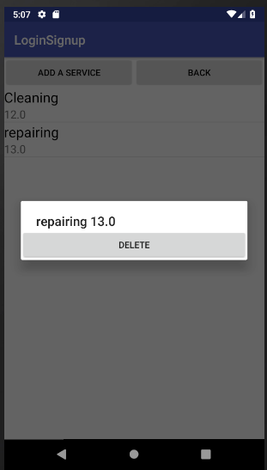

Figure 10 Service provider Deleting service he provides

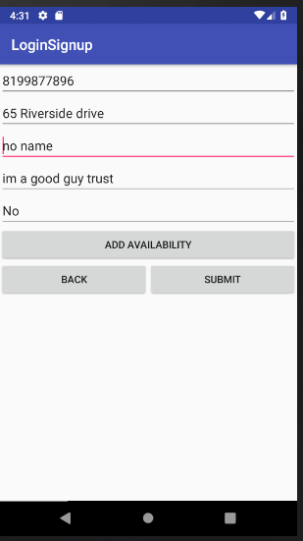

Figure 11 Service Provider Profile

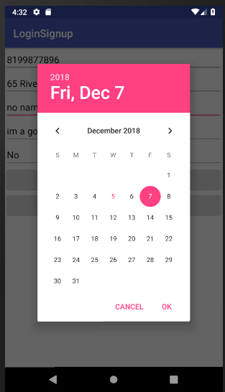

Figure 12 Service provider adding availability day

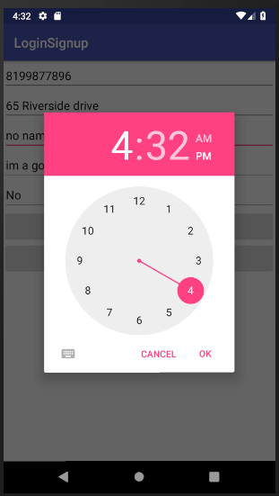

Figure 13 Service provider picking start/end time

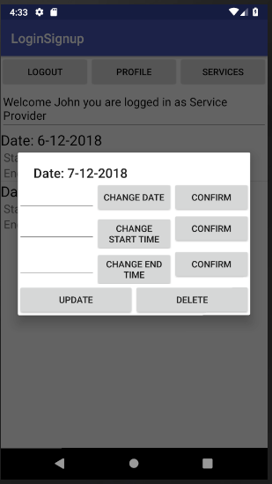

Figure 14 Service provider updating availability

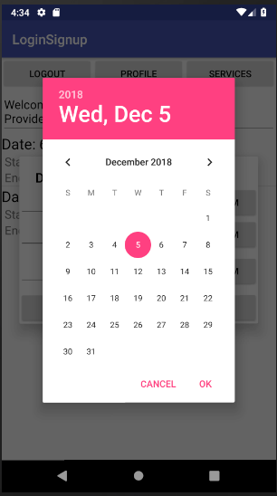

Figure 15 Service Provider updating availability day

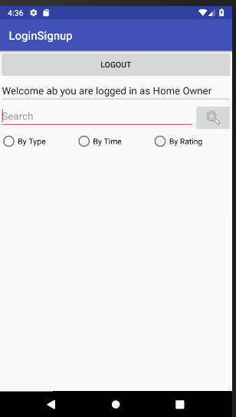

Figure 16 Home Owner welcome page

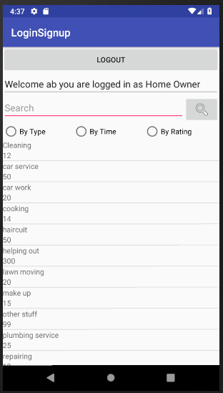

Figure 17 Home Owner when empty search

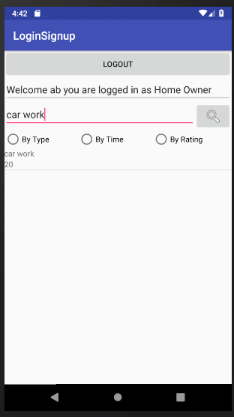

Figure 18 Searching

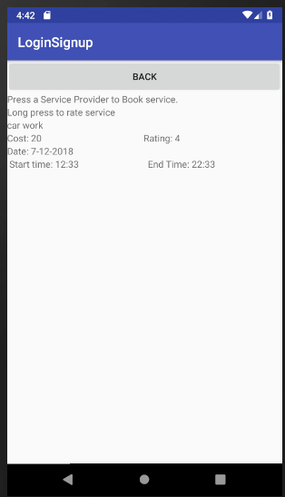

Figure 19 Looking for available service providers

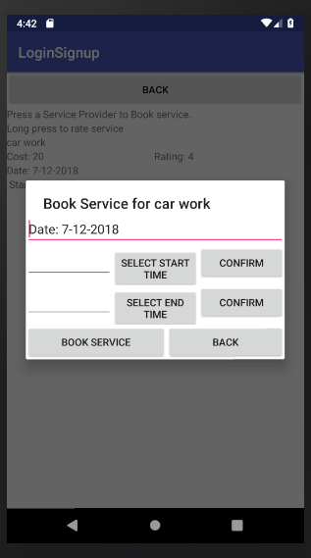

Figure 20 Booking

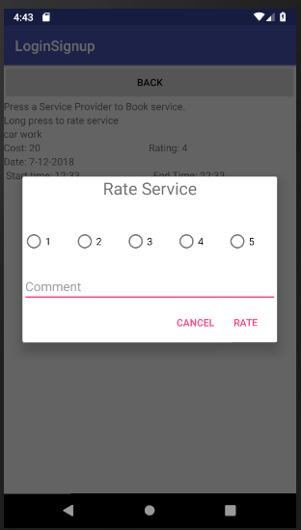

Figure 21 Rating

**Lessons learned**

When we first got this project no one in the group knew how to use android studio it was going to be all of our first android app and although it was exciting to learn something new it was also terrifying to get a project using something we didn’t learn yet. We were all a little worried about this project and one thing we learned as a group was to not worry so much because as time passed we learned how to us tools like android studio and firebase in our labs which we were then able to implement in our project. We also learned that one person does not have to know everything because it was a group based project we had team members that were able to work together to get the answer. Aside from all the technical skills we learned throughout the project such as using android studio, firebase real time databases, firebase authorization searching firebase databases and many more technical skills we also learned practical skills such using docs when trying to implements new features or searching Google trying to figure a solution to a bug we had in our code instead of just messaging our prof/TA as soon as we ran in a problem we tried to figure it out ourselves first then got help from other team members and finally we would try and search for the bug we were facing online and try and get the solution that way. We learned how to solve debug software on our own as well as to rely on team members for support when we didn’t know how to do something

**Update UML class diagram**

