**Fantasy Draft App Features for 2019:**

* Move filter by position functionality to buttons above the available player board with an additional search bar
  + 
* Improve the visibility of selected players on the draft board, change cell content to “Player Stickers” with logo, face, position, bye, etc.

**Sample in Prelim Work:**

* + 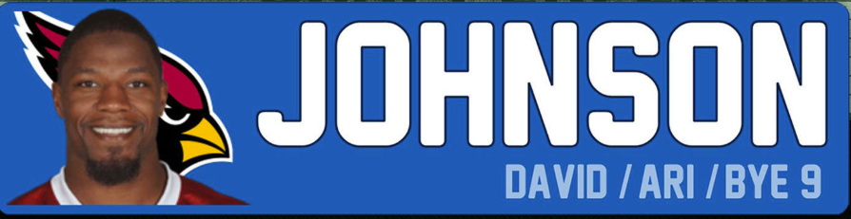
  + Injury status will appear on the label if they are currently injured and what week they will return as an overlay
* Add some AI to grade the individual drafts when they are complete
* Pop-up window when you click on a player to show
  + Last year’s fantasy stats
  + Injury Status
  + Some recent news blurbs about them

**Estimated Effort: 100 Hours of Development Work**

**Not all these features will be possible in just a week anymore. A lot of these are front-end heavy tasks that may require some creativity to get them work. But then again, that’s why it’s fun**