Critical background

* Summer was not as wet or hot this year as last
* September hurricane, Christmas eve storms last year and January storms this year mixed the water column and helped facilitate cooler late fall and winter water temps than we’ve seen since winter 2018-2019.

Ecosystem indicator report ideas

* Overwinter temperature and precipitation linked to tomcod nearshore abundance
  + More this year—did better with cooler temps and little precip
* Overwinter temperature linked to mummichog and silverside spawn timing
  + Later this year—did worse with cooler temps
  + Visually identified gravid mummichogs and silversides in July, “dip” in length tied to YOY recruitment to net happened much later in the year
* Smaller (numbers) average catches of herring and sandlance (historic low)

Cool shit

* Single, random catches: moonfish, saury
* Repeated catches: white perch, crevalle jack, permit at QBC
* White mullets still persistent in QBC data—shallow, sheltered areas only

Sections:

New Species: Rastergrid of pres/absence, blue crabs and shore crabs

Emergent Trends: tomcod and temp, length-frequency and temp for silversides and mummis, growth and temp for silversides and herring (highlight student project)

Ecosystem change: physical changes

Insights and commentary: extratropical storms, bottom temperatures

Prioritize: growth (Courtney), tomcod, southern orphans raster

eDNA: bubble plots for SFF

New Species (suggestion: change this to “Species of Note”)

Beach seine results indicated that the Casco Bay nearshore fish community assemblage in 2024 was similar to the previous ten years of results. Our ten most commonly caught species were green crabs, Atlantic silverside, mummichog, winter flounder, Atlantic herring, alewife, Atlantic tomcod, bluefish, grubby sculpin, and northern pipefish.

Three new species were caught: fallfish (*Semotilus* *corporalis*), Atlantic saury (*Scomberesox* *saurus*), and Atlantic moonfish (*Selene* *setapinnis*). Fallfish, a large freshwater minnow species native to New England, were caught in the fresher reaches of the Presumpscot River. Atlantic saury are native across most of the North Atlantic region, with an estimated distribution stretching from North Carolina to the Gulf of Saint Lawrence along the North American coast. They are highly migratory. Though we had not caught one prior to September 2024, they are known to move inshore during the summer and may form large shoals. Atlantic moonfish are native to coastal tropical and subtropical regions in the Western Atlantic, and are seldom seen north of Cape Cod. We caught a juvenile moonfish in early October 2024, which indicates that it was likely entrained in the Gulf Stream current and advected far north of the spawning ground from which it originated.

We have noted an increasing presence of “southern species” in recent years of our survey efforts. Some of these species, like the moonfish, are often called “Gulf Stream Orphans.” These tropical or subtropical fish are not adapted to the cold winters of the Northern Atlantic, and will not survive beyond their first winter. Other orphans we have caught include crevalle jack, permit, and white mullet. However, we have noted persistent and increasing presence of white mullet since 2022, which may indicate colonization as winter waters have warmed.

Emergent Trends

There is evidence that the Gulf of Maine may be at the beginning of a “cold wave,” which would see the reversal of many of the warm-water conditions common to the region since 2012 (Record et al. 2024). Though this claim is mostly tied to bottom water temperature trends, we noted that the average annual surface water temperature at the Portland Harbor NOAA tide gauge was the coldest it has been since 2020. Though water temperatures in 2024 were still anomalously hot as compared to the 2003-2020 climate reference period, the slight temperature decrease may have associated impacts on the nearshore Casco Bay ecosystem.

The size distribution of estuarine residents (like Atlantic silversides and mummichogs) caught in our seine samples suggests that spawning occurred a few weeks later in 2024 as compared to 2023. Anecdotal evidence from commercial fishers further suggests that Casco Bay was cooler and ecosystem processes were delayed as compared to the last few years (see the On the Water section for more detail).

Though we did not see dramatic changes in fish community assemblage, the decreased heat likely led to changes in the relative abundance of common Casco Bay fishes. We captured more Atlantic tomcod, a cold-adapted species, than in any previous year of the survey. Tomcod spawn in freshwater reaches of estuarine rivers from November to February, and juveniles will migrate downstream to the nearshore marine ecosystem by June. They reach sexual maturity by 11 months, then repeat the cycle. Though they can live up to 4 years, it is thought that very few live past their first spawning event. As such, tomcod abundance in the summer is highly dependent on the spawning success of the previous year’s cohort. We related tomcod catch per unit effort (number of fish divided by number of seine samples) to the average annual temperature in each spawning year (where the year begins November 1st and ends October 31st, to better match tomcod spawning dynamics) and found a negative relationship—high temperatures were associated with low tomcod catch per unit effort. Though there are many factors that can impact tomcod abundance, these results imply that temperature is highly important.

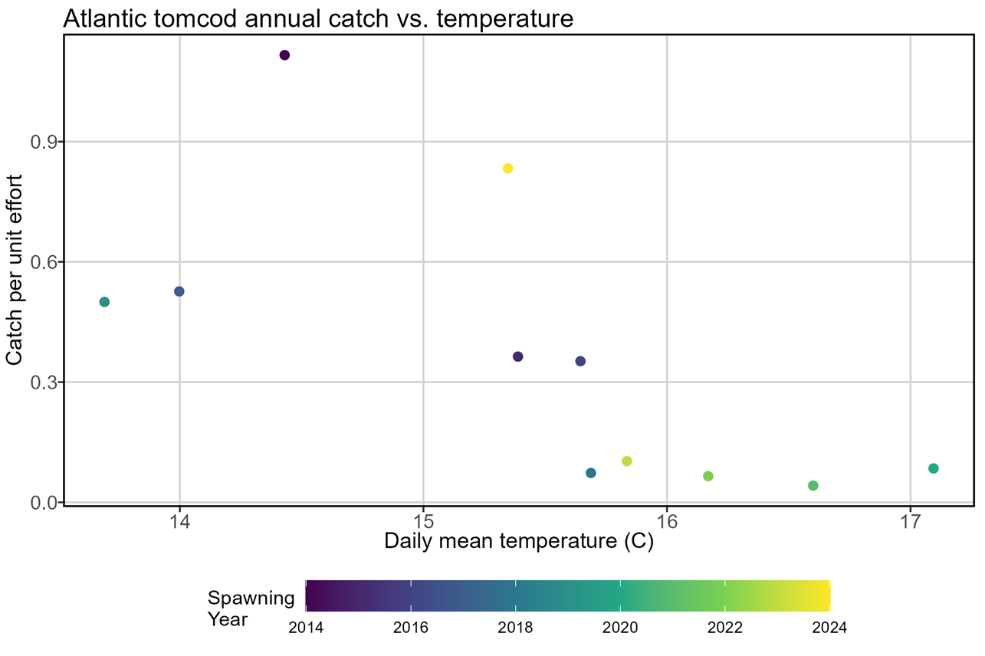

Atlantic herring, another cold-adapted species, may also have benefitted from the decreased heat.