Soil nutrient comparison between an annual burned (ABG) and patch burn grazing (PBG) system

Ethan Isaac

2023-03-26

## Load libraries and datasets

library(tidyverse)

## ── Attaching packages ─────────────────────────────────────── tidyverse 1.3.2 ──  
## ✔ ggplot2 3.4.0 ✔ purrr 1.0.1   
## ✔ tibble 3.1.8 ✔ dplyr 1.0.10  
## ✔ tidyr 1.2.1 ✔ stringr 1.5.0   
## ✔ readr 2.1.3 ✔ forcats 1.0.0   
## ── Conflicts ────────────────────────────────────────── tidyverse_conflicts() ──  
## ✖ dplyr::filter() masks stats::filter()  
## ✖ dplyr::lag() masks stats::lag()

PBG_N <- read.csv('PBG_N_compiled_raw_2021 (1).csv')  
PBG_P <- read.csv('PBG_P_compiled_raw_2021 (1).csv')  
PBG_trts <- read.csv('PBG_trts (1).csv')

## Tidy up data

PBG_bind <- rbind(PBG_N, PBG_P) %>%   
 filter(grepl('U', sample)) %>%   
 group_by(Sample) %>%   
 filter(dilution==max(dilution)) %>%   
 ungroup() %>%   
 separate(col=Sample, into=c('watershed', 'transect', 'plot', 'N_P'), sep='-') %>%   
 merge(PBG_trts) %>%   
 select(watershed, plot, concentration, units, test, treatment) %>%   
 mutate(test=ifelse(test %in% c('HCl PO4_1','KCl Ammonia 10','KCL NO3_NO2 2'),c('Phosphorous','Ammonia', 'Nitrate'),test))

## Warning: Expected 4 pieces. Missing pieces filled with `NA` in 70 rows [3, 4, 5,  
## 8, 9, 30, 31, 34, 35, 57, 58, 61, 78, 79, 80, 81, 82, 83, 86, 87, ...].

## Boxplot of the data set

ggplot(PBG_bind, aes(test, as.numeric(concentration), fill=as.factor(test))) + geom_boxplot() + facet_wrap(~treatment, scales='free') +scale_fill_manual(values=c('purple', 'light blue', 'green')) + xlab('Treatment') + ylab('Concentration')

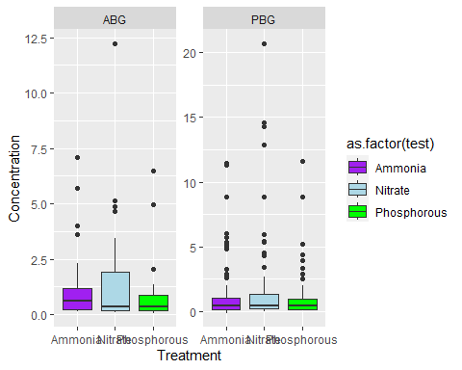

## Creating CV function and dataframe

cv <- function(x) 100* (sd(x, na.rm =TRUE)/mean(x, na.rm=TRUE))  
cv_frame <- PBG_bind %>%   
 group_by(treatment, test) %>%   
 summarize(cv=cv(as.numeric(concentration))) %>%   
 ungroup()

## `summarise()` has grouped output by 'treatment'. You can override using the  
## `.groups` argument.

## Barplot

ggplot(cv_frame, aes(x=test, y=as.numeric(cv), fill=as.factor(test))) +   
 geom_bar(stat='identity') +  
 facet_wrap(~treatment, scales='free') +scale_fill_manual(values=c('blue', 'light blue', 'red')) + xlab('Treatment') + ylab('CV of Concentration')

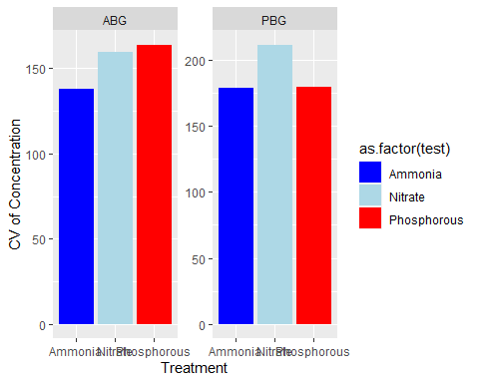 ## Summary ###Summary### Referencing the bar graphs we can see the PBG had more variation in soil nutrients. However, effects of the nutrient variatoion was not measured meaning further research is reuired to find the effect on the biodiversity.