independent_project
Tanner Lyons
2026-04-30

Setup
- Load the .xlsx file containing the dataset
file <- "Kehrberger_Scientific_Reports.xlsx"
Convert every sheet to a separate data frame - Clean colnames using janitor - Manually rename leftover names for clarity
T1 <- read_excel(file, sheet = "T1") %>%
as_tibble() %>%
janitor::clean_names() %>%
rename(
j_day = julian_date_of_year_2015,
flower_count = number_of_p_vulgaris_flowers,
visitation_rate = day_specific_flower_visitation_rate_individuals_per_hour,
competitor_count = day_specific_number_of_other_than_p_vulgaris_flowering_plant_species,
temperature = temperature_c
)
T2 <- read_excel(file, sheet = "T2") %>%
as_tibble() %>%
janitor::clean_names() %>%
rename(
week = week_of_the_year_2015,
flower_count = number_of_p_vulgaris_flowers,
bee_abundance = mean_bee_abundance,
visitation_rate = mean_bee_visitation_rate_on_p_vulgaris_flowers,
competitor_count = total_number_of_other_flowering_plant_species
)
T3 <- read_excel(file, sheet = "T3") %>%
as_tibble() %>%
janitor::clean_names() %>%
rename(
j_open = julian_date_of_bud_opening,
longevitiy = floral_longevity_days,
pollinator_hours = flower_specific_number_of_pollinator_suitable_hours,
seed_set = seed_set_percent,
mean_temp = flower_specific_mean_temperature_c,
bee_visits = estimated_total_number_of_bee_visits_per_flower_of_p_vulgaris
)
T4 <- read_excel(file, sheet = "T4") %>%
as_tibble() %>%
janitor::clean_names() %>%
rename(
j_open = julian_date_of_bud_opening,
seed_set = seed_set_percent
)
T5 <- read_excel(file, sheet = "T5") %>%
as_tibble() %>%
janitor::clean_names() %>%
rename(
j_open = julian_date_of_bud_opening,
seed_set = seed_set_percent
)
Convert Julian dates to Date objects -if j_day = 1, date should = 2015-01-01 Factorize categorical variables Fix incorrectly assigned numerical values (NAs as characters)
T1 <- T1 %>%
mutate(date = as.Date(j_day - 1, origin = "2015-01-01"),
site = as.factor(site),
visitation_rate = as.numeric(visitation_rate),
temperature = as.numeric(temperature)
)
## Warning: There were 2 warnings in `mutate()`.
## The first warning was:
## ℹ In argument: `visitation_rate = as.numeric(visitation_rate)`.
## Caused by warning:
## ! NAs introduced by coercion
## ℹ Run `dplyr::last_dplyr_warnings()` to see the 1 remaining warning.
T2 <- T2 %>%
mutate(site = as.factor(site),
bee_abundance = as.numeric(bee_abundance),
visitation_rate = as.numeric(visitation_rate),
competitor_count = as.numeric(competitor_count)
)
## Warning: There were 3 warnings in `mutate()`.
## The first warning was:
## ℹ In argument: `bee_abundance = as.numeric(bee_abundance)`.
## Caused by warning:
## ! NAs introduced by coercion
## ℹ Run `dplyr::last_dplyr_warnings()` to see the 2 remaining warnings.
T3 <- T3 %>%
mutate(date_open = as.Date(j_open - 1 , origin = "2015-01-01"),
site = as.factor(site),
flower_id = as.factor(flower_id))
T4 <- T4 %>%
mutate(date_open = as.Date(j_open - 1, origin = "2015-01-01"),
site = as.factor(site),
pollen_limitation = as.numeric(pollen_limitation))
## Warning: There was 1 warning in `mutate()`.
## ℹ In argument: `pollen_limitation = as.numeric(pollen_limitation)`.
## Caused by warning:
## ! NAs introduced by coercion
T5 <- T5 %>%
mutate(date_open = as.Date(j_open - 1, origin = "2015-01-01"),
site = as.factor(site),
treatment = as.factor(treatment)
)
T4 has a really nasty outlier that’ll interfere with our statistics, lets remove it!
Q1 <- quantile(T4$pollen_limitation, 0.25, na.rm = T)
Q3 <- quantile(T4$pollen_limitation, 0.75, na.rm = T)
IQR <- Q3 - Q1
T4 <- T4 %>%
filter(pollen_limitation >= (Q1 - 1.5 * IQR) & pollen_limitation <= (Q3 + 1.5 * IQR))
Verify data structure before proceeding
glimpse(c(T1, T2, T3, T4, T5))
## List of 32
## $ site : Factor w/ 8 levels "1","2","3","4",..: 1 1 1 1 1 1 1 1 1 1 ...
## $ j_day : num [1:192] 72 77 79 82 84 86 89 91 93 96 ...
## $ flower_count : num [1:192] 0 22 50 102 220 ...
## $ visitation_rate : num [1:192] NA 0.3836 0 0 0.0182 ...
## $ competitor_count : num [1:192] 0 0 0 0 0 0 0 0 1 1 ...
## $ temperature : num [1:192] NA 17.9 17.7 7.1 22 NA NA 6.8 7.9 11.7 ...
## $ date : Date[1:192], format: "2015-03-13" "2015-03-18" ...
## $ site : Factor w/ 8 levels "1","2","3","4",..: 1 1 1 1 1 1 1 1 1 1 ...
## $ week : num [1:80] 11 12 13 14 15 16 17 18 19 20 ...
## $ flower_count : num [1:80] 0 36 161.6 164.2 82.2 ...
## $ bee_abundance : num [1:80] NA 14.63 5 2.89 19.67 ...
## $ visitation_rate : num [1:80] NA 0.19179 0.00911 0.00893 0.03251 ...
## $ competitor_count : num [1:80] NA 0 0 1 2 4 4 6 6 NA ...
## $ site : Factor w/ 8 levels "1","2","3","4",..: 1 1 1 1 1 1 1 1 1 1 ...
## $ flower_id : Factor w/ 64 levels "F1","F10","F11",..: 1 12 23 34 45 56 62 63 64 2 ...
## $ j_open : num [1:64] 84 84 87 91 91 94 96 98 105 108 ...
## $ longevitiy : num [1:64] 12 9 16 9 5 9 7 7 7 9 ...
## $ pollinator_hours : num [1:64] 45 32 106 59 20 86 79 87 86 107 ...
## $ seed_set : num [1:64] 70.2 96.9 69.1 0 0 ...
## $ mean_temp : num [1:64] 7.04 7.72 9.21 8.03 5.46 ...
## $ bee_visits : num [1:64] 2.129 0.583 2.585 1.528 1.918 ...
## $ date_open : Date[1:64], format: "2015-03-25" "2015-03-25" ...
## $ site : Factor w/ 7 levels "1","2","3","5",..: 1 1 1 1 1 2 2 2 2 2 ...
## $ j_open : num [1:35] 84 87 94 96 98 74 79 81 90 97 ...
## $ pollen_limitation: num [1:35] 0.0536 0.6261 2.5697 0 1.4876 ...
## $ seed_set : num [1:35] 83.5 69.1 26.4 48.6 38.6 ...
## $ date_open : Date[1:35], format: "2015-03-25" "2015-03-28" ...
## $ site : Factor w/ 8 levels "1","2","3","4",..: 1 1 1 1 1 1 1 1 1 1 ...
## $ treatment : Factor w/ 3 levels "hand","open",..: 1 1 1 1 1 1 1 1 1 1 ...
## $ j_open : num [1:174] 80 84 87 91 94 94 96 98 103 108 ...
## $ seed_set : num [1:174] 23.33 4.48 43.28 100 66.67 ...
## $ date_open : Date[1:174], format: "2015-03-21" "2015-03-25" ...

Data Transformation
Summarize statistics across sites
T1_site_summary <- T1 %>%
group_by(site) %>%
summarize(
mean_flowers = mean(flower_count, na.rm = TRUE),
mean_visitation = mean(visitation_rate, na.rm = TRUE),
mean_temp = mean(temperature, na.rm = TRUE),
total_competitors = sum(competitor_count, na.rm = TRUE)
) %>%
ungroup()
T2_site_summary <- T2 %>%
group_by(site) %>%
summarize(
mean_flowers = mean(flower_count, na.rm = T),
mean_bees = mean(bee_abundance, na.rm = T),
mean_visitation = mean(visitation_rate, na.rm = T)
) %>%
ungroup()
T3_site_summary <- T3 %>%
group_by(site) %>%
summarize(
mean_longevity = mean(longevitiy, na.rm = T),
mean_pollinator_hours = mean(pollinator_hours, na.rm = T),
mean_seed_set = mean(seed_set, na.rm = T)
) %>%
ungroup()
T4_site_summary <- T4 %>%
group_by(site) %>%
summarize(
mean_pollen_limitation <- mean(pollen_limitation, na.rm = T),
mean_seed_set = mean(seed_set, na.rm = T)
) %>%
ungroup()
T5_site_summary <- T5 %>%
group_by(site,treatment) %>%
summarize(
mean_open_date = mean(j_open, na.rm = T),
mean_seed_set = mean(seed_set, na.rm = T)
) %>%
ungroup()
## `summarise()` has regrouped the output.
## ℹ Summaries were computed grouped by site and treatment.
## ℹ Output is grouped by site.
## ℹ Use `summarise(.groups = "drop_last")` to silence this message.
## ℹ Use `summarise(.by = c(site, treatment))` for per-operation grouping
## (`?dplyr::dplyr_by`) instead.
Summarize stats across dates
T1_date_summary <- T1 %>%
group_by(date) %>%
summarize(
mean_flowers = mean(flower_count, na.rm = TRUE),
mean_visitation = mean(visitation_rate, na.rm = TRUE),
mean_temp = mean(temperature, na.rm = TRUE),
total_competitors = sum(competitor_count, na.rm = TRUE)
) %>%
ungroup()
T2_date_summary <- T2 %>%
group_by(week) %>%
summarize(
mean_flowers = mean(flower_count, na.rm = T),
mean_bees = mean(bee_abundance, na.rm = T),
mean_visitation = mean(visitation_rate, na.rm = T)
) %>%
ungroup()

Visualization
Visualize flowering abundance over time using gganimate
(plot_T1_time <- T1 %>%
ggplot(aes(x = date,
y = flower_count,
color = site,
group = site)) +
geom_line(alpha = 0.9) +
theme_bw() +
labs(title = "Flowering Abundance over Time",
x = "Date",
y = "Flower Count",
color = "Site") +
transition_reveal(date)
)
## `geom_line()`: Each group consists of only one observation.
## ℹ Do you need to adjust the group aesthetic?
## `geom_line()`: Each group consists of only one observation.
## ℹ Do you need to adjust the group aesthetic?

Visualize the relationship between flower abundance and bee visitation
(plot_T1_visitation <- T1 %>%
ggplot(aes(x = flower_count,
y = log1p(visitation_rate),
color = site)) +
geom_jitter(alpha = 0.4, height = 0.01, width = 5) +
theme_bw() +
labs(title = "Flower Abundance versus Bee Visitation",
x = "Flower Count",
y = "log(Visitation Rate + 1)",
color = "Site")
)
## Warning: Removed 65 rows containing missing values or values outside the scale range
## (`geom_point()`).
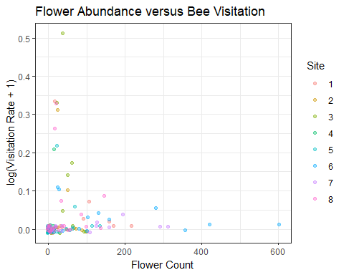
Visualize bee abundance over time across each site
(plot_T2 <- T2 %>%
ggplot(aes(x = week,
y = bee_abundance,
color = site)) +
geom_line() +
geom_point(size = 0.8, alpha = 0.8) +
theme_bw() +
scale_x_binned(expand = c(0, 0)) +
labs(title = "Weekly Bee Abundance Across Sites",
x = "Week",
y = "Bee Abundance",
color = "Site")
)
## Warning: Removed 16 rows containing missing values or values outside the scale range
## (`geom_line()`).
## Warning: Removed 16 rows containing missing values or values outside the scale range
## (`geom_point()`).
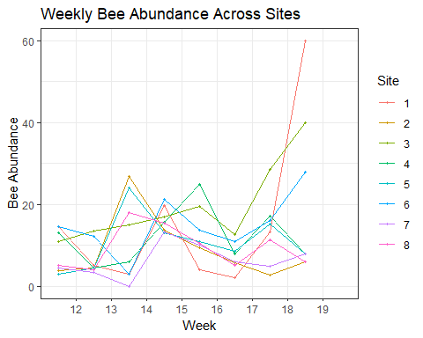
Visualize the relationship between Bee Visitation and Seed Set %
(plot_T3 <- T3 %>%
ggplot(aes(x = bee_visits,
y = seed_set,
color = site)) +
geom_point(alpha = 0.4) +
geom_smooth(method = "lm", se = F, linetype = "dashed") +
theme_bw() +
labs(title = "Bee Visits versus Seed Set",
x = "Bee Visits",
y = "Seed Set (%)",
color = "Site")
)
## `geom_smooth()` using formula = 'y ~ x'
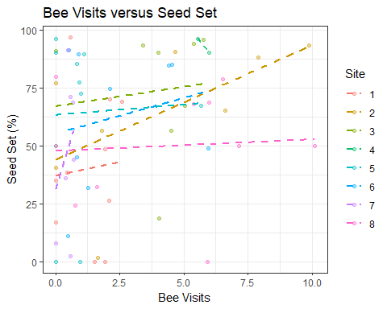
Visualize the relationship between Pollen Limitation and Seed Set %
(plot_T4 <- T4 %>%
ggplot(aes(x = pollen_limitation,
y = seed_set)) +
geom_jitter(alpha = 0.5, width = 0.2) +
geom_smooth(method = "lm", se = F) +
theme_bw() +
labs(title = "Pollen Limitation Effect on Seed Set",
x = "Pollen Limitation",
y = "Seed Set (%)") +
stat_poly_eq(aes(label = paste(..eq.label..,
..p.value.label..,
sep = "~")))
)
## Warning: The dot-dot notation (`..eq.label..`) was deprecated in ggplot2 3.4.0.
## ℹ Please use `after_stat(eq.label)` instead.
## This warning is displayed once per session.
## Call `lifecycle::last_lifecycle_warnings()` to see where this warning was
## generated.
## `geom_smooth()` using formula = 'y ~ x'
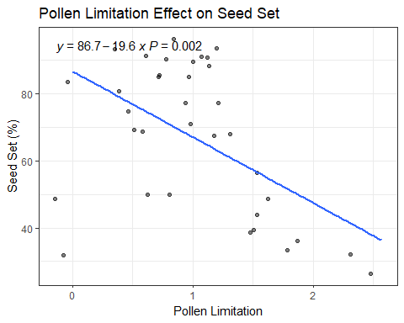
# ^ Fought with this for a wile, only works with the .. before and after each label,
# I'm not sure why! This is a new package/technique to me.
Visualize the results of each pollination treatment on Seed Set % -Add statistical significance w/ ggpubr
(plot_T5 <- T5 %>%
ggplot(aes(x = treatment,
y = seed_set,
fill = treatment)) +
geom_boxplot() +
theme_bw() +
labs(title = "Seed Set by Pollination Treatment",
x = "Treatment",
y = "Seed Set (%)") +
theme(legend.position = "none") +
stat_compare_means(method = "t.test",
label = "p.format",
comparisons = list(
c("hand", "open"),
c("hand", "pollinator exclusion"),
c("open", "pollinator exclusion")
))
)
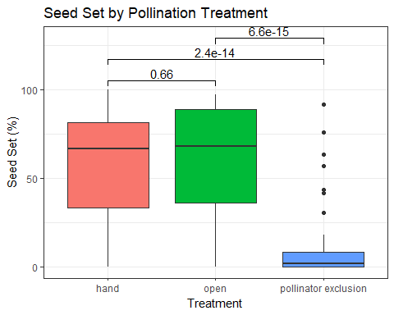

Export Results
# Export summary statistics as csv files
#write_csv(T1_date_summary, "T1_date_summary.csv")
#write_csv(T1_site_summary, "T1_site_summary.csv")
#write_csv(T2_date_summary, "T2_date_summary.csv")
#write_csv(T2_site_summary, "T2_site_summary.csv")
#write_csv(T3_site_summary, "T3_site_summary.csv")
#write_csv(T4_site_summary, "T4_site_summary.csv")
#write_csv(T5_site_summary, "T5_site_summary.csv")
# Export figures as .png and .gif files
#anim_save("T1_FlowerAbundance.gif", plot_T1_time, width = 1600, height = 1000)
#ggsave("T1_VisitationRate.png", plot_T1_visitation, height = 5, width = 8)
#ggsave("T2_BeeAbundance.png", plot_T2, height = 5, width = 8)
#ggsave("T3_BeePollination.png", plot_T3, height = 5, width = 8)
#ggsave("T4_PollenLimitation.png", plot_T4, height = 5, width = 8)
#ggsave("T5_PollinationTreatment.png", plot_T5, height = 5, width = 8)

