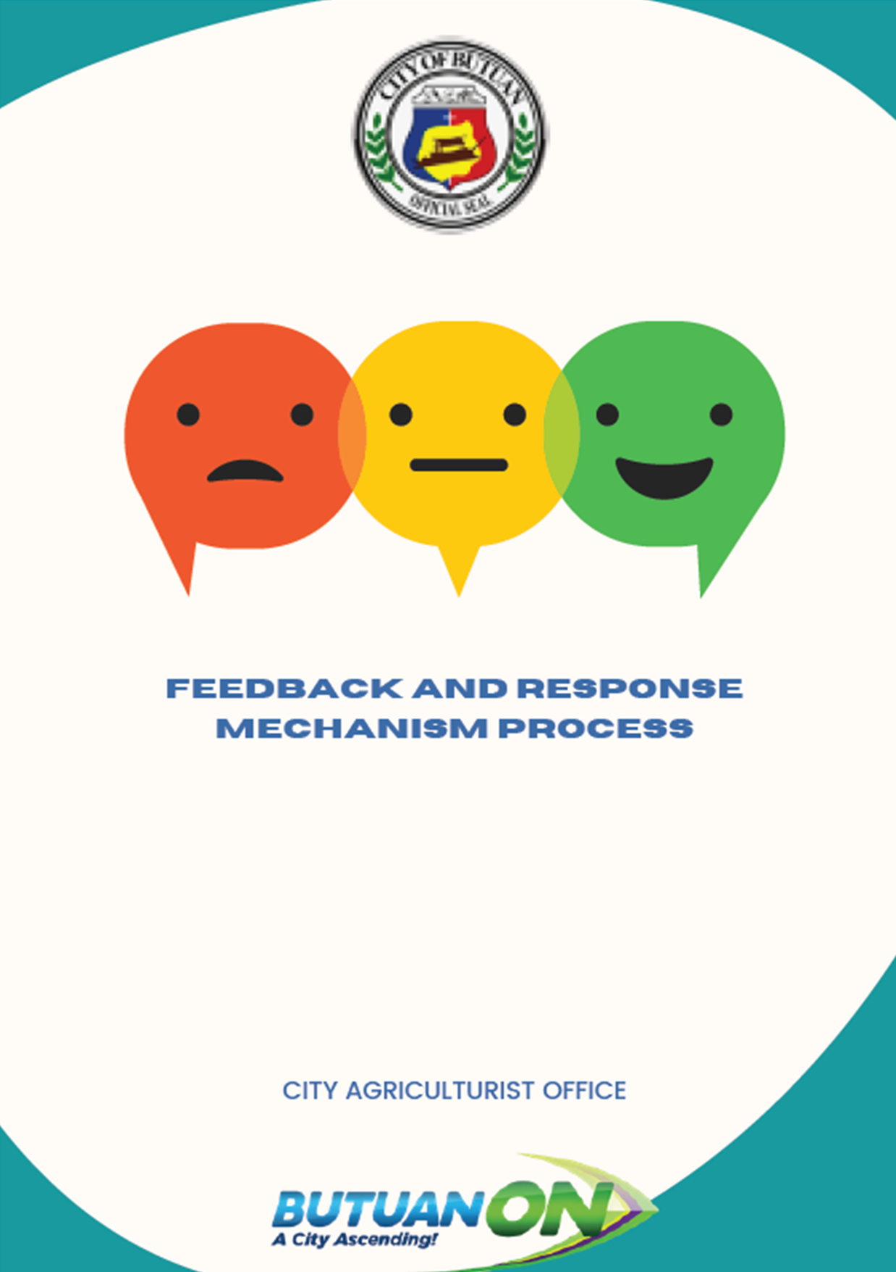

**GUIDELINES ON CAGRO'S CUSTOMER FEEDBACK AND RESPONSE HANDLING PROCESS**

**TABLE OF CONTENTS**

**TABLE OF CONTENTSi**

**LIST OF TABLESii**

**LIST OF FIGURESii**

**CHAPTER I. INTRODUCTION1**

**1.1 Executive Summary1**

**1.2 Rationale12**

1.2.1 Objectives12

1.2.2 Scope12

1.2.3. Definition of Terms13

1.2.4 Responsibilities14

**CHAPTER II. GENERAL PROCESS FLOW15**

**CHAPTER III. DETAILS OF THE PROCESS15**

**A. Inquiry/Requests15**

**B. Timelines 17**

**C. Monitoring/Reporting 18**

**D. Customer Satisfaction 18**

**E. Management Review20**

**F. Effectivity20**

**ANNEXES 21**

**CAgrO-CF Form 121**

**CAgrO-CF Form 223**

**CAgrO-CF Form 324**

**CAgrO-CF Form 425**

**CAgrO-CF Form 526**

**CAgrO-CF Form 627**

**CAgrO-CF Form 729**

**CAgrO-CF Form 830**

**CAgrO-CF Form 931**

**CAgrO-CF Form 1032**

**LIST OF TABLES**

Table 1 Strategic Objectives and Strategies 2

Table 2 Checklist of Nature of Office Function 5

Table 3 Office Major Final Output (MFOs) 5

**LIST OF FIGURES**

Figure 1 Office Location and Layout 10

Figure 2 Actual View of Office of the City Agriculturist 10

Figure 3 Existing Organizational Chart 11

**CHAPTER I: INTRODUCTION**

1.1 Executive Summary

The City of Butuan envisions to become a great hub city of opportunities for all that spurs and supports Caraga’s sustainable growth and development. The agriculture, forestry and fisheries sector plays a vital role in the attainment of this vision.

For this to happen, the city’s priority development goal is to achieve a “Robust Trade and Industry and Competitive and Sustainable Agriculture. With this, the Office of the City Agriculture is guided by its aim of achieving a “Himsog nga Agrikultura, Lagsik nga Ekonomiya.”

For the first time, Butuan City reached food self-sufficiency in rice, corn and banana in 2020. Using certified and hybrid rice varieties, palay yield ranges from 4.0 metric tons per hectare to 9.0 metric tons per hectare. Annual Average rice yield increased to 4.64 metric tons per hectare which is 16% higher than the national average rice yield of 4 metric tons per hectare. This resulted to 101% self-sufficiency on rice. In the span of six years, the city government boosted its agricultural sector by accelerating infrastructure support through construction of Farm to Market Roads worth PhP 440 Million to concrete 33.75 Kilometers.

The office recognizes the right of benefeciaries to give feedback and seek response from projects affecting them. Feedback and Response Mechanism (FRM) delivered a mechanism that enables the beneficiaries and community members to provide feedback and seek responses in relation to activities of CAgrO and other development partners, in a manner that is safe, non-threatening and accessible. The initiative also promotes beneficiary accountability and feedback and response mechanism to other development actors.

Through collaborative efforts with our farmers and other development partners, the city has made itself recognized as outstanding performers both in rice and corn production- gaining financial incentives which were immediately utilized to acquire tractors and other farm machineries to improve farmers’ mechanization capability.

However, while the sector exceeded its performance targets and generated higher growth rates over the last six years, it is still far from its desired level of productivity. Hence, the city needs to be more strategic and deliberate in terms of identifying and implementing development interventions to optimize the sector’s resource potential, following a development framework.

Table 1 Strategic Objectives and Strategies

| **Sectoral Goals** | **Strategic Objectives and Strategies** |
| --- | --- |
| Short-term (2022-2024)  Developed Agri-entrepreneurship and technology competencies for farmers cooperatives and associations | Increased production input support (farm inputs and working capital) through external fund access from RLAs and financial institutions to support the City’s agricultural production areas  Increased investment in applied research and technology demonstration in farm diversification using farm business models  Developed infrastructure for agricultural areas (roads and bridges, power, irrigation, communication, and primary storage facilities) – PHASE I  Increased Farm Mechanization Level I  Access to local market (Level I - Provincial) |
| Medium-term (2022-2028)  Food self-sufficiency and resiliency safeguarded  Agri-fishery supply and value chain developed | Increased Farm Mechanization Level II  Optimized production to achieve 100% food self-sufficiency through adoption of best available technologies (BAT) and best environmental practices (BEP)  Enhanced value-adding capabilities of farm products through the introduction of processing and storage technologies  Enhanced supply chain capabilities of farm products through the development of logistical support mechanisms (dry and cold storage facilities, transport vehicles, etc.)  Developed infrastructure for agricultural areas (roads and bridges, power, irrigation, communication, and primary storage facilities) – PHASE II  Access to local market (Level II - Regional) |
| Long-term (2022-2031)  Agro-industrialization attained | Infrastructure development for the agricultural areas (roads and bridges, power, irrigation, communication, and primary storage facilities) – PHASE III  Development of Special Economic Development Zones (SEDZ-Food Industry) utilization  Create favorable agri-business environment for Agri-fishery Economic Zones as center of product consolidation, value adding and processing, and marketing  Access to local (Level III - National) and international market |

In order to enhance the agri-entrepreneurship competencies and farmers’ competitiveness by 2024, the City Government of Butuan shall pursue the following strategic interventions:

1. Enhance the competitiveness of farmers and fisherfolks through skills retooling and entrepreneurial mind-setting;
2. Hand-hold farmers and farmer organizations to prepare business plans to access finance and farm inputs;
3. Increase rice average yield to 6.0 metric tons per hectare in rice production through use of quality seeds, adoption of good agricultural practice and provision of efficient irrigation system;
4. Design a social business model innovation in vegetable and fruit sub-sector that will motivate all players in the value chain; and
5. Establish a Mariculture Park which will provide us reliable supply of fingerlings and sustainable fish culture production and raise the income of our marginalized fisherfolks.

Moreover, the city aims to ensure food self-sufficiency and attain production surplus by 2026; and safeguard sector resiliency and improve the agri-fishery value chain ecosystem by 2028. These medium-term goals could be realized by focusing on the following initiatives:

1. Increase farm mechanization level from 40% to 90% across the value chain through fund access of machineries and equipment worth 50M/year;
2. Optimize production to achieve 100% food self-sufficiency through adoption of best available technologies (BAT) like greenhouse farming and best environmental practices (BEP) through organic agriculture program;
3. Intensify product consolidation and improve access to market through fund access of warehouse and cold storage facilities worth 40M/year; and
4. Enhance value-adding capabilities from 10% to 50% of farm products through fund access of post-harvest and processing facilities worth 40M/year.

These laser-focused initiatives would position the city to become a the agri-processing center and technology hub of Caraga Region. This breakthrough goal will expand economic opportunities for the disadvantaged farmers and marginalized sectors, reduce of inequality in the city, and breed more middle-income households.

Once these short and midterm targets have been achieved, the City of Butuan is now ready for agro-industrialization by 2031.

With the establishment of fundamental and sustainable infrastructure support mechanisms in power generation, water, communications, logistics and road network systems, the city shall also establish the following support infrastructure projects that will promote high-value commodities, particularly those with potential for further value creation, processing and market expansion, to wit:

1. Taguibo Agro-Industrial Special Economic Development Zone (SEDZ);
2. Integrated coconut, banana, cacao, coffee food processing center;
3. Rubber and abaca industrial product processing center;
4. Livestock and poultry feed mill;
5. Poultry dressing plants;
6. Meat product fabrication plants; and
7. Aqua-based food processing center.

All these aspirations will be closely managed, monitored and evaluated by the Office of the City Agriculturist. The office will be in the forefront in:

1. Preparing project proposals to access public investments from regional line agencies for the establishment of support infrastructure like FMR and irrigation system;
2. Capacitating, empowering and improving competitiveness of farmers;
3. Engage women, youth and “displaced and informal” sectors to participate in agriculture-related livelihoods; and
4. Preparing the fundamentals and environment for the establishment of Special Economic Development Zones

In ten years, the Butuan City ity will be achieving food and nutrition security, increased income and expanded employment opportunities among farmers, fisherfolks and other marginalized sectors, and become the center for trade, logistics, processing and marketing in Caraga Region.

These gains will create ripple-effect in the local economy, positively affecting not only to the city’s neighboring municipalities, but to the whole Caraga Region as well.

This elaborates the city’s journey in attaining a competitive and sustainable agriculture and fishery sector towards an agro-industrialized economy.

Table 2 Checklist of Nature of Office Function

|  |  |  |
| --- | --- | --- |
| **Nature of Office Function** | **Documentary Compliance** | |
| **YES** | **NO** |
| Implementer / Frontline Service Provider | **/** |  |
| Regulator (Fishery Laws) | **/** |  |
| Facilitator / Coordinator | **/** |  |
| Controller |  | **/** |
| Audit / Internal Control | **/** |  |
| Technical Support |  |  |
| Legal |  | **/** |
| Engineering / Design | **/** |  |
| Medical |  | **/** |
| Financial |  | **/** |
| Research | **/** |  |
| Process Flow | **/** |  |
| IEC Promotion | **/** |  |
| Research and Planning | **/** |  |
| Revenue Generation (incidental in the conduct of technology demonstration) | **/** |  |

Table 3 Office Major Final Output (MFOs)

| **MAJOR FINAL OUTPUT/PAP** | **DESCRIPTION** |
| --- | --- |
|
| **STRATEGIC FUNCTIONS (50%): *Goal 1: Competitive and Sustainable Agriculture and Fishery Sector*** |  |
| **MFO 1: Planning and Analytics Services** | * Strategized planning to significantly contribute to the realization of the city’s vision towards agro-industrial economy; * Prepare local development plans (ex. Food Security Plan); * Update annual city agricultural profile; * Facilitate the preparation of Barangay Agricultural Development Plan; * Participate in LGU Technical Working Group (TWG) development planning; |
| 1.1, Formulation of Business Models for all agro/agri industrial products |
| 1.2, Formulation of agricultural and fishery development plans |
| 1.3 Updating of City Agricultural Profile |
| 1.4 Formulation of Farm to Market Roads (FMR) Project Proposals |
| 1.5 Institutionalization of QMS and CGB- Re-organization |
| **MFO 2: Agro-industrial Development Services** |  |
| 2.1 Formulation of Full Feasibility Study | * Prepare project proposals, business plans, pre-feasibility studies, and feasibility studies on agro-industrial development; * Prepare Program of Works (POW) and Detailed Engineering Designs (DED) for agri-fishery support infrastructures such as Farm-to-Market Roads (FMR), irrigation systems, greenhouses, warehouses, dry and cold storage facilities, commodity processing centers, and pre and post-harvest facilities; * Develop agri-fishery enterprises along the supply and value chain of regional agri-industrial business corridor (ABC); and * Lead in the establishment of agri-agro special economic development zones (SEDZ). |
| 2.2 Operationalization of Special Project Management |
| **CORE FUNCTIONS (40%):** |  |
| **MFO 3: Organic Agriculture Development Services** |  |
| 3.1 Establishment of Naturally Grown Areas | * Refers to the conduct of various activities to sustain the naturally grown rice areas and expand vegetable areas such as naturally grown areas profiling and updating, establishment of techno demo site, provision of production inputs such as raw materials for organic fertilizer and bio pesticides production, biological agents and organic rice seeds and implementation of organic agriculture standards and guideline to newly expand naturally grown rice areas. |
| 3.2 Establishment of Learning Sites |
| **MFO 4: Research and Development Services** |  |
| Establishment of Organic Rice Research Center | * The project has focused on the production of organically grown rice in 10.50 hectares which, will be the number one source of income generating in the city. * Basically, the production in ecological farming is a holistic production system to remain productive and healthy. * Conduct researches that focused on the different strategies that will help promote the operation, techniques and methods used in the field. |
| **MFO 5: Technology Management Services** |  |
| *5.1 Development and Operation of Organic Demonstration Farm and Plant Nursery Facility* | * Sustains the operation of Butuan City Nursery is to demonstrate how to optimize the productivity of a particular area through adoption of best available technologies (BAT) and best environmental practices (BEP), for replication by farmers and the public. * Conduct genetic enhancement for swine industry development. |
| *5.2 Operation of City Swine Breeder Farm* |
| **MFO 6: Agricultural Crops Development Services** |  |
| *6.1 Institutionalization Rice Self-sufficiency Program* | * + - Provide technical assistance to farmers in agricultural barangays across all priority agri-crops;     - Conduct farm visits to provide advisory and extension services to farmers for improve farming systems;     - Leads in the implementation of national and local agriculture programs and projects geared towards increasing farmers’ income;     - Be in the frontline in the provision of farm production input assistance, crop insurance and access to market and credit;     - Facilitate farmers in the preparation of farm plan and operational plan;     - Act as resource person or trainer in the conduct of capacity development activities; and * Validate and consolidate planting and harvesting data across all priority agri-crops. |
| *6.2 Institutionalization Corn Development Program* |
| *6.3 Institutionalization High Value Crops Development Program* |
| *6.4 Institutionalization Farm Mechanization Program* |
| **MFO 7: Livestock and Poultry Development Services** |  |
| Sustainability of livestock and poultry production projects | * + - Provide technical assistance to livestock and poultry growers in agricultural barangays;     - Conduct farm visits to provide advisory and extension services to livestock and poultry growers;     - Leads in the implementation of national and local agriculture programs and projects geared towards increasing farmers’ income;     - Be in the frontline in the provision of farm production input assistance, crop insurance and access to market and credit;     - Faciliate farmers in the preparation of farm plan and operational plan;     - Act as resource person or trainer in the conduct of capacity development activities; and     - Validate and consolidate livestock and poultry data. |
| **MFO 8: Aquaculture Development Services** |  |
| 8.1 Fish Sanctuary Development | * + - Provide technical assistance to fisherfolks in coastal, riverine and fishpond establish barangays;     - Conduct field visits to provide advisory and extension services to fisherfolks;     - Leads in the implementation of national and local agri-fishery programs and projects geared towards increasing fisherfolks’ income;     - Be in the frontline in the provision of aquaculture production input assistance, crop insurance and access to market and credit;     - Facilitate fisherfolks in the preparation of farm plan and operational plan;     - Act as resource person or trainer in the conduct of capacity development activities;     - Validate and consolidate fish catch and production data;     - Conservation and rehabilitation of coastal areas; and     - Regulate fishery law. |
| 8.2 Mariculture Park Establishment |
| 8.3 Established Freshwater Hatching Facility |
| 8.4 Provision of Livelihood Support Services to Fisherfolks |
| **MFO 9: Rural-based Organization (RBOs) and Gender Development Services** |  |
| Learning and Development and Extension Services to farmers, fisherfolks and cooperators | * Inspire and motivate farmers and fisher folks to participate and contribute in the good governance and local economic development of Butuan City. * It is also the platform where the issues and gaps in their development process are properly addressed. * Conduct training and seminars to capacitate farmers and fisherfolks on different agri-fishery technology. |
| **MFO 10: Agri-Investment and Marketing Services** |  |
| 10.1 Accessed to finance and market outlets | * Link farmers and fisherfolks to financial institutions and market outlets; * Coordination activities with RLAs conducted in providing development interventions |
| 10.2 Linkage projects from other NGAs |
| **MFO 11: Performance Management Services** |  |
| 11.1 Institutionalization of Strategic Planning | * Be responsible in the consolidation of the OCAg’s Annual Budget Proposal, Work and Financial Plan (WFP), and Project Procurement Management Plan (PPMP); * Provide technical assistance to the Department Head during activities relevant to the preparation and presentation of the OCAg’ Annual Budget Proposal, WFP and PPMP; * Coordinate with the Division Heads in the planning and studying of the OCAg’s programs, projects and activities, such as Strategic Planning, Mid-year and Year-end Assessments, and other OCAg related activities; * Take accounts on the office and individual performance target and rating; and * Conducts capability training activities for employees personal and team development. |
| 11.2 Institutionalization of Office Performance Management Review |
| *11.2.1 Conduct of Mid-year Assessment* |
| *11.2.2 Conduct of Year-end Assessment* |
| 11.3 Conduct of Team Building |
| **SUPPORT FUNCTIONS (10%)** |  |
| **MFO 12: Administrative Support Services** |  |
| 12.1 Preparation and Submission of Office Monthly Accomplishment Report and other Reports | * Lead in the consolidation of the OCAgs monthly and annual accomplishment reports; * Inform the Department Head of meetings, activities, and other important activities of the CGB; * Ensure that all received communication, memoranda, executive orders, administrative orders, and other documents relevant to the operations of the OCAg are relayed to the Department Head; * Analyze and propose existing office policies, rules and regulations to avoid duplication or conflict with other issuances, and to recommend appropriate corrective actions; and * Ensure that all scheduled activities of the OCAg are properly handled |

### c. Office location and layout

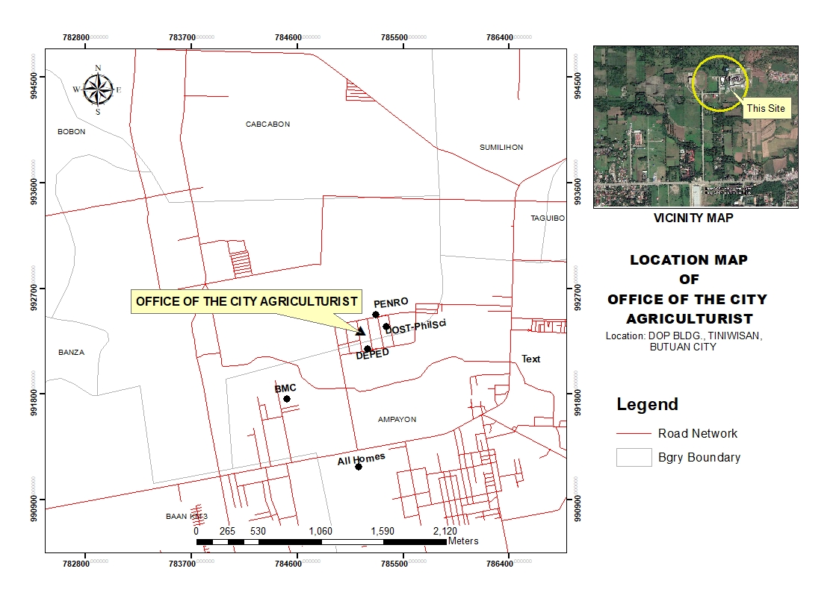

Figure 1 Office Location and Layout

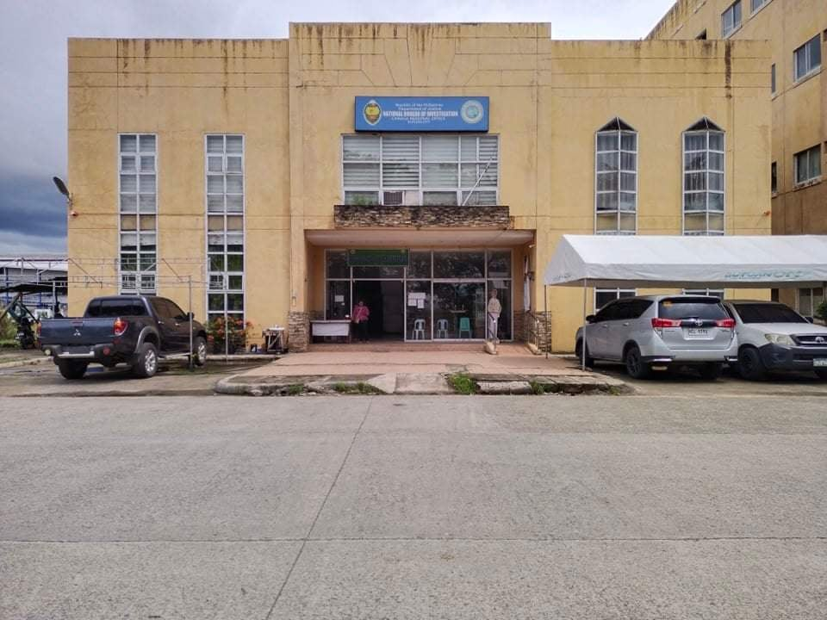

Figure 2 Actual View of Office of the City Agriculturist

### 

### d. Organizational Chart

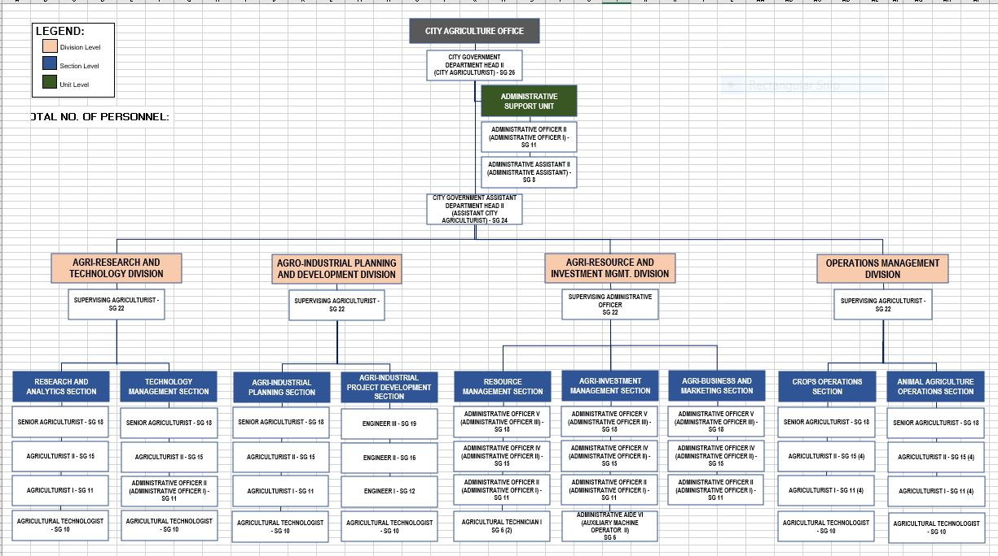

Figure 3 Existing Organizational Chart

**1.2. Rationale**

The CAgrO Customer Satisfaction Management System establishes the system and identifies the procedures on meeting customer requirements through the Office's identified modalities. The monitoring and analysis of the information gathered from customer inquiries/requests gathered from various customer segments and access modes are significant inputs to continuous improvement and customer centric strategies and actions.

Republic Act 11032 otherwise known as "Ease of Doing Business and Efficient Delivery of Government Services Act of 2018 provides for the adoption of a simplified requirement and procedure that will expedite government transactions according to prescribed timelines per type of transaction. With the foregoing, a Circular to harmonize the requirements of Republic Act 11032 and the existing procedures relating to customer and stakeholders inquiry/request handling is being pursued.

# 1.2.1. Objectives

1. To unify and harmonize the current customer inquiry/request handling process under CAgrO Customer Satisfaction Management System with the requirement of RA 11032 otherwise known as "Ease of Doing Business and Efficient Delivery of Government Services Act of 2018.
2. To align the process with the requirement of Freedom of Information (FOI) Manual as required by Executive Order No. 2 Series 2016.
3. To ensure inquiries, requests, needs and expectations of customers and stakeholders are understood, monitored and analyzed for continual process improvement.

# 1.2.2. Scope

1. Handling, monitoring and reporting of inquiries and requests for frontline services received from any of the following CAgrO access modes:

1. Public Assistance and Complaints Desk (PACD)/Officer of the Day (OD)
2. Telephone (Hotline *085-817-8486*)
3. Electronic Mails/Mails (bxuagriculturist@yahoo.com/bxuagriculturist01@gmail.com)
4. Official CAgrO Facebook Account (Butuan City Agriculture Office)
5. Other Government Agencies

2. Reporting of inquiry/request and comments gathered from consultations, forum and dialogues with CAgrO stakeholders.

# 1.2.3. Definition of Terms:

|  |  |
| --- | --- |
| **TERM** | **DEFINITION** |
| **Access Modes** | Modalities identified by the Agency in gathering and responding to customer queries, requests for service, feedback, comment, suggestion, commendation and complaint. |
| **Action Taken** | A term used to denote a response or step taken to address an inquiry/issue raised by a customer. |
| **Inquiry** | An act of seeking information about CAgrO 's programs and services. Chatbot is a software application used to conduct an on-line chat conversation via text or text-to-speech, in lieu of providing direct contact with a live human agent. |
| **Contact Center ng Bayan** | Created by the Civil Service Commission. It is a feedback  Bayan (CCB) mechanism designated as the government's main helpdesk where citizens can request for information and assistance  on government frontline service procedures and report  commendations, appreciations, complaints and feedback. |
| **Customers** | Individual or groups also known as 'Citizen' availing of CAgrO programs and services, such as but not limited to other government offices, and the transacting public. |
| **Customer Satisfaction Focal** | A CAgrO employee covered by a CAgrO Office Focal Order, designated to monitor, consolidate and submit required reports. |
| **Officer of the Day** | Designated to serve as a Public Assistance and Complaints Desk (PACD) Officer of the Day (OD). |
| **Email** | Electronically received mails or messages through the [bxuagriculturist@yahoo.com/bxuagriculturist01@gmail.com](mailto:bxuagriculturist@yahoo.com/bxuagriculturist01@gmail.com) accounts. |
| **Inquiry** | Questions/requests for information on programs and  services. |
| **PACD** | Acronym for Public Assistance and Complaint Desk. The PACD is the face to face access mode for walk-in customers in all Offices. |
| **Official CAgrO Facebook Account** | The official social media account managed by the Public Information Unit (PIU) used to promote CAgrO's programs and services, gather queries, feedback, comments, commendations and complaints. |
| **Social Media Officer** | A CAgrO employee designated as Public Information Officer tasked to post engaging social media content that will promote CAgrO. He/she provides information for simple inquiry/request. |
| **Stakeholders** | A person or organization with an interest or concern in an organization. Stakeholders include government, providers of training, industry, clients and the community. |

# 1.2.4. Responsibilities

**Local Quality Management Committee**

Reviews the Quality Management System (QMS) and monitors its continuing suitability, adequacy and effectiveness and ensures allocation of available resources to support the implementation of the Office’s QMS.

**Customer Satisfaction Committee**

Ensures that customers' requirements are identified and achieved; provide a framework for the gathering of information; ensure that processes conform to specific customer and other regulatory requirements related to service delivery; and facilitate the provision of customer requirement.

**Customer Satisfaction Focal (CSF)**

Monitors, consolidates and submits all reports and actions taken on customer inquiry/request and complaints. The CSF is an employee covered by a CAgrO Office Order designated to perform the abovementioned function.

**Officer of the Day (OD)**

Logs and records customer information inquiry/request; generates, monitors, maintains, and processes data from prescribed monitoring and reporting forms. The OD is an employee covered by a CAgrO Office Order designated to perform the abovementioned functions.

**Resource Management Section**

Monitors, consolidates and submits all reports and actions taken on customer and stakeholders inquiry/request and complaints to the HRMO.

# CHAPTER II. GENERAL PROCESS FLOW

# (Attached as Annex A)

# CHAPTER III. DETAILS OF THE PROCESS

A. Inquiry/Requests received by:

**A.1. Public Assistance and Complaints Desk (PACD)**

1. The Officer of the Day (OD) receives/welcomes the customer.

2. The OD requests customer to affix signature in the consent form attached to the Customer Feedback Form (CFF) given at the PACD.

3. The OD requests the customer to fill out the Customer Feedback Form.

4. The OD checks the accomplished CFF and asks customers question to further clarify the inquiry/request.

1. Simple inquiry/request is immediately responded to/provided by the OD.
2. Complex inquiries/requests are referred to Concerned Division/Focal Persons for assistance/action.

b.1 The OD informs the Concerned Division/Focal Person of the customer inquiry/request.

b.2 The OD endorses the customer to the Concerned Office/Focal Person.

b.3 The Concerned Office/Focal Person provides assistance/addresses/provides information/action to inquiry/request

5. The customer obtains the requested information from the Concerned Office/Focal Person.

6. The customer accomplishes the feedback form after receiving information on inquiry/request.

7. The transaction ends when the customer has no other inquiry/request and drops the feedback form in the designated feedback box.

8. The OD retrieves all the feedback at the end of the day.

9. The OD encodes the customer response to the Monitoring Sheet for Customer Feedback Form Results.

**A.2.Calls/Telephone Lines**

**A.2.1 Hotline 085-817-8486**

The inquiries/requests received through the CAgrO Contact Hotline Number 085-817-8486 shall be handled as follows:

1. The OD receives/answers the incoming call of the customer. The call is answered within two (2) rings.

2. Greets the caller/customer courteously. Uses this spiel "Thank you for calling CAgrO, this is *Introduces Self.*

3. The OD seeks customer consent for CAgrO's request information that will be requested for CAgrO monitoring. If the customer agrees to give personal information such as names and contact details, OD logs the customer information in the CCU Client Log Sheet. If the customer refuses to give personal information such as names and contact details, OD logs anonymous customer in the CCU Client Log Sheet.

4.The OD finds out why the customer is calling. Listens attentively to the customer and write down notes if necessary.

5. The OD repeats the requested information/inquiry to clarify the inquiry/request. Apologizes if there is an issue.

6. The OD logs and provides action on the inquiry/request.

1. For simple inquiries/requests

a.1 Immediately provides action

a.2 Informs customer of action taken

a.3 Requests customer feedback

1. Complex inquiries/requests are referred to Concerned Division/Focal persons for assistance/action.

b.1 The OD assists customer by providing the contact details of the Concerned Division that will be able to provide the assistance/information requested/required.

b.2 The Concerned Division/Focal Person provides assistance/addresses/provides information/action to inquiry/ request.

7. The customer obtains the requested information from the OD/Concerned Division/Focal Person.

8. The transaction ends when the customer obtains the information and has no other inquiry/request.

**A.3. SMS, Emails**

**A.3.1 Officer of the Day**

1. The OD receives/answers the inquiry/request coursed through SMS (texts) and electronic mails.

These access modes are accessible 24/7. The Officer of the Day replies to the inquiry/request from Monday to Friday, 8:00am to 5:00pm however, for inquiry/request lodged beyond 5:00pm and on weekends, holidays and work suspension, action shall be provided within the succeeding working day.

Note: The SMS facility of the CAgrO takes on/receives and replies through text messages only.

2. The OD logs and provides action on the inquiry/request.

1. For simple inquiries/requests

a.1 Immediately provides action

a.2 Informs customer of action taken

a.3 Requests customer feedback

1. Complex inquiries/requests are referred to Concerned Division/Focal persons for assistance/action.

b.1 The OD prepares the transmittal sheet to be signed by the Administrative Officer.

b.2 The refers signed transmittal sheet and inquiry/request to Concerned Office/Focal Person for action.

3. The customer obtains the requested information form the AO/Concerned Office/Focal person.

4. The transaction ends when the customer obtains the information and has no other inquiry/request.

**A.4. CAGRO Facebook Page/ Messenger**

**A.4.1 Public Information Unit (PIU)**

1. Simple inquiry/request are immediately responded/provided through the messenger and the PIU Social Media Officer.

2. Complex inquiries/requests are referred to the Concerned Division/Focal person for assistance/action.

a. The PIU Social Media Officer provides customer with contact details of the Concerned Offices (email and Hotline numbers)

This access mode is accessible 24/7. The PIU Social Media Officer replies to the inquiry/request from Monday to Friday, 8:00am to 5:00pm however, for inquiry/request lodged beyond 5:00pm and on weekends, holidays and work suspension, action shall be provided within the succeeding working day.

3. The transaction ends when the customer obtains the information and has no other inquiry/request.

B. Timelines

The Process Cycle Time (PCT) per type of transaction for each access mode as shown below shall be adopted in the office.

**Access Mode PCT**

**PACD** 15minutes (Simple), 35 minutes (Complex)

**Telephone** 5 minutes (Simple), 10 minutes (Complex)

**Access Mode PCT**

SMS, E-mail, 5 minutes (Simple), 2 days and 10 minutes (Complex)

Facebook Real-time response (Monday to Friday, 8:00am to 5pm)

**Section 8 (e) of ARTA reiterated in Section 21 (f) of the Ease of Doing Business Act, requires ALL government offices and agencies which render frontline services to adopt working schedules which will ensure that all clients are attended to and served before the end of the day even during lunch break (NO NOON BREAK POLICY).**

**C**. Monitoring/Reporting

**C.1. The monitoring and reporting of action taken on inquiry and request received through the CAgrO access modes shall be as follows:**

**C.1.1. Officer of the Day**

The Officer of the Day prepares the reports and submits the next day to the Office’s Customer Satisfaction Focal the following reports:

• Summary of Customer Comments

• Summary of Customer Inquiry/Request

• Summary Report for Face to Face Transaction

**C.1.2. Administrative Officer**

The Administrative Officer prepares and submits consolidated report every Friday to the City Agriculturist.

• Summary of Customer Comments

• Monitoring of Complaints Received

• Summary of Customer Inquiry/Request

• Total Number of Customers Served

• Summary Report for Face to Face Transaction

• Customer Satisfaction Rating

**C.2.2. City Agriculturist Office**

a. Acknowledges receipt of the report.

b. Recommended action taken on the Summary of Customer Inquiry/Request for inclusion in the weekly meeting

c. Submits to the HRMO the consolidated report every 5th day of the succeeding Month

D. Customer Satisfaction

To measure the performance of CAgrO QMS, it is important to monitor information relating to customer perception as to whether we are able to meet the customer requirements. The method for obtaining and using this information is defined below.

The information collected and analyzed by the Resource Management Section are as follows:

• Response to Customer Feedback Form

• Other

**D.1. Customer Feedback Form (CFF)**

The OD shall consolidate and compute the responses from the survey instrument Customer Feedback Form given to the CAgrO customers at the PACD.

The two (2) components with overall eight (8) "service quality dimensions" of CAgrO PACD Customers are determined through the responses to the following:

1. Kalidad sa Aktibidad:

a. Pagkaon (Food)

b. Lugar (Venue)

c. Mamumulong (Speaker)

d. Pamaagi sap ag presentar (Way/Mode of presentation)

2. Kalidad sa Pagpanerbisyo

a. Ang katahuran sa empleyado (Respectfulness)

b. Ang kahibalo/ katakos sa empleyado (Expertise)

c. Kapaspason sa serbisyo nga nahatag (Quick response)

h. Kalidad sa serbisyo nga nahatag (Quality of Service)

The customer overall satisfaction rating shall be derived from the response to the statement:

**D.2. Single Question Survey**

The OD may use a single question rating survey for customers through telephone, CAgrO email account, and SMS/mobile number. The following rating survey question may be used to gather Customer perception/feedback.

Electronic Mail

*• Thank you for giving us the opportunity to serve you better. Please help us by taking a few minutes to rate our service from 1 to 5 (1 is the lowest 3 is average and 5 is the highest rate). Hope that we meet your expectations.*

Telephone/SMS

*• Maaari po bang i rate nyo ang aming serbisyo ng 1 (pinakamababa), 3 at 5 (pinakamataas) para mapaganda pa naming ang aming serbisyo. Salamat pol*

The OD may collect survey response from a minimum of ten (10) customers per month using the above rating survey question. The data collected are recorded and compiled in a Customer Satisfaction Monitoring Report for review purposes. The survey data shall be summarized form part of the report submitted to the HRMO.

E. Management Review

The Customer Satisfaction Committee presents to the HRMO the consolidated monitoring reports and the results of the customer satisfaction survey conducted. This is to recommend and address opportunities for improvement in the implementation of the customer inquiry/request handling process.

F. Effectivity

A transition period to this new procedure shall be enforced which will commence upon approval of this Circular until further notice. This document with all Annexes shall take effect as indicated and supersedes all other issuances inconsistent herewith.

ANNEX A

CAgrO-CF Form 1

**Customer Feedback Form**

**Public Assistance Counter**

**(Front)**



Division/Section:

**CUSTOMER FEEDBACK FORM**

**CAgrO-CF Form 1.1**

**Customer Feedback Form**

**(Back)**

|  |  |  |  |  |  |  |  |  |  |  |  |  |  |  |  |  |
| --- | --- | --- | --- | --- | --- | --- | --- | --- | --- | --- | --- | --- | --- | --- | --- | --- |
| **Services/Rendered** | | | |  |  |  |  |  | | |  | |  | |  | |
|  |  |  | |  |  |  |  |  | | |  | |  | |  | |
| **Farm Mechanization** | | | | **Products** | | **Program Registration** | | **Certification** | | | | | **Training** | | |
|  |  |  | |  |  |  |  |  | | |  | |  | |  | |
|  | Tractor |  | |  | Seedlings |  | RSBSA |  | | | Re-classification | |  | | Regular | |
|  | others |  | |  | Piglets |  | P4MP |  | | | others | |  | | Scholarship | |
| Pls. specify______________ | | | |  | Palay |  | others | Pls. specify______________ | | | | |  | | others | |
|  |  |  | |  | Rice Certified Seeds | Pls. specify______________ | |  | | |  | | Pls. specify______________ | | | |
|  |  |  | |  | others |  |  |  | | |  | |  | |  | |
|  |  |  | | Pls. specify______________ | | |  |  | | |  | |  | |  | |
|  |  |  | |  |  |  |  |  | | |  | |  | |  | |
|  |  |  | |  |  |  |  |  | | |  | |  | |  | |
| **Avail Farm Inputs** | | | |  |  | **Technical/Extension** | | **Admin** | | | | | **Others** | | | |
|  |  |  | |  |  |  |  |  | | |  | |  | |  | |
|  | Seeds |  | |  |  |  | Farm and Home Visit |  | | |  | |  | |  | |
|  | Fertilizers |  | |  |  |  | Farmers meeting |  | | |  | |  | |  | |
|  | Farm Tools |  | |  |  |  | Consultation |  | | |  | |  | |  | |
|  | Farm machinery and equipment | | | | |  | Monitoring |  | |  | |  | |  | | |
|  | Fingerlings dispersal | | |  |  |  | others |  | | |  | |  | |  | |
|  | Livestock and poultry dispersal | | | | | Pls. specify______________ | | |  | |  | |  | |  | |
|  | others |  | |  |  |  |  |  | | |  | |  | |  | |
| Pls. specify______________ | | | |  |  |  |  |  | | |  | |  | |  | |
|  |  |  | |  |  |  |  |  | | |  | |  | |  | |
|  |  |  | |  |  |  |  |  | | |  | |  | |  | |
|  |  |  | |  |  |  |  |  | | |  | |  | |  | |
| ACTION TAKEN: | | |  |  |  |  |  |  | | |  | |  | |  | |
|  |  |  | |  |  |  |  |  | | |  | |  | |  | |
|  | Referred to |  | |  |  |  |  |  | | |  | |  | |  | |
|  | Specify Action Taken of Concerned Office/Focal Person | | | | | | | |  | |  | |  | |  | |
|  |  |  | |  |  |  |  |  | | |  | |  | |  | |
|  |  |  | |  |  |  |  |  | | |  | |  | |  | |
|  |  |  | |  |  |  |  |  | | |  | |  | |  | |
|  |  |  | |  |  |  |  |  | | | Printed Name and Signature of  Customer Service Officer/Officer of the Day | | | | | |

# **CAgrO-CF Form 2**

|  |  |  |  |  |  |  |  |  |  |  |  |  |  |  |  |  |  |  |
| --- | --- | --- | --- | --- | --- | --- | --- | --- | --- | --- | --- | --- | --- | --- | --- | --- | --- | --- |
| **Monitoring Report of Customer Feedback Form Results** | | | | | | | | | | | | | | | | |  |  |
| Period Covered: _______________ | | | |  |  |  |  |  |  |  |  |  |  |  |  |  |  |  |
|  |  |  |  |  |  |  |  |  |  |  |  |  |  |  |  |  |  |  |
| **Feedback Box Location** | | | | **Public Assistance Counter- CAgrO Resource Management Section** | | | | | | |  |  | | | | |  |  |
| **No.** | **Type of Modality  (CFF/Tel./Emails/FB/Messenger)** | **Date** | **Control Number** | **Name of Client** | **Age** | **Gender** | **Contact No.** | **Email address** | **Division/Section Visited** | **Service Requested** | **Action Provided** | **Rating Format in the Citizen's Charter** | | | | | **Citizens Comment** | **Action Taken, if any** |
| **P** | **US** | **S** | **VS** | **E** |
|  |  |  |  |  |  |  |  |  |  |  |  |  |  |  |  |  |  |  |
|  |  |  |  |  |  |  |  |  |  |  |  |  |  |  |  |  |  |  |
|  |  |  |  |  |  |  |  |  |  |  |  |  |  |  |  |  |  |  |
|  |  |  |  |  |  |  |  |  |  |  |  |  |  |  |  |  |  |  |

**CAgrO-CF Form 3**

**OFFICE CLIENT LOG FORM**

**Period Covered_____________**

|  |  |  |  |  |  |  |  |  |  |  |  |  |  |
| --- | --- | --- | --- | --- | --- | --- | --- | --- | --- | --- | --- | --- | --- |
| **Officer of the Day (OD)____________________** | | | **ADDRRESS** | **GENDER** | **4Ps/IPs** | **AGE** | **SENIOR CITIZEN** | **CONTACT NO.** | **SERVICES** | **SPECIFY SERVICE RENDERED** | **SUGGESTED PERSONNEL TO ATTEND** | **NUMERICAL RATING** | **ADJECTIVAL RATING** |
| **DATE** | **CONTROL NO.** | **NAME** |  |  |  |  |  |  |  |  |  |  |  |
|  |  |  |  |  |  |  |  |  |  |  |  |  |  |
|  |  |  |  |  |  |  |  |  |  |  |  |  |  |
|  |  |  |  |  |  |  |  |  |  |  |  |  |  |
|  |  |  |  |  |  |  |  |  |  |  |  |  |  |
|  |  |  |  |  |  |  |  |  |  |  |  |  |  |
|  |  |  |  |  |  |  |  |  |  |  |  |  |  |
|  |  |  |  |  |  |  |  |  |  |  |  |  |  |
|  |  |  |  |  |  |  |  |  |  |  |  |  |  |
|  |  |  |  |  |  |  |  |  |  |  |  |  |  |

**CAgrO-CF Form 4**

**MONITORING OF COMPLAINTS RECEIVED**

**Period Covered: __________________**

|  |  |  |  |  |  |  |  |  |  |  |  |  |  |
| --- | --- | --- | --- | --- | --- | --- | --- | --- | --- | --- | --- | --- | --- |
| **No.** | **Name of Complainant** | **Date Complaint Received** | **Nature of Complaint** | **Area Complained** | **Complaint Received thru** | **Details of Complaint** | **Action Taken** | **Date Acted** | **Office Referred to** | **Date Referred** | **Action Taken by Responsible Office** | **Date of Action** | **Status of Complaint** |
|  |  |  |  |  |  |  |  |  |  |  |  |  |  |
|  |  |  |  |  |  |  |  |  |  |  |  |  |  |
|  |  |  |  |  |  |  |  |  |  |  |  |  |  |
|  |  |  |  |  |  |  |  |  |  |  |  |  |  |

|  |  |  |
| --- | --- | --- |
|  | **CAgrO-CF Form 5** | |
| **MONITORING OF CUSTOMERS SERVED**  **Period Covered _______________** | | |
|  | |  |
| **MODALITIES** | **NUMBER OF INQUIRIES** | |
| **Total Telephone Calls Received** |  | |
| **Total SMS Received** |  | |
| **Total emails Received** |  | |
| **Total Facebook Customers Served** |  | |
| **Total** |  | |

**CAgrO-CF Form 6**

**CUSTOMER FEEDBACK SATISFACTION MONTHLY ANALYSIS**

**(Customer Inquiry and Feedback Form 1)**

**For the month of**

1. **Total Number of Clients Served by Gender**

|  |  |
| --- | --- |
| Gender | No. of Clients |
| Female |  |
| Male |  |
| **Total** |  |

1. **Distribution of Clients Served by Age Group**

|  |  |
| --- | --- |
| Age Group | No. of Clients |
| 15-25 |  |
| 26-35 |  |
| 36-45 |  |
| 46-55 |  |
| 56-65 |  |
| 66 and Above |  |
| Age not indicated |  |
| Total |  |

1. **Total Number of Clients by Reason of Visit**

|  |  |
| --- | --- |
| Reason for Visit | No. of Clients |
| Farm Mechanization |  |
| Products |  |
| Program Registration |  |
| Certification |  |
| Training |  |
| Avail Farm Inputs |  |
| Technical/Extension |  |
| Admin Related Concerns |  |
| Others |  |
| Total |  |

1. **Action Provided Relative to Purpose of Visit**

|  |  |
| --- | --- |
| Action Provided | No. of Clients |
|  |  |
|  |  |
|  |  |
|  |  |
|  |  |
|  |  |
| Total |  |

1. **Overall Rating**

|  |  |
| --- | --- |
| Rating | No. of Clients |
|  |  |
|  |  |
|  |  |
|  |  |

1. **Feedback on Other Service Area**

|  |  |  |  |  |  |  |
| --- | --- | --- | --- | --- | --- | --- |
| Other Areas Rated | P | US | S | VS | E | TOTAL |
|  |  |  |  |  |  |  |
|  |  |  |  |  |  |  |
|  |  |  |  |  |  |  |
|  |  |  |  |  |  |  |
|  |  |  |  |  |  |  |
|  |  |  |  |  |  |  |

**ANALYSIS:**

|  |  |  |  |  |  |  |  |  |  |  |
| --- | --- | --- | --- | --- | --- | --- | --- | --- | --- | --- |
| **CAgrO-CF Form 7** | | | | | | | | | | |
| **City Agriculturist Office**  **(CAgrO)** | | | | | | | | | | |
| **Form (Year)____** | | | **REQUEST FORM** | | | | | | | |
|  |  | | |  | | |  | | | |
| **Name** | |  | | |  | | **Date** |  | | |
| **Address** | |  | | | **Tel/Cell No.** |  | | |
|  | |  | | | |  |  |  | | |
| **Office/FCA’s** | |  | | | | **Email address** | | |  |
|  | | | | | |  |  | |  | |
| **DETAILS OF REQUEST** | | | | | | | | | | |
|  | | | | | | | | | | |
|  | | | | | | |  | | | |
|  | | | | | | | (Clients Signature over Printed Name) | | | |

|  |  |  |  |  |  |
| --- | --- | --- | --- | --- | --- |
|  |  | **FOR CAgrO USE** |  | |  |
|  |  |  | **Tracking Number** |  | |
|  |  |  |  |  | |
| **Endorsed to** | **Date Endorsed** | **Remarks** | **Action Taken** | | **Date of Action** |
|  |  |  |  | |  |
|  |  |  |  | |  |
|  |  |  |  | |  |
|  |  | | | |  |

**CAgrO-CF Form 8**

|  |  |  |  |  |  |  |  |  |  |  |  |  |
| --- | --- | --- | --- | --- | --- | --- | --- | --- | --- | --- | --- | --- |
| **City Agriculturist Office**  **(CAgrO)** | | | | | | | | | | | | |
| **Year ____** | | **COMPLAINT REPORT FORM** | | | | | | | | **DATE** |  | |
|  |  | |  | | | | | |  | | | |
| **NAME OF COMPLAINANT:** | | | |  | **Person/Office Involved** | | | | | | | |
|  |  | | | | | |  |
|  |  | | | | | |  |
|  | | | | | | |  | | | | | |
| **DETAILS OF COMPLAINT** | | | | | | | | | | | | |
|  | | | | | | | | | | | | |
|  | | | | | | |  | | | | | |
|  | | | | | | | Name and Signature of Complainant | | | | | |
|  | | | | | | |  |  | | | | |
|  | | | | | | |  |  | | | | |
|  | | | | | | |  |  | | | | |
| Name and Signature of Personnel Receiving the Complaint | | | | | | |  |  | | | | |

|  |  |  |  |  |  |  |  |  |  |  |
| --- | --- | --- | --- | --- | --- | --- | --- | --- | --- | --- |
|  |  |  |  |  |  |  |  | **CAgrO-CF Form 9** |  |  |
| **Summary of Results of Citizen’s Feedback System Report Form** | | | | | | | | |  |  |
|  | |  |  |  |  |  |  |  |  |  |
|  | |  | |  |  |  |  |  |  |  |
| Period Covered: | |  | | | | |  |  |  |  |
|  |  |  |  |  |  |  |  |  |  |  |
| Feedback Box Location | Public Assistance Counter- CAgrO Resource Management Section | | | | | | | | | |
| Division/Section Visited | Mo/Yr | Rating Format in the Citizen's Charter | | | | | | Summary of Clients Comments | Action/s Taken on Negative Feedbacks | Suggestions/Recommendation |
| P | US | S | VS | E | Total Respondents |
|  |  |  |  |  |  |  |  |  |  |  |
|  |  |  |  |  |  |  |  |  |  |  |
|  |  |  |  |  |  |  |  |  |  |  |
|  |  |  |  |  |  |  |  |  |  |  |
|  |  |  |  |  |  |  |  |  |  |  |
|  |  |  |  |  |  |  |  |  |  |  |

**CAgrO-CF Form 10**

|  |  |  |
| --- | --- | --- |
|  | | |
|  |  |  |
| **Inventory/Accomplishments of Citizen's Served in the Frontline Services Enrolled in the Citizen's Charter** | | |
|  |  |  |
| Period Covered: |  |  |
|  |  |  |
| Feedback Box Location |  | |
|  |  |  |
| Frontline Service in the Citizen Charter | Month/ Year | Total Number of Clients Served |
| **Farm Mechanization** |  |  |
| **Products** |  |  |
| **Program Registration** |  |  |
| **Certification** |  |  |
| **Training** |  |  |
| **Avail Farm Inputs** |  |  |
| **Technical/Extension** |  |  |
| **Admin Related Concerns** |  |  |
| **Others** |  |  |
| **Total** |  |  |