# Homework

1. Using the Google Search (without opening search results) check (write down the search queries): **(1pkt)**
   1. The value of 15PLN in Euro

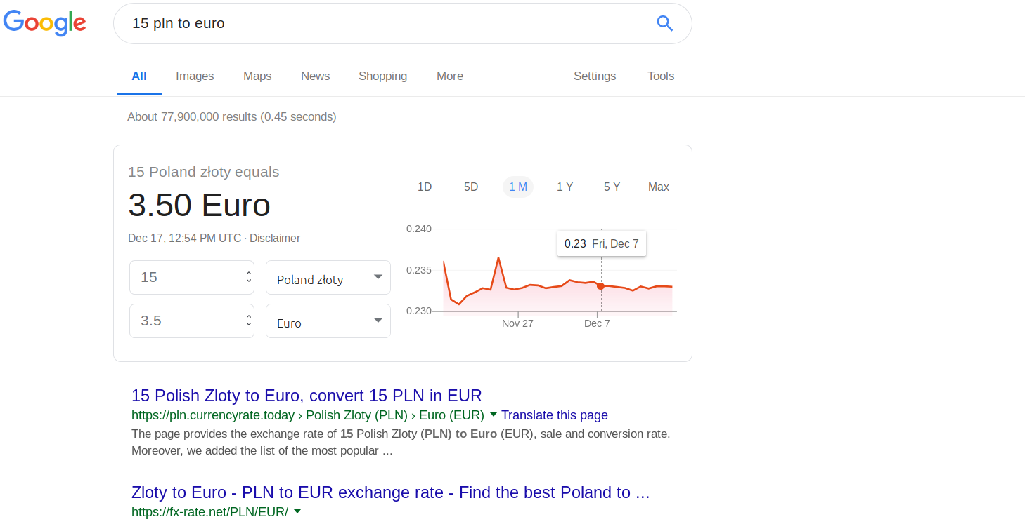

* 1. Results of last 5 games of Manchester United

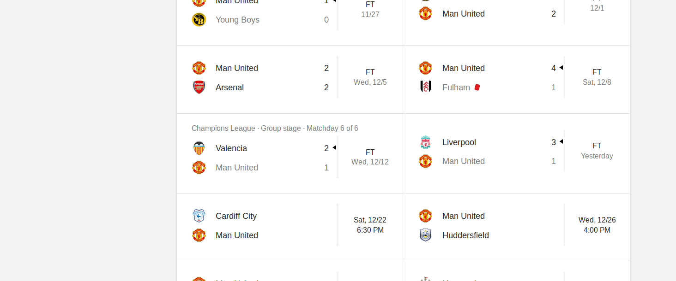

* 1. Birth and death dates of Nelson Mandela

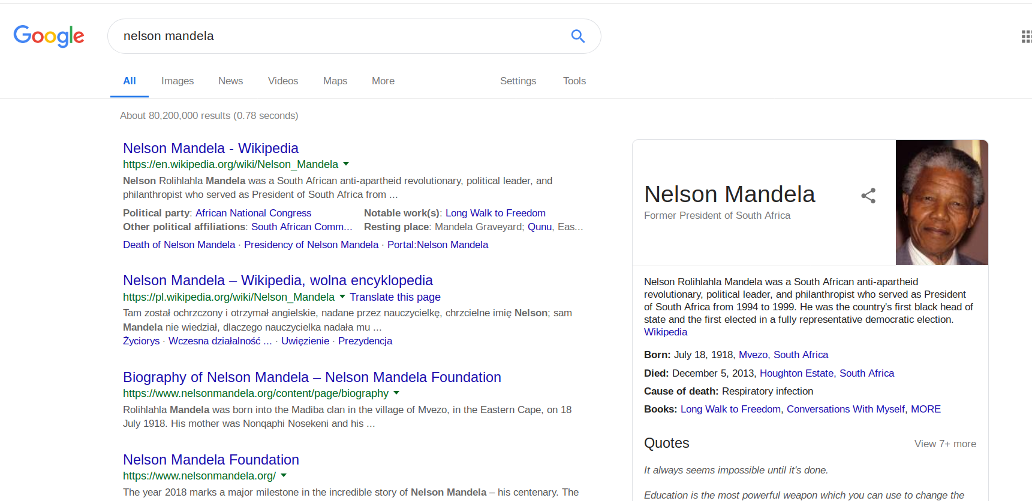

1. Find first 3 paragraphs of the Indian Constitution (in Hindi). Translate them into English with the Google Translator. In your report put both the Hindi and English text. **(1 pkt)**.

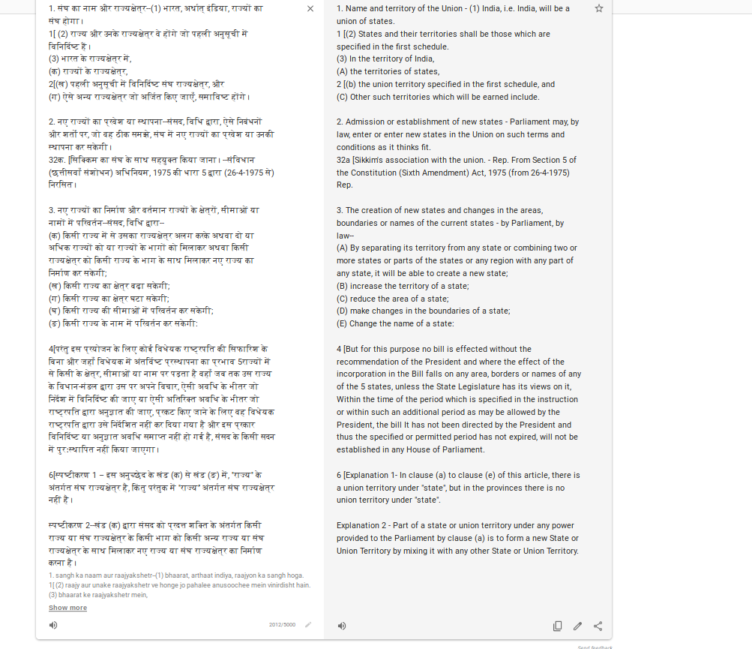

1. Using Google Search (write down the search queries): **(1 pkt)**
   1. Find information about Rafał Jaworski on the site wmi.amu.edu.pl

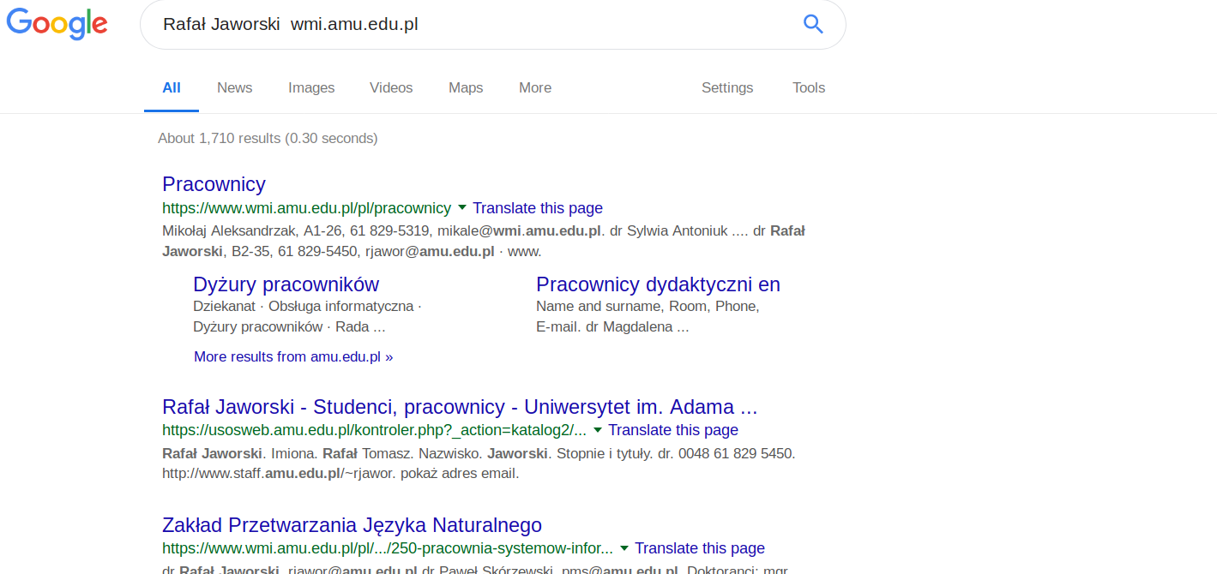

* 1. Find pages similar to amu.edu.pl

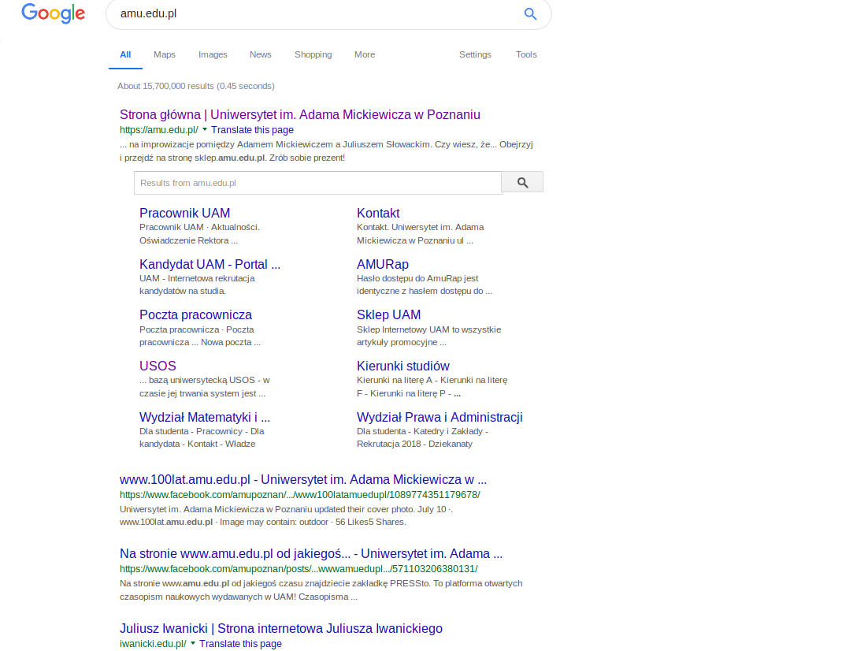

1. Create a folder in Google Drive and share it for editing and organizing for people with link. Inside the folder create a dokument, spreadsheet and a presentation with the same rights as the folder. Write down the sharing slink. **(1 pkt)**

https://drive.google.com/drive/folders/1sMOaBLKqh17ctNVEEuUn7aBrm6ofvJY_?usp=sharing