Exersise 2

Google ip: 216.58.194.110

amu.edu.pl ip: 150.254.65.170

wmi.amu.edu.pl ip: 150.254.78.3

Exersise 1

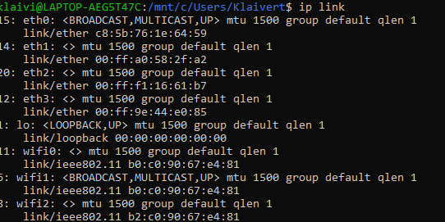

My ip:150.254.107.112

Exerciese 3

