# Spatial analysis of association between dog ownership and health in Seattle, Washington

Kathryn Lau, ENVH 565 A, 12/8/19

## Introduction

The health benefits of pet ownership, particularly of dogs, is an active and evolving area of health research. Although more studies are needed to fully understand the pet-health effect, there are many promising findings suggesting that dog ownership improves health. As one example, the American Heart Association in 2013 published a review stating that dog ownership is associated with reduced cardiovascular risk.1 Similar conclusions are echoed in a Special Health Report written by Harvard Medical School entitled “Get Healthy, Get a Dog.”2 Proposed mechanisms for improved health include increased physical activity due to behaviors like dog-walking, and decreased heart rate and blood pressure and increased production of beneficial hormones while playing and spending time with dogs. The pet-health effect may even extend to brief exposures to dogs, with some studies hypothesizing that dogs serve as a “social catalyst”, spurring positive social interaction among people and reducing loneliness.1 The goal of this analysis was to analyze spatial data on dog ownership and health indicators consistent with current research on the pet-health effect to identify any observable spatial patterns.

## Methods

Four main datasets were used in this analysis. Pet data was extracted from the Seattle Pet Licenses database, maintained by the Department of Finance and Administrative Services of the City of Seattle.3 The database contains all current Seattle pet licenses as of July 2019 and includes animal type and owner zip code for each licensed pet. Pet data was subset to only include dogs, and some rows with implausible zip codes were dropped (zip codes that corresponded to locations far outside of Seattle and likely entered in error). To standardize dog ownership to account for variation in zip code population size, a second dataset of population by Washington state zip code was downloaded from the U.S. Census Bureau.4 Population estimates for 2017 produced by the Census Bureau’s Population Estimates Program and based on the American Community Survey were used and merged onto the dog ownership data by zip code. A measure of dogs per 100 people was calculated by dividing the total dog ownership in a zip code by the population for that zip code. Median household income in the past 12 months (in 2017 inflation-adjusted dollars) was also extracted from this source, in order to assess any association with income.

Health indicator data was extracted from the Washington state Behavioral Risk Factor Surveillance System (BRFSS).5 BRFSS is a national survey that collects representative data on many different indicators, and Washington state adds some additional questions to the survey as well. BRFSS data was subset to three health indicators, chosen based on relevance to dog ownership shown previously in the literature. These indicators are defined in the table below.

**Table 1. Health indicator definitions from BRFSS**

|  |  |
| --- | --- |
| **Indicator** | **Survey definition** |
| Any physical activity | During the past month, other than your regular job, did you participate in any physical activities or exercises such as running, calisthenics, golf, gardening, or walking for exercise? |
| Body mass index | Calculated from self-reported height and weight |
| Overall mental health | Thinking about your mental health, which includes stress, depression, and problems with emotions, for how many days during the past 30 days was your mental health not good? |

Last, shape files of the Seattle zip codes were obtained from Seattle GeoData, an online portal run by the city of Seattle. Zip code data was originally supplied by King County and last updated in December 2018.6 Since zip codes do not align precisely with city boundaries, all zip codes containing any area within the Seattle city boundaries was included. Specifically, the following zip codes were considered to fall within the city of Seattle: 98101, 98102, 98103, 98104, 98105, 98106, 98107, 98108, 98109, 98112, 98115, 98116, 98117, 98118, 98119, 98121, 98122, 98125, 98126, 98133, 98134, 98136, 98144, 98146, 98154, 98164, 98174, 98177, 98178, 98195, and 98199. All these datasets were combined in ArcGIS through joins on zip code. For the health indicators, the specific measures used in ArcGIS were proportion of respondents reporting any physical activity in a zip code, mean BMI in a zip code, and mean days in poor mental health out of the past 30 days in a zip code.

Spatial distribution was assessed by creating chloropleth maps of per capita dog ownership, median household income, and each of the three health indicators. ArcGIS was also used to plot the health indicators against per capita dog ownership and visualize trends across zip codes. Median household income was included in the scatter plots represented by color of the data points, in order to also visualize the impact of income on the main relationships of interest. Median household income was not available for one zip code.

## Results

Based on the chloropleth maps, the distribution of per capita dog ownership appeared most similar to the distribution of mean body mass index (BMI), with zip codes with lowest mean BMI often corresponding to zip codes with highest per capita dog ownership, and vice versa (Figure 1).

**Figure 1. A) Per capita dog ownership by zip code (left) and b) mean BMI by zip code (right).**

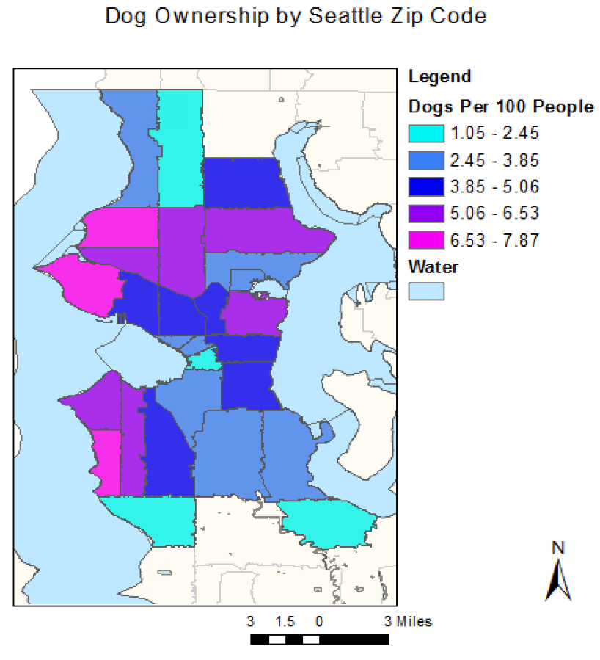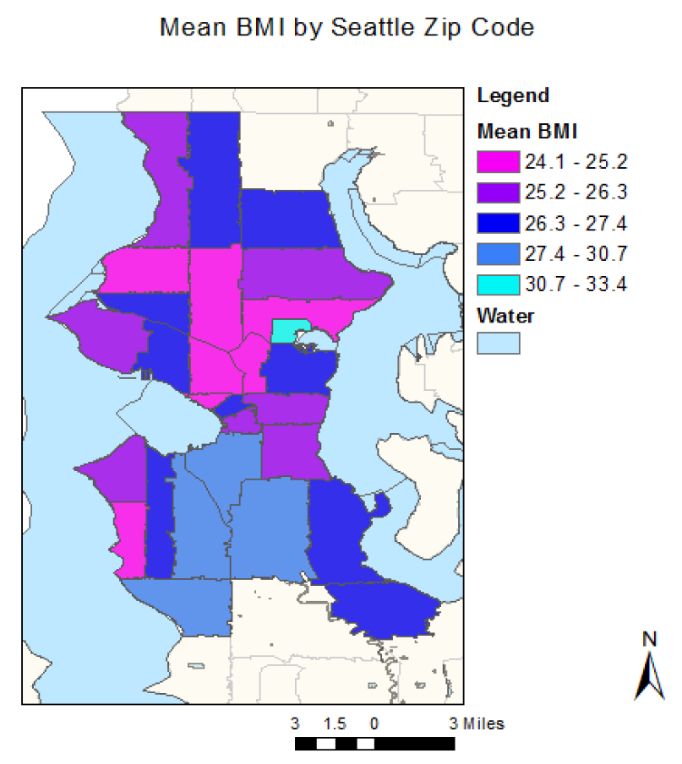

The scatter plots confirm that the strongest association among the three health indicators is the association with mean BMI (Figure 2). A negative trend is observed between mean BMI and per capita dog ownership, and median household income appears to explain some of the trend, with higher median incomes (in pink) associated with both higher dog ownership and lower mean BMI.

**Figure 2. Mean BMI versus dogs per capita by zip code. Colors correspond to median household income within that zip code (orange point is where no income information was available).**

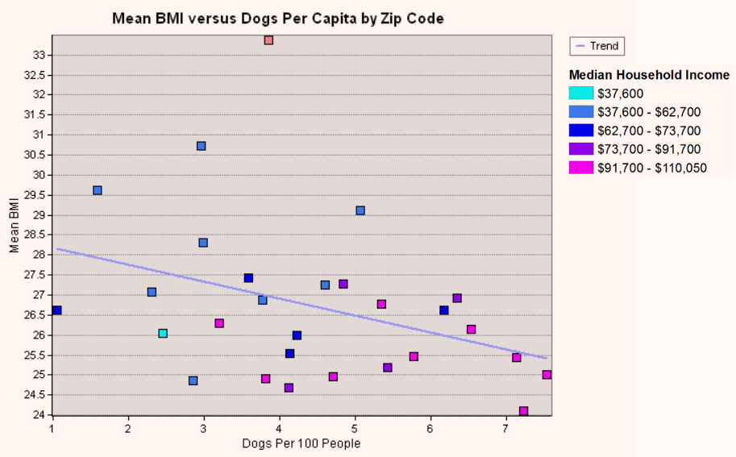

A weaker, positive association was observed between per capita dog ownership and proportion of survey respondents in a zip code reporting any non-work physical exercise (Figure 3), and no significant association was observed between per capita dog ownership and mean days in poor mental health (Figure 4). Similar to mean BMI, median household income appears to explain some of the relationship with physical activity.

**Figure 3. Physical activity versus dogs per capita by zip code. Colors correspond to median household income within that zip code (orange point is where no income information was available).**

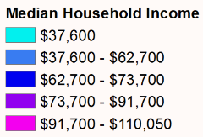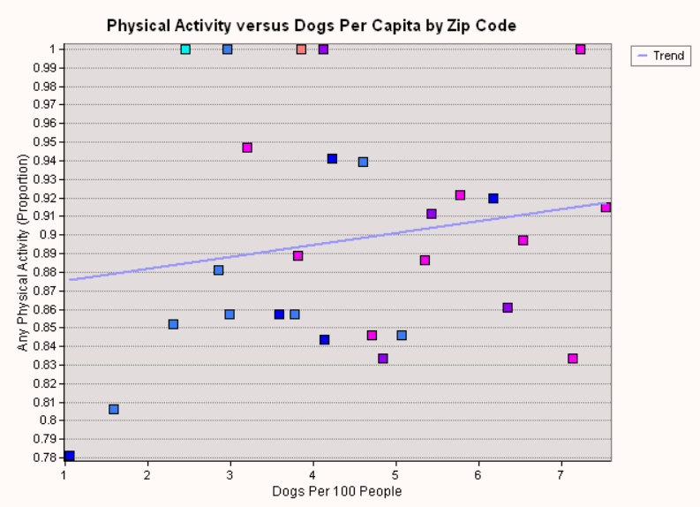

**Figure 4. Mean days of poor mental health (out of the last 30 days) versus dogs per capita by zip code. Colors correspond to median household income within that zip code (orange point is where no income information was available).**

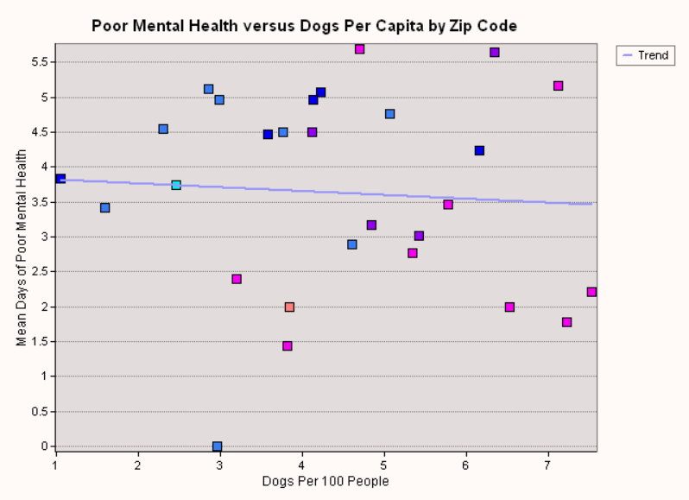

## Discussion

The results of this analysis suggest that mean BMI is negatively associated with per capita dog ownership within a zip code, which is consistent with previous studies conducted in other settings, and that physical activity is positively associated with per capita dog ownership, though to a lesser extent. Surprisingly, self-reported mental health does not appear correlated with dog ownership. For both of the observed associations, median household income is likely a confounder that explains at least part of the relationship. Further analysis should be done to quantify the extent of the contribution of income to these observed trends.

There are some significant limitations on interpreting and generalizing these results. First, although Seattle pet owners are legally required to license their pets (punishable by a $125 fine)7, it’s unclear that this policy is well-enforced, and therefore this is likely an incomplete measure of all the pets in the area. Second, all three health indicators from BRFSS are self-reported and thus may be subject to certain well-documented biases associated with self-reporting. Third, and perhaps most importantly, due to data availability and interest in utilizing publicly available data, this is an ecological study rather than a study of individuals (i.e. the individuals reporting health data are not necessarily the same individuals reporting pet ownership data). As a consequence, the results of this study suggest associations between the level of dog ownership in a zip code and mean BMI and participation in physical activity in that same zip code, not an individual-level association between owning a dog and having lower BMI and higher physical activity. Although this limits the conclusions that can be drawn for individual behaviors and health, it presents an opportunity to study the ecological benefits of living in an area with dogs, even if you do not own one yourself, which may also be of interest.

## References

1 Matchock RL. Pet ownership and physical health. *Current Opinion in Psychiatry* 2015; **28**: 386.

2 Harvard Medical School. Having a dog can help your heart — literally. Harvard Health Publishing. https://www.health.harvard.edu/staying-healthy/having-a-dog-can-help-your-heart--literally (accessed Dec 1, 2019).

3 Seattle Pet Licenses | City of Seattle Open Data portal. https://data.seattle.gov/Community/Seattle-Pet-Licenses/jguv-t9rb (accessed Dec 1, 2019).

4 U. S. Census Bureau. 2013-2017 American Community Survey 5-Year Estimates. https://factfinder.census.gov/faces/tableservices/jsf/pages/productview.xhtml?pid=ACS_17_5YR_DP05&prodType=table (accessed Dec 1, 2019).

5 Washington State Department of Health, Center for Health Statistics, Behavioral Risk Factor Surveillance System, supported in part by the Centers for Disease Control and Prevention, Cooperative Agreement NU58/DP006066-04 (2018). .

6 King County. Zip Codes. Seattle GeoData. 2018; published online Dec 20. http://data-seattlecitygis.opendata.arcgis.com/datasets/83fc2e72903343aabff6de8cb445b81c_2 (accessed Dec 1, 2019).

7 Mail or In-Person Licensing - Animal Shelter | seattle.gov. http://www.seattle.gov/animal-shelter/license/mail-or-in-person-licensing#:~:targetText=Licensing%20your%20pet%20is%20the%20law&targetText=050%20requires%20that%20all%20cats,result%20in%20a%20%24125%20citation. (accessed Dec 8, 2019).