
Faculty of Economic Cybernetics, Statistics and Informatics

The Impact of Artificial Intelligence Implementation on Various Sectors of the Labor Market: A Student Perspective

Statistics and economic forecasting
Author: Vișoiu Ioana-Claudia

Bucharest
January 2026
Contents
Objectives 3
Formulating the statistical hypotheses 5
Defining the target group 8
Data collection method 9
The design of the questionnaire 10
Sample statistical survey 11
Calculating the sample size 12
Data collection and coding (Preparation for SPSS) 13
Data processing 15
Part I 15
1. Verifiying the accuracy and completeness of the data 15
2. Verifying the representativeness of the sample 19
3. Processing of the numeric variables 19
4. Processing of the qualitative variables 25
Part II – Statistical tests 31
1. Testing the research hypotheses 31
2. Tests for independent samples 36
3. Test pentru observații perechi (eșantioane dependente) 40
4. ANOVA 41
Partea a III-a 47
1. Relația dintre doua variabile numerice 47
2. Relația dintre două variabile ordinale 49
3. Testul Chi-pătrat 52
Concluzii 56

Objectives

The central objective of this research is to conduct a multidimensional investigation into how students, as future participants in the labor market, perceive and integrate Artificial Intelligence (AI) tools into their academic and professional paths. The study aims to determine whether there is a convergence between the skills acquired today and the anticipated demands of a labor market undergoing rapid technological transformation.
To ensure a rigorous analysis, the central objective was broken down into the following specific objectives:
Objective 1. To assess the degree of adoption and frequency of use of AI technologies in students’ daily activities.
- This objective aims to determine whether AI is a tool used only occasionally or whether it has become an integral part of student life.
- We will analyze the types of platforms used (e.g., ChatGPT, Gemini, Claude) to understand user preferences based on their features.
Objective 2. Analyze the impact of AI on the learning process and academic performance.
- Measuring the amount of time students estimate they save by automating repetitive or complex tasks (projects, research, summaries).
- Identifying the extent to which AI tools are used as creative tools versus technical tools.
Objective 3. Assessing the level of trust and critical thinking regarding results generated by AI.
- Investigating the extent to which students verify the accuracy of information provided by algorithms, a critical factor for academic and professional integrity.
- Assessing perceptions of AI’s reliability as a source of expertise in specialized fields.
Objective 4. Identifying attitudes and feelings toward one’s future career in the context of automation.
- Analysis of the degree of optimism versus anxiety (concern) regarding the possibility that AI might replace certain roles or tasks in the field chosen by the student.
- Assessing perceptions of positive impacts (increased productivity) versus negative impacts (job losses or the erosion of human creativity).
By achieving these objectives, this study aims to provide an overview of the “digital maturity” of the current generation of students, while also offering recommendations for adapting the university curriculum to new technological realities.

Formulating the statistical hypotheses

- H₁: There is a significant positive correlation between participation in AI courses and perceived job readiness.
  - Justification: Participation in formal or non-formal artificial intelligence courses, such as those offered by universities or through workshops and online courses, helps students become familiar with AI concepts and tools. This can positively influence their level of confidence and their perception of their own readiness to use these technologies in a professional setting. Thus, it is assumed that there is a positive relationship between participation in AI courses and the perceived level of readiness to use AI in the workplace.
  - Proposed statistical test: Pearson's correlation coefficient or, in the case of ordinal variables or when the conditions of normality are not met, Spearman's correlation coefficient (α = 0,05).
  - Used variables: Participarea la cursuri formale despre IA / participarea la workshopuri sau cursuri online despre IA [Attended formal courses on AI / attended workshops or online courses on AI], Gradul de pregătire resimțit pentru utilizarea IA la locul de muncă [Perceived level of readiness to use AI in the workplace]
- H₂: Computer science students use AI tools more frequently than students in other fields.
  - Justification: Students who are currently working or plan to work in the field of computer science have more frequent contact with digital technologies and artificial intelligence-based applications. They are more likely to use AI chatbots and other intelligent tools in their daily, academic, or professional activities. Therefore, it is expected that the frequency of AI tool use will be higher among computer science students compared to those in other fields.
  - Proposed statistical test: The t-test for independent samples, provided that the variable representing the frequency of AI use is measured on a metric scale. If the conditions for its application are not met, the nonparametric Mann–Whitney U test should be used (α = 0,05).
  - Used variables: Domeniul în care studenții doresc să activeze (informatică vs. alte domenii) [The field in which students wish to work (computer science vs. other fields)], Frecvența utilizării chat-urilor IA în viața de zi cu zi [Frequency of use of AI chatbots in daily life]
- H₃: More than 70% of students believe that AI will have a positive impact on their future careers.
  - Justification: Artificial intelligence is increasingly present in various fields of activity, and is associated with increased productivity and the emergence of new career opportunities. Students are frequently exposed to information about the benefits of using AI, which can lead to a predominantly positive perception of its impact on their future careers. In this context, it is assumed that a significant proportion of students believe that AI will have a positive impact on their career paths.
  - Proposed statistical test: The proportion test (z-test), which compares the observed proportion with the reference value of 70%. For small samples, the binomial test can be used (α = 0,05).
  - Used variable: Percepția asupra impactului IA asupra carierei [Perceptions of the impact of AI on one's career]
- H₄: There is a significant difference between undergraduate and graduate students in terms of the amount of time saved each month by using AI.
  - Justification: Graduate students generally face more complex academic tasks and can use artificial intelligence tools in a more advanced and efficient manner. By using AI for research, writing, or analysis, they can save more time each month compared to undergraduate students. Thus, it is assumed that there is a significant difference between the two levels of study in terms of time saved through the use of AI.
  - Proposed statistical test: The t-test for independent samples, provided that the variable is approximately normally distributed. Otherwise, the Mann–Whitney U test should be used (α = 0,05).
  - Ciclul de studii (Licență / Master / Doctorat) [Cycle of study (Bachelor’s / Master’s / Doctorate)], Timpul estimat economisit lunar prin utilizarea IA [Estimated monthly time savings from using AI]
Each research hypothesis will be tested against the null hypothesis, which assumes that there are no significant differences or correlations among the variables under analysis.

Defining the target group

The target group for the study is all students in Romania, regardless of the level of study (Bachelor’s, Master’s, or Doctorate), who are currently undergoing professional training and preparing to enter the labor market. The choice of this group is justified by the increasingly important role of artificial intelligence in educational and professional settings, as well as by the need to understand how the future workforce perceives and uses these technologies.

The unit of analysis is the student, viewed as an individual engaged in an active process of academic development. Each respondent is analyzed in terms of sociodemographic characteristics (level of education, gender, background), level of exposure to artificial intelligence (participation in formal or non-formal courses, frequency of AI tool use), and perceptions regarding the impact of AI on productivity and professional career.

The key criteria for inclusion in the study population are being an active student enrolled in a higher education institution in Romania, using or being exposed to artificial intelligence tools, and preparing to enter the labor market. This criterion ensures the relevance of the responses to the research objectives, which aim to assess the level of use, attitudes, and perceptions regarding artificial intelligence.

The analysis of this group is relevant because students are among the groups most likely to use artificial intelligence, both in the educational process and in professional training. The research findings can provide useful insights for adapting university curricula and developing educational policies focused on digital skills.

Data collection method

Data used in this study were collected through a statistical survey, using a questionnaire as the research tool. This method was chosen because it allows for the rapid and efficient collection of information from a large number of respondents, as well as because of the standardized nature of the questions, which enables subsequent statistical analysis of the data in IBM SPSS.

The questionnaire was conducted online and distributed to students in Romania via digital platforms and social media. This method of data collection facilitated access to respondents from various fields of study, academic levels, and backgrounds, contributing to a diverse sample.
The survey instrument includes closed-ended questions, most of which are measured on Likert-type ordinal scales (1–5), as well as questions with nominal responses (such as “yes/no” or multiple-choice). The questionnaire is structured into several sections, covering: the socio-demographic characteristics of respondents, the level of use of artificial intelligence tools, perceptions regarding the impact of AI on productivity and career, as well as concerns related to the use of these technologies.

Participation in the study was voluntary, and respondents were assured of anonymity to encourage honest and objective responses. The collected data were processed and statistically analyzed using IBM SPSS software to test the hypotheses formulated in the study.

The chosen method is appropriate for the research objectives, as it allows for the capture of students’ opinions and behaviors regarding the use of artificial intelligence in a contemporary educational and professional context.

The design of the questionnaire

The questionnaire used in the study was designed to collect the information needed to test the hypotheses formulated and was structured into three main sections, corresponding to the study’s objectives.

The first section, dedicated to identifying information, includes questions regarding the respondent’s educational background, gender, socioeconomic background, and the field in which they wish to work or are already working. The variables included in this section are nominal variables, serving to provide a sociodemographic profile of the sample under analysis.

The second section focuses on AI usage behavior and includes questions regarding participation in formal or informal courses on AI, the frequency of using AI tools in daily life, as well as the AI platforms used most often. The variables in this section are measured on both ordinal and nominal scales, with some allowing for multiple responses.

The third section addresses respondents’ perceptions and attitudes toward artificial intelligence, including items regarding their level of trust in AI-generated information, concerns about its use, and perceptions of AI’s impact on their careers and productivity. To measure these variables, 5-point Likert scales were used, where a score of 1 corresponds to the minimum level (not at all / very little) and a score of 5 to the maximum level (very much / completely).

Sample statistical survey

Before distributing the questionnaire to the entire sample, a pilot survey was conducted to verify the clarity of the questions, the structure of the questionnaire, and the time required to complete it. The questionnaire was distributed to 10 students selected from the study’s target population.

Based on the feedback received from participants in the pilot survey, several issues requiring clarification were identified. Thus, the question regarding the time saved each month through the use of artificial intelligence was rephrased by introducing more clearly defined time intervals (e.g., 1–3 hours, 4–10 hours) to facilitate understanding and reduce ambiguity in the responses. Additionally, the response options for the question regarding the field of activity were expanded to better capture the diversity of the respondents’ areas of interest.

Conducting the pilot survey helped improve the content validity of the questionnaire and ensure that the research instrument was better aligned with the study’s objectives.

Calculating the sample size

The sample size was determined based on the research objectives, the data collection method, and the availability of respondents. The study collected 101 valid questionnaires completed by students in Romania, which form the database used in the analysis.
Given that the target population is very large and the study is quantitative and exploratory in nature, a sample of over 100 respondents is considered adequate for conducting basic descriptive and inferential statistical analyses. The sample size allows for the application of statistical tests used in the study, such as correlation tests, tests of differences between groups, and tests of proportions.
Furthermore, the sample size is sufficient to produce results that are relevant to the research hypotheses, given an acceptable level of statistical precision, in light of the study’s purpose and nature.

Data collection and coding (Preparation for SPSS)

The data was collected using the previously developed structured questionnaire, and for statistical analysis in IBM SPSS, the variables were numerically coded to enable automatic processing and the application of statistical tests.

Nominal variables:
- Ciclul de studii [Cycle of studies] (Q1): Undergraduate = 1, Graduate = 2, Doctorate = 3
- Gen [Gender] (Q2): Masculine = 1, Feminine = 2
- Mediul de proveniență [Social background] (Q3): Urban = 1, Rural = 2
- Curs formal urmat [Formal course/s taken] (Q4): No = 0, Yes = 1
- Participare workshop/bootcamp/curs online [Participation in a workshop/bootcamp/online course] (Q5): No = 0, Yes = 1
- Credeți că IA poate crește productivitatea angajaților? [Do you believe that AI can increase employee productivity?] (Q13): No = 0, Yes = 1, I don’t know = 2
- Principală îngrijorare legată de IA [Main concern regarding AI] (Q15): Reduced creativity = 1, Dependence on technology = 2, Incorrect information = 3, Ethical issues = 4, Job loss = 5, No concerns = 0
- Domeniu de activitate dorit [Desired field of activity] (Q16): Computer Science = 1, Economics / Business = 2, Social Sciences = 3, Engineering = 4, Education = 5, Art / Design / Media = 6, Law / Judiciary = 7
- Platforme IA folosite cel mai des [Most frequently used AI platforms] (Q17): ChatGPT = 1, Gemini = 2, Claude AI = 3, DeepSeek = 4, Copilot = 5, Midjourney = 6, Others = 7
- Time saved monthly using AI (Q19): 0 hours = 0, 1–3 hours = 1, 4–10 hours = 2, Over 10 hours = 3

Scalar variables (Likert 1–5)
For questions regarding frequency of use, use of AI to save time, perceived readiness, trust in AI, impact on career, concern about job displacement, and the need for practical training (Q6–Q12, Q14, Q18), a 1–5 Likert scale was used, where 1 corresponds to the minimum value (not at all / very little) and 5 to the maximum value (very much / completely).
This coding enables the correct application of descriptive and inferential statistical tests in SPSS, such as the correlation coefficient, t-tests for independent samples, Mann–Whitney tests, and proportion analyses.

Data processing

Part I

Verifiying the accuracy and completeness of the data

For the nominal variables:
After checking the data using the Descriptive Statistics → Frequencies method in SPSS, it was found that there were no missing values for any variable. This confirms the completeness of the dataset, ensuring that all collected responses can be used in the statistical analysis without the need to impute or exclude any observations.

For the numeric/scalar variables (Q6–Q12, Q14, Q18, Q19):
The Descriptive Statistics → Explore method in SPSS was used, which allows for the visualization of distributions, the calculation of the median and quartiles, and the identification of any outliers. The analysis was conducted to understand the general trends and variability in students’ responses.

For the variable “Use of AI tools in the desired field” (Q8), the distribution of responses is concentrated around the mean values, but the boxplot highlights a few outliers corresponding to respondents who do not intend to use AI tools at all. These outliers were retained in the analysis because they reflect the actual diversity of students’ intentions and attitudes and allow for correlation with other individual responses.

Regarding “Level of confidence in the accuracy of AI-generated information” (Q10), most responses fall within the low-to-moderate confidence range, and the boxplot indicates the presence of outliers with maximum scores, corresponding to respondents with very high confidence in AI. These outliers were retained for their analytical relevance, contributing to a complete picture of students’ opinions.

The other numerical variables analyzed, including “Frequency of AI tool use in daily life” (Q6), “Use of AI to save time” (Q7), “Perceived readiness to use AI at work” (Q9), “Impact of AI on career” (Q11), “Concern about job replacement” (Q12), “Need for practical AI training” (Q14), “Verification of AI-generated information” (Q18), and “Estimated time saved monthly using AI” (Q19), exhibit homogeneous distributions and do not indicate the presence of significant outliers. Their distributions allow for the assessment of the mean, variability, and general trends in students’ responses.

In conclusion, the descriptive analysis of the numerical variables indicates that most respondents report moderate to frequent use of AI tools, with moderate levels of perceived proficiency and confidence in the accuracy of the information generated by AI. The outliers identified in Q8 and Q10 are retained for their analytical relevance, and the remaining variables show relatively uniform and stable distributions, ready for subsequent stages of inferential analysis.

Accuracy of the encodings:
All variables were checked to confirm adherence to the established coding schemes: nominal variables have values corresponding to the range 0–2, Likert-scale variables were coded between 1 and 5, and the “time saved per month” variable between 0 and 3. The analysis in SPSS revealed no errors or discrepancies, which attests to the accuracy and consistency of the data prepared for statistical processing.
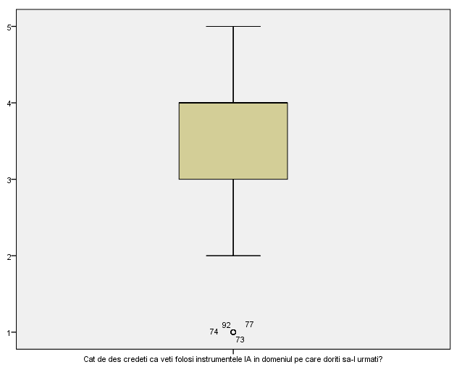
Figure 1: „Using AI tools in the desired field” (Q8)
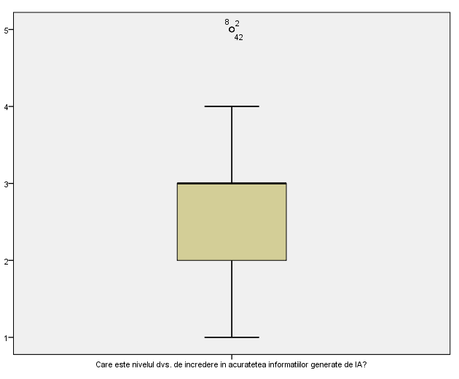
Figure 2: „Level of confidence in the accuracy of AI-generated information” (Q10)

Verifying the representativeness of the sample

To assess the representativeness of the sample of 101 respondents, their sociodemographic distributions were analyzed, including level of study (Q1), gender (Q2), background (Q3), and desired future field of work (Q16). The analysis of frequencies and proportions showed a balanced distribution among undergraduate, master’s, and doctoral students; among male and female respondents; and among those from urban and rural backgrounds.
The distribution by field of study showed that the sample was representative of the main professional areas covered. The results were assessed as being roughly balanced in relation to the structure of the student population, thus ensuring that the sample reflects the general trends of the target population and allows for a correct interpretation of the collected data.

Processing of the numeric variables
The analysis of the numerical variables was performed using the Descriptive Statistics → Explore method in SPSS, which allowed us to calculate the median, mean, standard deviation, and confidence interval, as well as to identify outliers. Three variables representative of students’ behavior and perceptions regarding the use of AI were analyzed.
Descriptives
 |  |  | Statistic | Std. Error
Cat de des folositi in viata de zi cu zi chat-uri IA? (ex. ChatGPT, DeepSeek, Claude, Gemini etc.) [How often do you use AI chatbots in your daily life? (e.g., ChatGPT, DeepSeek, Claude, Gemini, etc.)] | Mean |  | 3.76 | .104
 | 95% Confidence Interval for Mean | Lower Bound | 3.56
 |  | Upper Bound | 3.97
 | 5% Trimmed Mean |  | 3.82
 | Median |  | 4.00
 | Variance |  | 1.083
 | Std. Deviation |  | 1.041
 | Minimum |  | 1
 | Maximum |  | 5
 | Range |  | 4
 | Interquartile Range |  | 2
 | Skewness |  | -.538 | .240
 | Kurtosis |  | -.191 | .476
Cat de des credeti ca veti folosi instrumentele IA in domeniul pe care doriti sa-l urmati? [How often do you think you will use AI tools in the field you plan to pursue?] | Mean |  | 3.50 | .118
 | 95% Confidence Interval for Mean | Lower Bound | 3.26
 |  | Upper Bound | 3.73
 | 5% Trimmed Mean |  | 3.55
 | Median |  | 4.00
 | Variance |  | 1.412
 | Std. Deviation |  | 1.188
 | Minimum |  | 1
 | Maximum |  | 5
 | Range |  | 4
 | Interquartile Range |  | 2
 | Skewness |  | -.353 | .240
 | Kurtosis |  | -.755 | .476
Cat de pregatit(a) va simtiti sa utilizati instrumente IA la locul de munca? [How prepared do you feel to use AI tools at work?] | Mean |  | 3.60 | .115
 | 95% Confidence Interval for Mean | Lower Bound | 3.38
 |  | Upper Bound | 3.83
 | 5% Trimmed Mean |  | 3.65
 | Median |  | 4.00
 | Variance |  | 1.342
 | Std. Deviation |  | 1.158
 | Minimum |  | 1
 | Maximum |  | 5
 | Range |  | 4
 | Interquartile Range |  | 2
 | Skewness |  | -.317 | .240
 | Kurtosis |  | -.941 | .476

How often do you use AI chatbots in your daily life? (e.g., ChatGPT, DeepSeek, Claude, Gemini, etc.) (Q6)
The first variable, “Use of AI tools in daily life” (Q6), has a mean of 3.76 and a median of 4, indicating frequent use of AI tools in daily life. The distribution of responses is slightly negatively skewed, showing that most students have high scores (4–5), and the histogram highlights a high concentration of responses in the medium-to-high range. The conclusion is that AI is already integrated into students’ daily routines. 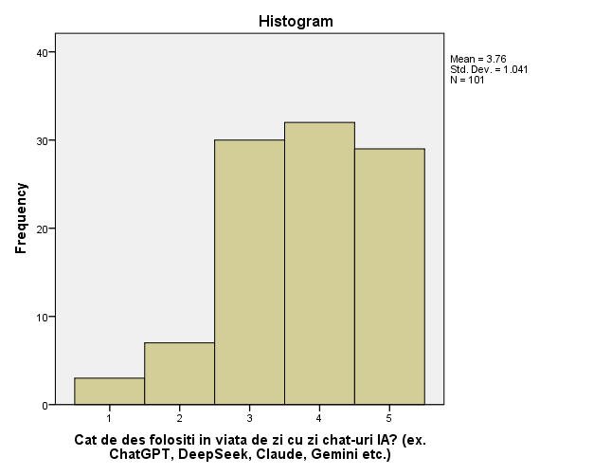
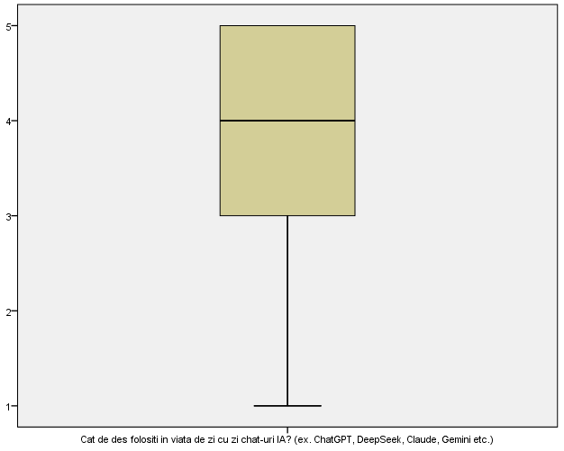

How often do you think you will use AI tools in the field you plan to pursue? (Q8)
The second variable, “Confidence in using AI in the desired professional field” (Q8), has a mean of 3.5 and a median of 4, suggesting moderate optimism regarding the professional applicability of AI tools. The distribution of responses is more varied (standard deviation 1.188), indicating divided opinions among students, and the boxplot analysis identified several outliers corresponding to students who do not express confidence in the use of AI in their field. These outliers were retained for their analytical relevance, contributing to a comprehensive understanding of individual perceptions. The overall conclusion is that there is moderate skepticism regarding the professional applicability of AI.
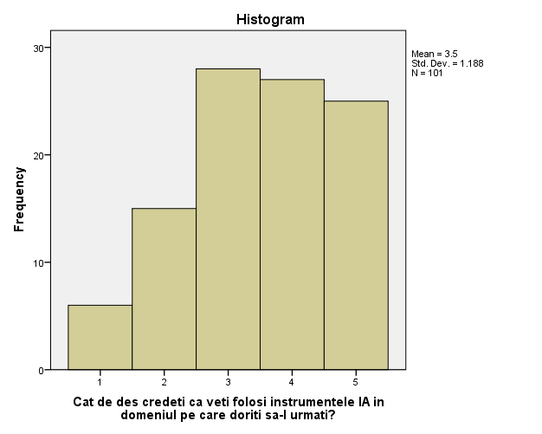
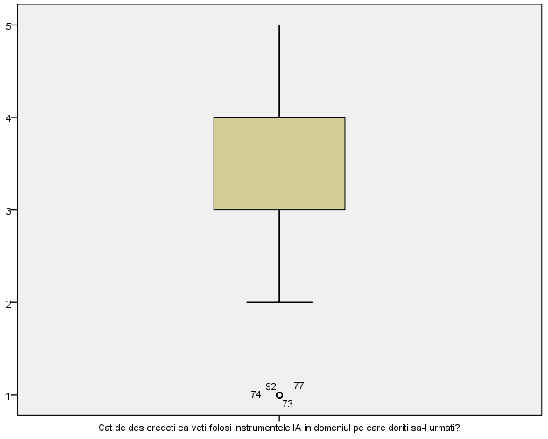

How prepared do you feel to use AI tools at work?
The third variable, “Perceived readiness to use AI in the workplace” (Q9), has a mean of 3.6 and a median of 4, indicating that most students consider themselves relatively prepared to use AI tools in their professional work. The distribution of responses is more homogeneous, with a gradual increase from low to high scores and no significant outliers. This suggests a positive self-perception and confidence in one’s own abilities to use AI in a professional setting.
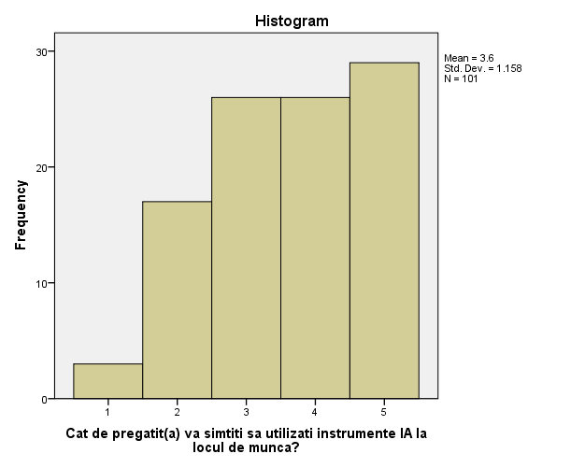
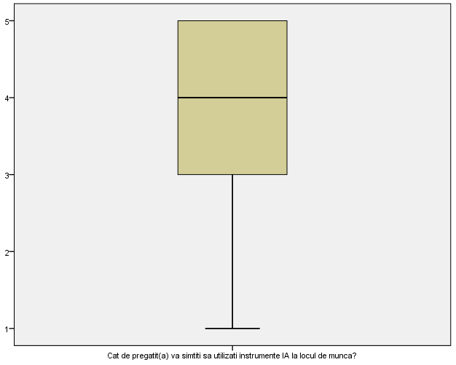
Conclusion
Overall, the descriptive analysis of the three variables shows that students frequently use AI in their daily lives, have moderate optimism regarding its applicability in their professional field, and feel prepared to use AI in the workplace; the presence of outliers in the variable related to professional confidence reflects the diversity of individual opinions and attitudes.

Processing of the qualitative variables
The analysis of qualitative variables was performed using the Analyze → Descriptive Statistics → Frequencies function in SPSS, which provided frequencies, percentages, and, where relevant, 95% confidence intervals for the proportions of responses. This provided a clear picture of the sociodemographic distribution and students’ perceptions, contributing to the interpretation of the results and the verification of the formulated hypotheses.
The following nominal variables were analyzed: Level of education (Q1), Gender (Q2), Social background (Q3), Availability of a formal course related to AI (Q4), Availability of a workshop/course on AI (Q5), Opinion regarding increased employee productivity if they use AI (Q13), Main concern regarding the use of AI (Q15), and Area of interest (Q16)

Cycle of study
 |  | Frequency | Percent | Valid Percent | Cumulative Percent
Valid | Undergraduate | 75 | 74.3 | 74.3 | 74.3
 | Graduate | 22 | 21.8 | 21.8 | 96.0
 | Doctorate | 4 | 4.0 | 4.0 | 100.0
 | Total | 101 | 100.0 | 100.0

Gender
 |  | Frequency | Percent | Valid Percent | Cumulative Percent
Valid | Masculine | 50 | 49.5 | 49.5 | 49.5
 | Feminine | 51 | 50.5 | 50.5 | 100.0
 | Total | 101 | 100.0 | 100.0

Social background
 |  | Frequency | Percent | Valid Percent | Cumulative Percent
Valid | Urban | 81 | 80.2 | 80.2 | 80.2
 | Rural | 20 | 19.8 | 19.8 | 100.0
 | Total | 101 | 100.0 | 100.0

Have you taken any formal courses on AI at the university?
 |  | Frequency | Percent | Valid Percent | Cumulative Percent
Valid | No | 73 | 72.3 | 72.3 | 72.3
 | Yes | 28 | 27.7 | 27.7 | 100.0
 | Total | 101 | 100.0 | 100.0

Have you participated in any workshops, boot camps, or online courses on AI?
 |  | Frequency | Percent | Valid Percent | Cumulative Percent
Valid | No | 66 | 65.3 | 65.3 | 65.3
 | Yes | 35 | 34.7 | 34.7 | 100.0
 | Total | 101 | 100.0 | 100.0

Do you think AI can increase employee productivity?
 |  | Frequency | Percent | Valid Percent | Cumulative Percent
Valid | No | 10 | 9.9 | 9.9 | 9.9
 | Yes | 70 | 69.3 | 69.3 | 79.2
 | I don’t know | 21 | 20.8 | 20.8 | 100.0
 | Total | 101 | 100.0 | 100.0

What is your main concern regarding the use of AI?
 |  | Frequency | Percent | Valid Percent | Cumulative Percent
Valid | No concerns | 2 | 2.0 | 2.0 | 2.0
 | Reduced creativity | 39 | 38.6 | 38.6 | 40.6
 | Technology addiction | 22 | 21.8 | 21.8 | 62.4
 | Wrong information | 21 | 20.8 | 20.8 | 83.2
 | Ethical issues | 7 | 6.9 | 6.9 | 90.1
 | Job cuts/Layoffs | 10 | 9.9 | 9.9 | 100.0
 | Total | 101 | 100.0 | 100.0

In what field would you like to work in the future (or are you already working in)?
 |  | Frequency | Percent | Valid Percent | Cumulative Percent
Valid | IT / Computer Science / Data Science | 48 | 47.5 | 47.5 | 47.5
 | Economics / Business / Management | 19 | 18.8 | 18.8 | 66.3
 | Social Sciences and Humanities (sociology, psychology, social work, HR, communication, geography, history, etc.) | 15 | 14.9 | 14.9 | 81.2
 | Engineering (all branches) | 6 | 5.9 | 5.9 | 87.1
 | Education (teaching, pedagogy) | 4 | 4.0 | 4.0 | 91.1
 | Art, Design, Media, and Communication | 5 | 5.0 | 5.0 | 96.0
 | Law / Judiciary | 4 | 4.0 | 4.0 | 100.0
 | Total | 101 | 100.0 | 100.0

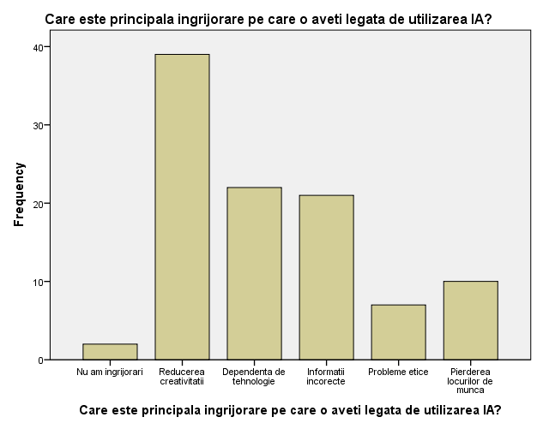
Translation: [What is your main concern regarding the use of AI?]
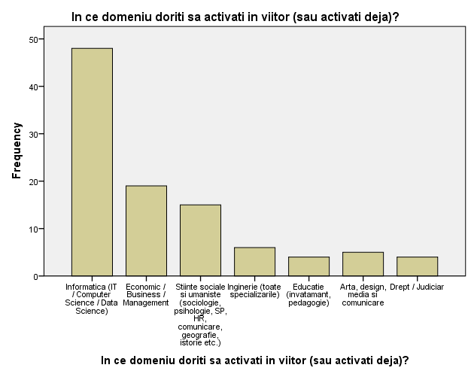
Translation: [In what field would you like to work in the future (or are you already working in)?]
In terms of academic level (cycle of study) (Q1), the majority of respondents are undergraduate students (74.3%), followed by master’s students (21.8%) and doctoral students (4.0%). This predominance of undergraduate students may influence the overall level of experience and exposure to AI in an advanced academic context. The gender distribution (Q2) is nearly perfectly balanced, with 50.5% women and 49.5% men, ensuring representativeness from a gender perspective. Regarding social background (Q3), 80.2% of respondents come from urban areas, suggesting easier access to technology and possibly greater exposure to AI tools.
An analysis of participation in formal courses on AI (Q4) shows that only 27.7% of students have taken such courses, while the majority (72.3%) have not received formal education in the field. This indicates that knowledge of AI stems largely from self-directed or informal learning, a factor that partially explains the variability in the level of confidence and use of AI tools. Similarly, only 34.7% of students participated in workshops, boot camps, or online courses on AI (Q5), which points to a formal educational deficit, despite the frequent use of these tools.
Regarding perceptions of AI’s impact on productivity (Q13), a clear majority of students (69.3%) believe that AI can increase employee productivity, with 20.8% undecided and only 9.9% expressing skepticism. This result indicates moderate to high optimism, possibly influenced by personal experience with AI tools and a lack of formal education.
Regarding the main concerns related to the use of AI (Q15), the list is dominated by fears of reduced creativity (38.6%), followed by dependence on technology (21.8%) and inaccurate information generated by AI (20.8%). Surprisingly, only 9.9% of students fear job loss, and nearly all respondents express at least one reservation, with ethical concerns mentioned by only 6.9%.
Regarding the desired field of work (Q16), nearly half of the respondents (47.5%) are in the IT/Tech sector, which explains the frequent use of AI in daily life and familiarity with digital tools. The other fields are represented to a moderate extent: business/economics 18.8%, social sciences 14.9%, and the others at less than 6% each. This distribution may introduce a slight bias in the responses, including more positive attitudes toward technology.
Looking at the results, a typical respondent profile emerges: undergraduate students (74%), living in urban areas (80%), with no formal training in AI (72%), working in the IT/tech field (48%), with an even gender distribution, and whose main concern is the potential reduction in creativity. There is also a notable paradox between education and usage: although most have not participated in formal courses or workshops, they frequently use AI tools. Overall, students recognize the benefits of AI but express serious reservations regarding creative aspects and personal autonomy..

Part II – Statistical tests

Testing the research hypotheses

Hypothesis 1
”There is a significant positive correlation between participation in AI courses and perceived job readiness”
Utilised variables
- Q4: Participation in AI courses – Q4 (0 = no, 1 = yes)
- Q5: Participation in workshops / online courses (0 = no, 1 = yes)
- Q9: Perceived readiness to use AI in the workplace – Q9 (Likert 1–5 scale)
The first thing I did in SPSS was to create a new variable representing a combination of Q4 and Q5 (Edu_IA = Q4+Q5).
Encoding interpretation:
- 0 = did not take any type of course
- 1 = took only one type of course (formal or informal)
- 2 = took both types of courses

The analysis of the correlation between participation in artificial intelligence courses and the perceived level of readiness to use AI in the workplace was conducted using Spearman’s correlation coefficient. The results indicate the existence of a moderate positive correlation (ρ = 0.359), suggesting that students who participated in formal and/or informal AI courses perceive themselves as being better prepared to use these technologies in a professional context.
The correlation is statistically significant (p < 0.05), confirming the research hypothesis that educational exposure to artificial intelligence is associated with a higher level of perceived preparedness. Therefore, hypothesis H1 is supported by the empirical data.

Correlations
 |  |  | How prepared do you feel to use AI tools at work? | Have you completed any AI-related courses?
Spearman's rho | How prepared do you feel to use AI tools at work? | Correlation Coefficient | 1.000 | .359**
 |  | Sig. (2-tailed) | . | .000
 |  | N | 101 | 101
 | Have you completed any AI-related courses? | Correlation Coefficient | .359** | 1.000
 |  | Sig. (2-tailed) | .000 | .
 |  | N | 101 | 101
**. Correlation is significant at the 0.01 level (2-tailed).

Hypothesis 2
”Computer science students use AI tools more frequently than students in other fields”
Utilised variables
- Q16: Desired / current field of work
- Q6: Frequency of AI use
To make the analysis as straightforward as possible, I decided to recode the variables in the field of activity into two categories:
  - IT / Tech
  - Other fields (business, social sciences, law etc.),
and after the recoding, I have been left with the new variable Domeniu_IT_altele [Field_IT_Others].
To test hypothesis H2, the nonparametric Mann–Whitney U test was applied, which compares the frequency of AI tool use between two independent groups: computer science students and students from other fields. The choice of this test is justified by the ordinal nature of the variable regarding the frequency of AI use and the lack of the assumption of normal distribution.
The results show that students in the field of computer science have a higher average rank for the use of AI tools (Mean Rank = 59.48; N = 48) compared to students in other fields (Mean Rank = 43.32; N = 53), suggesting more frequent use of these tools among those in the IT field.
The Mann–Whitney test revealed a statistically significant difference between the two groups (U = 865, Z = -2.889, p = 0.004). The p-value, which is lower than the significance threshold of α = 0.05, indicates that the observed difference is not due to chance.
In conclusion, hypothesis H2 is confirmed: computer science students use artificial intelligence tools significantly more frequently in their daily lives than students in other fields.

Ranks
 | IT vs other fields | N | Mean Rank | Sum of Ranks
How often do you use AI chatbots in your daily life? (e.g., ChatGPT, DeepSeek, Claude, Gemini, etc.) | Informatica | 48 | 59.48 | 2855.00
 | Alte domenii | 53 | 43.32 | 2296.00
 | Total | 101

Test Statisticsª
 | How often do you use AI chatbots in your daily life? (e.g., ChatGPT, DeepSeek, Claude, Gemini, etc.)
Mann-Whitney U | 865.000
Wilcoxon W | 2296.000
Z | -2.889
Asymp. Sig. (2-tailed) | .004
a. Grouping Variable: Domeniu IT vs alte domenii

Hypothesis 3
”More than 70% of students believe that AI will have a positive impact on their future careers”
Utilised variable:
- Q11: „Do you think AI will have a positive impact on your career?”
To test a proportion, the variable was recoded into a binary variable as follows:
- values 4 and 5 → „positive impact” (1)
- values 1, 2 and 3 → „neutral or negative impact” (0)
This recoding is justified by the fact that scores of 4–5 indicate clear agreement with the statement.

Binomial Test
 |  | Category | N | Observed Prop. | Test Prop. | Exact Sig. (1-tailed)
Career impact | Group 1 | Positive | 35 | .3 | .7 | .000ª
 | Group 2 | Non-positive | 66 | .7
 | Total |  | 101 | 1.0
a. Alternative hypothesis states that the proportion of cases in the first group < .7.

To test hypothesis H3, the binomial test was applied, comparing the proportion of students who believe that artificial intelligence will have a positive impact on their careers with the reference value of 70%.
The test results show that only 35 out of 101 students (approximately 34.7%) have a positive perception of the impact of AI. The difference from the reference proportion of 70% is statistically significant (p < 0.001), indicating that hypothesis H3 is not confirmed.
This suggests that most students do not currently perceive AI as having a positive impact on their future careers, which may reflect a lack of practical experience, limited formal education in the field of AI, or uncertainty regarding the applicability of intelligent technologies in their future workplaces.

Hypothesis 4
” There is a significant difference between undergraduate and graduate students in terms of the amount of time saved each month by using AI”
Utilised variables
- Q1: Cycle of study (Undergraduate, Graduate)
- Q19: Estimated time saved each month through AI

Ranks
 | Cycle of study | N | Mean Rank | Sum of Ranks
How much do you estimate you save each month by using AI? | Licenta | 75 | 51.16 | 3837.00
 | Master | 22 | 41.64 | 916.00
 | Total | 97

Test Statisticsª
 | How much do you estimate you save each month by using AI?
Mann-Whitney U | 663.000
Wilcoxon W | 916.000
Z | -1.478
Asymp. Sig. (2-tailed) | .140
a. Grouping Variable: Cycle of study

To test hypothesis H4, the Mann–Whitney U test was applied, given that the distribution of the “monthly time saved” variable does not follow a normal distribution. The variable was coded into four levels (0 = 0 hours, 1 = 1–3 hours, 2 = 4–10 hours, 3 = over 10 hours), and the Doctoral group was excluded from the analysis due to the very small number of respondents (N = 3).
Descriptive analysis shows that undergraduate students estimate an average time of 1.96 hours, with a median of 2, while graduate students estimate an average time of 1.68 hours, with a median of 1.5. The distribution for the Bachelor’s program is slightly skewed to the left, including a few extremely skeptical respondents (score of 0), while the distribution for the Master’s program is more concentrated, with no completely skeptical respondents, although there is an outlier at a score of 3, indicating exceptional optimism.
The results of the Mann–Whitney U test show that the difference between the two groups is not statistically significant (U = 663, Z = -1.478, p = 0.140). This indicates that, although there is an apparent difference in means (0.28 points), it could be random, and the level of education (Bachelor’s vs. Master’s) does not significantly influence the estimated time saved monthly by using AI tools within the analyzed sample.
The statistical conclusion is that hypothesis H4 cannot be confirmed based on the collected data, and the differences observed between the Bachelor’s and Master’s programs reflect natural variations among respondents, with no statistical significance.

2. Tests for independent samples

For this subsection, we have selected the following variables to test:
• Frequency of AI use in daily life (Q6) compared across groups (e.g., gender, environment, field)
• Perceived AI training in the workplace (Q9) by degree level (Bachelor’s vs. Master’s) and field
• Level of confidence in the accuracy of AI (Q10) compared to the average

The Kolmogorov-Smirnov and Shapiro-Wilk normality tests indicated that the variables did not follow a normal distribution (p < .001 for all). Therefore, nonparametric statistical tests were used for the analysis.
Tests of Normality
 | Kolmogorov-Smirnovª |  |  | Shapiro-Wilk
 | Statistic | df | Sig. | Statistic | df | Sig.
How often do you use AI chatbots in your daily life? (e.g., ChatGPT, DeepSeek, Claude, Gemini, etc.) | .195 | 97 | .000 | .877 | 97 | .000
How prepared do you feel to use AI tools at work? | .183 | 97 | .000 | .886 | 97 | .000
How confident are you in the accuracy of AI-generated information? | .261 | 97 | .000 | .881 | 97 | .000
a. Lilliefors Significance Correction

  - Q6: Frequency of AI use in daily life
To analyze differences in the frequency of AI tool use between men and women, the Mann–Whitney U test was applied, given the ordinal nature of the “frequency of AI use” variable (Q6) and the failure to meet the assumption of normality. The analysis included 50 male respondents and 51 female respondents.
The results indicate a slightly higher mean rank for men (Mean Rank = 53.78) compared to women (Mean Rank = 48.27), suggesting a slight tendency for men to use AI more frequently in their daily lives. However, the difference is not statistically significant (U = 1136, Z = -0.985, p = 0.324). This means that the observed difference can be attributed to chance, and gender does not significantly influence the frequency of AI tool use within the analyzed sample.
Test Statisticsª
 | How often do you use AI chatbots in your daily life? (e.g., ChatGPT, DeepSeek, Claude, Gemini, etc.)
Mann-Whitney U | 1136.000
Wilcoxon W | 2462.000
Z | -.985
Asymp. Sig. (2-tailed) | .324
a. Grouping Variable: Gender

With regard to social background, the results show that students from rural areas have a higher mean rank (Mean Rank = 59.10) compared to students from urban areas (Mean Rank = 49.00), suggesting a tendency for rural students to use AI tools more frequently in their daily lives. However, the statistical test does not indicate a significant difference between the groups (U = 648, Z = -1.441, p = 0.150). This means that the difference observed in mean ranks cannot be considered statistically significant, and AI usage does not differ significantly between urban and rural students within the analyzed sample, although a slight trend in favor of rural students can be observed.
Test Statisticsª
 | How often do you use AI chatbots in your daily life? (e.g., ChatGPT, DeepSeek, Claude, Gemini, etc.)
Mann-Whitney U | 648.000
Wilcoxon W | 3969.000
Z | -1.441
Asymp. Sig. (2-tailed) | .150
a. Grouping Variable: Social background

  - Q9: Perceived AI readiness in the workplace
Test Statisticsª
 | How prepared do you feel to use AI tools at work?
Mann-Whitney U | 449.500
Wilcoxon W | 3299.500
Z | -3.341
Asymp. Sig. (2-tailed) | .001
a. Grouping Variable: Cycle of study
To assess differences in perceived readiness to use AI in the workplace between undergraduate and graduate students, the Mann–Whitney U test was applied, given the ordinal nature of variable Q9 and the failure to meet the assumption of normality. The analysis included 75 undergraduate students and 22 graduate students.
The results indicate a significantly higher mean rank for master’s students (Mean Rank = 66.07) compared to undergraduate students (Mean Rank = 43.99). The statistical test confirms the significant difference between the groups (U = 449.5, Z = -3.341, p = 0.001 < 0.05). This suggests that master’s students feel much more prepared to use AI tools in the workplace than undergraduate students, highlighting the influence of academic experience and level of education on professional confidence. The observed difference is highly statistically significant, with less than a 0.1% chance that it is due to chance.
Test Statisticsª
 | How prepared do you feel to use AI tools at work?
Mann-Whitney U | 1169.500
Wilcoxon W | 2600.500
Z | -.720
Asymp. Sig. (2-tailed) | .472
a. Grouping Variable: IT vs other fields

For the desired fields or those in which students are already active, the results indicate a slightly higher mean rank for IT students (Mean Rank = 53.14) compared to other students (Mean Rank = 49.07). However, the statistical test shows that the difference is not significant (U = 1169.5, Z = -0.720, p = 0.472 > 0.05). This suggests that there is insufficient evidence to claim that IT students feel more prepared than those in other fields. The difference observed between the groups is minor and likely random, indicating a similar level of confidence in AI usage skills regardless of the field of study.
  - Q10: Level of confidence in the accuracy of AI
Test Statisticsª
 | How confident are you in the accuracy of information generated by AI?
Mann-Whitney U | 753.500
Wilcoxon W | 4074.500
Z | -.520
Asymp. Sig. (2-tailed) | .603
a. Grouping Variable: Social background

To determine whether the participants’ background influences their level of confidence in the accuracy of information generated by artificial intelligence, the Mann–Whitney U test was applied, as it is suitable for ordinal variables and distributions that do not follow a normal distribution. The analysis included 81 students from urban areas and 20 from rural areas.

The results show a slightly higher mean rank among students from rural areas (Mean Rank = 53.83) compared to those from urban areas (Mean Rank = 50.30). However, the difference is not statistically significant (U = 753.5; Z = -0.520; p = 0.603 > 0.05). This indicates that the level of trust in AI-generated information does not differ significantly between urban and rural students. The difference observed in the mean ranks is minor and likely random, suggesting similar perceptions regarding AI accuracy regardless of the students’ background.

Test for paired observations (dependent samples)

Ranks
 |  | N | Mean Rank | Sum of Ranks
To what extent do you use or would you use AI tools to save time on homework or projects? - How often do you use AI chatbots in your daily life? (e.g., ChatGPT, DeepSeek, Claude, Gemini, etc.) | Negative Ranks | 20ª | 25.60 | 512.00
 | Positive Ranks | 32^{b} | 27.06 | 866.00
 | Ties | 49^{c}
 | Total | 101
a. To what extent do you use or would you use AI tools to save time on homework or projects? < How often do you use AI chatbots in your daily life? (e.g., ChatGPT, DeepSeek, Claude, Gemini, etc.)
b. To what extent do you use or would you use AI tools to save time on homework or projects? > How often do you use AI chatbots in your daily life? (e.g., ChatGPT, DeepSeek, Claude, Gemini, etc.)
c. To what extent do you use or would you use AI tools to save time on homework or projects? = How often do you use AI chatbots in your daily life? (e.g., ChatGPT, DeepSeek, Claude, Gemini, etc.)

Test Statisticsª
 | To what extent do you use or would you use AI tools to save time on homework or projects? - How often do you use AI chatbots in your daily life? (e.g., ChatGPT, DeepSeek, Claude, Gemini, etc.)
Z | -1.677^{b}
Asymp. Sig. (2-tailed) | .094
a. Wilcoxon Signed Ranks Test
b. Based on negative ranks.

The Wilcoxon test was used to analyze whether there is a significant difference in the frequency of use of artificial intelligence tools for saving time on homework or project-related activities, comparing their use in daily life with their use in the desired professional field.
The results show that 32 participants reported an increase in frequency (median rank = 27.06), while 20 reported a decrease (median rank = 25.60), and 49 of the respondents reported no change. The test statistics indicate Z = -1.677 with p = 0.094 (2-tailed), meaning that, at the conventional significance level α = 0.05, the difference is not statistically significant. However, there is a positive trend: more participants increased their use of AI tools than decreased it, suggesting a possible behavioral shift. Furthermore, the large number of ties indicates stability in usage or a plateau effect.
The overall conclusion is that there is an upward trend in the use of AI to save time on homework and projects, but this trend does not reach the threshold for statistical significance; further analysis using a larger sample or over a longer period could confirm this change.

ANOVA
- Q8: ”Frequency of AI use in the field you’re interested in” (dependent) cu Q16:” Field of study/profession” and Q2: ”Gender” (independent factors)
A two-way ANOVA was conducted to examine the effect of gender (Q2) and field of study/profession (Q16) on the frequency of AI use in the desired field (Q8). The model explains 34.3% of the variation in the dependent variable (R² = 0.343).
Univariate tests show that the effect of field of study is highly significant (F(6, 86) = 5.262, p < .001), indicating clear differences between fields in terms of the perceived credibility of AI. The gender effect is also significant (F(1, 86) = 6.901, p = .010), with men reporting a higher average level of perceived credibility than women (a difference of ~0.86 points). No significant interaction between gender and domain was identified (p = .089), suggesting that the gender effect is similar across all domains.
An analysis of the estimated averages shows that students in IT/Computer Science have the highest level of trust in AI tools, followed by those in Economics/Business/Management and Social Sciences and Humanities, while the fields of Engineering, Arts/Design/Media, and Education recorded the lowest levels of perceived credibility.
The results suggest that both field of study and gender influence perceptions of AI, with men and students in technical fields showing higher levels of trust.
Tests of Between-Subjects Effects
Dependent Variable: How often do you think you will use AI tools in the field you plan to pursue?
Source | Type III Sum of Squares | df | Mean Square | F | Sig.
Corrected Model | 48.428ª | 12 | 4.036 | 3.826 | .000
Intercept | 371.096 | 1 | 371.096 | 351.826 | .000
Q2_Gen [Gender] | 5.788 | 1 | 5.788 | 5.488 | .021
Q16_Domeniu [Field] | 30.298 | 6 | 5.050 | 4.787 | .000
Q2_Gen * Q16_Domeniu | 10.448 | 5 | 2.090 | 1.981 | .089
Error | 92.820 | 88 | 1.055
Total | 1375.000 | 101
Corrected Total | 141.248 | 100
a. R Squared = .343 (Adjusted R Squared = .253)

Estimates
Dependent Variable: How often do you think you will use AI tools in the field you plan to pursue?
In what field would you like to work in the future (or are you already working)? | Mean | Std. Error | 95% Confidence Interval
 |  |  | Lower Bound | Upper Bound
IT / Computer Science / Data Science | 4.093 | .150 | 3.794 | 4.392
Economics / Business / Management | 3.261 | .236 | 2.792 | 3.730
Social Sciences and Humanities (sociology, psychology, social work, HR, communication, geography, history, etc.) | 3.125 | .331 | 2.466 | 3.784
Engineering (all branches) | 2.200 | .563 | 1.082 | 3.318
Education (teaching, pedagogy) | 3.000 | .514 | 1.980 | 4.020
Art, Design, Media, and Communication | 2.400ª | .459 | 1.487 | 3.313
Law / Judiciary | 2.667 | .593 | 1.488 | 3.845
a. Based on modified population marginal mean.

Univariate Tests
Dependent Variable: How often do you think you will use AI tools in the field you plan to pursue?
 | Sum of Squares | df | Mean Square | F | Sig.
Contrast | 33.301 | 6 | 5.550 | 5.262 | .000
Error | 92.820 | 88 | 1.055
The F tests the effect of In ce domeniu doriti sa activati in viitor (sau activati deja)?. This test is based on the linearly independent pairwise comparisons among the estimated marginal means.

Estimates
Dependent Variable: How often do you think you will use AI tools in the field you plan to pursue?
Gen | Mean | Std. Error | 95% Confidence Interval
 |  |  | Lower Bound | Upper Bound
Masculine | 3.471ª | .211 | 3.052 | 3.889
Feminine | 2.610 | .251 | 2.110 | 3.109
a. Based on modified population marginal mean.

Univariate Tests
Dependent Variable: How often do you think you will use AI tools in the field you plan to pursue?
 | Sum of Squares | df | Mean Square | F | Sig.
Contrast | 7.279 | 1 | 7.279 | 6.901 | .010
Error | 92.820 | 88 | 1.055
The F tests the effect of Gen. This test is based on the linearly independent pairwise comparisons among the estimated marginal means.

- Q9: „Perceived AI readiness in the workplace” (dependent) cu Edu_IA: ” Are there any formal or informal AI courses available?” and Q3: ”Social background” (independent factors)
The results show that the students’ background does not have a significant effect on their perceived preparation. Students from urban areas scored an average of 3.84, while those from rural areas scored an average of 3.64, a difference of only 0.2 points, which is statistically insignificant. The ANOVA model explains 16.4% of the variation in perceived readiness (R² = .164).
In contrast, participation in AI courses has a clear and significant impact. Students who did not take any courses reported an average score of 3.09, those who took a single course had an average score of 4.13, and those who took both types of courses had an average score of 3.99. This highlights a significant increase in perceived preparedness for students who participated in at least one AI course. The difference between those who took a single course and those who took both types of courses is very small (0.14 points), suggesting that a single well-structured course may be sufficient to increase confidence and professional readiness.
Post-hoc comparisons confirm that the most significant difference is found between students who took no courses and those who took one course (difference ~1.03 points, p = .003), while other comparisons are not significant.
The main takeaway is that taking AI courses significantly contributes to students’ perceived preparedness, while geographic location does not significantly influence the outcome. Thus, investing in AI education—even through a single course—can substantially enhance students’ skills and confidence in the professional application of intelligent technologies.
Between-Subjects Factors
 |  | Value Label | N
Social background | 1 | Urban | 81
 | 2 | Rural | 20
Do you have any AI courses completed? | .00 | None | 54
 | 1.00 | Just one (formal or informal) | 31
 | 2.00 | Both formal and informal | 16

Descriptive Statistics
Dependent Variable: How prepared do you feel to use AI tools at work?
Social background | Do you have any AI courses completed? | Mean | Std. Deviation | N
Urban | None | 3.28 | 1.241 | 43
 | Just one (formal or informal) | 3.92 | .909 | 25
 | Both formal and informal | 4.31 | .855 | 13
 | Total | 3.64 | 1.154 | 81
Rural | None | 2.91 | 1.221 | 11
 | Just one (formal or informal) | 4.33 | .816 | 6
 | Both formal and informal | 3.67 | .577 | 3
 | Total | 3.45 | 1.191 | 20
Total | None | 3.20 | 1.234 | 54
 | Just one (formal or informal) | 4.00 | .894 | 31
 | Both formal and informal | 4.19 | .834 | 16
 | Total | 3.60 | 1.158 | 101

Tests of Between-Subjects Effects
Dependent Variable: How prepared do you feel to use AI tools at work?
Source | Type III Sum of Squares | df | Mean Square | F | Sig. | Partial Eta Squared
Corrected Model | 21.989ª | 5 | 4.398 | 3.725 | .004 | .164
Intercept | 687.291 | 1 | 687.291 | 582.090 | .000 | .860
Q3_Mediu [Background] | .489 | 1 | .489 | .414 | .522 | .004
Edu_IA | 15.578 | 2 | 7.789 | 6.597 | .002 | .122
Q3_Mediu * Edu_IA | 2.537 | 2 | 1.269 | 1.074 | .346 | .022
Error | 112.169 | 95 | 1.181
Total | 1446.000 | 101
Corrected Total | 134.158 | 100
a. R Squared = .164 (Adjusted R Squared = .120)

Estimates
Dependent Variable: How prepared do you feel to use AI tools at work?
Social background | Mean | Std. Error | 95% Confidence Interval
 |  |  | Lower Bound | Upper Bound
Urban | 3.836 | .136 | 3.566 | 4.105
Rural | 3.636 | .278 | 3.084 | 4.189

Univariate Tests
Dependent Variable: How prepared do you feel to use AI tools at work?
 | Sum of Squares | df | Mean Square | F | Sig. | Partial Eta Squared
Contrast | .489 | 1 | .489 | .414 | .522 | .004
Error | 112.169 | 95 | 1.181
The F tests the effect of Mediul de provenienta. This test is based on the linearly independent pairwise comparisons among the estimated marginal means.

Estimates
Dependent Variable: How prepared do you feel to use AI tools at work?
Do you have any AI courses completed? | Mean | Std. Error | 95% Confidence Interval
 |  |  | Lower Bound | Upper Bound
None | 3.094 | .184 | 2.730 | 3.459
Just one (formal or informal) | 4.127 | .247 | 3.636 | 4.617
Both formal and informal | 3.987 | .348 | 3.296 | 4.678

Univariate Tests
Dependent Variable: How prepared do you feel to use AI tools at work?
 | Sum of Squares | df | Mean Square | F | Sig. | Partial Eta Squared
Contrast | 15.578 | 2 | 7.789 | 6.597 | .002 | .122
Error | 112.169 | 95 | 1.181
The F tests the effect of How prepared do you feel to use AI tools at work?. This test is based on the linearly independent pairwise comparisons among the estimated marginal means.

Part III

The correlation between two numerical variables
To analyze the relationship between the frequency of artificial intelligence use and the perceived level of readiness to use it in the workplace, the Spearman correlation coefficient was used, since the variables are measured on ordinal (Likert) scales and a normal distribution is not assumed.
The following variables were analysed:
- Q6: Frequency of AI use in daily life
- Q9: Perceived readiness to use AI in the workplace
Correlations
 |  |  | How often do you use AI chatbots in your daily life? (e.g., ChatGPT, DeepSeek, Claude, Gemini, etc.) | How prepared do you feel to use AI tools at work?
Spearman's rho | How often do you use AI chatbots in your daily life? (e.g., ChatGPT, DeepSeek, Claude, Gemini, etc.) | Correlation Coefficient | 1.000 | .394**
 |  | Sig. (2-tailed) | . | .000
 |  | N | 101 | 101
 | How prepared do you feel to use AI tools at work? | Correlation Coefficient | .394** | 1.000
 |  | Sig. (2-tailed) | .000 | .
 |  | N | 101 | 101
**. Correlation is significant at the 0.01 level (2-tailed).
The results indicate a moderate and statistically highly significant positive correlation between the two variables (ρ = 0.394, p < 0.01, N = 101). This value shows that as the frequency of AI use increases, so does the perceived level of readiness to use these tools in a professional context. In other words, students who use AI more frequently in their daily activities tend to feel more confident and better prepared to use it in the workplace.
The coefficient of determination (R² = 0.155) indicates that approximately 15.5% of the variation in perceived competence can be explained by the frequency of AI use, with the remainder being influenced by other factors, such as formal education, practical experience, field of study, or professional context. Although this proportion is not the majority, it is socially and educationally relevant, indicating an important role of current AI use in the development of a sense of competence.
These results help clarify some earlier observations from the analysis. Although computer science students use AI tools significantly more frequently than students in other fields, this does not automatically translate into a higher level of perceived proficiency. The correlation obtained suggests that it is not belonging to a specific field that is decisive, but rather the actual degree of AI usage, regardless of the field. Thus, repeated practical experience appears to play a more important role than academic specialization in shaping the perception of professional competence.
In conclusion, the analysis confirms the existence of a significant relationship between frequent AI use and perceived readiness to use it in the workplace, supporting the idea that the familiarity gained through consistent use contributes to increased confidence and perceived competence.
For the second analysis, the following variables were analysed:
- Q9: Perceived readiness to use AI in the workplace (Likert 1–5)
- Q19: Time saved monthly using AI (0–3, codificat numeric)

Correlations
 |  |  | How prepared do you feel to use AI tools at work? | How much time do you estimate you save each month by using AI?
Spearman's rho | How prepared do you feel to use AI tools at work? | Correlation Coefficient | 1.000 | .271**
 |  | Sig. (2-tailed) | . | .006
 |  | N | 101 | 101
 | How much time do you estimate you save each month by using AI? | Correlation Coefficient | .271** | 1.000
 |  | Sig. (2-tailed) | .006 | .
 |  | N | 101 | 101
**. Correlation is significant at the 0.01 level (2-tailed).
The results indicate a statistically significant positive correlation between the two variables (ρ = 0.271, p = 0.006). This result suggests that as students perceive that they save more time by using artificial intelligence, their perceived level of readiness to use AI in the workplace tends to be higher.
However, the strength of the relationship is weak to moderate, indicating that time saved is only one of the factors contributing to the sense of professional readiness. The coefficient of determination shows that approximately 7.3% of the variation in perceived readiness can be explained by time saved each month, with the remainder of the variation influenced by other factors, such as practical experience, level of formal education, or confidence in digital skills
In conclusion, although the use of artificial intelligence to save time is associated with a higher level of perceived readiness, this relationship is not a strong one, suggesting that additional factors are needed to support the development of the skills required to use AI in a professional context.

The correlation between two ordinal variables
Analysed variables:
- Q8: "How often do you think you will use AI tools in the field you plan to pursue?"
- Q12: " How concerned are you about the possibility that AI might replace certain jobs in your field?"

Correlations
 |  |  | How often do you think you will use AI tools in the field you plan to pursue? | How concerned are you about the possibility that AI might replace certain jobs in your field?
Spearman's rho | How often do you think you will use AI tools in the field you plan to pursue? | Correlation Coefficient | 1.000 | .156
 |  | Sig. (2-tailed) | . | .120
 |  | N | 101 | 101
 | How concerned are you about the possibility that AI might replace certain jobs in your field? | Correlation Coefficient | .156 | 1.000
 |  | Sig. (2-tailed) | .120 | .
 |  | N | 101 | 101

The relationship between the intention to use artificial intelligence tools in the desired professional field and the level of concern regarding the possibility that AI might replace certain jobs was analyzed using Spearman’s correlation coefficient.
The results indicate a weak positive correlation between the two variables (ρ = 0.156), suggesting that as the intention to use AI in the professional sphere increases, there is also a slight increase in the level of concern regarding its impact on jobs.
However, this relationship is not statistically significant (p = 0.120 > 0.05), which means that the observed association may be due to chance. Therefore, it cannot be concluded that there is a clear link between the anticipated frequency of AI use and the perceived risk of job displacement in the chosen field. The results suggest that students may intend to use AI without this automatically being accompanied by increased fear regarding its impact on their careers
Analysed variables:
- Q10: „To what extent do you use or would you use AI tools to save time on homework or projects?”
- Q11: „How confident are you in the accuracy of AI-generated information?”

Correlations
 |  |  | To what extent do you use or would you use AI tools to save time on homework or projects? | How confident are you in the accuracy of AI-generated information?
Spearman's rho | To what extent do you use or would you use AI tools to save time on homework or projects? | Correlation Coefficient | 1.000 | .405**
 |  | Sig. (2-tailed) | . | .000
 |  | N | 101 | 101
 | How confident are you in the accuracy of AI-generated information? | Correlation Coefficient | .405** | 1.000
 |  | Sig. (2-tailed) | .000 | .
 |  | N | 101 | 101
**. Correlation is significant at the 0.01 level (2-tailed).

The relationship between the practical use of artificial intelligence tools for saving time and the level of confidence in the accuracy of the generated information was analyzed using Spearman’s correlation coefficient.
The results indicate a moderate positive correlation between the two variables (ρ = 0.405, p < 0.001, N = 101), suggesting that as confidence in the accuracy of AI increases, so does its use to streamline academic activities. The correlation is highly statistically significant, meaning that the association cannot be attributed to chance.
A practical interpretation suggests that students who have greater trust in AI-generated information tend to use these tools more frequently, and positive experiences with AI can reinforce this trust. The results highlight a logical bidirectional relationship between trust and usage: frequent usage can increase trust, and trust stimulates more intensive use of AI tools.

Chi-square test
To investigate whether there are associations between the nominal variables in the study, we applied the chi-square test.
Analysed variables:
- Q4: „Have you taken any formal courses on AI at the university?”
- Q5: „Have you participated in any workshops, bootcamps, or online courses on AI?”
Have you taken any formal courses on AI at the university? * Have you participated in any workshops, bootcamps, or online courses on AI? Crosstabulation
 |  |  | Have you participated in any workshops, bootcamps, or online courses on AI? |  | Total
 |  |  | Nu | Da
Have you taken any formal courses on AI at the university? | No | Count | 54 | 19 | 73
 |  | Expected Count | 47.7 | 25.3 | 73.0
 | Yes | Count | 12 | 16 | 28
 |  | Expected Count | 18.3 | 9.7 | 28.0
Total |  | Count | 66 | 35 | 101
 |  | Expected Count | 66.0 | 35.0 | 101.0

Chi-Square Tests
 | Value | df | Asymp. Sig. (2-sided) | Exact Sig. (2-sided) | Exact Sig. (1-sided)
Pearson Chi-Square | 8.653ª | 1 | .003
Continuity Correction^{b} | 7.333 | 1 | .007
Likelihood Ratio | 8.395 | 1 | .004
Fisher's Exact Test |  |  |  | .005 | .004
Linear-by-Linear Association | 8.567 | 1 | .003
N of Valid Cases | 101
a. 0 cells (0.0%) have expected count less than 5. The minimum expected count is 9.70.
b. Computed only for a 2x2 table

Analyzing the tables, we can see that there is a clear association between taking a formal AI course and participating in workshops or online courses. Out of the 28 students who took formal courses, 16 (57%) participated in workshops, compared to only 19 out of 73 (26%) of those who did not take a formal course. This indicates that students who had their first exposure to AI through formal courses are significantly more likely to seek out other forms of training, suggesting a greater interest and motivation for continuous development.

Analysed variables:
- Q3: "Social background"
- Q18: "To what extent do you verify information generated by AI?"

Social background * To what extent do you verify information generated by AI? Crosstabulation
 |  |  | To what extent do you verify information generated by AI? |  |  |  |  |  | Total
 |  |  | 1 | 2 | 3 | 4 | 5
Social background | Urban | Count | 6 | 17 | 18 | 21 | 19 | 81
 |  | Expected Count | 8.0 | 18.4 | 17.6 | 20.0 | 16.8 | 81.0
 | Rural | Count | 4 | 6 | 4 | 4 | 2 | 20
 |  | Expected Count | 2.0 | 4.6 | 4.4 | 5.0 | 4.2 | 20.0
Total |  | Count | 10 | 23 | 22 | 25 | 21 | 101
 |  | Expected Count | 10.0 | 23.0 | 22.0 | 25.0 | 21.0 | 101.0

Chi-Square Tests
 | Value | df | Asymp. Sig. (2-sided)
Pearson Chi-Square | 4.802ª | 4 | .308
Likelihood Ratio | 4.607 | 4 | .330
Linear-by-Linear Association | 4.334 | 1 | .037
N of Valid Cases | 101
a. 5 cells (50.0%) have expected count less than 5. The minimum expected count is 1.98.

Looking at the tables, we can see a clear trend: respondents in urban areas check AI-generated information more frequently than those in rural areas.
- Among urban residents (N = 81), only 7.4% never verify information, while 49.4% often or always do so.
- Among rural residents (N = 20), 20% never verify the information, and only 30% verify it frequently.
Although the overall Pearson chi-square test was not statistically significant (p = 0.308), the Linear-by-Linear Association analysis reveals a significant trend (p = 0.037), indicating a linear association between the source of information and the frequency of fact-checking.
This difference can be explained by factors such as: stronger digital literacy in urban areas, greater experience with technology, easy access to alternative sources of verification, and a higher degree of skepticism toward AI.
In conclusion, urban respondents tend to be more cautious and critical when using AI, while rural respondents may be given more implicit trust in AI-generated information.
Variabilele analizate:
- Q4: "Have you taken any formal courses on AI at the university?"
- Q14: "To what extent do you think the university should offer practical AI courses?"
Have you taken any formal courses on AI at the university? * To what extent do you think the university should offer practical AI courses? Crosstabulation
 |  |  | To what extent do you think the university should offer practical AI courses? |  |  |  |  | Total
 |  |  | 1 | 2 | 3 | 4 | 5
Have you taken any formal courses on AI at the university? | No | Count | 2 | 7 | 14 | 20 | 30 | 73
 |  | Expected Count | 2.2 | 8.0 | 15.2 | 17.3 | 30.4 | 73.0
 | Yes | Count | 1 | 4 | 7 | 4 | 12 | 28
 |  | Expected Count | .8 | 3.0 | 5.8 | 6.7 | 11.6 | 28.0
Total |  | Count | 3 | 11 | 21 | 24 | 42 | 101
 |  | Expected Count | 3.0 | 11.0 | 21.0 | 24.0 | 42.0 | 101.0

Chi-Square Tests
 | Value | df | Asymp. Sig. (2-sided)
Pearson Chi-Square | 2.266ª | 4 | .687
Likelihood Ratio | 2.389 | 4 | .665
Linear-by-Linear Association | .387 | 1 | .534
N of Valid Cases | 101
a. 3 cells (30.0%) have expected count less than 5. The minimum expected count is .83.

Analysing the table, we can see that most students believe the university should offer practical AI courses, regardless of whether or not they have taken a formal course. Among those without formal coursework, 87.7% selected levels 3–5 on the scale, and 68.5% selected levels 4–5, while among those with formal coursework, 82.1% selected levels 3–5, and 57.2% selected levels 4–5. The highest category, level 5 (“to a large extent”), is nearly identical for both groups, with 41.1% of those without training and 42.9% of those with training.
The chi-square test shows that there is no significant difference between the groups, p = 0.687. This means that students’ opinions regarding the necessity of practical AI courses do not depend on their prior experience with formal courses.
Overall, approximately 86% of students believe that the university should offer practical AI courses. Those without formal coursework are slightly more enthusiastic, likely due to a lack of practical skills, while those with formal coursework have more nuanced opinions, likely because they already have practical experience. In conclusion, there is a clear consensus that practical education in AI is necessary, and universities should consider expanding their offerings of practical courses.

Conclusions
This study provided a multidimensional perspective on how the current generation of students interacts with Artificial Intelligence (AI) technologies, highlighting both the deep integration of these tools into daily life and a series of educational and professional challenges.
Analysis of the data collected from the 101 respondents led to the following key findings:
- The paradox of usage versus education: Although AI is already an integral part of students’ daily routines (averaging 3.76 on a scale of 5), there is a significant gap in formal education, with only 27.7% of them taking a university course dedicated to this field.
- The impact of education on professional confidence: It has been demonstrated that participation in AI courses (whether formal or informal) correlates positively with perceived readiness for the job market. Furthermore, it has been observed that completing a single well-structured course is sufficient to significantly increase students’ confidence in their technical skills.
- Demographic and academic differences: Master’s students report a significantly higher perceived level of readiness than undergraduate students, suggesting that academic maturity contributes to better mastery of digital tools. At the same time, although students in the IT field use AI more frequently, they do not necessarily feel more prepared than their peers in other fields, indicating that individual practical experience is more relevant than academic specialization.
- Perceptions and concerns: There is moderate optimism regarding increased productivity (69.3% of respondents), but the assumption that over 70% of students foresee a positive impact on their careers was refuted, with only 34.7% confirming this view. Students’ main fear is not job loss, but a reduction in human creativity (38.6%).
- The need for curricular adaptation: A notable finding is the general consensus (approximately 86%) regarding the need for universities to offer more practical AI courses, regardless of students’ prior exposure to the subject.
Finally, the study highlights that Romanian students are active but cautious users of AI. To ensure a successful transition to an automated labor market, it is imperative that higher education institutions integrate the practical aspects of artificial intelligence into the curricula of all majors, transforming sporadic use into a rigorous and critical professional skill.

