ACADEMIA DE STUDII ECONOMICE
Facultatea de Cibernetică, Statistică and Informatică Economică (CSIE)

DATABASES
“ Design and implementation of a database for the economic sector using Oracle Database”

Project by:
Vișoiu Ioana Claudia
Description of the database:
Objective of the project
The purpose of the database is to efficiently manage the operations of a retail company, such as a retailer like Froo, which sells food products. It will enable the management of products, inventory, orders, and customers. The database will support sales processes, inventory monitoring, and the generation of activity reports.
Description of the tables and atributes
- Table Produse [Products], which contains information about the products offered by the company (id_produs, nume_produs, categorie, pret, stoc, id_furnizor) [product_id, product_name, category, price, stock, supplier_id]
- Table Furnizori [Suppliers], which stores data about the suppliers who deliver products to the company (id_furnizor, nume_furnizor, adresa, telefon) [supplier_id, supplier_name, address, phone]
- Table Clienti [Clients], which stores information about the company’s customers (id_client, nume, prenume, email, telefon) [customer_id, last_name, first_name, email, phone]
- Table Comenz [Orders], which stores information about orders placed by customers (id_comanda, id_client, data_comanda, valoare_comanda) [order_id, customer_id, order_date, order_value]
- Table Detalii_Comenzi [Order_Details], which contains details about the products included in each order (id_detaliu, id_comanda, id_produs, cantitate, pret_unitar) [detail_id, order_id, product_id, quantity, unit_price]
Restricții and tipuri de legături
- Primary keys: id_produs from table Produse, id_furnizor from table Furnizori, id_client from table Clienti, id_comanda from table Comenzi, id_detaliu from table Detalii_Comenzi
- Foreign keys:
- id_furnizor from table Produse makes reference to id_furnizor from table Furnziori,
- id_client from table Comenzi makes reference to id_client from table Clienti,
- id_comanda from table Detalii_Comenzi makes reference to id_comanda from table Comenzi,
- id_produs from table Detalii_Comenzi makes reference to id_produs from table Produse.
- Links between tables:
- Link between Produse and Furnizori is type 1-n
- Link between Comenzi and Clienti is type 1-n
- Link between Detalii_Comenzi and Comenzi is type 1-n
- Link between Detalii_Comenzi and Produse is type 1-n
- Link between Produse and Comenzi is type n-n

Corect scheme of the database:
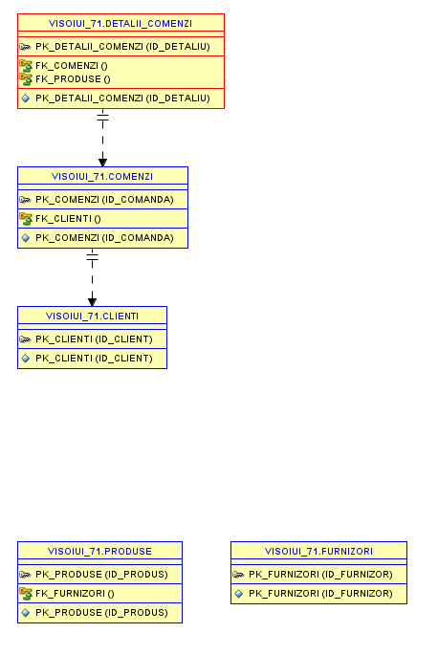
(Note: The SQL Developer application isn't displaying the schema correctly, but I checked the constraints and the tables were created correctly, so I created a correct schema on a website, dbdiagram.io)
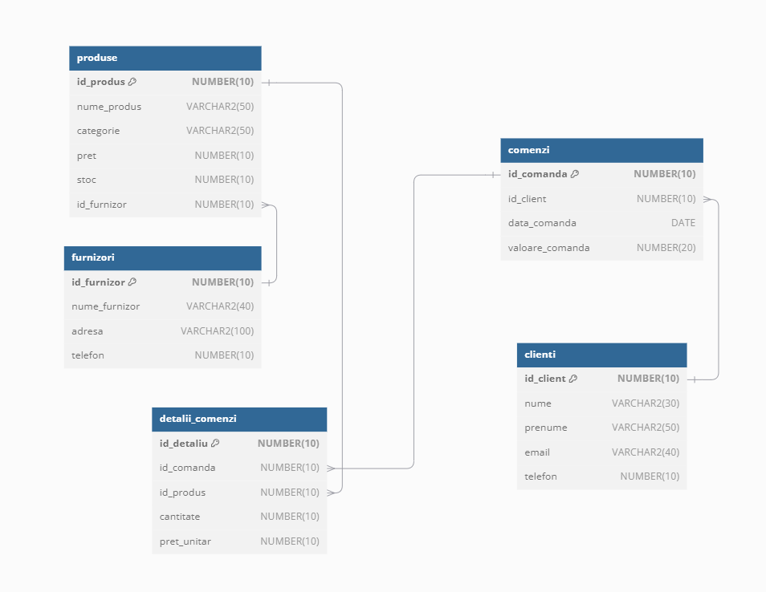

Tables creation:
create table furnizori (
id_furnizor NUMBER(10) constraint pk_furnizori primary key,
nume_furnizor VARCHAR2(40),
adresa VARCHAR2(100),
telefon NUMBER(10)
);

create table produse (
id_produs NUMBER(10) constraint pk_produse primary key,
nume_produs VARCHAR2(50),
categorie VARCHAR2(50),
pret NUMBER(10),
stoc NUMBER(10),
id_furnizor NUMBER(10), constraint fk_furnizori foreign key(id_furnizor) references furnizori(id_furnizor)
);

create table clienti (
id_client NUMBER(10) constraint pk_clienti primary key,
nume VARCHAR2(30),
prenume VARCHAR2(50),
email VARCHAR2(40),
telefon NUMBER(10)
);

create table comenzi(
id_comanda NUMBER(10) constraint pk_comenzi primary key,
id_client NUMBER(10), constraint fk_clienti foreign key(id_client) references clienti(id_client),
data_comanda DATE,
valoare_comanda NUMBER(20)
);

create table detalii_comenzi(
id_detaliu NUMBER(10) constraint pk_detalii_comenzi primary key,
id_comanda NUMBER(10), constraint fk_comenzi foreign key(id_comanda) references comenzi(id_comanda),
id_produs NUMBER(10), constraint fk_produse foreign key(id_produs) references produse(id_produs),
cantitate NUMBER(10),
pret_unitar NUMBER(10)
);

Examples of updates to existing tables:

1. The addition of a new column to store the ZIP code in the clienti table:
alter table clienti add cod_postal VARCHAR2(10);
2. Modification of the telefon column from clienti table, to accept a maximum of 15 characters:
alter table clienti modify telefon VARCHAR2(15);
3. Adding a UNIQUE constraint for supplier names in the furnizori table:
alter table furnizori add constraint unq_nume_furnizor UNIQUE (nume_furnizor);
4. Deleting a column, such as stoc from the produse table:
alter table produse drop column stoc;

Adding records to each table:
- In furnizori table we add the next information:
insert into furnizori (id_furnizor, nume_furnizor, adresa, telefon) values (1, 'Mirdatod', 'Adresa 1', 0771232345);
insert into furnizori (id_furnizor, nume_furnizor, adresa, telefon) values (2, 'Unilever', 'Adresa 2', 0723585648);
insert into furnizori (id_furnizor, nume_furnizor, adresa, telefon) values (3, 'Boromir', 'Adresa 3', 0779259999);
insert into furnizori (id_furnizor, nume_furnizor, adresa, telefon) values (4, 'Cristim', 'Adresa 4', 0764323171);
insert into furnizori (id_furnizor, nume_furnizor, adresa, telefon) values (5, 'Dorna', 'Adresa 5', 0755345555);
insert into furnizori (id_furnizor, nume_furnizor, adresa, telefon) values (6, 'Albalact', 'Adresa 6', 0781921000);
insert into furnizori (id_furnizor, nume_furnizor, adresa, telefon) values (7, 'Roshen', 'Adresa 7', 0231564328);
insert into furnizori (id_furnizor, nume_furnizor, adresa, telefon) values (8, 'Delaco', 'Adresa 8', 0733784321);
insert into furnizori (id_furnizor, nume_furnizor, adresa, telefon) values (9, 'Mars', 'Adresa 9', 0799123456);
insert into furnizori (id_furnizor, nume_furnizor, adresa, telefon) values (10, 'Davidoff', 'Adresa 10', 0231100250);

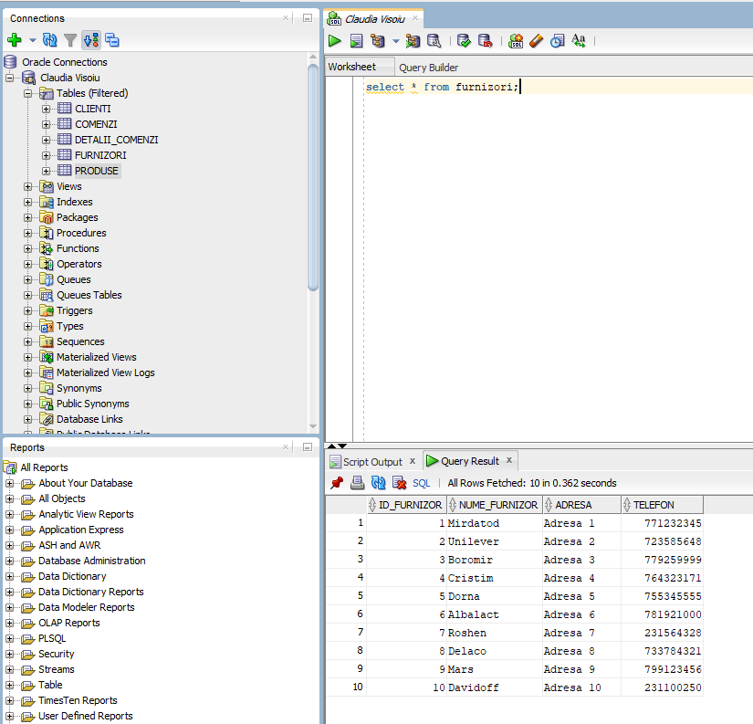

- In produse table we add the next information (we added the stoc column back):
insert into produse (id_produs, nume_produs, categorie, pret, stoc, id_furnizor) values (1, 'Cascaval', 'Lactate', 100, 50, 1);
insert into produse (id_produs, nume_produs, categorie, pret, stoc, id_furnizor) values (2, 'Biscuiti', 'Dulciuri', 200, 30, 2);
insert into produse (id_produs, nume_produs, categorie, pret, stoc, id_furnizor) values (3, 'Cozonac', 'Patiserie', 150, 20, 3);
insert into produse (id_produs, nume_produs, categorie, pret, stoc, id_furnizor) values (4, 'Salam sasesc', 'Mezeluri', 300, 10, 4);
insert into produse (id_produs, nume_produs, categorie, pret, stoc, id_furnizor) values (5, 'Lapte', 'Lactate', 400, 15, 5);
insert into produse (id_produs, nume_produs, categorie, pret, stoc, id_furnizor) values (6, 'Unt', 'Lactate', 50, 25, 6);
insert into produse (id_produs, nume_produs, categorie, pret, stoc, id_furnizor) values (7, 'Ciocolata', 'Dulciuri', 250, 40, 7);
insert into produse (id_produs, nume_produs, categorie, pret, stoc, id_furnizor) values (8, 'Cascaval', 'Lactate', 700, 5, 8);
insert into produse (id_produs, nume_produs, categorie, pret, stoc, id_furnizor) values (9, 'Ciocolata', 'Dulciuri', 350, 12, 9);
insert into produse (id_produs, nume_produs, categorie, pret, stoc, id_furnizor) values (10, 'Tigari', 'Tigari', 500, 8, 10);

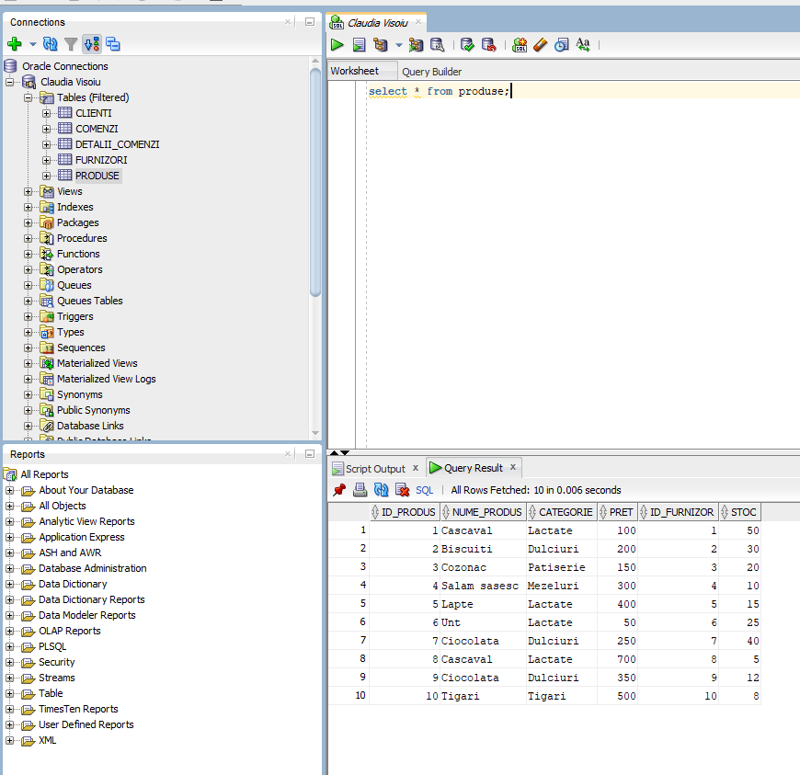

- In clienti table we add the next information:
insert into clienti (id_client, nume, prenume, email, telefon) values (1, 'Popescu', 'Ion', 'popescu.ion@example.com', 0777777081, 57901);
insert into clienti (id_client, nume, prenume, email, telefon) values (2, 'Ionescu', 'Maria', 'ionescu.maria@example.com', 0723232421, 62019);
insert into clienti (id_client, nume, prenume, email, telefon) values (3, 'Georgescu', 'Andrei', 'georgescu.andrei@example.com', 0721558423, 40192);
insert into clienti (id_client, nume, prenume, email, telefon) values (4, 'Dumitrescu', 'Elena', 'dumitrescu.elena@example.com', 0757875591, 78192);
insert into clienti (id_client, nume, prenume, email, telefon) values (5, 'Stan', 'Mihai', 'stan.mihai@example.com', 0791523497, 10231);
insert into clienti (id_client, nume, prenume, email, telefon) values (6, 'Radu', 'Cristina', 'radu.cristina@example.com', 0723112081, 44021);
insert into clienti (id_client, nume, prenume, email, telefon) values (7, 'Vasilescu', 'Alex', 'vasilescu.alex@example.com', 0764797312, 71823);
insert into clienti (id_client, nume, prenume, email, telefon) values (8, 'Marinescu', 'Oana', 'marinescu.oana@example.com', 0793174890, 99124);
insert into clienti (id_client, nume, prenume, email, telefon) values (9, 'Popa', 'Vlad', 'popa.vlad@example.com', 0748064891, 42557);
insert into clienti (id_client, nume, prenume, email, telefon) values (10, 'Tudor', 'Roxana', 'tudor.roxana@example.com', 0744781553, 61239);

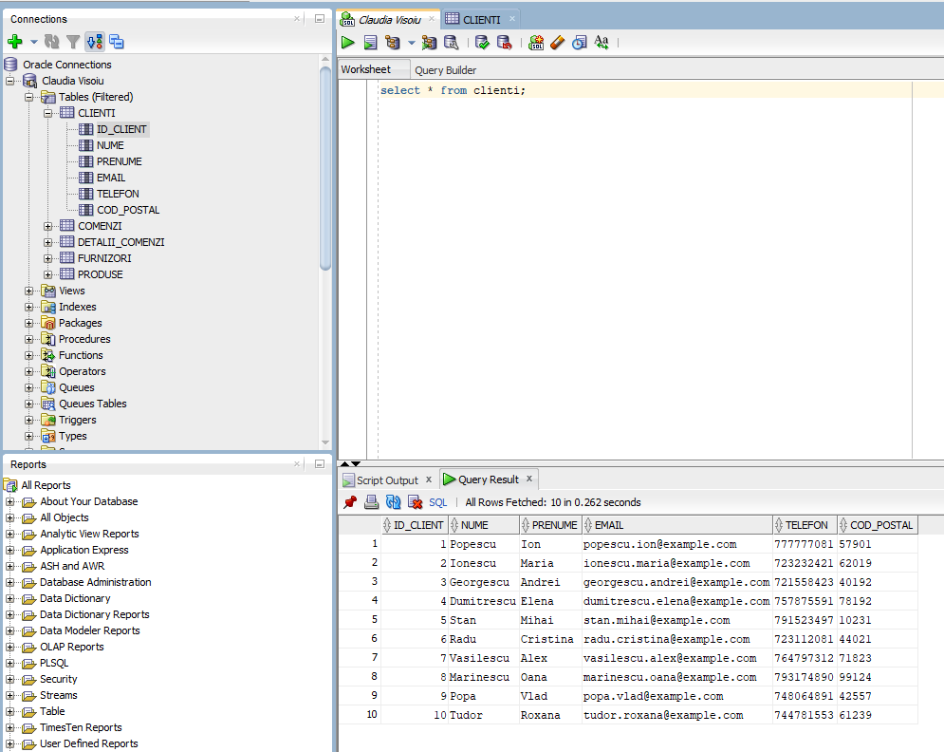

- In comenzi table we add the next information:
insert into comenzi (id_comanda, id_client, data_comanda, valoare_comanda) values (1, 1, TO_DATE('2025-01-01', 'YYYY-MM-DD'), 1500);
insert into comenzi (id_comanda, id_client, data_comanda, valoare_comanda) values (2, 2, TO_DATE('2025-01-02', 'YYYY-MM-DD'), 2500);
insert into comenzi (id_comanda, id_client, data_comanda, valoare_comanda) values (3, 3, TO_DATE('2025-01-03', 'YYYY-MM-DD'), 1800);
insert into comenzi (id_comanda, id_client, data_comanda, valoare_comanda) values (4, 4, TO_DATE('2025-01-04', 'YYYY-MM-DD'), 2200);
insert into comenzi (id_comanda, id_client, data_comanda, valoare_comanda) values (5, 5, TO_DATE('2025-01-05', 'YYYY-MM-DD'), 3000);
insert into comenzi (id_comanda, id_client, data_comanda, valoare_comanda) values (6, 6, TO_DATE('2025-01-06', 'YYYY-MM-DD'), 1200);
insert into comenzi (id_comanda, id_client, data_comanda, valoare_comanda) values (7, 7, TO_DATE('2025-01-07', 'YYYY-MM-DD'), 1700);
insert into comenzi (id_comanda, id_client, data_comanda, valoare_comanda) values (8, 8, TO_DATE('2025-01-08', 'YYYY-MM-DD'), 2600);
insert into comenzi (id_comanda, id_client, data_comanda, valoare_comanda) values (9, 9, TO_DATE('2025-01-09', 'YYYY-MM-DD'), 1900);
insert into comenzi (id_comanda, id_client, data_comanda, valoare_comanda) values (10, 10, TO_DATE('2025-01-10', 'YYYY-MM-DD'), 3100);

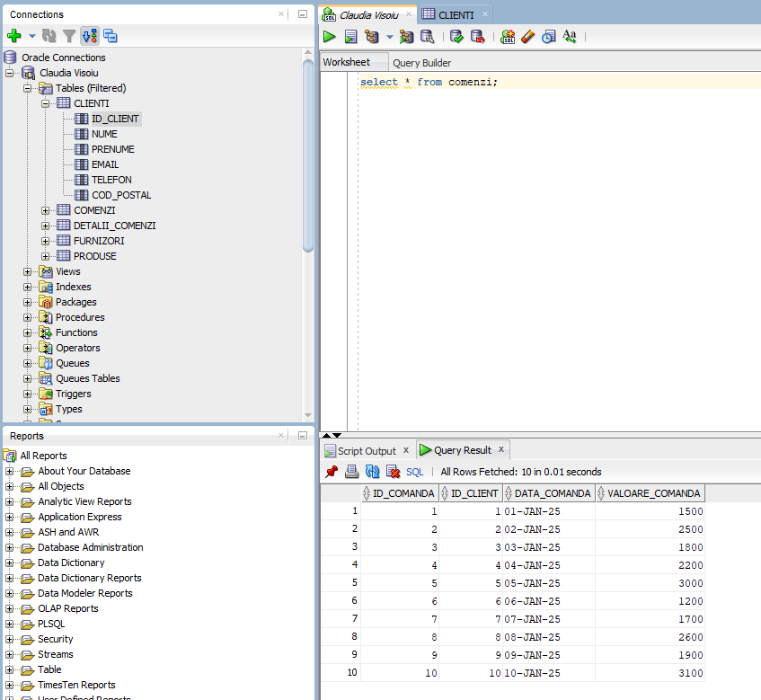

- In detalii_comenzi table we add the next information:
insert into detalii_comenzi (id_detaliu, id_comanda, id_produs, cantitate, pret_unitar) values (1, 1, 1, 2, 100);
insert into detalii_comenzi (id_detaliu, id_comanda, id_produs, cantitate, pret_unitar) values (2, 1, 2, 2, 200);
insert into detalii_comenzi (id_detaliu, id_comanda, id_produs, cantitate, pret_unitar) values (3, 2, 3, 3, 150);
insert into detalii_comenzi (id_detaliu, id_comanda, id_produs, cantitate, pret_unitar) values (4, 2, 4, 1, 300);
insert into detalii_comenzi (id_detaliu, id_comanda, id_produs, cantitate, pret_unitar) values (5, 3, 5, 4, 400);
insert into detalii_comenzi (id_detaliu, id_comanda, id_produs, cantitate, pret_unitar) values (6, 3, 6, 5, 50);
insert into detalii_comenzi (id_detaliu, id_comanda, id_produs, cantitate, pret_unitar) values (7, 4, 7, 6, 250);
insert into detalii_comenzi (id_detaliu, id_comanda, id_produs, cantitate, pret_unitar) values (8, 4, 8, 2, 700);
insert into detalii_comenzi (id_detaliu, id_comanda, id_produs, cantitate, pret_unitar) values (9, 5, 9, 3, 350);
insert into detalii_comenzi (id_detaliu, id_comanda, id_produs, cantitate, pret_unitar) values (10, 5, 10, 1, 500);
insert into detalii_comenzi (id_detaliu, id_comanda, id_produs, cantitate, pret_unitar) values (11, 6, 1, 3, 100);
insert into detalii_comenzi (id_detaliu, id_comanda, id_produs, cantitate, pret_unitar) values (12, 6, 2, 2, 200);
insert into detalii_comenzi (id_detaliu, id_comanda, id_produs, cantitate, pret_unitar) values (13, 7, 3, 1, 150);
insert into detalii_comenzi (id_detaliu, id_comanda, id_produs, cantitate, pret_unitar) values (14, 7, 4, 2, 300);
insert into detalii_comenzi (id_detaliu, id_comanda, id_produs, cantitate, pret_unitar) values (15, 8, 5, 5, 400);
insert into detalii_comenzi (id_detaliu, id_comanda, id_produs, cantitate, pret_unitar) values (16, 8, 6, 4, 50);
insert into detalii_comenzi (id_detaliu, id_comanda, id_produs, cantitate, pret_unitar) values (17, 9, 7, 3, 250);
insert into detalii_comenzi (id_detaliu, id_comanda, id_produs, cantitate, pret_unitar) values (18, 9, 8, 1, 700);
insert into detalii_comenzi (id_detaliu, id_comanda, id_produs, cantitate, pret_unitar) values (19, 10, 9, 4, 350);
insert into detalii_comenzi (id_detaliu, id_comanda, id_produs, cantitate, pret_unitar) values (20, 10, 10, 2, 500);

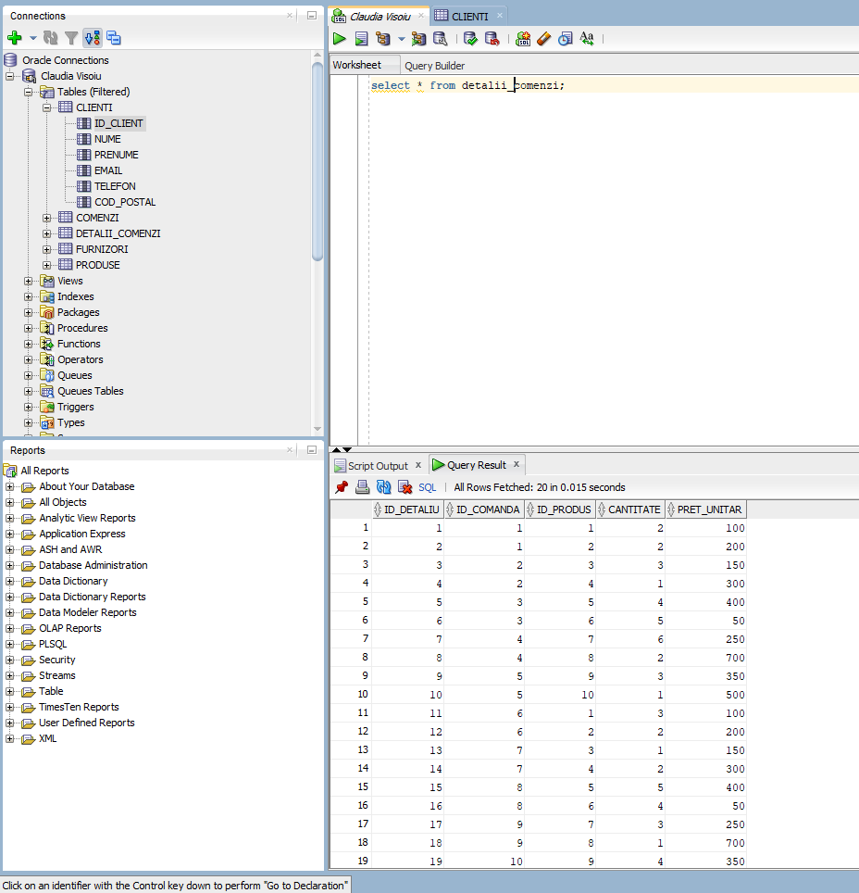

Updating the records:

- Updating a single record:

update clienti
set adresa = 'Strada Noua, Nr. 10', cod_postal = '70010'
where id_client = 1;

select * from furnizori;

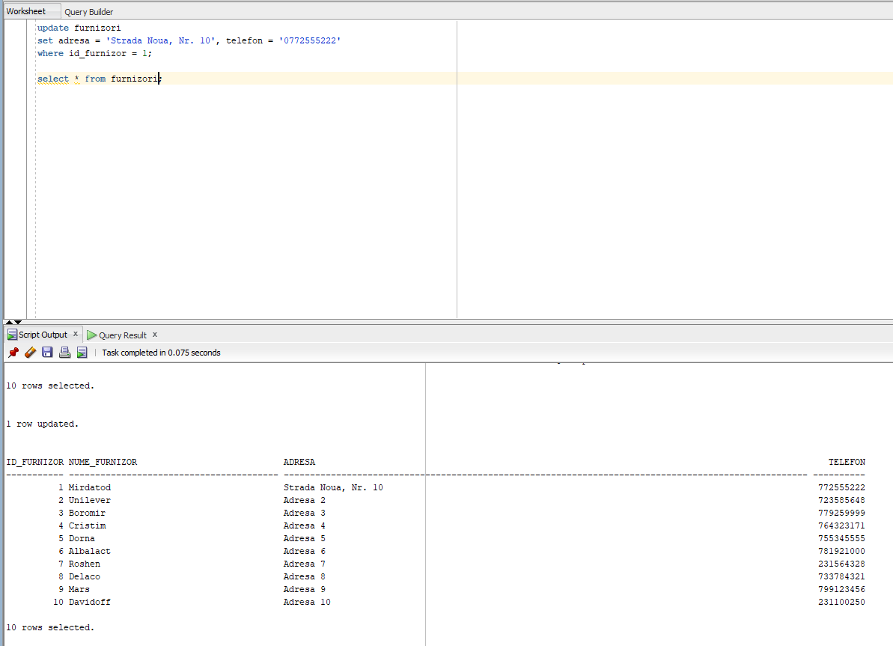

update furnizori
set adresa = 'Strada Mare, Nr. 2', telefon = '0723585648'
where id_furnizor = 2;

update furnizori
set nume_furnizor = 'Ana Pann', adresa = 'Strada Kuala Lumpur, Nr. 16', telefon = '0744718226'
where id_furnizor = 3;

select * from furnizori;
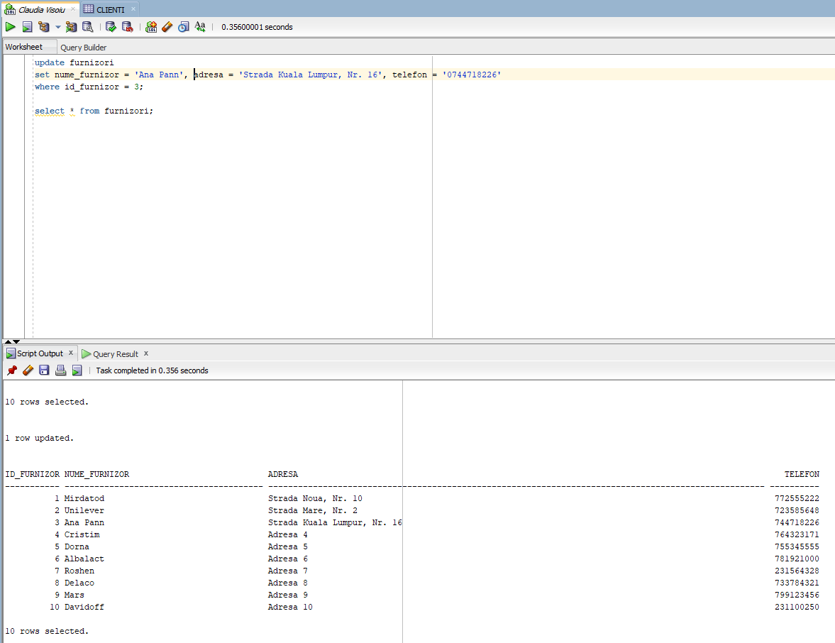

I also added the fourth customer's address using the following command:

update furnizori
set adresa = 'Strada Eliade, Nr. 24', telefon = '0724888112'
where id_furnizor = 4;

- Updating multiple records:

alter table furnizori add (cod_postal VARCHAR2(10));

update clienti set cod_postal = '500500' where adresa like 'Strada Mare%';

select * from furnizori;

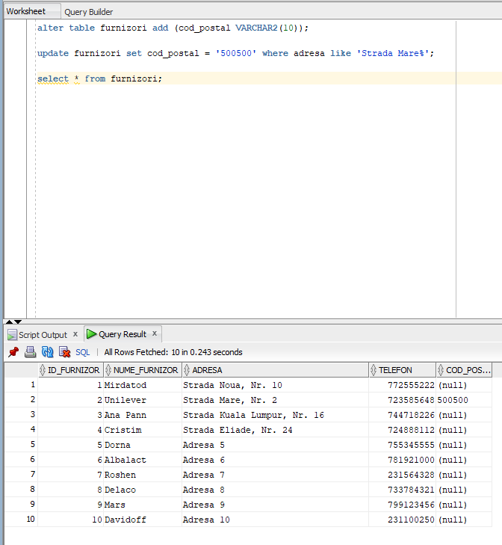

- Update for all records:

update clienti
set cod_postal = '000000';

select * from clienti;
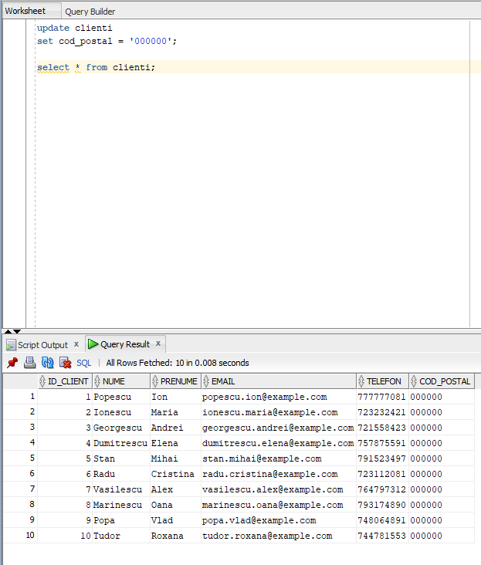

Deletion and recuperation of a table

To delete a table, we create a table that is not linked to any other table (an independent table), named "employees," which will contain the employees' names, dates of birth, genders, hours worked per workday, and salaries.

Running the following code creates the table:

create table angajati (
id_angajat int primary key,
nume_angajat VARCHAR2(100) not null,
data_nasterii date not null,
sex CHAR(1) check (sex in ('M', 'F')),
ore_lucrate NUMBER(3, 1) check (ore_lucrate >= 0 and ore_lucrate <= 24),
salariu NUMBER(10, 2) check (salariu >= 0)
);

And next, to fill in the columns of the angajati table:

insert into angajati (id_angajat, nume_angajat, data_nasterii, sex, ore_lucrate, salariu)
values (1, 'Ion Popescu', DATE '1985-06-15', 'M', 8.5, 4000.00);
insert into angajati (id_angajat, nume_angajat, data_nasterii, sex, ore_lucrate, salariu)
values (2, 'Maria Ionescu', DATE '1990-11-20', 'F', 7.0, 3800.50);
insert into angajati (id_angajat, nume_angajat, data_nasterii, sex, ore_lucrate, salariu)
values (3, 'George Vasile', DATE '1975-01-25', 'M', 9.0, 4500.00);
insert into angajati (id_angajat, nume_angajat, data_nasterii, sex, ore_lucrate, salariu)
values (4, 'Elena Dumitrescu', DATE '1982-03-10', 'F', 8.0, 4200.75);
insert into angajati (id_angajat, nume_angajat, data_nasterii, sex, ore_lucrate, salariu)
values (5, 'Andrei Stoica', DATE '1995-07-05', 'M', 7.5, 3700.00);
insert into angajati (id_angajat, nume_angajat, data_nasterii, sex, ore_lucrate, salariu)
values (6, 'Cristina Neagu', DATE '1988-12-12', 'F', 8.5, 4100.25);
insert into angajati (id_angajat, nume_angajat, data_nasterii, sex, ore_lucrate, salariu)
values (7, 'Mihai Radu', DATE '1979-09-18', 'M', 9.0, 4600.00);
insert into angajati (id_angajat, nume_angajat, data_nasterii, sex, ore_lucrate, salariu)
values (8, 'Raluca Voicu', DATE '1993-04-28', 'F', 6.5, 3600.50);
insert into angajati (id_angajat, nume_angajat, data_nasterii, sex, ore_lucrate, salariu)
values (9, 'Vlad Mihailescu', DATE '1986-02-14', 'M', 8.0, 4000.00);
insert into angajati (id_angajat, nume_angajat, data_nasterii, sex, ore_lucrate, salariu)
values (10, 'Ana Georgescu', DATE '1991-10-01', 'F', 7.5, 3750.00);

and we will display the table with: select * from angajati;

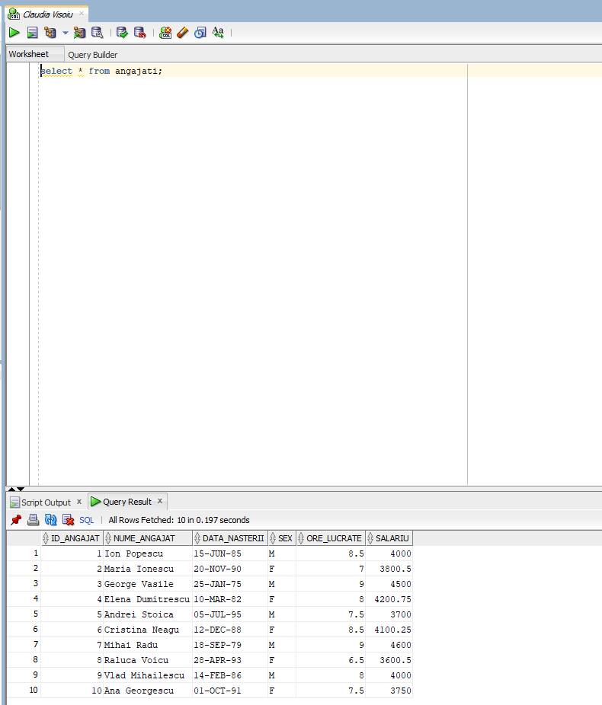

And now we're going to use the DELETE command to delete only the data for the last employee, Ana Georgescu.

delete from angajati
where id_angajat = 10;
select * from angajati;

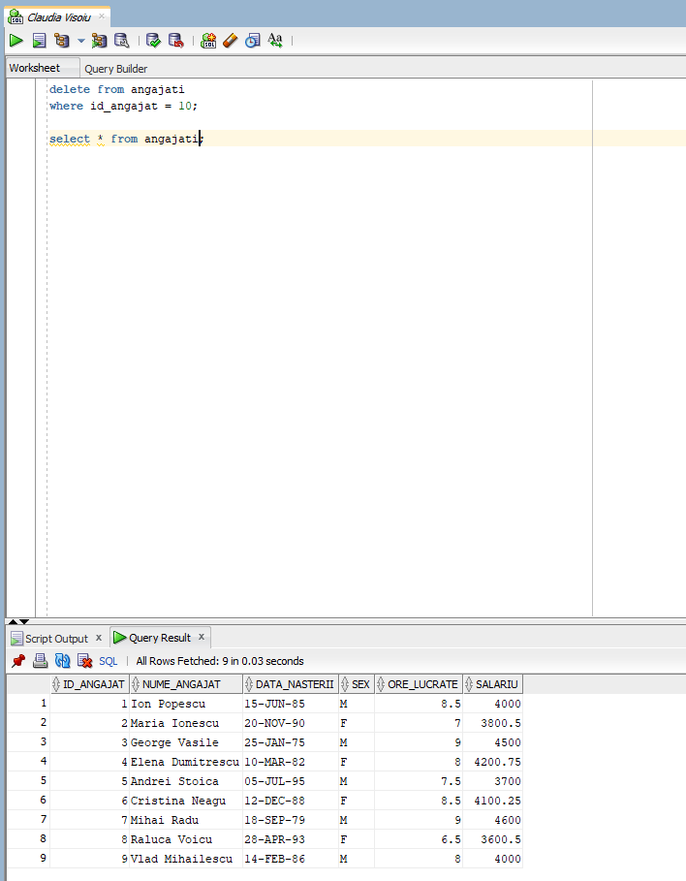

If we want to delete the entire angajati table, we use the DROP command.
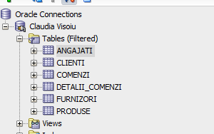

drop table angajati;

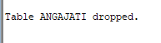

and to retrieve this table, we use the command flashback table angajati to before drop;

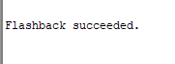

If we restart the SQL Developer application, we can see that the angajati table is still in the list of tables.

Exemples of various queries – including the UNION, INTERSECT and MINUS operators, DECODE and CASE expressions, nested queries, various single-row functions, group functions, hierarchical sturctures, joins
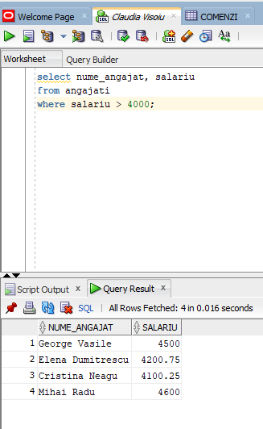
- Simple selection with filter:

select nume_angajat, salariu
from angajati
where salariu > 4000;

- Use of UNION operator

select nume_angajat, salariu
from angajati
where salariu > 4000
union
select nume_angajat, salariu
from angajati
where ore_lucrate < 8;

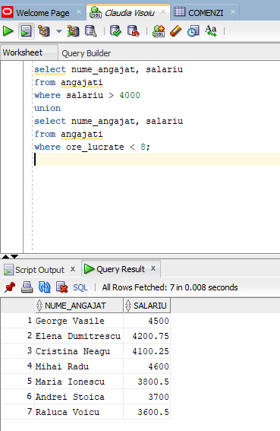

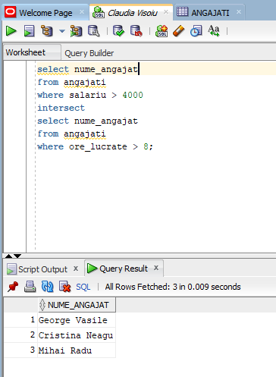
- Use of INTERSECT operator

select nume_angajat
from angajati
where salariu > 4000
intersect
select nume_angajat
from angajati
where ore_lucrate > 8;

- Use of MINUS operator

select nume_angajat
from angajati
where salariu > 4000
minus
select nume_angajat
from angajati
where sex = 'F';

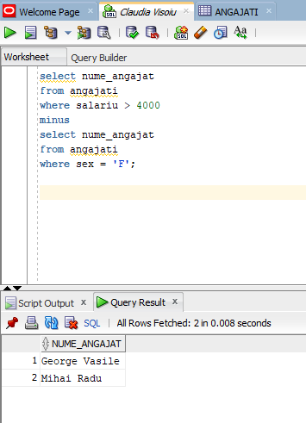
- Use of DECODE expression
select nume_angajat,
decode(sex, 'M', 'masculin', 'F', 'feminin', 'necunoscut') as gen
from angajati;

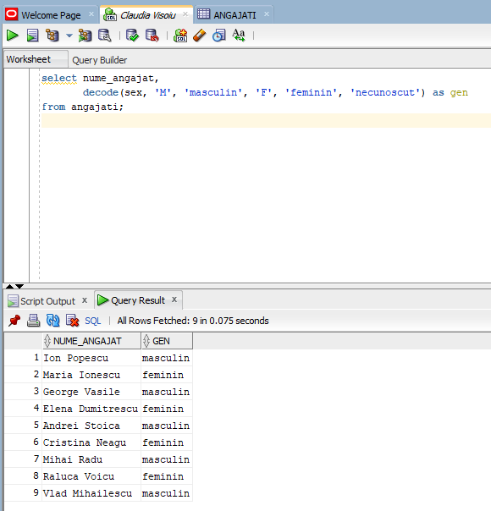

- Use of CASE expression
select nume_angajat, salariu,
case
when salariu > 4500 then 'Salariu mare'
when salariu between 3500 and 4500 then 'Salariu mediu'
else 'Salariu mic'
end as categorie_salariu
from angajati;

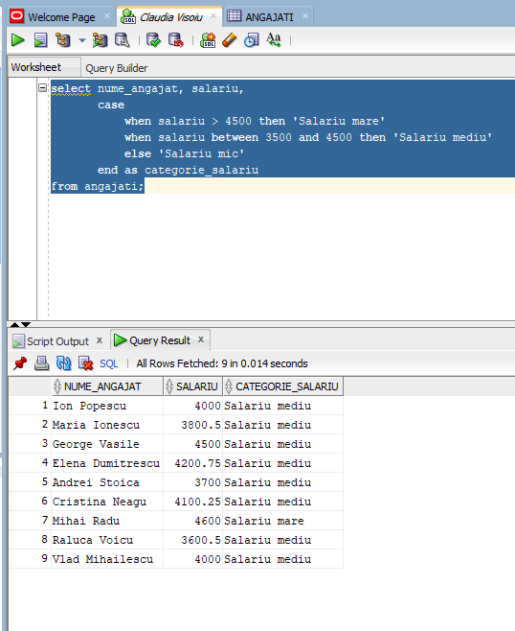
- Aggregation using group functions
select sex, avg(salariu) as salariu_mediu, max(salariu) as salariu_maxim
from angajati
group by sex;

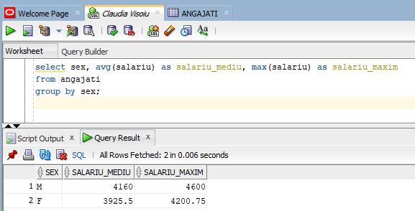
- Single-row functions for data processing
select nume_angajat, upper(nume_angajat) as nume_mare, length(nume_angajat) as lungime_nume
from angajati;

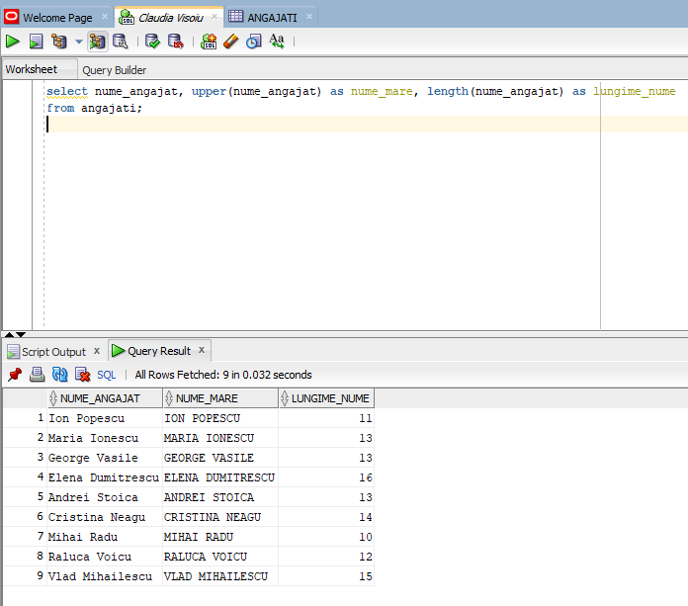
- Use of simple subquery
select nume_angajat, salariu
from angajati
where salariu > (select avg(salariu) from angajati);
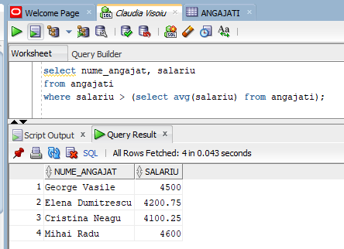
- Subquery with IN
select nume_angajat
from angajati
where id_angajat in (select id_angajat from angajati where salariu > 4500);
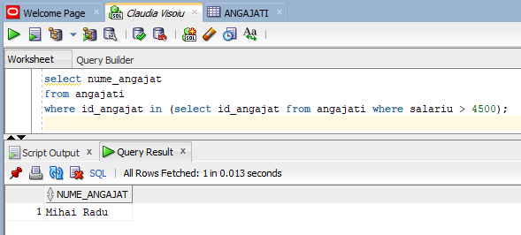
- ROWNUM function for limitation
select nume_angajat, salariu
from angajati
where rownum <= 5;
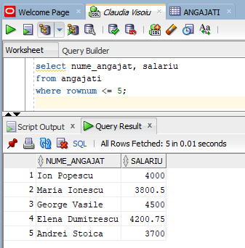
- SYSDATE function for current data
select nume_angajat, salariu, sysdate - data_nasterii as varsta_zile
from angajati;
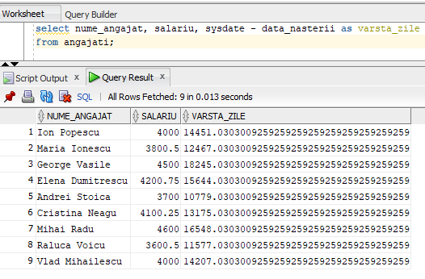
- Group function with conditioning
select count(*) as numar_angajati, sum(salariu) as total_salariu
from angajati
where sex = 'F';

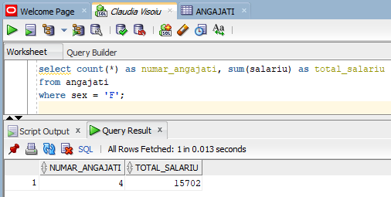

- Join between two tables
select p.nume_produs, d.cantitate, d.pret_unitar
from produse p
join detalii_comenzi d on p.id_produs = d.id_produs
where p.categorie = 'Lactate';

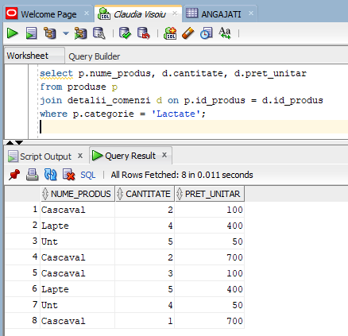

- External join (LEFT JOIN)
select p.id_produs, p.nume_produs, p.categorie, p.pret, d.id_comanda, d.cantitate
from produse p
left join
detalii_comenzi d
on
p.id_produs = d.id_produs
order by
p.id_produs;
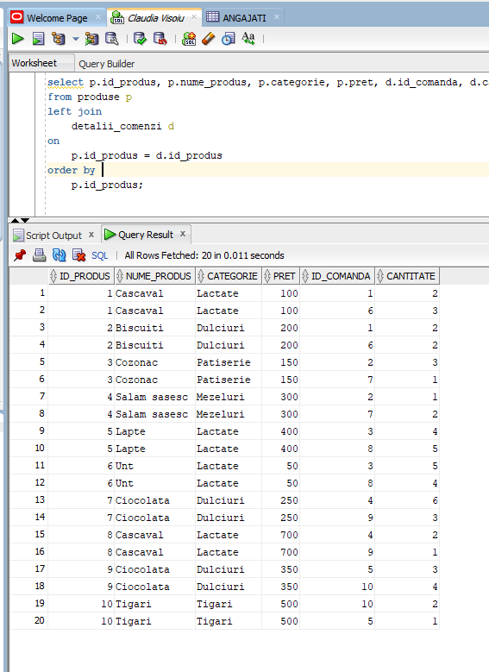
- Use of TRUNC function
select nume_angajat, TRUNC(salariu, -2) as salariu_trunchiat
from angajati;
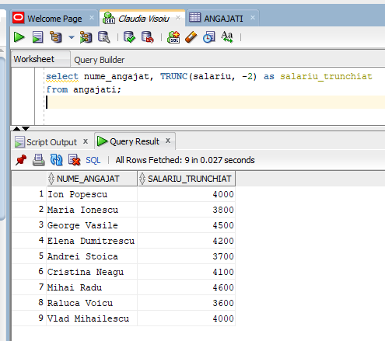
- Analitical function (RANK)
select nume_angajat, salariu,
rank() over (order by salariu desc) as pozitie_salariu
from angajati;
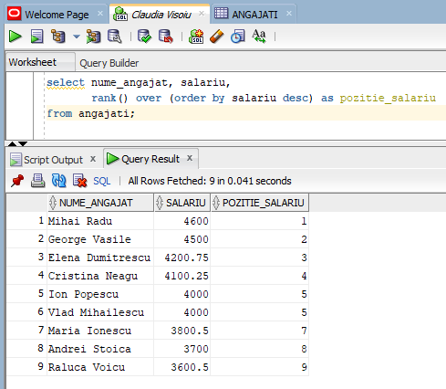
- Birth month extraction
select nume_angajat, extract(month from data_nasterii) as luna_nasterii
from angajati;
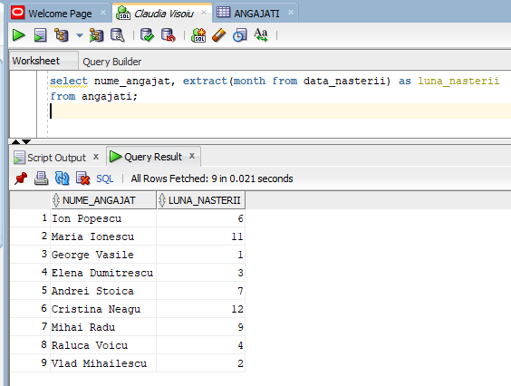
- Complex subquery
select nume_angajat, salariu
from angajati
where salariu > (
select avg(salariu)
from angajati
where sex = 'M'
);
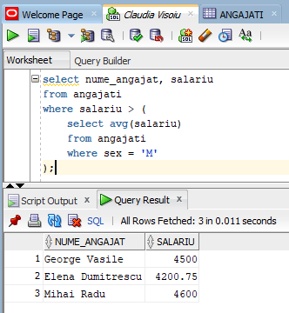
- GROUP BY and HAVING (finding products whose total stock exceeds a given value)
select
nume_produs,
sum(stoc) as stoc_total
from
produse
group by
nume_produs
having
sum(stoc) >= 20
order by
stoc_total desc;
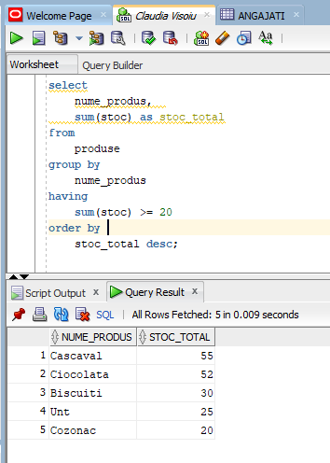

Managing other database objects: views, indexes, synonyms, sequences

- Creation of a view
A view is a database object that stores a query, useful for simplifying data access or for restricting access to specific columns.
create or replace view detalii_comenzi_view as
select
dc.id_comanda,
dc.id_produs,
p.nume_produs,
dc.cantitate,
dc.pret_unitar
from
detalii_comenzi dc
join
produse p on dc.id_produs = p.id_produs;
select * from detalii_comenzi_view;
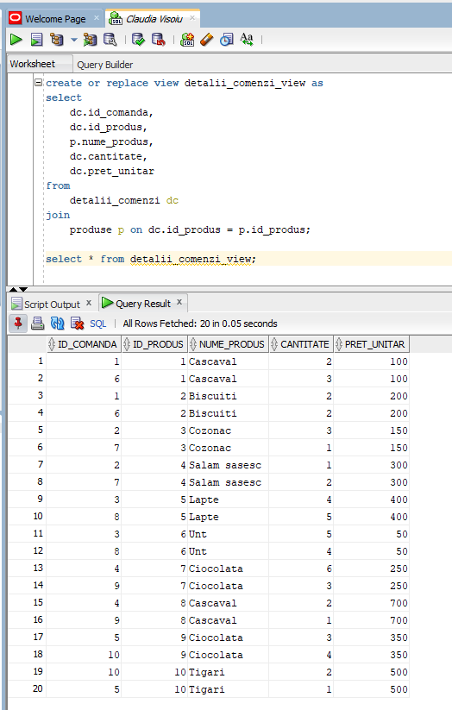

- Creation of an index
An index is used to improve query performance. Here, I'm creating an index to speed up searches on the product_name column in the products table.
create index idx_nume_produs on produse(nume_produs);
explain plan for
select * from produse where nume_produs = 'Ciocolata';
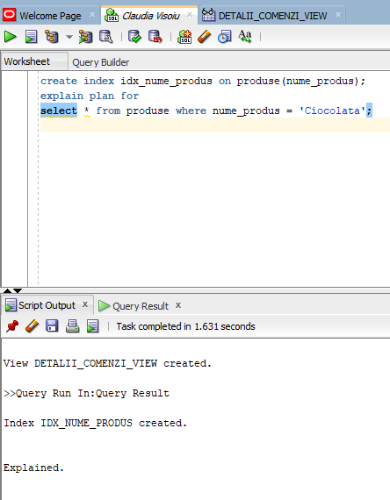

- Creation of a synonym
Synonyms are aliases for other database objects. They simplify access, especially in situations where there are multiple schemas.

create synonym produse_simplificat for produse;
select * from produse_simplificat where categorie = 'Lactate';

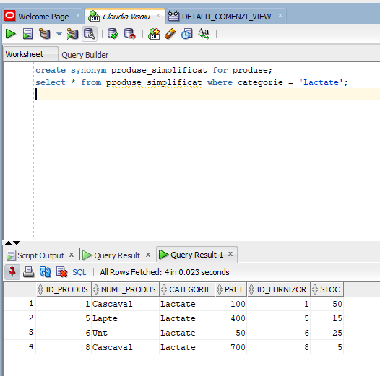

- Creation of a sequence
A sequence automatically generates unique values, which are useful for populating primary key columns.
create sequence seq_id_comanda
start with 1
increment by 1
nocache;
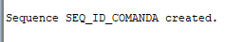
insert into comenzi (id_comanda, id_client, data_comenzii)
values (seq_id_comanda.nextval, 1, TO_DATE('2025-01-05', 'YYYY-MM-DD'));

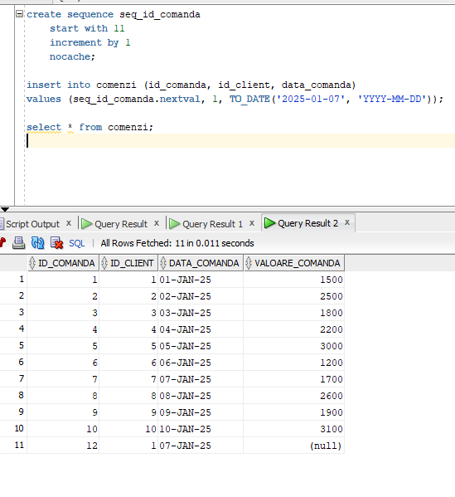
(Personal note: In the image, on line 11, the `id_comanda` value is 12 because I tried to create a new row in the sequence (which starts at 11), but `id_comanda` was defined as `UNIQUE`, so I had to modify the constraint for `id_comanda` to make the sequence work; it should have been 11, not 12)

- Deletion of an object
To delete a created object (e.g., view, index, synonym, sequence), we use specific commands.

drop view detalii_comenzi_view;

drop index idx_nume_produs;

drop synonym produse_simplificat;

drop sequence seq_id_comanda;

