# Stm32F4

File🡪new🡪c++ Project 🡪 c++ Managed Build

“Project Name” angeben und “empty project“ auswählen und „ARM Cross GCC“

Rechtsklick auf neues Projekt 🡪Properties

C/C++-Build🡪BuildVariables

* Configuration: All Configurations
* Add: HAL_PATH = C:\stm32\STM32Cube_FW_F4_V1.24.0; “Apply to all Configurations”

C++-Build🡪Settings

* Target Processor🡪ARM family cortex-m4
* Optimization🡪Optimization Level Og, -ffunction-sections fdata-sections -flto
* Warings -Wall

C/C++ General 🡪Path and Symbols 🡪Includes (All Configurations + All Languages)

${HAL_PATH}\Drivers\CMSIS\Device\ST\STM32F4xx\Include

${HAL_PATH}\Drivers\CMSIS\Include

${HAL_PATH}\Drivers\STM32F4xx_HAL_Driver\Inc

${HAL_PATH}\Middlewares\Third_Party\LwIP\src\include

${HAL_PATH}\Middlewares\Third_Party\LwIP\system

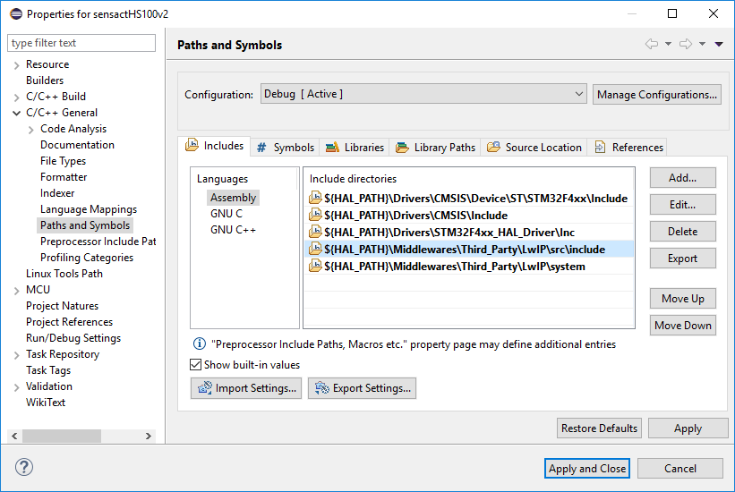

C/C++ General 🡪Path and Symbols🡪Symbols (All Configurations + All Languages)

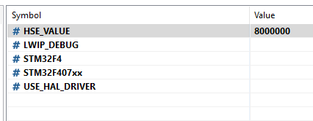

C/C++ General 🡪Path and Symbols🡪Source Folders

Link folder; Link to folder in File System

Im Projekt Rechtsklick auf diese Dateien 🡪Resource Configuration🡪Exclude from Build (for all configurations)

HAL/*_template.c

Im Lwip unnötige Apps; im core das ipv6; im netip das ppp und das ethernetif_template

Im USB Device Libary

Jetzt: Neuen Source-Ordner „sys“ hinzufügen