Teodor-Klaus Mosnegutu

V8015944

Games Development with C++

SnakeGame

***Game Instructions***

|  |  |  |  |
| --- | --- | --- | --- |
| *Up Arrow Key* | *Down Arrow Key* | *Left Arrow Key* | *Right Arrow Key* |
| *Move Snake Up* | *Move Snake Down* | *Move Snake to Left* | *Move Snake to Right* | |

***Problems encountered:***

My most considerable problem was that I couldn’t create the state machine to display the menu and then to click play and load the game; but I have created some of the bits and a working menu. I have left it “//”.

For some reason when the water levels drops, the y position to be under 600 the game does not end and I don’t quite know why that is but I have left the code in.

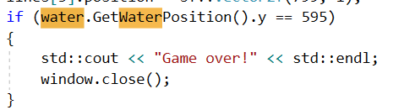

***Reflection:***

The most important thing I have learned during this development is how to get a function from a class into the game class with the “returnPosition” for example or something like that to use the position of an object existing in another class. Also, I have learned how to pass a class into a function to check if the Snake is above the water, I needed to pass the water reference into the function so that I can use the water position to compare it to the snake’s head. And, of course I have learned how to use and display things with SFML.

Overall, I think that this process went really well and if I were to do it again, it would definitely go faster and smoother just because of when you code something for the first time it takes some time to learn the concept and how you need to think in order to understand certain things when programming.

If I were to do this project another time I would definitely improve it with graphics, sound or just make it look nice as well as the code being good just because that would be the next step into development of a game.