Retreat 2022 Feedback Report

Klaus Frieler

2022-05-09

### Introduction

In 2022, the MPIAE went out again for a retreat after two years of pandemic-induced üaise. The event took place from April 20-24, 2022 in the Harnack House in Berlin-Dahlem.

In the second week following the retreat, we rana short survey to gather feedback from theparticipants, with the main goal to be able to (possibly) improve the upcoming retreats in the future.

After one week of run-time, a total of 34 persons responded. The distribution of professional roles can be seen in Table 1.

**Table** : Number of participants by professional role.

| PhD | Post-Doc | Service staff | Administrative staff | Other | Scientific staff | Total |
| --- | --- | --- | --- | --- | --- | --- |
| 9 | 9 | 5 | 4 | 4 | 3 | 34 |

### Assessment items

The survey contained 15 rating questions with five answer options each ranging from **strongly disagree** (= 1) to **strongly agree** (= 5). Mean values and other descriptors can be found in Table 2. From this it can be quite safely concluded, without too much exaggeration, that the retreat was a full success. The overall satisfaction reached an mean value of 4.4 (SD = .6, range 3 to 5). Most of the participant were very satisfied with the general (and new) concept of a joint meeting with all units, the overall organization as well as with location and accommodation (all means 4.5). The intention to bring people together was clearly fulfilled as many participants stated that they have met people that they have not met before (AM = 4.5), and that they were very happy with the personal meetings and get-togethers (AM = 4.2). They also feel more integrated in the institute and more motivated and inspired. The least approval, but still over the mid-point of the scale, received the question regarding the amount of scientific content (AM = 3.2). Similarly, the social program and the workshops were not to everybody’s full satisfaction (with means of 3.6 and 3.7).

**Table** : Mean values, range, and standard deviation of the rating items.

| Item | Mean | SD | Range |
| --- | --- | --- | --- |
| I met many people which I haven't met before. | 4.6 | 0.7 | 2-5 |
| I liked the concept of meeting together with administration and services. | 4.5 | 0.6 | 3-5 |
| Location, accommodation & food was good. | 4.5 | 0.6 | 3-5 |
| The retreat was well organized. | 4.5 | 0.8 | 2-5 |
| I was satisfied with the retreat. | 4.4 | 0.6 | 3-5 |
| I was satisfied with the get-togethers and personal meetings. | 4.2 | 0.8 | 2-5 |
| I feel more inspired and motivated after the retreat. | 4.2 | 0.8 | 3-5 |
| I feel more integreated into the institute after the retreat. | 4.2 | 0.9 | 2-5 |
| The scientific program was interesting and of good quality. | 4.0 | 0.9 | 2-5 |
| The pandemic security measures were adequate. | 3.9 | 0.7 | 2-5 |
| I learned a lot. | 3.9 | 0.7 | 3-5 |
| I liked the overall program structure | 3.9 | 0.7 | 2-5 |
| The workshops I attended were interesting and stimulating. | 3.7 | 0.9 | 1-5 |
| I was satisfied with the social program (Dahlem/museum tours). | 3.6 | 0.9 | 2-5 |
| The amount of scientific talks was just right. | 3.2 | 0.9 | 1-5 |

### Highlights & Wishes

We further asked which part of the program was the most satisfying for the participants and what they like to see more in the future in regard to general program parts and more specific topics. Results can be seen in Fig. 1 to 3.

Clearly, the most satisfying part was meeting people, followed with a wide margin by the workshops, the scientific and social program. Information on the institute and administrative topics did only sometimes win with the participants.

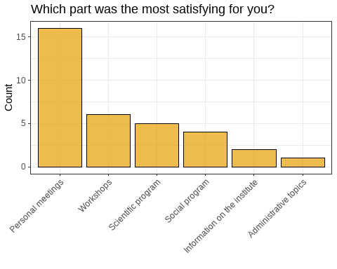

We also asked what should be more in the focus in the future. Here people could select more than one item from a variety of predefined options. The most requested are artistic and musical program points as well as hands-on workshops. This is mostly driven by the post-docs and PhD students, however, which made up the bulk of respondents. See Table 3 of a list of top wishes for the different professional roles. An artistic or musical program was not included in this year’s program, but very often requested, so this might definitely bea point to think about for the future.

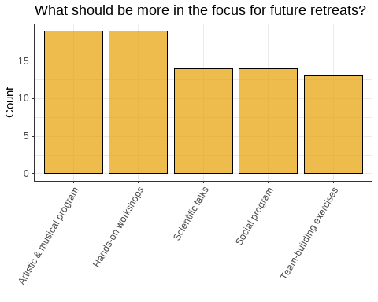

**Table** : Top answers for future program sections by professional role.

| Role | Section | Mentions |
| --- | --- | --- |
| Administrative staff | Team-building exercises | 3 |
| Other | Team-building exercises | 4 |
| PhD | Artistic & musical program | 6 |
|  | Hands-on workshops | 6 |
|  | Social program | 6 |
| Post-Doc | Artistic & musical program | 6 |
|  | Hands-on workshops | 6 |
| Scientific staff | Scientific talks | 3 |
| Service staff | Artistic & musical program | 3 |
|  | Scientific talks | 3 |

To explore the last point a bit deeper, we also asked for specific topics that participant might want to be covered in the future. The clear winners here are meta-scientific topics, such as “Scientific methods in general”, “Bridging the gap between science and humanities” and “Open Science”. It seems that these are important topics which, however, are seldom covered in everyday life of our scientists, and also of others as this was not only requested by scientific members of the institute, as can be seen from Table 4.

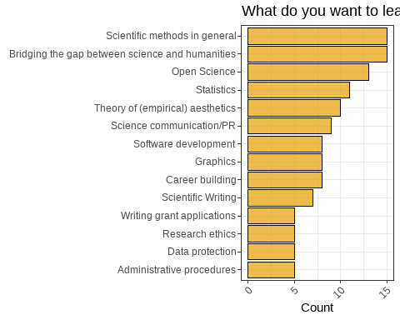

**Table** : Top answers for future topics by professional role.

| Role | Topic | Mentions |
| --- | --- | --- |
| Administrative staff | Administrative procedures | 2 |
|  | Bridging the gap between science and humanities | 2 |
|  | Graphics | 2 |
|  | Science communication/PR | 2 |
| Other | Data protection | 3 |
|  | Graphics | 3 |
|  | Research ethics | 3 |
| PhD | Scientific Writing | 6 |
| Post-Doc | Scientific methods in general | 5 |
| Scientific staff | Scientific methods in general | 2 |
|  | Software development | 2 |
|  | Statistics | 2 |
| Service staff | Theory of (empirical) aesthetics | 4 |

Finally, we also had two free text questions, one was “What was you personal highlight?” and “What could be improved in the future?”. The answer can be seen in Table 5 and 6.

The highlights reflect more or less the results from above. Most often mentioned were personal meetings, particularly, after the pandemic dire straits. But also the key notes received good feedback, especially the first one.

**Table** : Free text answers (highlights).

| Answer | What was you personal highlight? | status |
| --- | --- | --- |
| 1 | getting to know people in a relaxed environment and chat | Service staff |
| 2 | All the personal meetings and getting to know everybody. Oh and the Harnack House and the room where we stayed, i loved it. Everything was so beautiful. | Post-Doc |
| 3 | The meetings during coffee breaks and afterwards in the Einstein lounge | PhD |
| 4 | to get to know people I havent met before and engage in interesting discussions | Post-Doc |
| 5 | Get togethers | Scientific staff |
| 6 | Dancing with Frau Fricke :) | PhD |
| 7 | Hard to say. I guess it was a string of positive experiences rather than a single peak :-) | Post-Doc |
| 8 | The two evening talks. Both speakers were extremely well prepared and a lot was to be learned both from the perspective of the humanities and natural sciences. | Scientific staff |
| 9 | Social networking | Post-Doc |
| 10 | Meeting colleagues in real life | Service staff |
| 11 | Going back into a new normality | PhD |
| 12 | Meeting people in person | PhD |
| 13 | After dinner talk on Wednesday ; seeing so many members of the intistitute in vivid contact with each other at one place :-); meeting newcomers I only had known the names of before. | Administrative staff |
| 14 | Our admin presentation and the positive feedback we got from it. As well as feeling equally apart of the institute as the scientific members. | Administrative staff |
| 15 | I met a lot of new people from the institute and shared a lot with them and had a lot of fun. Now I feel more a part of the institute and the unfamiliar faces I used to see fleetingly in the corridor now have a name. | Other |
| 16 | 1st keynote talk + workshops (shiny, graphics) | PhD |
| 17 | Dahlem Tour | Service staff |
| 18 | The first keynote was fascinating and it was great to have conversations with the people straight after the talk. | PhD |
| 19 | from the group administration the video | Other |
| 20 | Presentation of the administration team. | Other |
| 21 | Writing workshop & Visiting the Philharmony | PhD |
| 22 | both key lectures | Service staff |
| 23 | Getting to know and hanging out with the people :)  Also, the new ArtLab. Wow! | Post-Doc |
| 24 | meeting new people :) | PhD |
| 25 | - seeing everyone in person after so long - the food and place - scientific talks were interesting | Post-Doc |

The suggestions for improvement also reflect more or less the results from above, but are much more diverse and sometimes rather specific. Most often mentioned was a certain of lack of scientific input (e.g,, talks and posters).

**Table** : Free text answers (improvement

| Answer | What could be improved in the future? | status |
| --- | --- | --- |
| 1 | I cannot think of anything | Post-Doc |
| 2 | wider range of topics more active involvement of participants in shaping the daily life of the institute (working and living together at the institute), formation of project groups, working with creativity techniques Team-building measures also across (service) groups Development of a mission statement and common values | Administrative staff |
| 3 | I think some parts were scheduled for an hour and lasted only half an hour in the end, so I think it could be better estimated how long some talks take. | PhD |
| 4 | all fine :-) However, I also liked the part where the new people introduced themselves. I was wondering, wether some more people could have been added here (maybe even from the people, who are already in the institute for a longer time)? | Post-Doc |
| 5 | I thought the topics were very good, but I would also like to see at least one presentation by our scientists.  It might be a good idea to ask people to check their details again just before booking their tickets or rooms, in case something has changed. Especially if it's been a while since they filled in the form.  I would be happy if there was also non dairy milk in the coffee breaks, especially since one could specify special needs beforehand. I survived, but it would have been nice :) | Service staff |
| 6 | The wine | Scientific staff |
| 7 | A little more free time/time for discussion/working on a specific topic for an extended period of time | PhD |
| 8 | Maybe try not to have the retreat during the official Easter holiday period of schools in Hesse? I know it's not entirely in your hands, but this way a lot of parents who didn't join this time might join next time - and those who did join anyway will not miss out on their kids' free time next time. Just if it's possible! | Post-Doc |
| 9 | This was the first retreat after the pandemic and was understandably mainly meant to build team spirit and to get to know each other - with success. Next time, it would be great to have a bit more of a scientific program, to learn more about the scientific projects of the members. This will help building collaborations and bonds between departments, research groups etc. This could be realized in a poster session, for example. | Scientific staff |
| 10 | It would be nuce to have more scientific presentations, maybe poster presentations to learn more about the research being conducted at the institute | Post-Doc |
| 11 | More science driven info, more talks from the departments, less entertainment from services & administration for the scientists. The retreat in parts felt like a school outing for the researchers. | Service staff |
| 12 | For me, the lunch breaks were a bit too short. I would have liked to finish the chats I have started maybe with a coffee or having a short walk | PhD |
| 13 | Collective transport of various material of any services or scientific groups to the retreat by rented car a day before the event. So a small group of people could have the necessary preparations in place when the rest of the institute arrives.  Of course everything worked out this time, but it could have been mor e relaxed.  Also for colleagues with physical handycaps, this would also have been an option. | Administrative staff |
| 14 | Clearer, detailed and and more visible information/communication in advance of the retreat. Especially about organizational particularities such as accomodations and the group travel. | Administrative staff |
| 15 | I can't think of anything. It was very well planned. | Other |
| 16 | vegan food options | PhD |
| 17 | Maybe no home trip on Saturday | Service staff |
| 18 | workshop for the assistants | Other |
| 19 | In my opinion, it should be communicated more clearly to people that the retreat is not a holiday. | Other |
| 20 | lectures earlier during the day instead of after dinner | PhD |
| 21 | balance between scientific and administrative / service sections | Service staff |
| 22 | social programs & timing of talks-workshops | PhD |
| 23 | - Social events after the day could improve - Alcoholic drinks should be free, at least in the reception day - the program was quite full-on, with small chances to relax | Post-Doc |

### Correlations

Finally, we also looked at some correlation between the basic rating items. The full correlation matrix can be found in Fig. 4. We only can higlight only some of the strongest relationships here. First of all, overall satisfaction is most strongly correlated with the get-togethers, the liking of the structure and the location as well as with the felt improvement in motivation. Boosted motivation, in turn, is strongly connected with feeling more integrated after the retreat, and even stronger so with meeting new people. This all underlines again the central importance of the personal meeting aspect for the retreat. Satisfaction with the quality of the scientific program is strongly related to the workshops and also with satisfaction with the quantity of the scientific program. Furthermore, this goes along with a satisfaction of the organization and probably result in a feeling to have learned a lot.



### Summary

All in all, the retreat seemed to have been an overwhelming success. Personal meetings were stage and center, so the overall concept of the retreat seemed have to work. Critique was sparse and mostly directed towards a ceratin lack of scientific program, which was deliberately held to a minimum this time, as it was the first post-pandemic meeting and a lot of structural and personal changes in the institute seemed to make it necessary to catch up on the personal side, which we are sure will bear fruits in the future. Nevertheless, we will take away some important suggestions and wishes to make the next retreat even better than the last one (if that is even possible).