Retreat 2023 Feedback Report

Klaus Frieler

2023-07-10

### Introduction

From June 14-17, 2023, the MPIAE went out again for a retreat this time at Castle Ringberg in Kreuth/Tegernsee. In the week following the retreat, we ran a short survey to gather feedback from the participants, in order to find avenues for possible improvements for future retreats. After two weeks of run-time, a total of 22 persons responded. The distribution of professional roles can be seen in Table 1. For more and detailed data, visit <http://testing.musikpsychologie.de/retreat_debrief_monitor/>.

**Table** : Number of participants by professional role.

| Post-Doc | PhD | Scientific staff | Other | Service staff | Total |
| --- | --- | --- | --- | --- | --- |
| 7 | 6 | 6 | 2 | 1 | 22 |

### Assessment items

The survey contained 13 rating questions with five answer options each ranging from **strongly disagree** (= 1) to **strongly agree** (= 5). Mean values and other descriptors can be found in Table 2. From this it can be quite safely concluded, without too much exaggeration, that the retreat was a complete success. The overall satisfaction reached an mean value of M = 4.5, location and accommodation was even better received (M = 4.9). The organization of the retreat was also deemed very good (M = 4.4). The intention to bring people together was clearly fulfilled as many participants stated that they have met people that they have not met before (M = 4.1), and that they were very happy with the personal meetings and get-togethers (M = 4.4). They also feel more integrated in the institute (M = 4.1) and more motivated and inspired (M = 3.9). The social program was even better received this year (M = 4.3) than last year (M = 3.6).

The least approval, but still over the mid-point (3) of the scale, found the scientific program: the amount (M = 3.3) as well as the quality of scientific content (M = 3.7). Participants agreed only moderately that they learned a lot (M = 3.5). Compared to last year, the workshops were a bit better evaluated (M = 4.0, last year: M = 3.7). All in all, it shows again that the retreat is maybe more of a social than of a scientific event.

**Table** : Mean values, range, and standard deviation of the rating items.

| Item | Mean | SD | Range |
| --- | --- | --- | --- |
| Location, accommodation & food was good. | 4.9 | 0.6 | 2-5 |
| I was satisfied with the retreat. | 4.5 | 0.6 | 3-5 |
| The retreat was well organized. | 4.5 | 0.7 | 3-5 |
| I was satisfied with the get-togethers and personal meetings. | 4.4 | 0.7 | 2-5 |
| I was satisfied with the social program (Tegernsee/Wolfsschlucht/Wallbergbahn). | 4.3 | 1.1 | 1-5 |
| I have met many people which I haven't met before. | 4.1 | 1.0 | 2-5 |
| I feel more integrated into the institute after the retreat. | 4.1 | 1.2 | 1-5 |
| I liked the overall program structure | 4.0 | 0.6 | 3-5 |
| The workshops I attended were interesting and stimulating. | 4.0 | 0.9 | 1-5 |
| I feel more inspired and motivated after the retreat. | 3.9 | 1.1 | 1-5 |
| The scientific program was interesting and of good quality. | 3.7 | 0.9 | 2-5 |
| I have learned a lot. | 3.5 | 1.0 | 2-5 |
| The amount of scientific talks was just right. | 3.3 | 1.0 | 1-5 |

### Highlights & Wishes

We further asked which part of the program was the most satisfying for the participants and what they like to see more in the future in regard to general program parts and more specific topics. Results can be seen in Fig. 1 to 3.

Clearly, the most satisfying part was meeting people, followed, with a wide margin, by the scientific program, administrative topics, and the workshops.

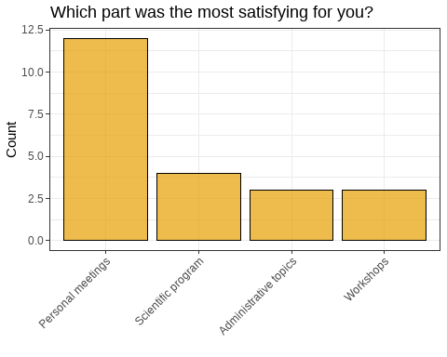

We also asked what should be more in the focus in the future. Here, people could select more than one item from a variety of predefined options. The most requested are open workshops formats, a new option that we added this year. This is followed by last year’s top wishes, artistic and musical program points as well as hands-on workshops.

Open workshop formats are mostly favored by post-docs, service staff and other staff, whereas PhD student have a preference for hands-on workshops, scientific talks, and team-building exercises. See Table 3 for a list of top wishes by the different professional roles. Just like last year, an artistic or musical program was not offered, but again very often requested. Hence, this might still be a point to think about for the future.

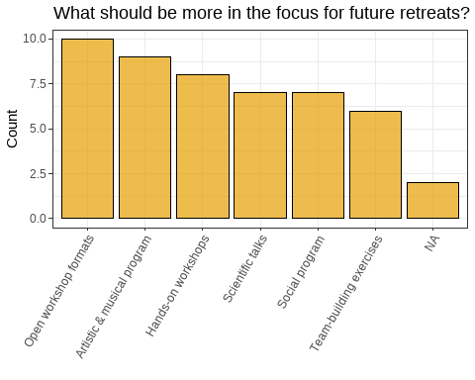

**Table** : Top answers for future program sections by professional role.

| Role | Section | Mentions |
| --- | --- | --- |
| Other | Open workshop formats | 2 |
| PhD | Hands-on workshops | 3 |
|  | Scientific talks | 3 |
|  | Team-building exercises | 3 |
| Post-Doc | Artistic & musical program | 4 |
|  | Open workshop formats | 4 |
| Scientific staff | Hands-on workshops | 3 |
| Service staff | Open workshop formats | 1 |
|  | Scientific talks | 1 |

To explore the wishes of the participants a bit deeper, we also asked for specific topics that they might want to be covered in the future. The clear winners here are meta-scientific topics, such as “Bridging the gap between science and humanities”, “Theory of (empirical) aesthetics”, and “Scientific methods in general.” Open Science, which was ranking highest last year, was only in the midfield this year. It seems that these more general topics are important but seldom covered in everyday life of the participants. Particularly, the more senior scientists seem to have an interest in the science-humanity gap, as can be seen from Table 4.

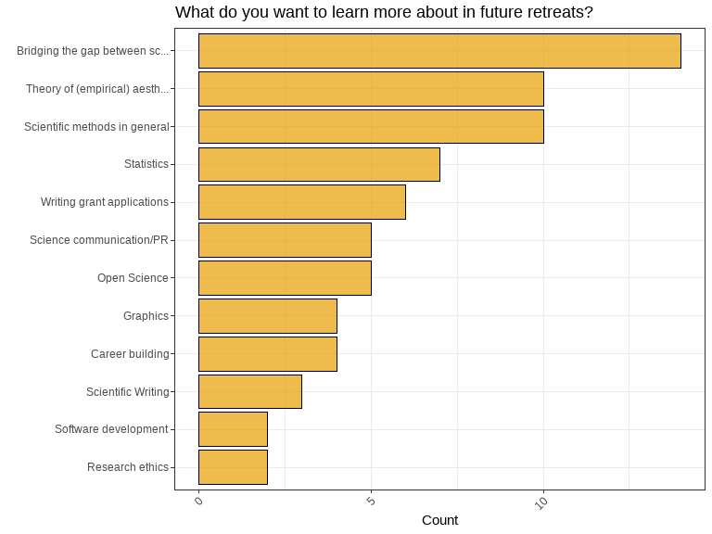

**Table** : Top answers for future topics by professional role.

| Role | Topic | Mentions |
| --- | --- | --- |
| Other | Bridging the gap between science and humanities | 1 |
|  | Open Science | 1 |
|  | Scientific methods in general | 1 |
|  | Theory of (empirical) aesthetics | 1 |
| PhD | Bridging the gap between science and humanities | 3 |
|  | Graphics | 3 |
|  | Open Science | 3 |
|  | Scientific methods in general | 3 |
|  | Statistics | 3 |
| Post-Doc | Bridging the gap between science and humanities | 4 |
|  | Scientific methods in general | 4 |
|  | Theory of (empirical) aesthetics | 4 |
|  | Writing grant applications | 4 |
| Scientific staff | Bridging the gap between science and humanities | 5 |
| Service staff | Bridging the gap between science and humanities | 1 |
|  | Science communication/PR | 1 |
|  | Scientific Writing | 1 |
|  | Scientific methods in general | 1 |
|  | Theory of (empirical) aesthetics | 1 |

Finally, as in last year, we also had two free text questions. One was “What was you personal highlight?” and the other was “What could be improved in the future?”. The answers can be seen in Tables 5 and 6.

The highlights reflect more or less the results from above. The answers are quite diverse, but most frequently mentioned were personal meetings, but also the castle (incl. the pool). The castle was the (not so) secret star of the retreat.

**Table** : Free text answers (highlights).

| Answer | What was you personal highlight? | status |
| --- | --- | --- |
| 1 | I think in the end, the PhD poster session worked quite well. It felt a bit rushed towards the end, but it was great to have such good discussions with colleagues. It could have been a bit better had the posters been spread out a bit more; in the space it felt a bit cramped.   Also, I felt the social program in the hike and the evenings is super important for feeling of togetherness, especially after corona. | PhD |
| 2 | Klaus' game workshop | Scientific staff |
| 3 | Am allowed only one? :-( Then it would be the Game Design workshop, which was really stimulating and genuinely useful for a concrete research problem. (but also getting to meet and hang out with colleagues) | Post-Doc |
| 4 | There were many highlights, but one that made an immediate change and set the atmosphere was opening the retreat at the pool. Good move of our directors! | Scientific staff |
| 5 | Bavarian Night | Scientific staff |
| 6 | Exploring the castle | Other |
| 7 | The castle | PhD |
| 8 | the overall social experience of belonging to this cool institute | Post-Doc |
| 9 | The food, the location, and the people in general. | PhD |
| 10 | BarCamp forever)) | Post-Doc |
| 11 | Melane Wald Fuhrmann's talk & the social programme in equal measure | Post-Doc |
| 12 | Got to talk to many colleagues I don't normally meet at the Institute | Post-Doc |

The suggestions for improvements also reflect more or less the results from above. Most often mentioned was a certain lack of free time, the program was perceived as rather tight. Particularly, the respondents wished for more time for discussions. The poster session was generally well-received but the acoustics of the poster space was deemed challenging. Oerall, there seem to be different fractions. A first, smaller, one who want the retreat to be more focused on science, and a second, larger, fraction who want the retreat to be more open and discursive.

**Table** : Free text answers (improvement

| Answer | What could be improved in the future? | status |
| --- | --- | --- |
| 1 | I think more time for discussions. A little more time for coffee breaks or between coffee breaks, also to keep on track with ongoing work; unless it is a bit shorter. | PhD |
| 2 | It would have helped to have 30 minutes break before dinner - the schedule was too packed. I felt that the Barcamp event created some friction between participants - so ideally no more of this. | Post-Doc |
| 3 | The timing overall. There should also be more open time that can be filled according to one's needs. | Scientific staff |
| 4 | A bit more time for meetings in small groups – it's rare to have everyone together in one place, we should make the most of it. | Service staff |
| 5 | Talks less long, more discussion, more time buffer in general so that it's not always running late. | PhD |
| 6 | A clearer shared sense of what the retreat is for. More collective and robust interrogation of how MPIEA can really drill into 'empricial aesthetics' with a coalition of humanities and science scholars: the prevailing energy is still, uncritically, scientistic. | Post-Doc |
| 7 | I think the place for the poster presentations was ideal. The resonance of so many voices was almost unbearable. I suggest to find another place in the castle next time. | Scientific staff |
| 8 | We could move the poster session outside (if weather allows) -> more space and better acoustics. | Scientific staff |
| 9 | Less delays with Deutsche Bahn | Scientific staff |
| 10 | More free time during the day (for personal meetings & to take a breath) | Other |
| 11 | The timings could be a bit better and it would also be nice to hear talks from the postdocs, since I think in general everyone has heard the talks from the departments and research groups several times now. | PhD |
| 12 | I liked the poster session a lot. There could be two poster sessions instead of the teambuilding part (Artlab BarCamp) | Post-Doc |
| 13 | More science focus. More hands-on knowledge and more planned team building exercises where everyone is instructed to talk to everyone. | PhD |
| 14 | Maybe more free time for walks | Post-Doc |
| 15 | It would still be nice for some of the postdocs to present their research cause we don't really know what exactly they are working on. | PhD |
| 16 | More time for the individual progamme points to relieve the constant rush. More open formats where people can discuss actual, not hypothetical ideas. More theory. Team-building exercises could be rooted in actual content to be less pointless. | Post-Doc |

### Correlations

Finally, we also looked at the correlations between the basic rating items. The full correlation matrix can be found in Fig. 4. We will highlight only some of the strongest relationships here.

First of all, overall satisfaction is most strongly correlated with feeling more integrated (r = .63), liking the overall structure (r = .62), and the location (r = .56), as well as with the social program and the get-togethers (r = .52). Boosted motivation, in turn, is strongly connected with feeling more integrated (r = .78) after the retreat and a approval of the structure (r = .75), and a bit less strongly so with meeting new people (r = .57).

This all underlines again the central importance of the personal meeting aspect for the retreat. Satisfaction with the quality of the scientific program is strongly related to the workshops and also with satisfaction with the quantity of the scientific program. Furthermore, this goes along with a satisfaction of the organization and a feeling to have learned a lot.

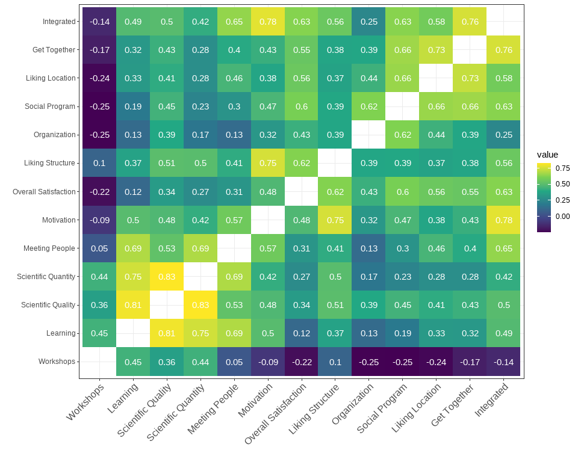

Applying a quick & dirty factor analysis with two factors (as suggested by a parallel analysis) and promax rotation, corroborated this observation as it revealed two factors, which can interpreted as a social (MR1) and a scientific/learning factor (MR2, c.f. Fig. 5). The correlation between the factors is .39.

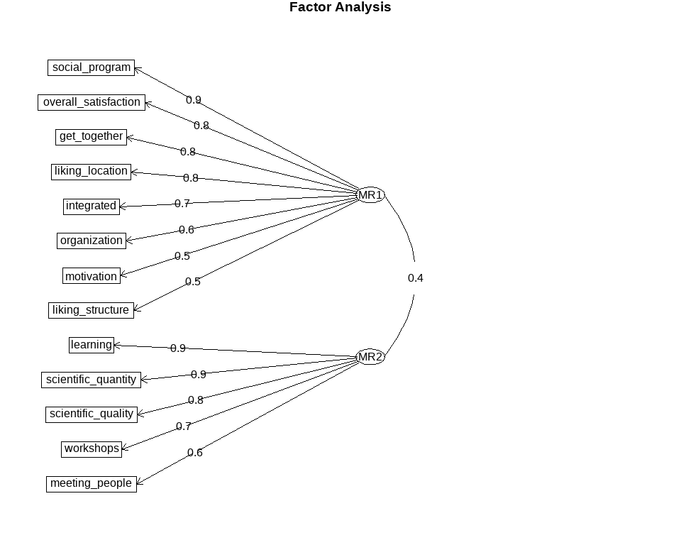

### Summary

All in all, the retreat was a complete success. Personal meetings and the castle were stage and center. As in last year, the overall satisfaction was mainly driven by the social aspects of the event. Critique was sparse and mostly directed towards a too tight schedule and sometimes to certain lack of scientific content or concrete learning opportunities. In regard to the wishes for the future, there is definitely an interest in more open formats and in more time for discussion, particularly with hindsight to the interdisciplinary nature of the institute. Finally, an artistic and musical program is still high on the wishlist.