Retreat 2024 Feedback Report

Klaus Frieler

2024-06-19

### Introduction

On May 22-24, 2024, the MPIAE went out again for a retreat at the Harnack House in Berlin. In the weeks following the retreat, we ran a short survey to gather feedback from the participants, in order to find avenues for possible improvements for future retreats. After two weeks of run-time, a total of 48 persons responded. The distribution of professional roles can be seen in Table 1. For more and detailed data, visit <http://testing.musikpsychologie.de/retreat_debrief_monitor/>.

``{=openxml}Tab. 1. Number of participants by professional role.

| Service staff | PhD | Senior Researcher | Other | Administrative staff | Post-Doc | Total |
| --- | --- | --- | --- | --- | --- | --- |
| 14 | 11 | 9 | 7 | 5 | 2 | 48 |

### Assessment items

The survey contained 15 rating questions with five answer options each ranging from **strongly disagree** (= 1) to **strongly agree** (= 5). Mean values and other descriptors can be found in Table 2. From this it can be quite safely concluded, without too much exaggeration, that the retreat was a complete success. The overall satisfaction reached an mean value of 4.1, a bit less than liking of location and accommodation (M = 4.1) and the concept of joint meeting of science and adminstration ((M = 4.4)). The organization of the retreat was also deemed very good (M = 4.1). The intention to bring people together was clearly fulfilled as many participants stated that they have met people that they have not met before (M =3.8), and that they were very happy with the personal meetings and get-togethers (M = 4.1). They also feel more integrated in the institute (M = 3.8) and more motivated and inspired (M = 3.8). The social program was clearly received worse this year (M = 2.8) than last year (M = 4.3). The choir singing event, a novelty this year, was overall very well received (with a few exception) with a mean o 4.1.

The second to least approval, after the social program, found the scientific program: the amount (M = 3) a bit less than the quality of scientific content (M = 3.5). Participants agreed only moderately that they learned a lot (M = 3.4). Compared to last year, the workshops were evaluated a bit worse (M = 3.8, last year: M = 4.0). All in all, it shows again that the retreat is maybe more of a social than of a scientific event.

``{=openxml}Tab. 2. Mean values, range, and standard deviation of the rating items.

| Item | Mean | SD | Range |
| --- | --- | --- | --- |
| I liked the concept of meeting together with administration and services. | 4.4 | 0.7 | 1-5 |
| Location, accommodation & food was good. | 4.4 | 0.7 | 2-5 |
| I was satisfied with the get-togethers and personal meetings. | 4.1 | 0.7 | 2-5 |
| I was satisfied with the retreat. | 4.1 | 0.7 | 2-5 |
| The retreat was well organized. | 4.1 | 0.9 | 2-5 |
| Singing was a good experience. | 4.1 | 1.1 | 2-5 |
| I liked the overall program structure | 3.9 | 0.8 | 2-5 |
| I feel more integrated into the institute after the retreat. | 3.8 | 0.7 | 3-5 |
| The workshops I attended were interesting and stimulating. | 3.8 | 0.8 | 2-5 |
| I feel more inspired and motivated after the retreat. | 3.8 | 0.9 | 2-5 |
| I have met many people which I haven't met before. | 3.8 | 1.0 | 1-5 |
| The scientific program was interesting and of good quality. | 3.5 | 0.8 | 2-5 |
| I have learned a lot. | 3.4 | 0.9 | 2-5 |
| The amount of scientific talks was just right. | 3.0 | 1.0 | 1-5 |
| I was satisfied with the social program (Dahlem Tours). | 2.8 | 1.2 | 1-5 |

### Highlights & Wishes

We further asked which part of the program was the most satisfying for the participants and what they like to see more in the future in regard to general program parts and more specific topics. Results can be seen in Fig. 1 to 3.

Clearly, the most satisfying part was meeting people, closely followed by the Choir Singing, whereas the workshops, the social program, the World Cafè were mentioned quite fewer. The scientific program is even ranked last, much worse than last year.

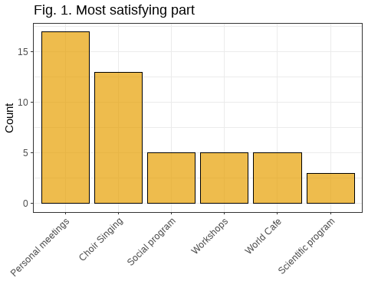

We also asked what should be more in the focus in the future. Here, people could select more than one item from a variety of predefined options. The most requested are artistic and musical program points as well as hands-on workshops, the least often requested are social program points and open workshops, but the margins are very small.

Open workshop formats are mostly favored by service staff, whereas PhD student have a preference for hands-on workshops (same as last years), Post-Docs and Senior Researcher are the most into artistic and cultural activities. See Table 3 for a list of top wishes by the different professional roles.

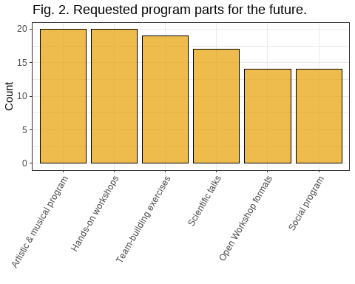

``{=openxml}Tab. 3. Top answers for future program sections by professional role.

| Role | Section | Mentions |
| --- | --- | --- |
| Administrative staff | Team-building exercises | 5 |
| Other | Hands-on workshops (focus on skills) | 5 |
| PhD | Hands-on workshops (focus on skills) | 7 |
| Post-Doc | Artistic & musical program | 2 |
| Senior Researcher | Artistic & musical program | 4 |
| Service staff | Open Workshop formats (e.g., BarCamp, OpenSpace) | 8 |
|  | Team-building exercises | 8 |

To explore the wishes of the participants a bit deeper, we also asked for specific topics that they might want to be covered in the future. The clear winners (like in the last years) are meta-scientific topics, such as “Bridging the gap between science and humanities”, “Theory of (empirical) aesthetics”, and “Scientific methods in general.” This is a continuity from the last two retreats. Open Science is again in the midfield this year. It seems that these more general topics are important but seldom covered in everyday life of the participants. Particularly, the more senior scientists seem to have an interest in the theory of empirical aesthetics, as can be seen from Table 4.

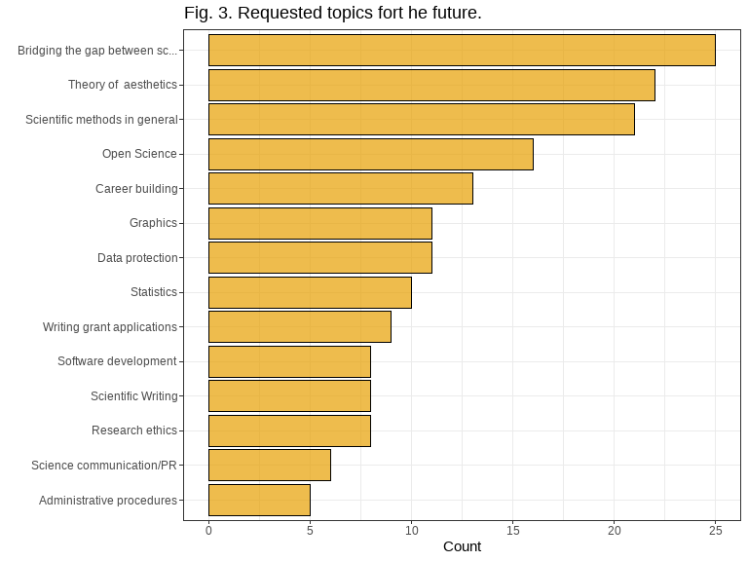

``{=openxml}Tab. 4. Top answers for future topics by professional role.

| Role | Topic | Mentions |
| --- | --- | --- |
| Administrative staff | Administrative procedures | 3 |
| Other | Bridging the gap between science and humanities | 3 |
| PhD | Scientific methods in general | 8 |
| Post-Doc | Bridging the gap between science and humanities | 2 |
|  | Theory of aesthetics | 2 |
| Senior Researcher | Theory of aesthetics | 6 |
| Service staff | Theory of aesthetics | 8 |

Finally, as in last year, we also had two free text questions. One was “What was you personal highlight?” and the other was “What could be improved in the future?”. The answers can be seen in Tables 5 and 6.

The highlights reflect more or less the results from above, but with a wide variety of topics and themes.

``{=openxml}Tab. 5. Free text answers (highlights).

| Answer | What was you personal highlight? | status |
| --- | --- | --- |
| 1 | socioscientific interaction | Senior Researcher |
| 2 | Junior Researchers’ Poster Session | Administrative staff |
| 3 | Building personal connections, getting more integrated into the social structure of the institute. | Administrative staff |
| 4 | food, social networking, | Service staff |
| 5 | Poster Session, Singing | Service staff |
| 6 | Choir singing | Senior Researcher |
| 7 | The poster session. Fantastic work, interesting conversations. | Post-Doc |
| 8 | Hanging out and singing | Post-Doc |
| 9 | Mahmood Anwar’s poem! | Other |
| 10 | world café and getting to know all people | Service staff |
| 11 | Felix's talk :-) | Senior Researcher |
| 12 | The poster session | PhD |
| 13 | The workshops | PhD |
| 14 | social program | Service staff |
| 15 | Time to spend with my PhD student and talk about the future | Senior Researcher |
| 16 | Poster session Get together in general | Service staff |
| 17 | Continuing singing till late in the evening with colleagues | PhD |
| 18 | Having fun with some colleagues I've didn't know on personal level before | Service staff |
| 19 | met people that I haven't seen them before; came together, socializing | Service staff |
| 20 | The Institute Singing was very exciting and communicated a good team spirit. Very good idea! | Administrative staff |
| 21 | PhD Posters | Administrative staff |

The suggestions for improvements are also very diverse this year, some participants even mentioned that the right balance for the retreated is found, see Table 6.

``{=openxml}Tab. 6. Free text answers (improvement)

| Answer | What could be improved in the future? | status |
| --- | --- | --- |
| 1 | No suggestions, I think it was great and I see that it always is a balance act to make everyone happy if it is a mixed staff retreat. | Senior Researcher |
| 2 | The only point in the program that was unclear was the post-doc session, which ended up not being anything. For that to work, there has to be some organized prepared topic(s) and a responsible person. | Senior Researcher |
| 3 | Ask an Administrator Workshop | Administrative staff |
| 4 | The packed schedule with departure early in the morning and arrival late in the evening was stressful/exhausting. A less concentrated programm with a little more breathing room might feel less draining. Maybe even splitting a purely scientific retreat from a more general all-insitute-retreat and have them as seperate events. It could lessen the pressure on the programm for the all-insitute-retreat and make both a more relaxed and stimulating experience. | Administrative staff |
| 5 | mehr Angebote für soziale Veranstaltungen nach dem Abendessen, mehr interaktive Workshops, | Service staff |
| 6 | More space for personal exchange/free time between the program points, for example to deepen conversations. | Service staff |
| 7 | It would be great to have a stronger focus on science again in the next retreat, e.g., with two keynote speakers as two years ago. Postdocs should be given the opportunity to present as well. PhD students mentioned that they would have liked more feedback from senior researchers (but probably a poster session doesn't allow seeing every student). What may be a work-around are mini-talks (instead of posters), where everybody listens and can give feedback. | Senior Researcher |
| 8 | The forced „concert“ for the reluctant staff at Harnack House was cringeworthy. Artistic workshops are awesome, but this felt forced and people around me said they were irritated to be expected to embarrass themselves. Also not a big fan of World Cafe. Format was great, the proposed topics were a bit dull. Maybe let’s put the emphasis on the topics, not the format in the future? (And yes, I get that it was meant as a conversation starter and builder of cohesion, but even that would have been improved with better topics) | Post-Doc |
| 9 | More collaborative development of the institute's academic mission (which I think world café revealed to be fuzzy) | Post-Doc |
| 10 | a bit more science and in paticular, overarching, general scientific questions | Other |
| 11 | One can play around with different variants but I think we have found a basic concept that is just right. | Senior Researcher |
| 12 | No more forced singing, please :-). Maybe several artistic workshops, but to choose from? | Senior Researcher |
| 13 | I really liked the World Cafe, but it could even be better if the groups were smaller, so that there would be more interactions between people. | PhD |
| 14 | the professionalism of the Dahlem Tour guides | Service staff |
| 15 | The workshops should not take place on the last day, I would prefer to hold them on the second day. | PhD |
| 16 | Invitation of interesting and engaging (inter)national guest speakers with research relevance to our institute's agenda | Service staff |
| 17 | No long journeys to the seminar location. | Other |
| 18 | More time for things that are of personal interest. Find people that share your specific research interests. | Senior Researcher |
| 19 | Greater involvement of postdocs in the programme. It felt like (almost) only doctoral students and services were involved as contributors | Service staff |
| 20 | It would be nice to have a little more time to talk to other colleagues. The program was very structured, so you didn't have much time. | Service staff |
| 21 | Workshops could be organized without overlapping | Service staff |
| 22 | Represent science more transparently | Service staff |
| 23 | More involvement of the Directors into the program: perspectives of the Institute's research efforts. | Administrative staff |

### Correlations

Finally, we also looked at the correlations between the basic rating items. The full correlation matrix can be found in Fig. 4. We will highlight only some of the strongest relationships here.

First of all, overall satisfaction is most strongly correlated with liking the organization of the retreat (r = 0.54), liking the overall structure (r = 0.5), and feeling more motivated (r = 0.31), as well as with meeting new people (r = 0.37). Boosted motivation, in turn, is strongly connected with feeling more integrated after the retreat (r = 0.67) and with singing (r = 0.34).

Contrary to last years, the data do not show such a dominance of the personal meeting aspect, maybe because this is already the second retreat after the pandemic. Generally, all evaluations are quite diverse.

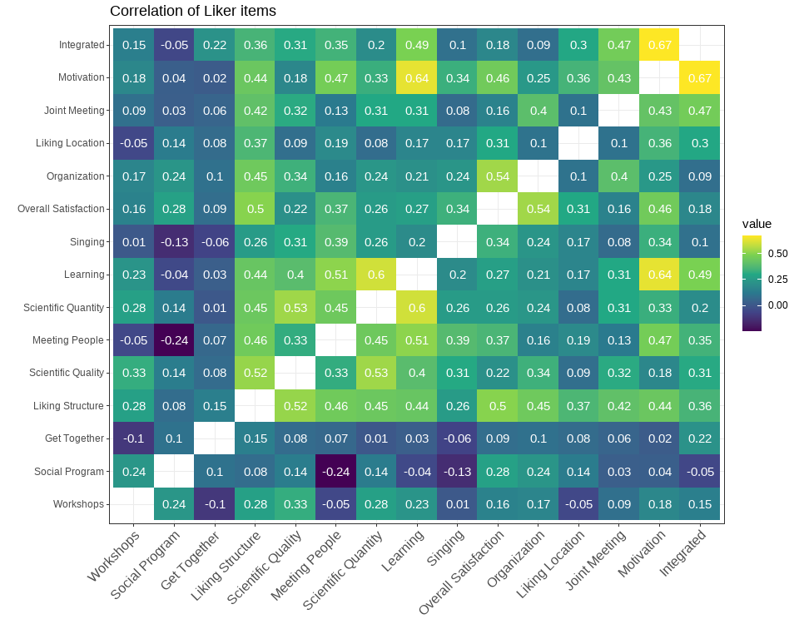

### Summary

All in all, the retreat was a nice success. Personal meetings and choir singing were the most important aspects (though a few participants clearly disliked the singing). Contrary to last years, the overall satisfaction was not mainly driven by social aspects of the event, as all evaluations, personal highlights and suggestions for improvement turned out very diverse this year. This can be positively interpreted as as an general satisfaction. There were no big positive or negative issues in this year’s edition of the retreat, so individual preferences could come more to foreground in the evaluation. A further reason might be that the last two retreats happened under the impression of the pandemic, in which many new people had begun to work at the Institute, without much social interactions before the last years retreats.