Chapter 1 — Software and Software Engineering
In this chapter: What software really is, why it refuses to behave like hardware, what “engineering” adds to programming, and how one small elder-care project — CareLink — will carry us through an entire software lifecycle.

Learning Objectives
After reading this chapter, you will be able to:
- Define software as more than programs: instructions, data, and documentation.
- Explain why software is developed rather than manufactured, and why it deteriorates without wearing out.
- Classify software into major categories and recognize legacy software.
- State the IEEE definition of software engineering and explain each keyword.
- Distinguish software engineering from programming in scope, discipline, and outcome.
- Apply the three essentials — process, methods, tools — to a concrete project.

Opening Scenario
Grandma Lin is 78. She lives alone in a third-floor apartment, and she wants to keep it that way. Her son Wei worries. He works in another city. A phone call every evening helps, but a phone call cannot notice that she has stopped boiling her morning kettle — which, for Grandma Lin, would be a signal that something is wrong.
A small company decides to build a system that does notice: wristbands, room sensors, a family app, a 24-hour care center, and an escalation chain that ends, in the worst case, with an ambulance. They call it CareLink.
The team is six people. None of them is uncertain how to write code. All of them are uncertain about something else: What should we build first? Who decides what “urgent” means? How will we know it is safe? What happens when the requirements change — and they will?
Writing programs was the skill they learned first. Building software is the discipline this book teaches. The distance between the two is software engineering, and it begins with a deceptively simple question: what, exactly, is software?

Core Concepts

1.1 Software Is More Than Programs
When students hear “software,” most picture lines of code. A professional definition is broader. Software is [1]:
- Instructions — programs that, when executed, provide the desired features, functions, and performance;
- Data structures — the information the programs manipulate, organized so that it can be used efficiently;
- Documentation — the descriptions of operation and use that make the programs understandable, installable, and maintainable.
The third item surprises beginners, yet it is often the one that decides a project’s fate. A system whose only artifact is source code is not software in any deliverable sense; it is an accident that happens to run. When a hospital cannot install a monitoring system because the setup steps live in one engineer’s memory, the failure is not in the code — it is in the missing documentation.
Key point. If it is not written down, it does not exist. Code, data, and documents are one product.

1.2 Software Is Engineered, Not Manufactured
Almost every property of software follows from one fact: software is a logical system, not a physical one. Compare it with a car.
A car is manufactured. Its cost is dominated by materials and assembly. Its quality is dominated by the consistency of the production line. Build the thousandth car, and it costs roughly what the first one cost.
Software is developed. The cost is almost entirely design effort — human thought, captured in instructions. Copying software is free; the entire cost of software is in creating the first copy. This is why software estimates are so hard: you are not predicting a production run, you are predicting the duration of an act of design.
The manufacturing metaphor fails in a second way. Quality in manufacturing means conformance to the spec of the line. Quality in software means fitness of the design itself — and the design lives in human minds, which is why reviews, pair work, and clear models matter more in this discipline than in any other engineering field.

1.3 Software Does Not Wear Out — It Deteriorates
Hardware fails on the classic “bathtub curve”: high failure rate early (manufacturing defects), low through its useful life, rising again as parts wear out. Software has no parts. It does not wear out.
Instead, software deteriorates. Every change — a new feature, a platform upgrade, a bug fix — has a chance of making the structure slightly worse: dependencies tangle, duplicate logic accumulates, and the design that was once clean becomes hard to reason about. The failure rate of an aging system rises not because the code decayed physically, but because change after change was made under time pressure to a design that no longer fits.
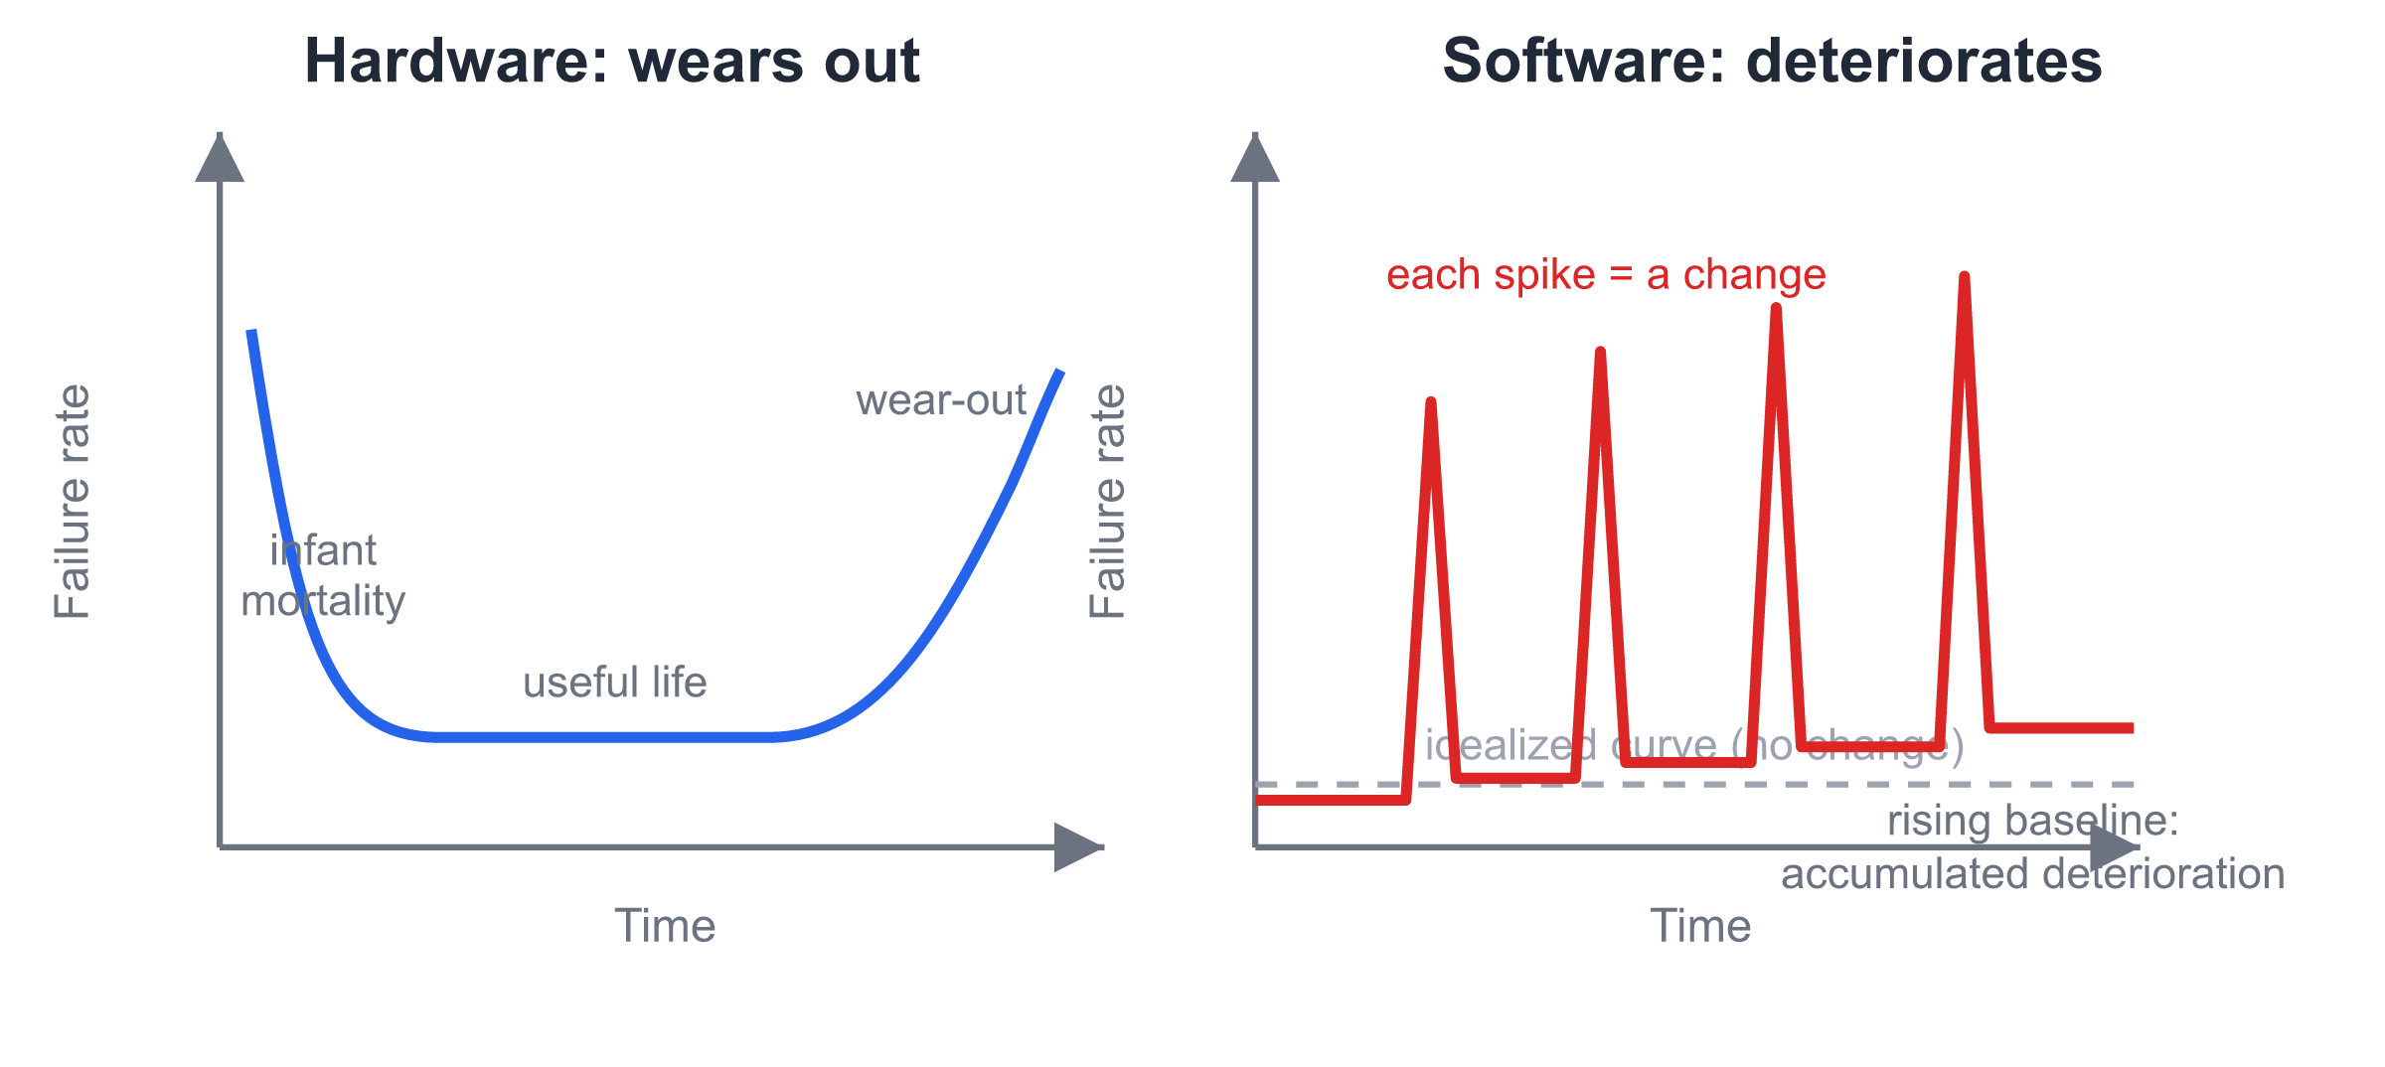
Hardware bathtub curve versus software deterioration curve
Fig. 1-1. Hardware follows the bathtub curve; software never wears out, but every change risks a failure-rate spike and a permanently higher baseline.
The practical consequence is uncomfortable and liberating at once: the quality of a software system in its fifth year is determined by the discipline of the changes in years one through four. Deterioration is not fate; it is negligence, accumulated.

1.4 Categories of Software
Software is usually classified by the job it does. The boundaries blur, but the categories are useful vocabulary:
Category | Examples | Characteristic concern
System software | Operating systems, compilers, drivers | Efficiency, correctness at scale
Application software | Office suites, business apps | Usability, domain fit
Engineering/scientific | CAD, simulation | Numerical accuracy
Embedded software | Appliance, automotive control | Resource limits, real-time
Web/mobile apps | CareLink’s family app | Rapid change, reach
AI/data systems | Recommendation, vision pipelines | Data quality, model behavior
CareLink, like most real systems, spans categories at once: an embedded component in the wristband, a mobile app for the family, a web console for the care center, and data analysis for the daily report. Most interesting software does.

1.5 Legacy Software and the Four Kinds of Change
Legacy software is old software that an organization still depends on. It is frequently unloved — built on dead platforms, undocumented, understood by few — and yet impossible to simply replace, because it encodes years of business knowledge. More of the world’s software budget is spent maintaining existing systems than building new ones.
Why does software refuse to stand still? Four forces drive change, and they map to the four classic maintenance activities:
- Corrective maintenance — fixing defects. Something behaved wrongly.
- Adaptive maintenance — adjusting to a new environment: a new OS, a new regulation, a new API version.
- Perfective maintenance — improving what exists: faster, clearer, safer.
- Preventive maintenance — restructuring so future change is easier.
Grandma Lin’s kettle is a small example of the fourth force in disguise: the team will one day refactor the sensor-abstraction layer before adding a new sensor type, precisely so that the addition is cheap.

1.6 From Crisis to Discipline: What Is Software Engineering?
By the 1960s, software projects were failing at a rate that could no longer be joked about. Systems ran years late, swallowed budgets, and — worse — were delivered and then abandoned because they did not do what users needed. The 1968 NATO conference in Garmisch, Germany, gave the problem a name and the answer a name at the same time: the software crisis, and software engineering.
The IEEE definition remains the standard [2]:
The application of a systematic, disciplined, quantifiable approach to the development, operation, and maintenance of software; that is, the application of engineering to software.
Unpack the three keywords:
- Systematic — the work follows a process: an ordered set of activities that can be planned, repeated, and improved. Heroic improvisation does not scale past one person.
- Disciplined — the team follows agreed methods and standards even when deadlines scream. Discipline is what you keep when it is inconvenient.
- Quantifiable — progress and quality are measured, not assumed. “Almost done” is not a measurement.

1.7 Software Engineering Is Not Programming
Every software engineer programs; very few programs are software engineering. The difference is not talent but scope:
 | Programming | Software engineering
Goal | Make a correct program | Deliver a working product that solves a user’s problem
Time horizon | Until the program runs | For the product’s whole life, including change
Team | Usually one person | Roles, coordination, communication
Requirements | Given to you | Elicited, negotiated, validated — by you
Success | It works | It is used, on time, within budget, and can evolve
A program that meets its specification but misses its users is a programming success and an engineering failure. CareLink’s team could build a flawless fall-detection algorithm and still fail, if elders find the wristband uncomfortable or operators drown in false alarms. Engineering owns the whole outcome.

1.8 The Three Essentials: Process, Methods, Tools
Software engineering is often described as three layers resting on a base of quality focus (Fig. 1-2):
- Process — the framework that holds everything together: which activities happen, in what order, with what feedback loops. A generic process contains five framework activities: communication (understand the problem), planning (map the road), modeling (analyze and design), construction (code and test), and deployment (deliver and gather feedback). Around them run umbrella activities — tracking, risk management, quality assurance, change control — continuously, not at the end.
- Methods — the “how-to” for each activity: how to elicit requirements (interviews, use cases), how to design (architecture, UML, patterns), how to test (unit, integration, system). This book is, mostly, a tour of methods.
- Tools — automation for process and methods: IDEs, Git, modeling tools, test frameworks, issue trackers. Tools multiply discipline; they do not substitute for it.
A useful memory device: process says when, methods say how, tools do it faster. 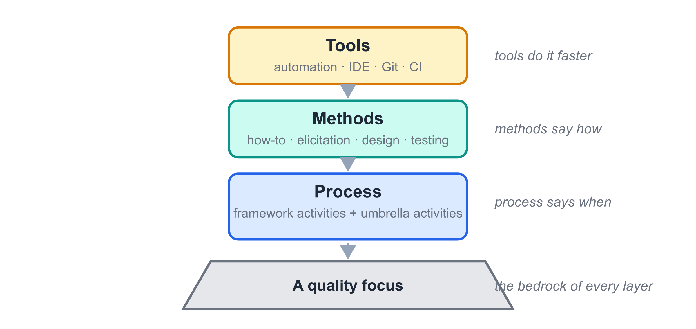
Fig. 1-2. The three essentials rest on a base of quality focus. Tools multiply the other layers; they cannot replace them.
A team with tools but no process is just accelerating in circles.

1.9 Goals — and Three Myths
The goals of software engineering are plain to state: deliver software that satisfies its users, within budget and schedule, that remains maintainable after release. Three beliefs sabotage newcomers repeatedly, so let us retire them now:
- Myth 1: “We have standards/documents/processes — that’s enough.” Reality: a standard nobody follows is a PDF, not a practice. What counts is what the team actually does under pressure.
- Myth 2: “If we fall behind, we can add more programmers.” Reality: adding people to a late project makes it later — newcomers must be trained by the very people who are already overloaded.
- Myth 3: “Requirements changes are trivial — software is soft.” Reality: a one-line change late in a project can ripple through design, code, tests, and documents. Flexibility is real but never free; the cost of change grows steeply with time (a fact Chapter 4 returns to with evidence).
The CareLink team believes all three myths in week one. The rest of this book is the story of how they stop.

CareLink in Action
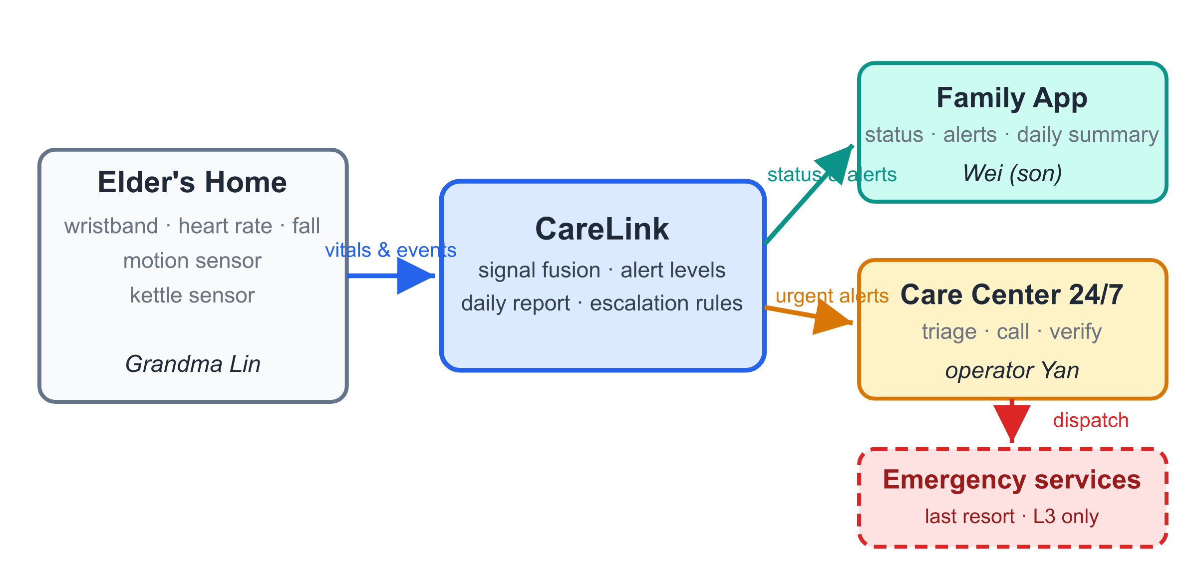
CareLink system context diagram
Fig. 1-3. CareLink at a glance: sensors in the elder’s home feed a platform that notifies family and care-center operators, escalating only when necessary.
Let us watch the three essentials appear in one ordinary week of the CareLink project — before the team has learned any formal method.
Process. Monday, the team lists what it must understand first: who the elders are, what “urgent” means to a care center, what sensors can actually detect. They have invented, without knowing its name, the communication activity. Tuesday they sketch a 16-week plan on a whiteboard: four weeks to requirements, five to design, five to build, two to test. That is planning. They do not yet know that the plan is wrong in a productive way — which is what Chapter 3 (agile) is about.
Methods. In the first customer interview, Wei says: “I want to know Mom is okay.” What does okay mean? The team argues: kettle used by 9 a.m.? Movement in the kitchen? Heart rate in range? They have hit the classic requirement problem — a real need hiding inside a vague word — and they will need elicitation techniques (Chapter 4) and modeling techniques (Chapters 5–9) to pin it down.
Tools. By Friday the team has a Git repository, an issue tracker, and a shared document folder. Nothing glamorous — and, correctly used, enough tooling to keep six people synchronized for the next four months.
One week, three essentials, no code written. That is what software engineering looks like on Day 5.

Common Pitfalls
- “Software = code.” Students ship zip files of source and call it a release. Correction: a release includes data schemas, installation steps, user guidance, and maintenance notes. If a new team member cannot get the system running from your artifacts alone, the product is incomplete.
- “It works, so it is done.” A program that runs is at the halfway mark of an engineering deliverable. The remaining half — readable structure, tests, documents, and deployability — is what gets maintained.
- “We will add requirements later; they are easy.” Every later chapter of this book will cost more because of this sentence. Late change is possible — agile methods exist to make it survivable — but it is never free.
- Confusing the three essentials. Teams that adopt tools (a Kanban board!) without a process get a prettier mess. Ask of any tool: which activity does this automate, and what is our manual version of that activity?

Guided Lab: Classify and Diagnose (45 minutes)
Pick a system your team uses daily — a messaging app, a food-delivery app, the university’s course system.
- Classify (10 min): Which software categories, from §1.4, does it belong to? Most interesting systems span several; name at least two.
- Decompose (15 min): The software-is-more-than-programs definition has three parts. For your system, find a concrete example of each — e.g., for a messaging app: the send-message instruction set; the contact/conversation data structures; the privacy policy and help pages.
- Diagnose (15 min): Find evidence of deterioration or the four maintenance kinds. Look at the changelog of any app: which entries are corrective (fixes), adaptive (new OS support), perfective (improvements), preventive (“stability and performance”)?
- Share (5 min): One minute per team.
Expected output: a one-page table with columns artifact / category / evidence, signed by the team. Keep it — the same system becomes the guinea pig for your course project’s first deliverable.

Summary and Key Terms
- Software = instructions + data structures + documentation. All three are the product.
- Software is developed, not manufactured; its entire cost is design.
- Software does not wear out but deteriorates under undisciplined change.
- Change is permanent: corrective, adaptive, perfective, preventive.
- Software engineering = a systematic, disciplined, quantifiable approach to software — process, methods, tools, on a base of quality focus.
- Software engineering differs from programming by owning scope, lifetime, team, requirements, and success — not just correctness.
Key terms: software 软件 · documentation 文档 · legacy software 遗留软件 · corrective/adaptive/perfective/preventive maintenance 修正性/适应性/完善性/预防性维护 · software crisis 软件危机 · software engineering 软件工程 · process 过程 · method 方法 · tool 工具 · umbrella activities 贯穿性活动

Exercises
(a) Concept checks
- In your own words — two sentences maximum — why does copying software cost nothing while creating it costs everything?
- A payroll system from 2003 still runs a company’s salary payments. The tax authority changes the deduction rules; the team updates the system. Which kind of maintenance is this? Justify.
- Which of the three essentials answers the question “what do we do first?” — and which answers “how do we draw the design?”
(b) Analysis problems
- The textbook claims late requirement changes are expensive. Sketch an argument for why, using the maintenance kinds of §1.5: what other artifacts must change when a requirement changes in month 8 of a project?
- Grandma Lin’s wristband team announces: “Sensors are hardware, so sensor quality is not a software engineering concern.” Argue against this in one paragraph, using at least two ideas from this chapter.
(c) Running Project Task 1 — due Week 2
Form your team (5–6 members) and choose a parallel case: a domain with users to protect, sensors or devices to integrate, and an alerting chain (pet-home monitoring, dormitory safety, clinic queueing, or propose your own). Deliver a one-page project charter: team name and roles, the problem in 3–4 sentences, the main stakeholders, and the single most uncertain thing about the project. (Compare it against CareLink’s §3 snapshot in the case-study appendix — same shape, your domain.)

References
[1] R. S. Pressman and B. R. Maxim, Software Engineering: A Practitioner’s Approach, 9th ed. McGraw-Hill, 2020.
[2] IEEE Standards Board, “IEEE Standard Glossary of Software Engineering Terminology,” IEEE Std 610.12-1990.

