Gizmoball Project- Group W12

# Physics Loop

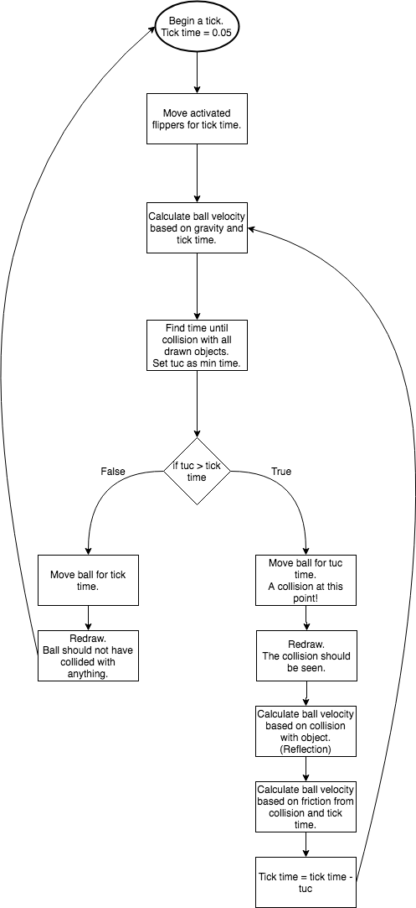

# Triggering System

There are two types of triggers in the system, user triggers and environment triggers.

A user trigger occurs when a pre-selected key is pressed whereas an environment trigger would occur when a pre-selected shape, absorber or flipper is hit by the ball.

Either of these triggers can affect a shape, an absorber or a flipper.

* Shape: The gizmo will perform some kind of visible change. The easiest change would be to change colour however if time permits a more interesting change could occur, such as rotation or change of shape e.g. circle -> square -> triangle -> circle ...
* Absorber: The absorber will change colour. This new colour will either be set by the user or will cycle through pre-selected colours.
* Flipper: The flipper will trigger. Multiple gizmos would be able to trigger the same flipper.