DSA06 - Data Handling and Visualization
Activity: Identify Skewness using Violin Plots | Slot C
Name | K.L Dinesh Eshwar
Reg no | 192425027
Course code | DSA0601
Roll no | 12
1. Aim
To study violin plots created in R with ggplot2, identify the skewness of each violin (right-skewed, left-skewed or symmetric), state how the mean compares with the median, and explain which measure of centre is more suitable for a skewed distribution.
2. Background and Theory
2.1 What is skewness?
Skewness describes the lack of symmetry in a distribution. In a symmetric distribution the left and right halves look like mirror images. In a skewed distribution one side has a long, thin tail of values that are far from the bulk of the data.
- Right (positive) skew: the tail is on the right (towards larger values). Most values are small and a few are very large.
- Left (negative) skew: the tail is on the left (towards smaller values). Most values are large and a few are very small.
- Symmetric: both sides are balanced and there is no long tail on either side.
2.2 How to read a violin plot
A violin plot shows the shape of the data distribution. The width of the violin at any height tells how many observations lie around that value: a wide part means many values and a narrow part means few values. The white dot in these charts marks the median. All the violins here are drawn vertically, so the tail of a violin points up (towards high values, right skew) or down (towards low values, left skew).
2.3 Mean versus median
The mean is the arithmetic average and it is sensitive to extreme values, so it is pulled towards the tail. The median is the middle value and is not affected by extreme values. This gives a simple rule that is used throughout this activity:
Shape | Position of the tail | Relation of mean and median
Right skew | Tail towards higher values (up) | Mean > Median
Left skew | Tail towards lower values (down) | Mean < Median
Symmetric | No long tail | Mean ≈ Median

2.4 Procedure followed for each violin
- Step 1: Look at where the bulk (widest part) of the violin lies.
- Step 2: Find the side with the long, thin tail. No clear tail means symmetric.
- Step 3: Note the skew: tail up is right skew, tail down is left skew.
- Step 4: Use the rule in the table above to decide whether the mean is greater than, less than or about equal to the median.
3. Part A – Analysis of the Charts
Each chart below is taken from the activity sheet. The table gives the answers, and the explanation below it gives the reason for each violin.
Chart 1: Sleep per night (hours)
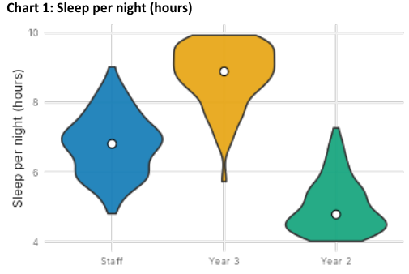
Violin | Skew | Mean vs Median
Staff | Symmetric | Mean ≈ Median
Year 3 | Left | Mean < Median
Year 2 | Right | Mean > Median

- Staff – Symmetric, Mean ≈ Median. The violin is widest around 7 hours and tapers evenly towards both ends (about 4.8 to 9 hours). The two sides are mirror images and the median dot sits in the centre, so the mean and median are almost equal.
- Year 3 – Left skew, Mean < Median. Most of the data is bunched near the top (8 to 10 hours) and the median is high, at about 8.9. A thin tail stretches down to about 6 hours. Because the tail points towards the lower values, it drags the mean below the median.
- Year 2 – Right skew, Mean > Median. The violin is fat near the bottom (4 to 5 hours) with the median at about 4.7. A long thin tail extends upwards to about 7.3 hours. The tail points towards the higher values, so the mean is pulled above the median.
Chart 2: Daily steps (thousand steps)
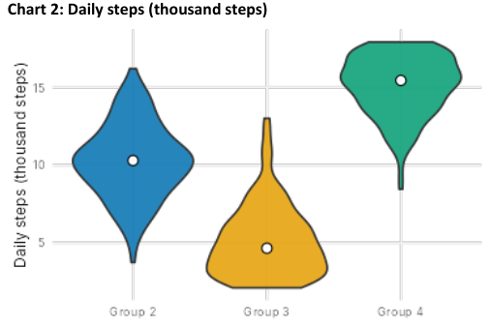
Violin | Skew | Mean vs Median
Group 2 | Symmetric | Mean ≈ Median
Group 3 | Right | Mean > Median
Group 4 | Left | Mean < Median

- Group 2 – Symmetric, Mean ≈ Median. The shape is a balanced diamond centred near 10 thousand steps, spreading evenly from about 4 to 16. The median dot is in the middle, so mean and median are nearly the same.
- Group 3 – Right skew, Mean > Median. Most people walk only 2 to 6 thousand steps (median about 4.6), but a narrow tail reaches up to about 13 thousand. A few high step counts raise the mean above the median.
- Group 4 – Left skew, Mean < Median. The bulk of the data lies between 14 and 18 thousand steps (median about 15.3), with a thin tail going down to about 8.5 thousand. The few low values pull the mean below the median.
Chart 3: Rainfall (mm)
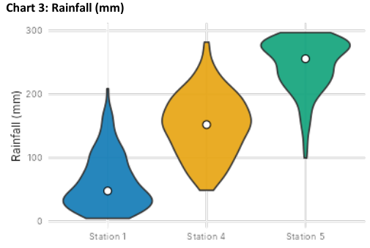
Violin | Skew | Mean vs Median
Station 1 | Right | Mean > Median
Station 4 | Symmetric | Mean ≈ Median
Station 5 | Left | Mean < Median

- Station 1 – Right skew, Mean > Median. Most readings are low (0 to 100 mm) with the median near 47 mm, but a very thin tail runs up to about 208 mm. Those few heavy-rain readings raise the mean above the median.
- Station 4 – Symmetric, Mean ≈ Median. The violin is centred around 150 mm and spreads about equally above and below (roughly 48 to 282 mm). The median sits in the middle, so mean and median are almost equal.
- Station 5 – Left skew, Mean < Median. Rainfall is concentrated between 200 and 300 mm (median about 255 mm) with a thin tail going down to about 100 mm. The few low values pull the mean below the median.
Chart 4: House price (Rs lakh)
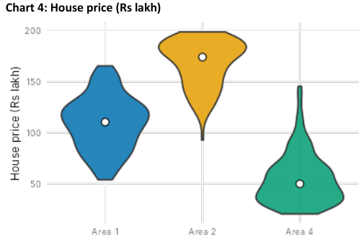
Violin | Skew | Mean vs Median
Area 1 | Symmetric | Mean ≈ Median
Area 2 | Left | Mean < Median
Area 4 | Right | Mean > Median

- Area 1 – Symmetric, Mean ≈ Median. The shape is evenly balanced around about 110 lakh, extending from roughly 55 to 165. The median dot is at the centre, so the mean is about equal to the median.
- Area 2 – Left skew, Mean < Median. Most houses are priced between 150 and 200 lakh (median about 173). A thin tail goes down to about 93 lakh. A few cheap houses pull the mean below the median.
- Area 4 – Right skew, Mean > Median. Most houses are cheap (20 to 80 lakh, median about 50) but a narrow tail rises to about 145 lakh. A few expensive houses push the mean above the median.
4. Summary of Part A Answers
Chart | Violin | Skew | Mean vs Median
1 – Sleep | Staff | Symmetric | Mean ≈ Median
 | Year 3 | Left | Mean < Median
 | Year 2 | Right | Mean > Median
2 – Daily steps | Group 2 | Symmetric | Mean ≈ Median
 | Group 3 | Right | Mean > Median
 | Group 4 | Left | Mean < Median
3 – Rainfall | Station 1 | Right | Mean > Median
 | Station 4 | Symmetric | Mean ≈ Median
 | Station 5 | Left | Mean < Median
4 – House price | Area 1 | Symmetric | Mean ≈ Median
 | Area 2 | Left | Mean < Median
 | Area 4 | Right | Mean > Median

In every chart the three violins show one symmetric, one left-skewed and one right-skewed distribution. In all cases the relation between the mean and the median follows the direction of the tail.
5. Part B
B1. Station 1 in Chart 3 (Rainfall): tail side and better measure
Question: In Chart 3, violin "Station 1" is not symmetric. Towards which side is its tail, and which is the better measure of a typical rainfall here: mean or median? Give one reason.
Answer: The tail of Station 1 is towards the right, that is, towards the higher rainfall values (up to about 208 mm). The distribution is therefore right-skewed. The median is the better measure of a typical rainfall for this station.
Reason: Most of the readings are small (the median is only about 47 mm), but a few very heavy rainfall readings in the long right tail pull the mean upwards, so the mean would overstate what a normal reading looks like. The median is the middle value and is not affected by these extreme readings, so it describes a typical rainfall better.
B2. ggplot2 line to draw violins with the median shown
Question: Write one ggplot2 line that draws violins of value for each group from a data frame df (columns group, value), with the median shown.
Answer:
ggplot(df, aes(x = group, y = value)) + geom_violin() + stat_summary(fun = median, geom = "point")
Explanation of each part of the line:
- ggplot(df, aes(x = group, y = value)): uses the data frame df and maps the group column to the x-axis and the value column to the y-axis.
- geom_violin(): draws one violin for every group, showing the shape of the distribution.
- stat_summary(fun = median, geom = "point"): calculates the median of value for each group and draws it as a point (dot) on its violin, which shows the median.
6. Conclusion
Violin plots show the full shape of a distribution, so skewness can be identified directly from the position of the long tail. A tail towards higher values gives a right skew with mean greater than median, a tail towards lower values gives a left skew with mean less than median, and a balanced shape gives a symmetric distribution with mean about equal to median. For skewed data such as the rainfall at Station 1, the median is the more reliable measure of a typical value because it is not pulled by extreme observations.

