

LAB EXPERIMENT RECORD
SET 11

Department | Artificial Intelligence and Data Science
Course Code / Course Name | DSA0601 / Data Handling and Visualization
Name / Register Number | K.L DINESH ESHWAR / 192425027
Date / Day | 06/10/2026

Aim
To analyze product category analysis using the requested visualizations and dashboard views.

Dataset
Product Category Analysis
Category | Sales
Electronics | 50000
Clothing | 35000
Appliances | 40000

Data note: The supplied data contains category totals only; it does not contain conversion-stage data.

R Data Setup
Run this setup once before the R programs below. The dataset is defined inline so each record can be copied and run without a separate CSV file.
R data setup
dat <- data.frame(
Category = c("Electronics", "Clothing", "Appliances"),
Sales = c(50000, 35000, 40000)
)

PROGRAM 1: Sales Funnel by Category
Create a labeled funnel chart to compare sales conversion by product category.
R code
ord <- order(dat$Sales, decreasing=TRUE)
barplot(dat$Sales[ord], names.arg=dat$Category[ord], horiz=TRUE, las=1, col=rainbow(nrow(dat)), xlab="Sales ($)", main="Sales by Product Category")

Data note: A conversion funnel normally requires ordered stages and conversion counts. This output ranks the supplied category sales as a funnel-style comparison.

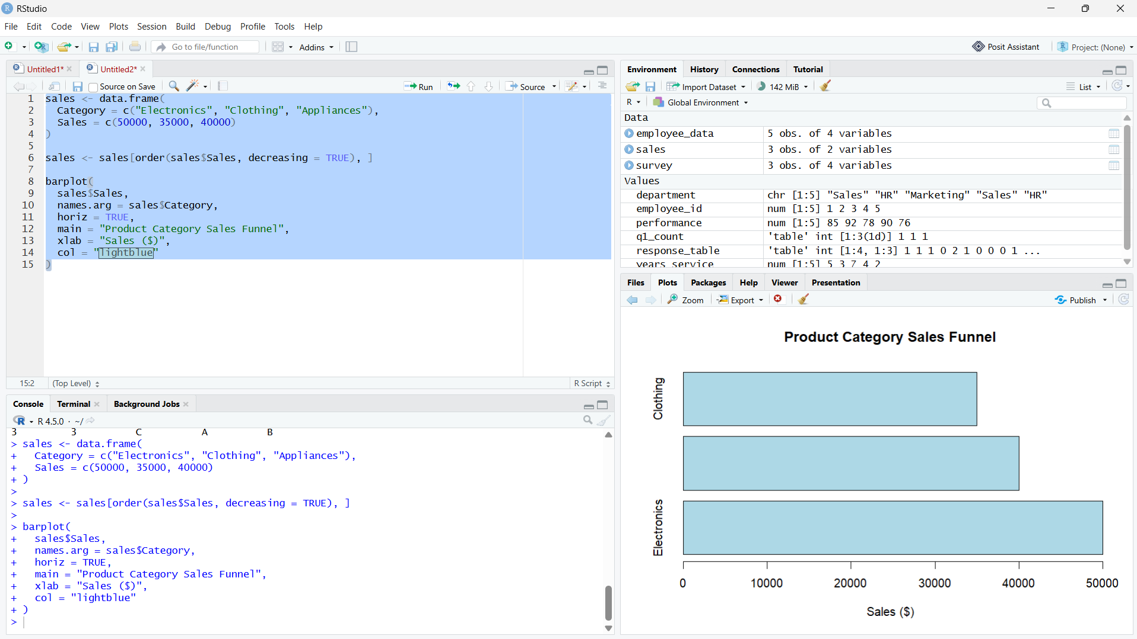

Output 1: Sales Funnel by Category

Observation: Electronics has the largest sales value and Clothing the smallest. The categories are shown as a descending sales funnel proxy; no conversion stages are supplied.

PROGRAM 2: Product Category Sales Table
Display sales for each product category in a labeled table.
R code
print(dat)

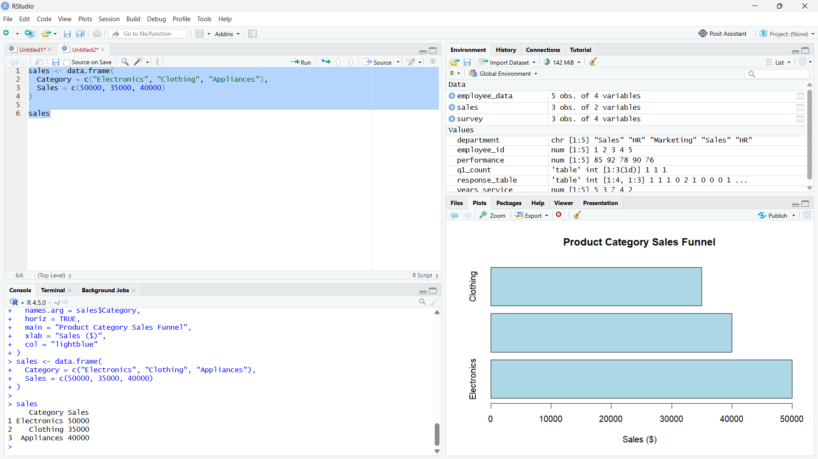

Output 2: Product Category Sales Table

Observation: The table reports the three supplied category sales values.

PROGRAM 3: Product Category Dashboard
Create a Tableau dashboard combining a pie chart, funnel chart, and sales table.
Tableau build steps
Tableau dashboard build
1. Connect to the product category sales table.
2. Build a pie chart of SUM(Sales) by Category.
3. Build a descending horizontal bar view for the funnel-style sales comparison.
4. Add the data table and place all views on a dashboard.

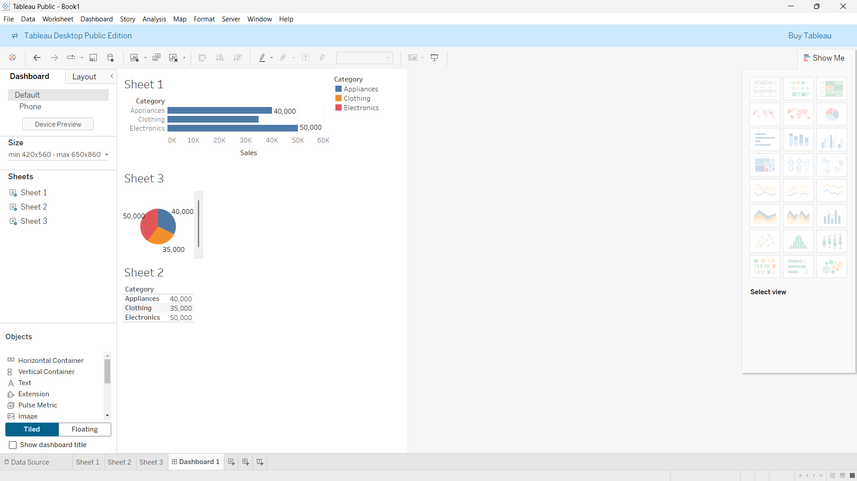

Output 3: Product Category Dashboard

Observation: The preview combines category sales share, descending sales comparison, and the source table.

PROGRAM 4: Pie Chart of Category Sales
Create a labeled pie chart showing the distribution of sales across product categories.
R code
pie(dat$Sales, labels=dat$Category, main="Sales Share by Product Category", col=rainbow(nrow(dat)))

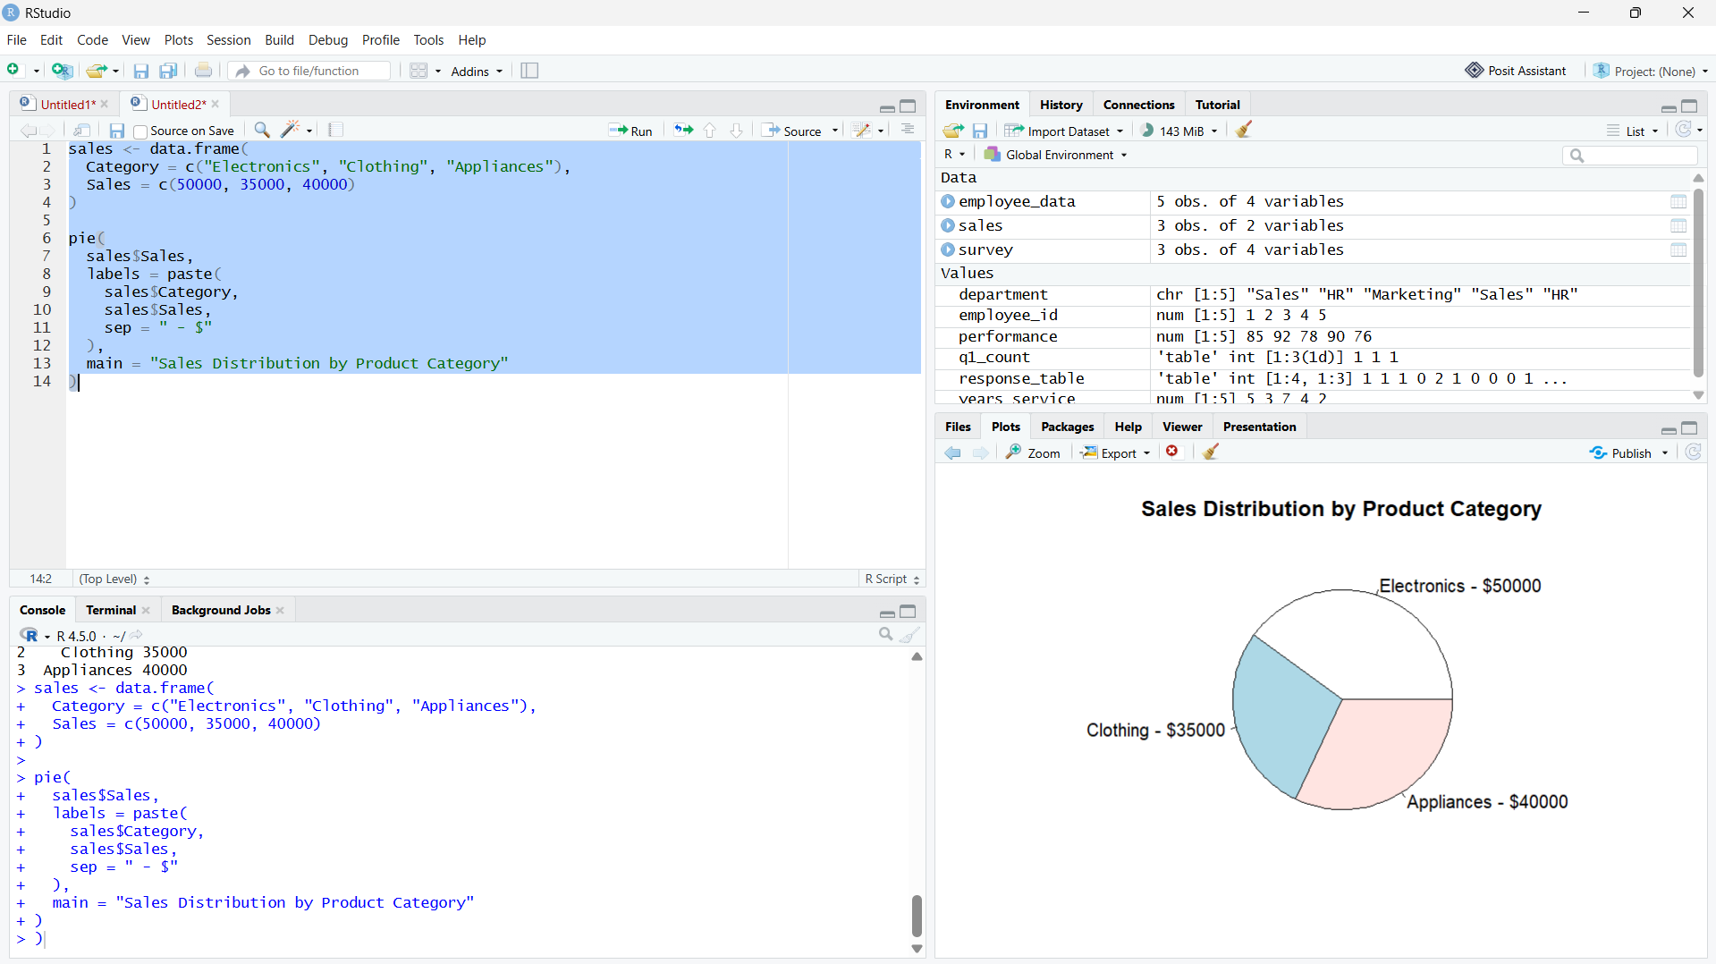

Output 4: Pie Chart of Category Sales

Observation: Electronics contributes the largest share of listed sales, followed by Appliances and Clothing.

Procedure
1. Review the dataset table and confirm any illustrative fields noted in the record.
2. Run the R setup block once, then run the requested program code.
3. Compare the output screenshot with the observation and replace illustrative values when actual data is available.
4. For Tableau tasks, connect to the displayed data and follow the dashboard build steps.

Result
The requested charts and dashboard views for Set 11 were prepared from the displayed dataset. Outputs include labels, short observations, and code or dashboard construction steps.

Key Functions Used
plot(), barplot(), hist(), boxplot(), table().

