DSA06 - Data Handling and Visualization
Activity 5: Normality Detection using Q-Q Plots
Slot C
Name | K.L Dinesh Eshwar
Course Code | DSA0601
Course Name | Data Handling and Visualization
Reg. No | 192425027
R.No | 12
Activity | Normality Detection using Q-Q Plots (stat_qq and stat_qq_line in R)
1. Aim
The aim of this activity is to decide, from Q-Q plots alone, whether four datasets can reasonably be treated as normally distributed. For every chart I state whether the data are normal, name the shape of any departure from the list given (Normal, Right-skewed, Left-skewed, Heavy-tailed, Light-tailed, Bimodal, Normal with outlier(s)), and cite the visual evidence. Part B then asks for a remedy for the chart that fails the normality check and for the R code that draws a Q-Q plot with its reference line.
2. Objectives
- To understand how a normal Q-Q plot is constructed and what the reference line represents.
- To recognise the standard Q-Q signatures of skewness, heavy tails, light tails, bimodality and outliers.
- To classify four real-looking datasets (resting pulse, lab duration twice, plant height) by their Q-Q plots.
- To choose a sensible remedy before applying mean-and-standard-deviation methods to non-normal data.
- To write the ggplot2 code that produces a Q-Q plot with its reference line.

3. Background: how a normal Q-Q plot works
3.1 Construction
A quantile-quantile (Q-Q) plot compares the quantiles of the observed sample with the quantiles of a theoretical distribution, here the standard normal. The observations are sorted from smallest to largest. Each sorted value is paired with the normal quantile that would be expected at its rank, usually taken at the plotting position (i - 0.5) / n. The x-axis therefore shows the theoretical quantiles (in standard-deviation units) and the y-axis shows the sample quantiles in the original units of the variable, such as beats per minute or centimetres.
3.2 The reference line
In ggplot2, stat_qq_line() draws the orange reference line through the first and third quartiles of the sample and the corresponding theoretical quartiles. If the data are normal, the points scatter closely around this line. Its slope estimates the standard deviation and its intercept estimates the mean, so a good fit means the data behave like a normal distribution with those parameters.
3.3 Reading the plot
What matters is not whether every point lies exactly on the line, because small random wobble is expected, especially with a small n. What matters is whether the deviations are systematic. A smooth bend, an S-shape, a plateau or a lone point far from the line is evidence against normality. The table below lists the signatures used in this activity.
Shape | How the points look against the line | What it means for the data
Normal | Points hug the line from end to end | Symmetric, bell-shaped, tails of normal length
Right-skewed | Convex curve: both ends bend above the line | Long upper tail; a few very large values
Left-skewed | Concave curve: both ends bend below the line | Long lower tail; a few very small values
Heavy-tailed | S-shape: lower end below the line, upper end above it | More extreme values in both tails than a normal
Light-tailed | Reverse S: lower end above the line, upper end below it | Fewer extremes; data are bounded or compressed
Bimodal | Steps or a flat gap in the middle of the plot | Two clusters or two subpopulations
Normal with outlier(s) | Points follow the line except for one or two far-off points | Normal body with isolated unusual observations

3.4 Reference patterns
The figure below shows what each pattern looks like for simulated data (n = 200). I used it as the benchmark when classifying the four activity charts.
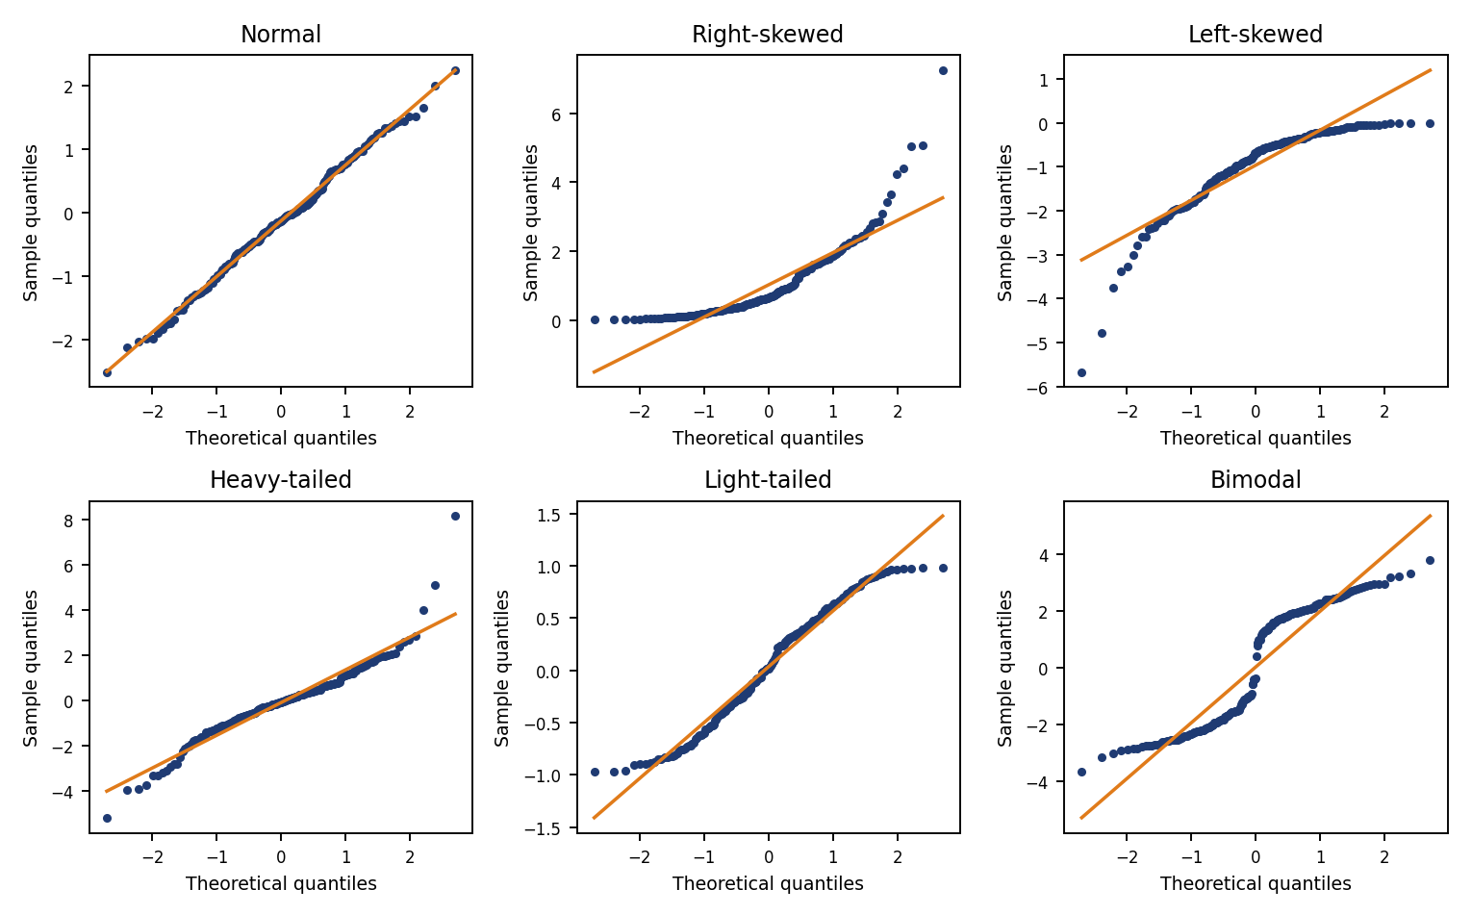
Figure 1: Simulated Q-Q plots of the standard shapes (blue points = sample, orange line = reference)
3.5 Method followed
- Look at the central part of the plot first: does it follow the line with roughly the right slope?
- Examine the lower tail and the upper tail separately and note whether each lies above or below the line.
- Combine the two tail directions to identify the shape (for example, both below the line = left-skewed).
- Check for isolated points that are far away from an otherwise good fit; these are outliers.
- Write the verdict together with the specific evidence, including approximate values read from the axes.

4. Part A: Chart-by-chart analysis (16 marks)
Chart 1: resting pulse (beats per minute), n = 100
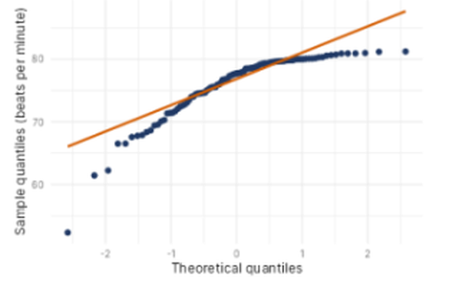
Q-Q plot supplied in the activity sheet
Normal? (Yes / No) | No
Shape (from the list) | Left-skewed (with a low outlier)
Evidence in the plot | The points form a concave-down curve. They sit above the line in the middle, then flatten into a plateau at about 80 to 81 bpm so the upper tail falls well below the line. The lower tail drops far below the line, ending in an isolated point near 52 bpm.

Central region: from about -1 to +1 on the theoretical axis the points rise steeply and sit on or slightly above the reference line. The centre is therefore reasonably well behaved, which means the problem is in the tails, not in the middle.
Upper tail: beyond about +0.5 the points almost stop rising. They level off at roughly 80 to 81 bpm even though the theoretical quantile increases to about 2.5. A normal distribution would keep climbing, as the orange line does. This ceiling means the largest observations are compressed against an upper limit, so the upper tail is shorter than normal.
Lower tail: below about -1 the points fall away from the line, ending near 52 bpm. The lowest values are far smaller than a normal distribution with the same centre and spread would produce, so the lower tail is stretched.
Conclusion: both tails lie below the line, which gives the concave (arch) shape typical of a left-skewed distribution: a long tail to the left and values piled up near a maximum. The single point near 52 bpm is a likely low outlier. Because of the skew, the mean (pulled down by the low values) would not represent the typical pulse well, and the median is the safer summary.

Chart 2: lab experiment duration (minutes), n = 40
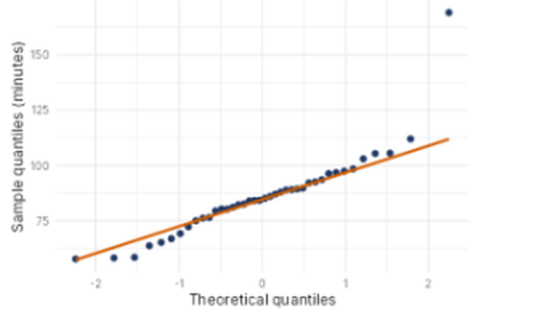
Q-Q plot supplied in the activity sheet
Normal? (Yes / No) | Yes (approximately normal, apart from one outlier)
Shape (from the list) | Normal with outlier(s)
Evidence in the plot | From about -1 to +1 the points lie right on the line with the correct slope. The only serious departure is one point at the top right, near 168 minutes, far above the line. There is no sustained curve in the body of the data.

Central region: the middle 70 percent or so of the points, between roughly -1 and +1, track the orange line very closely, with the median close to 85 minutes. This is the signature of a normal body.
Tails: the extreme few points on each side wander a little from the line. The lowest points sit slightly below it and the points between about +1 and +1.8 sit slightly above it. With only 40 observations this amount of looseness in the tails is normal sampling variation, so I do not read it as a real shape such as heavy-tailedness.
Outlier: the point near 168 minutes is about 55 minutes above the line, while the next highest value is only around 112 minutes. A gap that large cannot be explained by random variation in a normal sample of 40. It is a single outlier and not evidence of general skewness, since the rest of the upper tail does not bend progressively upward as it would in a right-skewed sample.
Conclusion: the data are approximately normal with one outlier. In practice I would check whether that run was a recording or equipment error. If it is genuine it should be reported, and the analysis can be done with and without it to see how much it affects the mean and standard deviation.

Chart 3: lab experiment duration (minutes), n = 60
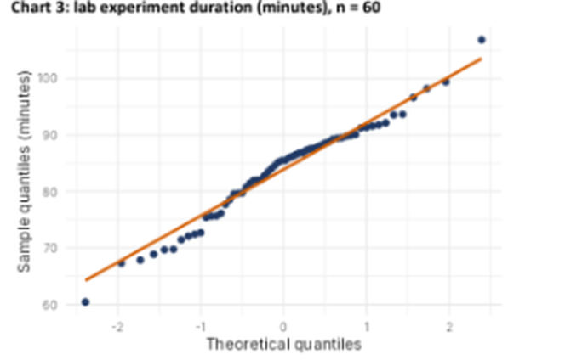
Q-Q plot supplied in the activity sheet
Normal? (Yes / No) | No
Shape (from the list) | Heavy-tailed
Evidence in the plot | The plot has an S-shape: the lower points (about 60 to 73 minutes, below -0.8) lie below the line, the middle points (about -0.5 to +0.5) lie on or slightly above it and are flatter than the line, and the top point (about 107 minutes) lies above the line.

Central region: between about -0.5 and +0.5 the points are bunched tightly around 85 to 88 minutes and rise more slowly than the reference line, which means the centre is more concentrated than a normal distribution with the same spread.
Lower tail: from about -2.4 to -0.8 the points lie clearly below the line. The smallest value, near 60 minutes, is much lower than the line predicts at that position. The lowest values are therefore more extreme than normal.
Upper tail: at the right the points drift to the line and the largest observation, near 107 minutes, finishes above it. The upper extremes are also at least as large as normal would predict.
Conclusion: lower points below the line and upper points above it, together with a tighter-than-normal centre, form the S-shape of a heavy-tailed distribution. Extreme observations occur in both tails more often than under normality, so the data are not normal. Standard deviations and z-scores should be used cautiously here, and a robust or transformed analysis is advisable.

Chart 4: plant height (cm), n = 30
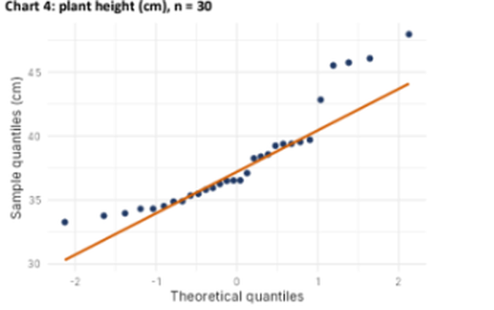
Q-Q plot supplied in the activity sheet
Normal? (Yes / No) | No
Shape (from the list) | Right-skewed (with a high outlier)
Evidence in the plot | The points form a convex curve. The lower end (about 33 to 35 cm) sits above the line, and the upper end bends sharply above it: values of about 43 cm, then 45 to 46 cm, and a final point near 48 cm.

Central region: between about -0.7 and +0.9 the points lie fairly close to the line, with heights between roughly 35 and 40 cm. The bulk of the plants are therefore similar in height.
Lower tail: the smallest heights, near 33 to 34 cm, are above the line. Their values are not as small as a normal distribution would give, so the lower tail is shorter than normal.
Upper tail: beyond about +1 the points leave the line and climb steeply. A jump from about 40 cm to 43 cm and then to 45 to 48 cm shows a small group of unusually tall plants. The upper tail is much longer than normal.
Conclusion: a short lower tail together with a long upper tail gives the convex curve of a right-skewed distribution. The tallest plant, near 48 cm, may also be an outlier. The mean would be pulled upward by the tall plants, so the median is a better measure of a typical plant height.

5. Summary of Part A
The table collects the decision for each chart. Charts 1, 3 and 4 fail the normality check, each for a different reason, and Chart 2 passes apart from one outlier.
Chart | Normal? | Shape | Key evidence
1. Resting pulse (n = 100) | No | Left-skewed | Concave arch; plateau near 81 bpm; low tail down to about 52 bpm
2. Lab duration (n = 40) | Yes (approx.) | Normal with outlier | Body on the line; one point near 168 min far above it
3. Lab duration (n = 60) | No | Heavy-tailed | S-shape; both tails more extreme than normal; flat centre
4. Plant height (n = 30) | No | Right-skewed | Convex curve; upper end climbs steeply above the line

Chart 1 and Chart 4 are mirror images of each other: Chart 1 bends below the line at both ends, which is left skew, whereas Chart 4 bends above the line at both ends, which is right skew. Chart 3 differs from both because its two ends bend in opposite directions, which is the mark of tails that are heavier than normal. Charts 2 and 3 show the same variable, lab experiment duration, from two different runs, yet the first looks normal and the second does not. That is a useful reminder that normality has to be checked for each dataset and cannot be assumed from the variable.

6. Part B (4 marks)
B1. Departure of Chart 1 and the remedy [2]
Departure: Chart 1 (resting pulse) departs from normality by being left-skewed. It has a long lower tail, a ceiling effect where the upper values pile up near 80 to 81 bpm, and a low outlier near 52 bpm.
Remedy to try before using mean-and-SD methods: transform the variable so that its distribution becomes more symmetric. Because the skew is to the left, the transformation has to stretch the upper end and compress the lower end. Typical choices are shown below.
Remedy | How to apply it | Why it helps
Square transform | y = x^2 | Stretches large values and compresses small ones, which reduces left skew
Reflect, then log | y = log(k - x), with k = max(x) + 1 | Turns left skew into right skew, which the log then removes
Check the outlier | Verify the reading near 52 bpm | A recording error would be corrected or removed; a real value is kept and reported
Robust methods | Median and IQR; trimmed mean; rank-based tests | Not distorted by the long tail and need no normality

After the transformation I would draw the Q-Q plot again. If the points now follow the reference line, the mean and standard deviation of the transformed values can be used. If not, I would split the data if the plateau shows two groups, or move to robust methods. The following R code shows the reflect-and-log version and the redrawn plot.
library(ggplot2)
k <- max(df$value) + 1
df$value_t <- log(k - df$value) # reflect, then log
ggplot(df, aes(sample = value_t)) +
stat_qq() + stat_qq_line()

B2. Q-Q plot with its reference line in ggplot2 [2]
The completed code is:
ggplot(df, aes(sample = value)) + stat_qq() + stat_qq_line()

Blank | Answer and purpose
Blank 1 | stat_qq() draws the sample quantiles against the theoretical normal quantiles as points
Blank 2 | stat_qq_line() draws the reference line through the quartiles, against which the points are judged

The aesthetic is aes(sample = value) and not aes(x = value), because the Q-Q geoms take the column to be compared as the sample argument. By default both functions use the normal distribution; the dist argument can be set to compare against another distribution.
7. Limitations and good practice
- A Q-Q plot is a visual judgement. With small samples, such as n = 30 or 40, random wobble can look like a pattern, so a formal test such as Shapiro-Wilk can be used alongside the plot.
- With very large samples, formal tests reject normality for trivial departures, so the plot is often more informative than the p-value.
- Outliers should be investigated before they are removed. They may be errors, but they may also be the most interesting observations.
- Many methods only need approximate normality, particularly when the sample is large, so a mild departure does not always require a transformation.
8. Conclusion
Reading the four Q-Q plots gave four different verdicts. The resting pulse data (Chart 1) are left-skewed, the first lab-duration data (Chart 2) are approximately normal with a single outlier, the second lab-duration data (Chart 3) are heavy-tailed, and the plant height data (Chart 4) are right-skewed. In each case the verdict comes from the direction in which the two tails leave the reference line and from any isolated points. For Chart 1 the proposed remedy is a transformation (square, or reflect and log), together with a check of the low outlier and the option of robust summaries. The Q-Q plot itself is drawn by ggplot(df, aes(sample = value)) + stat_qq() + stat_qq_line().

