

LAB EXPERIMENT RECORD
SET 3: Employee Performance Evaluation

Department | Artificial Intelligence and Data Science
Course Code / Course Name | DSA0601 / Data Handling and Visualization
Name / Register Number | K.L DINESH ESHWAR / 192425027
Date / Day | 29/09/2026

Aim
To analyze employee performance evaluation using the requested visualizations and dashboard views.

Dataset
Employee Performance Evaluation
Employee_ID | Department | Years_of_Service | Performance_Score
1 | Sales | 5 | 85
2 | HR | 3 | 92
3 | Marketing | 7 | 78
4 | Sales | 4 | 90
5 | HR | 2 | 76

PROGRAM 1: Employee Performance Scores
Plot employee performance scores as a labeled line chart. The table contains no time variable, so use employee ID as the ordered x-axis.
R code
dat <- data.frame(
Employee_ID = c(1, 2, 3, 4, 5),
Department = c("Sales", "HR", "Marketing", "Sales", "HR"),
Years_of_Service = c(5, 3, 7, 4, 2),
Performance_Score = c(85, 92, 78, 90, 76)
)
plot(dat$Performance_Score, type="o", xaxt="n", xlab="Employee ID", ylab="Performance score", main="Performance Score by Employee", col="#276B9A")
axis(1, at=seq_len(nrow(dat)), labels=dat$Employee_ID)

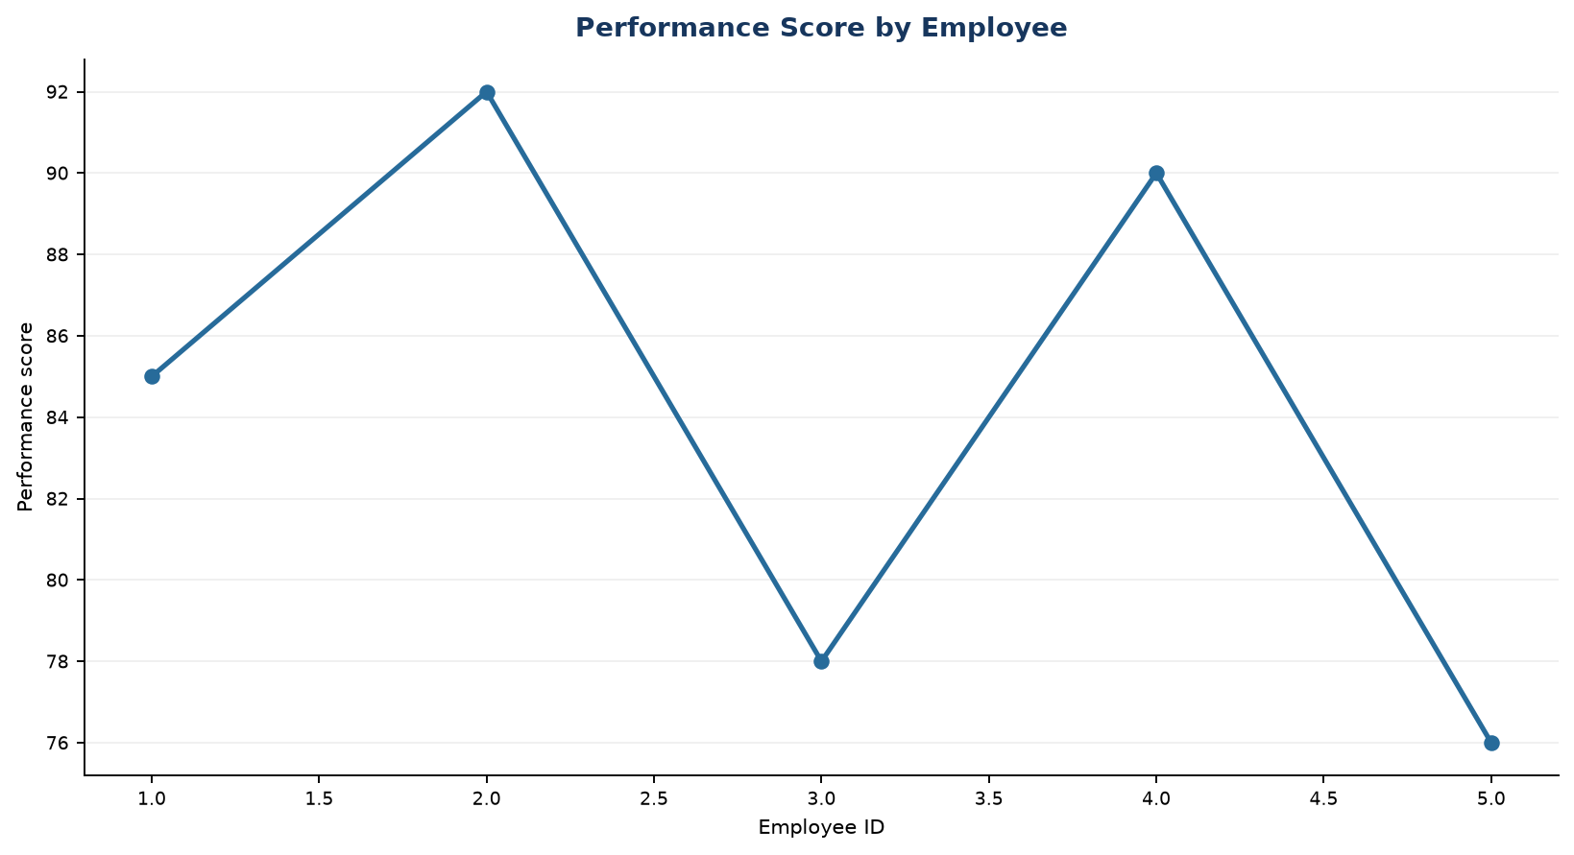
Output 1: Employee Performance Scores

Observation: Scores vary across the listed employees; this is a cross-sectional comparison rather than a time trend.

PROGRAM 2: Employee Count by Department
Show the distribution of employees across departments with a labeled bar chart.
R code
dat <- data.frame(
Employee_ID = c(1, 2, 3, 4, 5),
Department = c("Sales", "HR", "Marketing", "Sales", "HR"),
Years_of_Service = c(5, 3, 7, 4, 2),
Performance_Score = c(85, 92, 78, 90, 76)
)
counts <- table(dat$Department)
barplot(counts, col="skyblue3", xlab="Department", ylab="Count", main="Employees by Department")

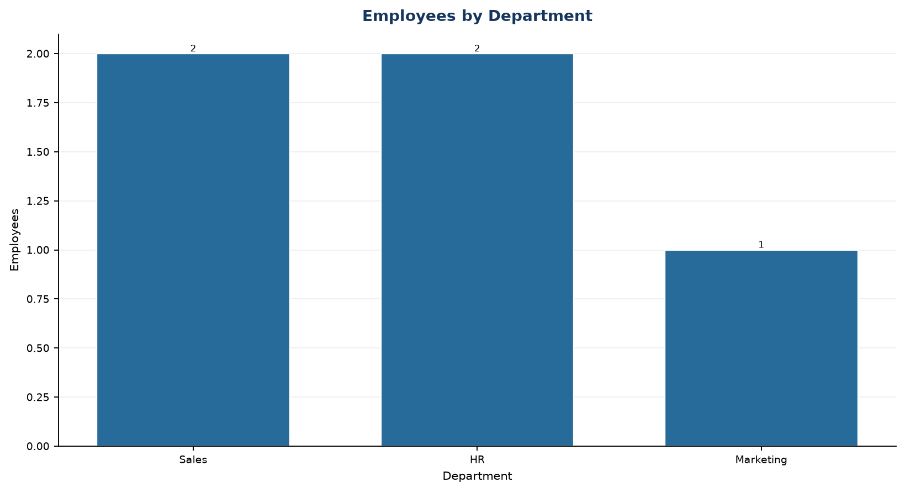
Output 2: Employee Count by Department

Observation: Sales and HR each have two employees; Marketing has one.

PROGRAM 3: Years of Service and Performance
Create a scatter plot of years of service versus performance score and explain the visible pattern.
R code
dat <- data.frame(
Employee_ID = c(1, 2, 3, 4, 5),
Department = c("Sales", "HR", "Marketing", "Sales", "HR"),
Years_of_Service = c(5, 3, 7, 4, 2),
Performance_Score = c(85, 92, 78, 90, 76)
)
plot(dat$Years_of_Service, dat$Performance_Score, pch=19, col="#276B9A", xlab="Years of service", ylab="Performance score", main="Service vs Performance")

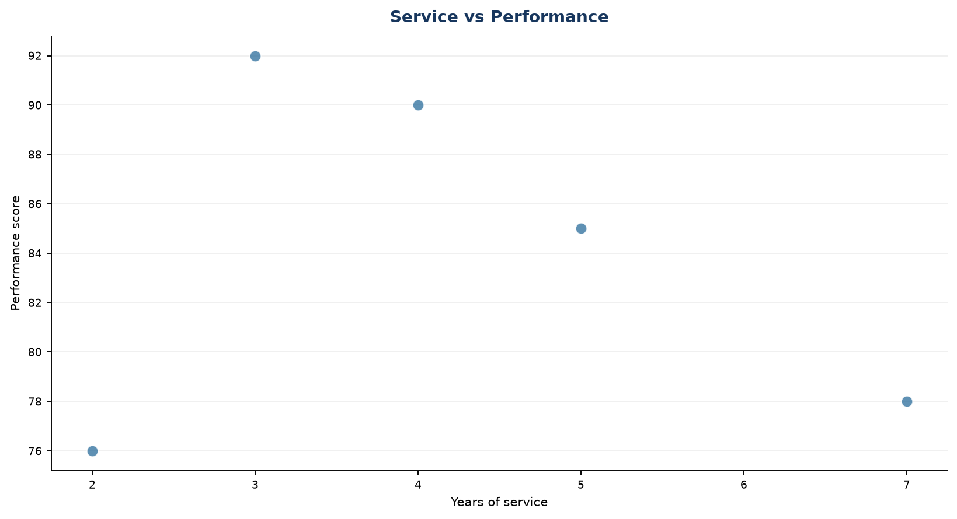
Output 3: Years of Service and Performance

Observation: The five points do not show a strong monotonic relationship between tenure and score.

PROGRAM 4: Employee Performance Dashboard
Create a Tableau dashboard with the performance line chart and department bar chart for interactive exploration.
Tableau build steps
Tableau dashboard build
1. Connect to the employee table shown on page 1.
2. Create a line view with Employee_ID on Columns and Performance_Score on Rows.
3. Create a bar view counting Employee_ID by Department.
4. Place both sheets on a dashboard and show a Department filter.

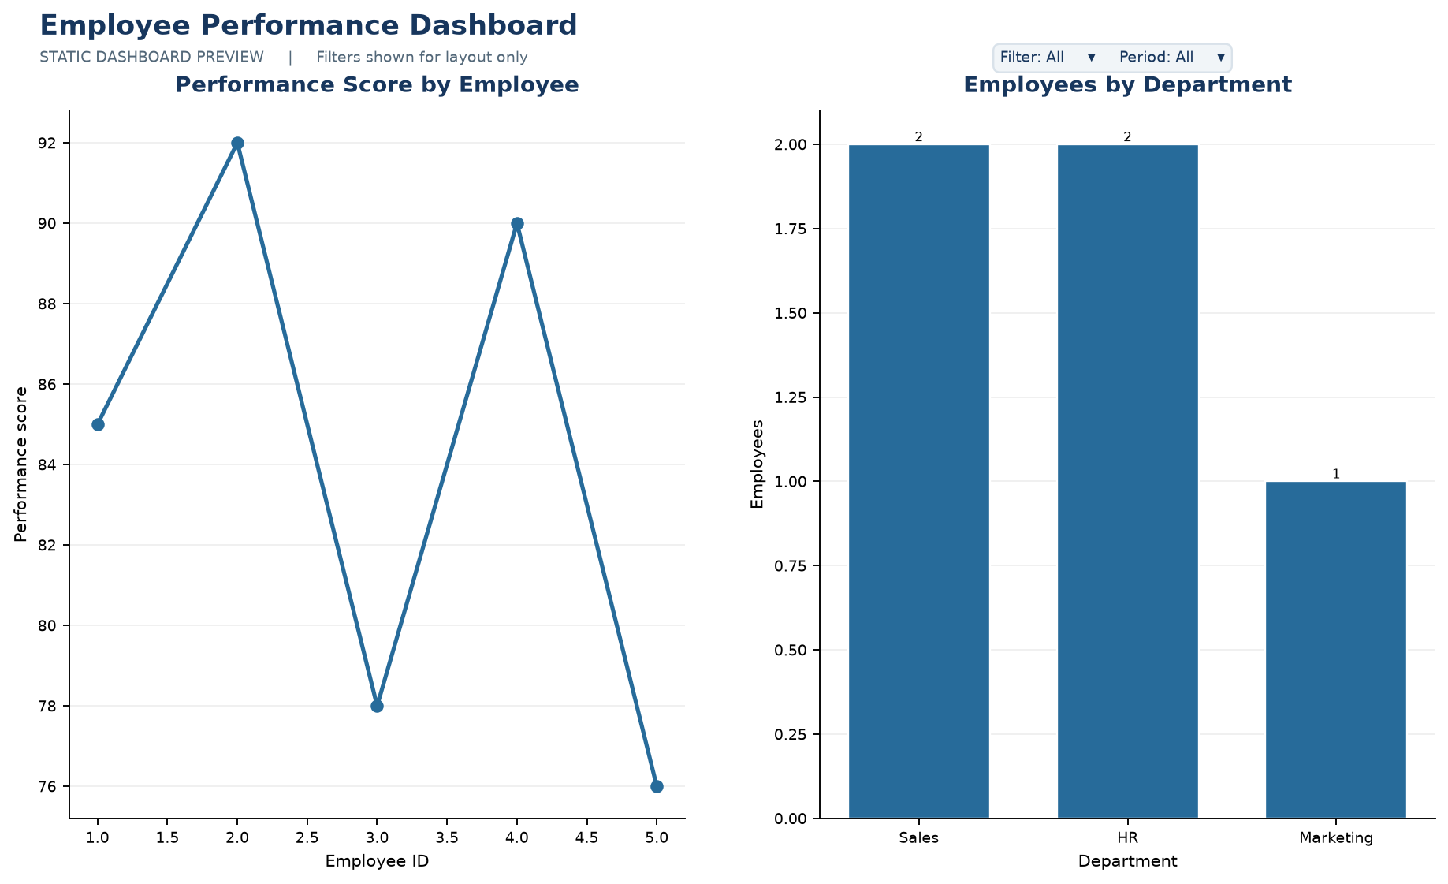
Output 4: Employee Performance Dashboard
Observation: The static preview places the score comparison beside department counts. In Tableau, selecting a department can filter the employee marks.

Procedure
1. Review the dataset table and confirm any illustrative fields noted in the record.
2. Run the R setup block once, then run the requested program code.
3. Compare the output screenshot with the observation and replace illustrative values when actual data is available.
4. For Tableau tasks, connect to the displayed data and follow the dashboard build steps.

Result
The requested charts and dashboard views for Set 3 were prepared from the displayed dataset. Outputs include labels, short observations, and code or dashboard construction steps.

Key Functions Used
plot(), barplot(), hist(), boxplot(), table().

