Reservio - User Scenarios, Use Cases & Requirements (US-21 to US-23)

Student: Eleana Zharkalli

User Scenarios List:
US-21 Room Cleaning Confirmation
Housekeeper: Marks a room as cleaned, triggering updates and notifications.
US-22 Sunbed Reservation
Guest: Reserves a sunbed using a visual layout with time selection.
US-23 Tenant Account Management
Super Admin: Manages tenant accounts (approve, suspend, delete).

User Scenarios Extended

US_21: Room Cleaning Confirmation
Housekeeper opens task board
Selects room
Marks as cleaned
System updates status
System notifies staff
System checks early check-in
System notifies guest if applicable
Errors handled if needed
US_22: Sunbed Reservation
User opens sunbed page
System shows layout
User selects sunbed
System locks selection
User selects time
User confirms
System validates and saves
US_23: Tenant Account Management
Admin logs in
Views tenants
Selects tenant
Performs action
System updates and enforces changes

User Case Template

UC-21: Room Cleaning Confirmation
Summary: Housekeeper marks room cleaned.
Actors: Housekeeper, System
Preconditions: Room assigned
Main Flow: Open → Select → Clean → Update → Notify
Postconditions: Room available

UC-22: Sunbed Reservation
Summary: Guest reserves sunbed.
Actors: Guest, System
Preconditions: Logged in
Main Flow: Open → Select → Lock → Confirm → Save
Postconditions: Sunbed reserved

UC-23: Tenant Account Management
Summary: Admin manages tenants.
Actors: Super Admin
Preconditions: Authenticated
Main Flow: View → Select → Action → Update
Postconditions: Tenant updated

Use case Diagram
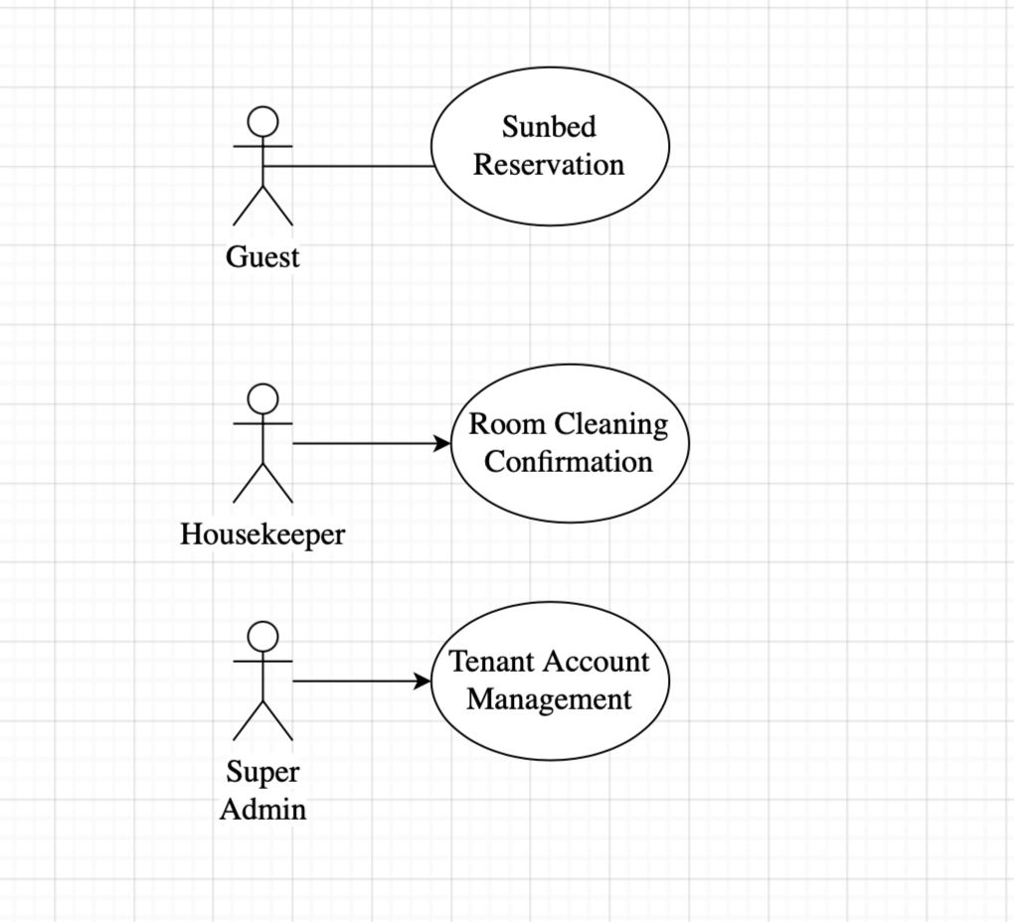

Requirements

Functional Requirements

Req# | Requirement | Comments
FR_21 | Housekeeper marks room cleaned | Tenant scoped
FR_22 | System updates room status | Real-time update
FR_23 | System notifies staff | WebSocket

Non-Functional Requirements

Req# | Requirement | Comments
NFR_21 | Response < 2s | Performance
NFR_22 | Real-time updates | WebSockets
NFR_23 | Data consistency | No double booking

