Заголовок дослідження

## Огляд набору даних

This is an [R Markdown](http://rmarkdown.rstudio.com) Notebook. When you execute code within the notebook, the results appear beneath the code.

Try executing this chunk by clicking the *Run* button within the chunk or by placing your cursor inside it and pressing *Ctrl+Shift+Enter*.

head(cars)

## speed dist  
## 1 4 2  
## 2 4 10  
## 3 7 4  
## 4 7 22  
## 5 8 16  
## 6 9 10

Середня швидкість 15.4.

## Візуальна оцінка

plot(cars)

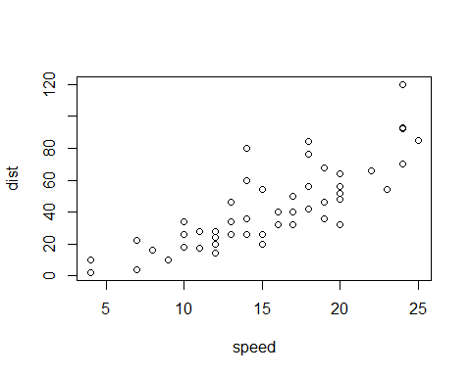

**Add a new chunk** by clicking the *Insert Chunk* button on the toolbar or by pressing *Ctrl+Alt+I*.

When you save the notebook, an HTML file containing the code and output will be saved alongside it (click the *Preview* button or press *Ctrl+Shift+K* to preview the HTML file).

The preview shows you a rendered HTML copy of the contents of the editor. Consequently, unlike *Knit*, *Preview* does not run any R code chunks. Instead, the output of the chunk when it was last run in the editor is displayed.