Winter school of System Analysis and AI
Yurii Kleban
2026-01-21


Introduction
This report uses the tidyverse package along with the SAFI dataset, which has columns that include:
- village
  - Name of village
- interview_date
  - Date of interview
- no_members
  - How many family members lived in a house
- years_liv
  - How many years respondent has lived in village or neighbouring village
- respondent_wall_type
  - Type of wall of house
- rooms
  - Number of rooms in house
We can also add a caption.
Village | Member Association | Mean Number of Members
Chirodzo | no | 8.062500
Chirodzo | yes | 7.818182
God | no | 7.133333
God | yes | 8.000000
Ruaca | no | 7.178571
Ruaca | yes | 9.500000
Text text
## Rows: 131 Columns: 45
## ── Column specification ────────────────────────────────────────────────────────
## Delimiter: ","
## chr (5): village, respondent_wall_type, memb_assoc, affect_conflicts, inst...
## dbl (8): key_ID, no_membrs, years_liv, rooms, liv_count, no_meals, number_...
## lgl (31): bicycle, television, solar_panel, table, cow_cart, radio, cow_plo...
## dttm (1): interview_date
##
## ℹ Use `spec()` to retrieve the full column specification for this data.
## ℹ Specify the column types or set `show_col_types = FALSE` to quiet this message.
## # A tibble: 33 × 3
## village items percent
## <chr> <chr> <dbl>
## 1 Chirodzo bicycle 43.6
## 2 Chirodzo television 38.5
## 3 Chirodzo solar_panel 48.7
## 4 Chirodzo table 28.2
## 5 Chirodzo cow_cart 15.4
## 6 Chirodzo radio 61.5
## 7 Chirodzo cow_plough 51.3
## 8 Chirodzo solar_torch 43.6
## 9 Chirodzo mobile_phone 64.1
## 10 Chirodzo motorcyle 33.3
## # ℹ 23 more rows
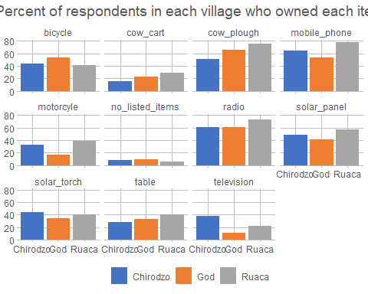
data <- interviews |>
select(village) |>
group_by(village) |>
summarise(count = n())
data
## # A tibble: 3 × 2
## village count
## <chr> <int>
## 1 Chirodzo 39
## 2 God 43
## 3 Ruaca 49
In village Chirodzo live 39 people.

© Yurii Kleban

