Rotinas de R para acompanhamento da conjuntura econômica

Kleber

2024-07-09

## R Markdown

This is an R Markdown document. Markdown is a simple formatting syntax for authoring HTML, PDF, and MS Word documents. For more details on using R Markdown see <http://rmarkdown.rstudio.com>.

When you click the **Knit** button a document will be generated that includes both content as well as the output of any embedded R code chunks within the document. You can embed an R code chunk like this:

| Mês | IPCA (%) |
| --- | --- |
| 07/2023 | 0,1 |
| 08/2023 | 0,2 |
| 09/2023 | 0,3 |
| 10/2023 | 0,2 |
| 11/2023 | 0,3 |
| 12/2023 | 0,6 |
| 01/2024 | 0,4 |
| 02/2024 | 0,8 |
| 03/2024 | 0,2 |
| 04/2024 | 0,4 |
| 05/2024 | 0,5 |
| 06/2024 | 0,2 |

## Including Plots

You can also embed plots, for example 07/2023:

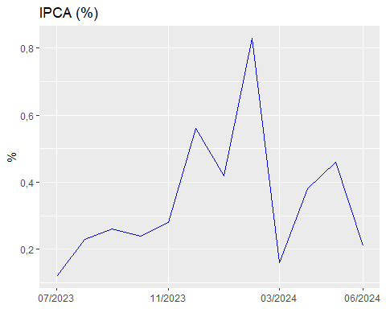

O IPCA mais recente disponível é de 06/2024 e o valor é 0,21