passos micro controlador

1 - instalar o micro python

https://thonny.org/

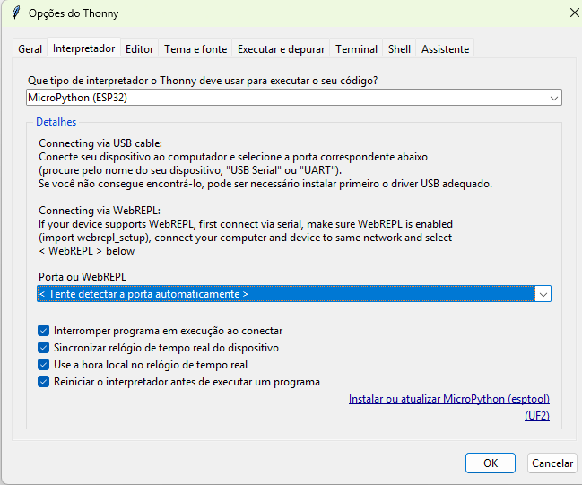
clicar em instalar ou atualizar micropython

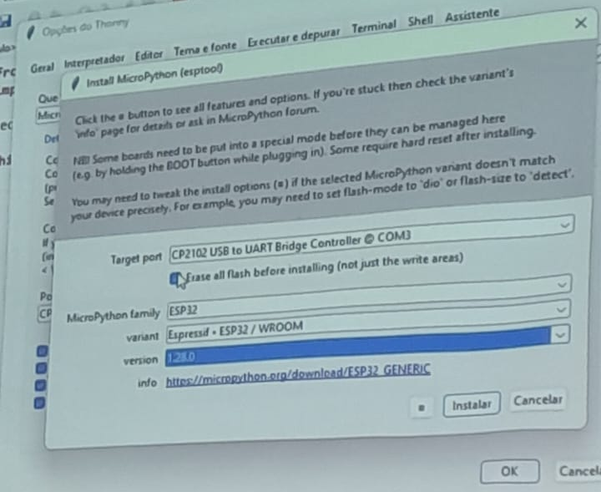

2 - api remoto professor

https://juice-wharf-decibel.ngrok-free.dev/api/temperatura

post
{
"temperatura":35.0
}

https://github.com/edjandir/iot

broker

instalar o mosquitto e startar o broker

prompt 1
iniciar um topico (processo )-> mosquitto_pub -h localhost -p 1883 -t “casa/sala/temperatura”

prompt 2
enviar informacao pro topico
mosquitto_pub -h localhost -p 1883 -t “casa/sala/temperatura” -m “24.5C”

