( , ) * ! " +   % # '

%! "

%" #

$% & '

# . & ! $ ' )+" / ) /) $ )4 1 /2 ! ! 3 ! / -" # !" " 0 ! % # ! ! " + % ) %) $ #+ !" ! # $ !" # '

- )

!

! $ -# "  " # !

%

"

! !+ )

! 4

!+$ "! 4

n(r

s ! $+ / )! $## " ! / # /+ o$$ p # + !# q ! " " $!! + ! ) % + ' $ + $ '$#'"!

" ( $ & ! ' ) * +

,

$ ! " ! -

$

" #

$ $%

**.** //B0/B090?;9=1 2 >( )6 ) ) 43) 7 3 4 +: + ( 6A*4 < ) 2 @ 2<2 26 2 2 6 8 (4+ )6 @ 6 5 4 6 6 +2 2 762 4 62)2 27 <* 6( 6< ): 6 ) 4 8A *+ 6 6 42 ( <2 2<2> 6>2 22 27 6( 6 4 )4 6 +* 4+6 2 2 724 6 242 62)2

**.** /=B=;1 2: C+ 2* 6 2 2: 7+62

ESZH[F GZM)HP)KSU HI\ J]K KJO LK IK MFYK Gb NL KF KLROcILSP7PQ ^R2_SR7( 8 (RT 6 )6 IS) :6: LI 34 IUK8 ( 2 L6 ( 7dRO4 C +H 2 2M 7 <dSKR R22 2SK *ddOK ) `2 3 62Oa24 47 FIG<*6dJ ):HL2 62I24A<dIGJ 67 dOK + 2P6 2QY2* 4+LV7 dIW<5:LA6 @2R2 7KIL 6dI\I2 4 K] d2RG )d7 62RR JJ 4 GG7 < XX +:O 6G2 2+L[2 dMI2 (GI>2d2JN d2K )(2 )(JH LS: 6RN 6 4RK4 SOI 2+J`2 dKdRS2FIL (2L IMK4 dGRA FT) IIS 4 (GJ OK 7 Y2 2a G6dLP6 PIGL84XRK7SOI6`L) NUL(G3SYPL K MR2PKLdFIKG

$ f 6 g6 ( 6 2 6: 6< ) $ + ++ 6 ! (* <26d 6 d 2 2d2 684d2 :d * 2 6 2< ( 2 2@ d 4 d <4 2 2* >2 d 2 2 d2A6d)2d@2 ( + 2 C: 7 2 2427 6d ) 2 4 + d26 +d+ 22d4 : A22)6@ ( d 4 (22> *6 > 2 d< : 262$ e d % 624 2 @d + A 422 7*6 +d$4 6 6) 2 2d d 2 d - $

$ ! ) 8 * )+) 6 $ % $ -

2

2@ 4(62 2@ 4* 2

! " #

#



d' V N U O E W -3 ? O$ P ' Q ?$R L 1**2** S ' E$- F GC * / F - G]& F 4G ( -( ^, ' - $ $ ( $0 $ 4 , H_H - * .'H _ & I 7 $ J K LI $M NJ$ OK $ L \ M $PN QO L LPI10 WQ`a`JLJ*K-ROLI&QPM'TQNZYROP-'JLM8MSTP=PRQL*ZNLJ.T([JLb.1PUWP2DTJMJVN4RM(QV-VLTc(RWYS,J'JMX-NXNONPLWLZNNUOUNJPJYLQLPRMZLPSVMPRNRVNRcSJU

ll

=%**(.l.0)-:9*'C->;91m0?-&1-1,&3=*L.F-17*c0,3-( C -.(')( 2-''?( 1-**2**'0 8'='*4.(-*.12)D'4C(.- '((,-' 4**-** (-*) 2+' 1 '7* ?$.?,-&*'.$1-0&>'.*(0$2D,--(&-' 41,((I-(&-1&P>(&O-2DN?L.1'J**2**R,)-'.L1C/-1-+12'1n'*40P'-*L*(O00(()J2D*nY.'-N1*O-0&j1,

PRU WNbbJR VR JNOW [PTN

$

JMS hiii [PTJ

$ $ $ FG ] ^ $ $ $ $ $ $ a I OM

LP LWJ PMVkVRNc LNYc

$ G ] ^ $ `

JNLJ N XNLNZMNTJ ZPM LWJ PQLOPT

$

$ FG $ H $ e $ H $ I ONcOQcN

LJTb Y

.(- - '

?' 1.

$

$ $ f I ONcOQcNLVPR PZ LWJ NYPMLVPRU WNbbJR VR Jg

4 ' 10(2*/-C*8' -

a OR

NJ LW

J Q PT

PZ LW NYPMLV

# %<%:0*/)&*8'.,;-)(&(')1.,-.*?=+*('71-.&(,-)-*(&*7-1.',-&13,*'?0((,'.',=7,1-'.1&,>.'-05'8/BE0B'-(.B0(+-C?3(-(1*2*(80/)'-2'?0*0,1+0-2D('-.-'1&(,'C)3&24('C(00*-4(/-80:&+-'D(.,9.'@1(()).2'*,.5-;16*-&0*(,7-A-&?='128.2A)95'B/B,B'A7?/2*78*.((003(?2&D,1C1,&91,4'710'4(,-&'

+4 4 ,2 ' # " 2 9 : ; ( 31 5 " " ! "0 6 $ !+ 4 ", 7 ( 8 / . ' ' +" ) / 0 " 8 " " + 0 / 2 + , % * " " 1 2 1 0 ! ! 0 "8 + " / # + $, % & #

**<**  8 F4/.G DG8+2 8

=> ? @@? AAH >B /./ I? >- -:>242

B BA> C>C / / > E>->A>2

, >- **>**?

**<** K . 8 G 8 G G G 8J G 8 G G

?>I:@HH>:IB?@E /?C>:>?I>-?>:C>?C2

A>:> / **?**>-E>2

**<** +8+ 8J 4 8 8 G G L G K K 8 **,**

BE??>:IB> / @>@>B>?>-?>:?I>?>2

?A?A>I>I>: /?>:>B>?->?>@>E2

**<**  G,8GG G KL 8 G8 G 8G + K K G8G 8

?H>IC>I>BC / >I>:BH->B>@C:2 I@AB>BA>C> /?B:>E>@-CA>A>@2

M8 8 :IH ?C @

**<** JLJ + G G88/ + 8G 88 /=N**2** >->HIE?>E>EI@ />-@>:B>>->BIE2 ?->:>E> />>@>->->->:>2 >- **>**?

OV]PQjRbaSTfU\VQWcQ]XS[U^SVQWcYUSZQ[dSe\_Vf]gWVUP^UUTU[]hTSTYiVPSUS^TSUP[P\US[VXUPU\_Q`ca]bS[U\^Qkcl]TS[U^PVQSc[QSQdSeT_UfWgUVSmPUU]UQ]SST[UhTSmYiQPUV^PUSPn[\S[XU\Qc]S[U^



["' E R1V" K\ RW $N I J K J(*) $ * 3 )'"% )/-]

j k 19` 8h " c ? \ Y7 6 ? 7 7 @f $ @ /7 d _7 3 9Ah 72@ae 8 ' 8` =" X X6 6 ? )8 7^ Y7 _ ( 7 @ `9 7 7 7 9 9f a78 56A 7 A? 8 f ? X57X797 Y 78 @ 7 ^ _ ` 79 9 7g5 ?

7 ` 6 h?7 X 79i ``7& 79 fX =*) $ 3 %"&)")/ 3 ]

F KI K 7J 9K ( R5 J K6 *7S87!8M 9 8Q "#) R8 D $ $ Q T % U & E &8N5* M6 % K7 " E8 + 9R 5' "7V86(! K 7! R 82 W "4 7N8)9: V; (F: :G ;OX:*:K ; U?: ) 7X $5>? 6 7$< "= >+>? $ = ,- & 7?)?9=%= ) 7 7@9)9 .$ A "+ 7@$@Y , Y - A 'A7B 7Y BYC ' "/ZCB R"0TDC KENFZ&EGR'HT FK%GIN"KJE**#**K FJF'OG TLK)UJ 1MF*QNORIT DUQF/TO&UF)PO2EQ NQ'MKR#KQD ENQ'3RETVUKF $RE WNNOM

,- ./0 ) " . 3 " # " " +" $ * * ' * !" * # ! & ) ' & " # " % $ $ !% ! & ( %#

1 2" 4 2 -5!6789:/.47;<#52= **5**;2-5>725?7/05876/:2.;@ **A**BC

,- 5[ ) " ) " ! ) ) + & $ ' !" ! #! # `' & & % $ % $ !% ! # ## # # & " ` ( % # % # #

:4 2 #.4 #2-5) )0.42&: ; 6 5" 27*"2-56[74542?:6.[.2\9/7>.0.;]:<7/2.7;4

,- 5 #) "# & # "# ) & ! & *+" ) $ # & # '! ) "!# ) !# " ) "') * & ) % # $# * % ! ! ) & # ) ( %# # *#

;5Z2:;:[\4.4 .4 /5 ]:/0.;]27:<7/2.7;67^;2.;@A_AC

A]ELCFCMQGNCBEDNBEMFSSMHENFMLJGGZGCVHHBIMPLMCLCOJPGGPCKC HPBEGF**L**FHHGMQEIZFCOBLJTCGIBPGLJGONHDECBKMIHSENIEFMGJLGGBGNJZGSLOCCOGEUWDRPCECMGPONHWEBEHEOGMNEMBQMIPUMRMESMCHPPECLTRHOIMC**R**GBBMGCPPEMOPHGEHJGOBMTNE[BM\I\U\EMCVPCIDGGEVPMP**G**PICEFEFGCFBMQMQFPLTHLHPO

XOY

AB

BG

)) 9: / ;

)) := 5>>53 3: 8>94

)) 2 03 4567 2 4589 : /0; < 2 = >6= 06>

1

PSOGHMEEH^NOSMNHEEBGMIQUCEBSMRMCSPHLIJGHEVBMHGIGLPGEXFFGMQNFGLTEVBGCNQEBMCSUEMJZGNKaHPOPCPFMQFLTBGNEBMSEMJGYKHIC_ZLCESHPIGUEMLM`GOECJMNUHLM`G

/

@

; + / + 1 < ?<

* + ,- . / 0

044 68745 064 7774

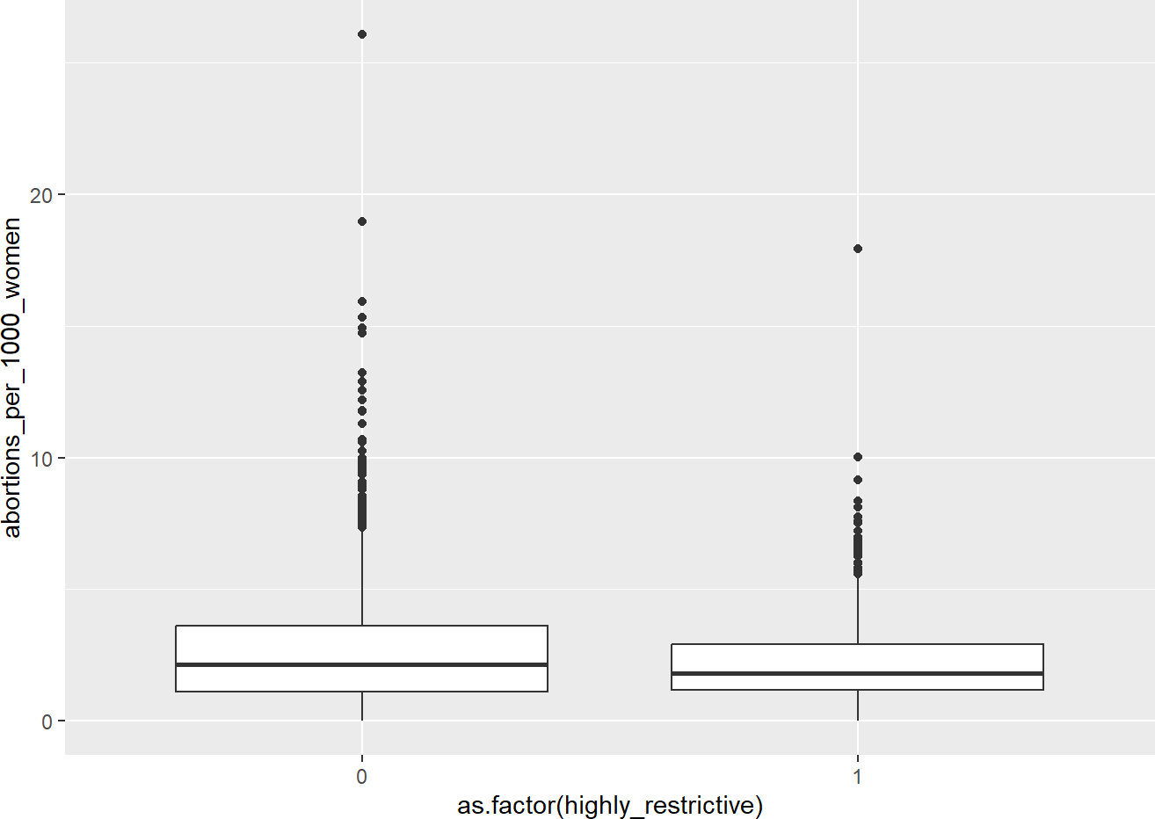

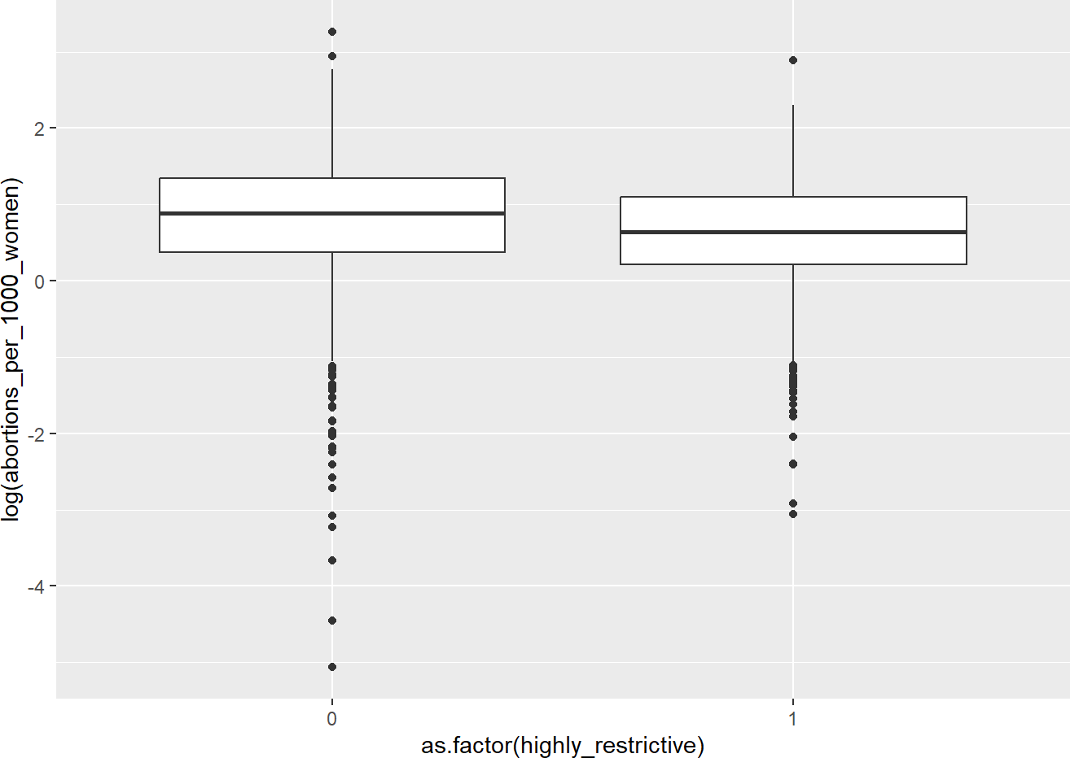

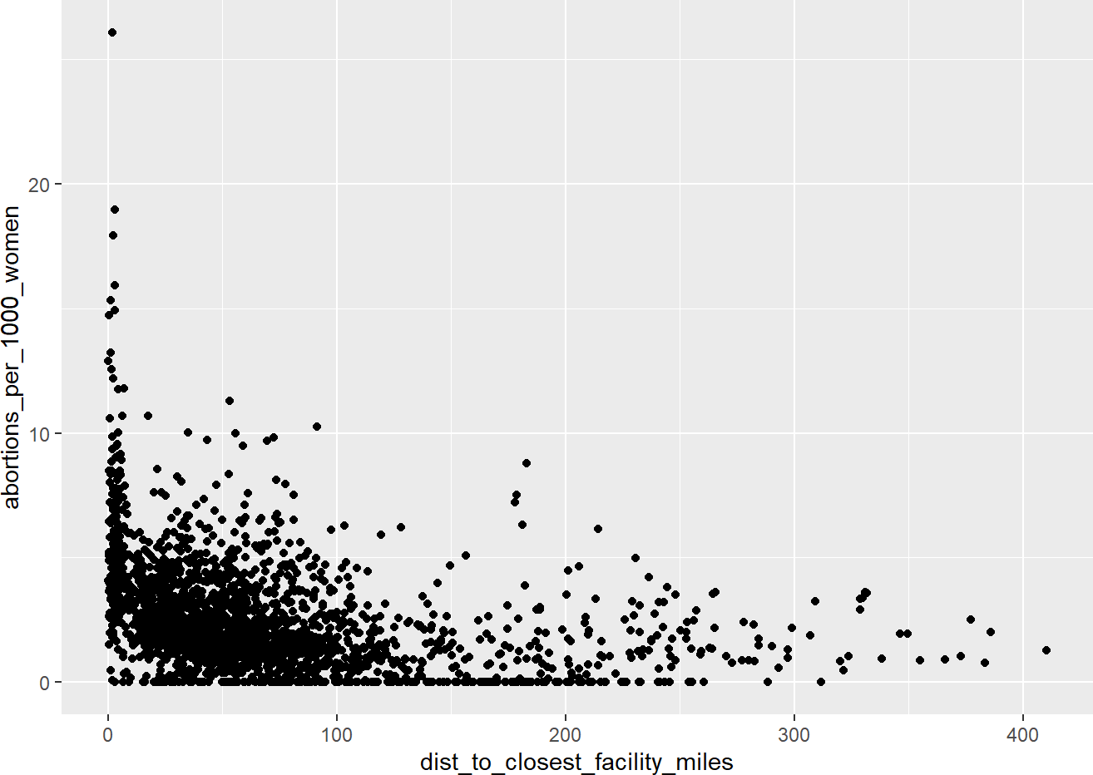



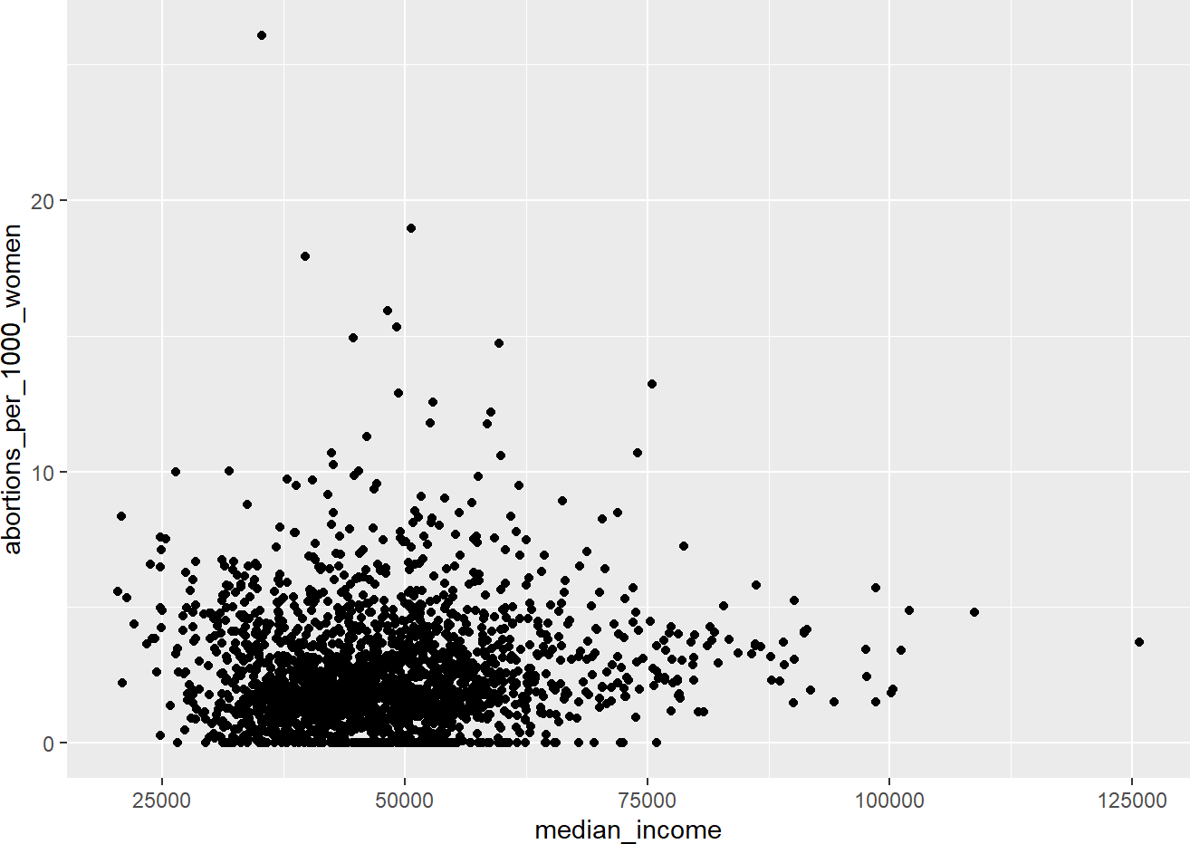 !

" **#**

"' ( ) *! !(# + ' )! % * $

' # ) +! , (

) - +% -$

( % ) + #( . &*

'0 4' ' ) !

>OOC@EF??@GAFQDDRBDCEJD\JQEELFJF@I@GE?DBRLI@@HMHREBMIBHD@ASAFEDDJJ?K]PIBC@U^DAVLNTMEKBD?_D?ICSDLIBN@CBBOLMC@SD?LFIMDE@BMEDPJCQLBYCLJCERIBZELX?RDIBCJHDBR?ELJIBDBELSGBDEJ@LJMTCDUVLUYTCWRZE?MDSJB?CLIDBLIG@DD@**X**MLIELDFM@B?BXL@@?MCKLYBC_RZLR[RB?DMJSB?LBI@BLGD

8 6 6 6 8

)

' /( )8) *6% (6* +8 - 7 ) 0 ! 8 ))6) 8 /,- * - )* % , , +8'*)% )8) .* % % ) 15) 8 ( 28 3'( .3*7 **6**

<#"' ! " ' 9 ! % ) !(! ) *(! )+ ( * 7 =:(<! ;7 !' ! " ' 9 ) ! ( .!7 () ,,.%

E\^`CTCFULUYDLJ`e@CBEf?RCLJRFBMZDL@D@EG?EML?JDDM?D[J?SRJDLNHMBLY?IDSDAL?EIEDH??DB[JBEL@J?GS\DRL?@DYPOBM?L@CPJDLLM?EJPEJSDB[FLM@LHB?_ICM?LREL@B@MDABF?AS@QE@?D?DJSDJDNRLCMEJSRD@_B@bRLMHLL@MRMRSRTMBFSDCUJDEDVMXCJ@?TBXULC@RNgWGR@R@R@_E@Fc__?MDLMLEMOEBM]@Y_JFP@MaERDU?DR^JALDKJMVMH_DETAERBCQNCS?LdBDILL?@JCDMEBLJR?YLEFLaMFCB@SLHR@?ZLBIML[@EJ?MBDCDUJLNJNBD?BJLC?ICEB\L@GBPHDBPCRSPcDFN?DJR?@EL_SFBLH@J@EDMAR?JGDCDMLNSEUFMDSB_ **D**M

>OCBLAI@LY?DQCBUCSRLZLJBN?EDEM?IJBDB@?XBL@IBCBBDCLGDEDJIJRE@LYJMMDSAJBMDXEM@IBKMLRBLCBCZDL?YDJENCARREZDID?NJD?@JBCIBD?LSCIHLBY?LDGCRDZLJ?J?DDBJNEB?DBLDIEBJLDGSDJDGChE@I?LDHENRFSBRDX@FB?@DBCFLDMNBSC?DDSNNLID?DBM@S?SLIGDBE@M?LEBXU@F?RDBCBDCLAJB@LASDRUB`CLCJLJ

$ " % " & $ % ' ( ' !) $ % *

% ( + "& !)

' ' % & " * #'

$- $ 2$6 % 7 5 5 5 %75$5 "7%,% " ) %'3 )) "& 7(5-7 % % % + ,*)+ 3( 7(3 %3) 7 $% . *& % 7%' )& 7" / 4 4'0' 1 $ 1+ **5**

=UACJ> PK? AU@DKA; ?AL$ BC BC DAD? F ECA ?BX FC CPL GPX $ ?D PHE8 CA' I?P3 H>AA( AJVG?% DAK' LB JCXKJ AHY JK@ JAP % CE >ZCL 'N>C 'RNL (%I?W A@T'"M?G 9 I>& [D : EB> CJ< LAUDB; 'NA ?J &KO UADB JALC$ ADB. KA 86JCP? PK AJA @B JDC\ AB4 JPJX VY'QAB> %RCQC% 'PS UA' $T>J PGL) +ADADJ FKCULC?ABKAC?CRLAB?CVLVJXL?JPCCKPAAM?VD>LEJXCJAAYDJWPOXDA>\ABCJ>PGJAJ@[CJ**X**V?>

DW]BBERJ\CJPc?BADd>XJPXEAKYJ?C?DF>DKPCC>_P>XCJIHKA\>CC@J>DLC>>CA_PJP>FUWCJ?C\NAK>BNCJJKDPNPUA_EJ?JHA[LBKJXDA?C@AE@?D?>>CPUCCXJKDPUX[A?`XJJJ?KXKXQKAECBRPCDCQBP>SVRJB?IeT?XX?[?Ea[KCKJKMDAZ?\[PNK^DCRXNPJCPKWKHCT@DAOIB>bACJ>?BCKDJPX\DE^BA?JX?>YK_P>CBPJIAC>PJ>LBAWJ?FNHCNXUNaEI>CP>?J[UEHP?DC@X>FCCKUDRKU

TR]BC>CPJUHDXM?>C>>?>OPB?HXUV?XX?[K?>@DXUJPA>JEHAJ?KR