Use this set of coronagraph images and their corresponding time stamps to estimate the speed of the St Patrick's Day 2015 CME. The feature used to trace the CME motion in the example answers for the class is outlined in green.
1
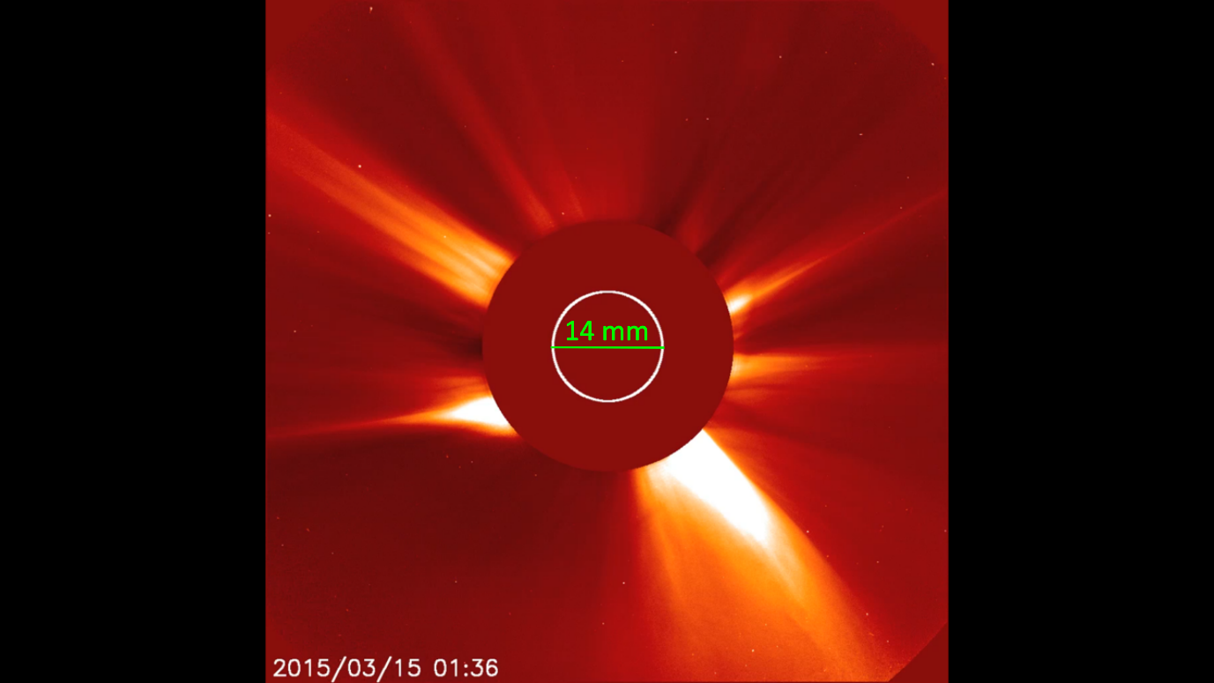
CME not visible in image 1, ejection time is approximately 02:10.
Diameter of Sun measures approximately 14 mm.
2
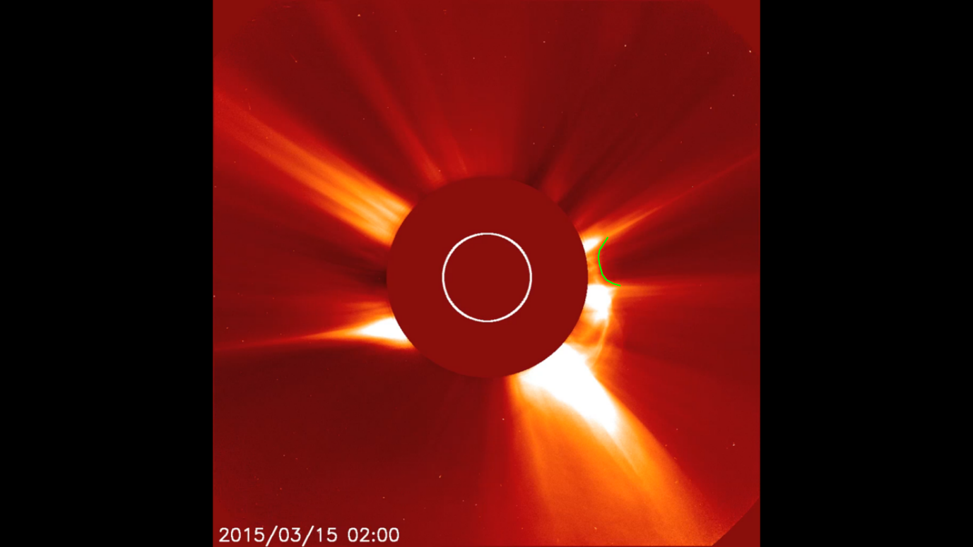

3
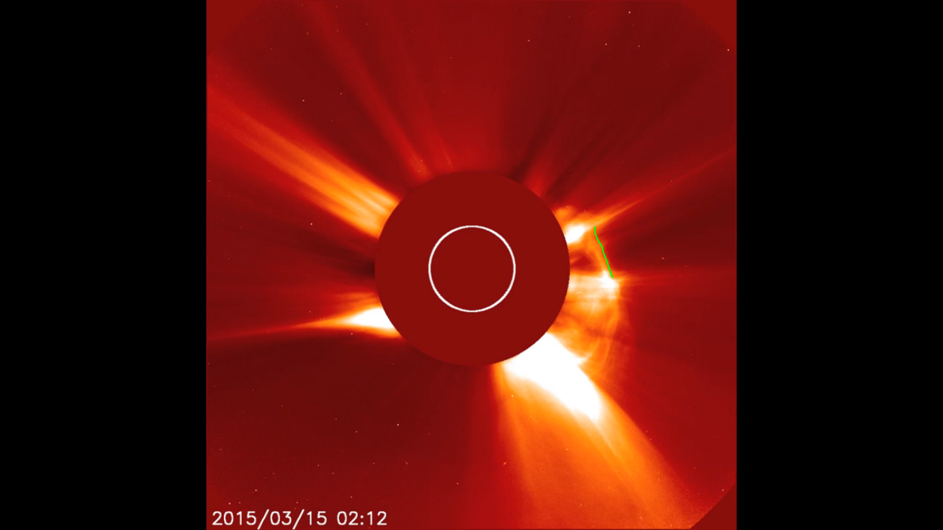

4
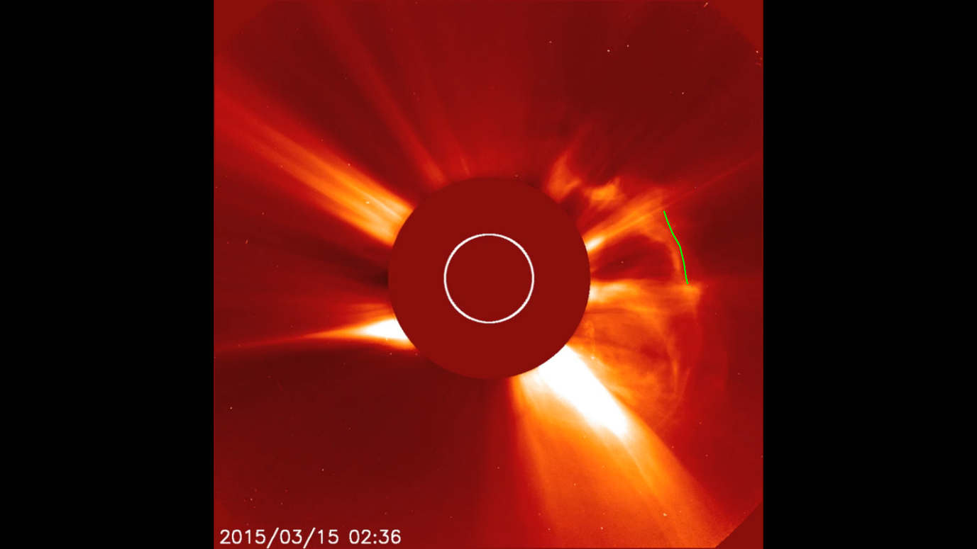

5
