
DATA STRUCTURES AND ALGORITHMS
23CSE203
LAB MANUAL
SUBMITTED BY
NAME | K LEELA VARDHAN
ROLL NO | AV.SC.U4CSE25208
YEAR/SEM/SECTION | 2ND YEAR/SEM-3/CSE-C
CREDITS | 05

SUBMITTED TO | Dr Gayathri Parasa
DESIGNATION | Asst. Professor (Sr. Gr)
DEPARTMENT | SCHOOL OF COMPUTING

INDEX
S.NO | TITLE | PAGE NO
1. | WEEK 1:  1(A). A rocket launch system displays a countdown before launch. Instead of using a loop, implement the countdown using recursion. Write a recursive python program to display a countdown from n to 1, followed by “Launch!”.  1(B). Banks calculate the growth of an investment using compound interest. The formula requires calculating powers, which can be implemented recursively. Write a recursive program to calculate P^{n}(power) where: P= principal growth factor, n= number of years.  1(C). A HR department stores employee ID’s in a list. Develop a recursive program to search for a given employee ID. Write a recursive function to search for an employee ID in a list.  1(D). In a logistics company, the number of possible ways to arrange n different parcels are calculated using the factorial formula (n!). Develop a recursive program to calculate the factorial of a given number.  1(E). Write a recursive python program to print the first n terms of the Fibonacci series.
2. | WEEK 2:  2(A). Write a python program to implement linear search.  2(B). Write a python program to implement binary search with and without sorted array as an input.
3. | WEEK-3:  3(A). Write a python program to implement bubble sort.  3(B). Write a python program to implement insertion sort.  3(C). Write a python program to implement selection sort.
4. | WEEK-4:  4(A). Write a python program to implement quick sort.  4(B). Write a python program to implement merge sort.
5. | WEEK-5:  5(A). Write a python program to implement a Singly Linked List with the below operations.  - Create Linked List  - Insert Beginning  - Insert End  - Insert at Index  - Delete by Value  - Delete First Node  - Delete Last Node  - Count number of nodes  - Sort the data of SLL  - Search data in SLL  - Display or Traverse  - Exit
6. | WEEK-6:  Write a python program to implement a Double Linked List with the below operations.  - Create Linked List  - Insert Beginning  - Insert End  - Insert at Index  - Delete by Value  - Delete First Node  - Delete Last Node  - Count number of nodes  - Display or Traverse  - Exit
7. | WEEK-7:  7(A). Write a python program to implement stack operations such as push, pop, peek, display using an array.  7(B). Write a python program to implement stack operations such as push, pop, peek, display using a linked list.
8. | WEEK-8:  8(A). Write a python program to implement Queue and its operations such as enqueue, dequeue, peek, display with a menu driven approach. Implement using array, and linked list data structures.  8(B). Write a python program to implement Circular Queue and its operations such as enqueue, dequeue, peek, display with a menu driven approach. Implement using array, and linked list data structures.
9. | WEEK-9:  Write a python program to implement a Binary Search Tree (BST) and perform the following operations.  1. Insertion  2. Deletion  3. Tree Traversals – in-order, pre-order and post-order  4. Count Leaf Nodes  5. Count Internal Nodes  6. Height of the Tree
10. | WEEK-10:  Write a menu driven python program to implement an AVL Tree and perform the following operations.  1. Insertion  2. Deletion  3. Tree Traversals  4. Count Leaf Nodes  5. Count Internal Nodes  6. Height of the Tree
11. | WEEK-11:  Write a menu-driven Python program to implement a Binary Heap (Max Heap and Min Heap) and perform the following operations:  - Insertion of an element into the Heap.  - Deletion of the root element from the Heap.  - Display the array representation of the Heap.  - Exit the program.
12. | WEEK-12:  Write a program to implement the following three collision resolution techniques in a Hash Table:  - Separate Chaining  - Linear Probing  - Quadratic Probing

WEEK – 1
PROGRAM-1(A):
AIM: A rocket launch displays a countdown before launch. Instead of using a loop, implement the countdown using recursion. Write a recursive Python program to display a countdown from n to 1, followed by “Launch!”.
CODE:
def countdown(n):
if n == 0:
print("Launch!")
else:
print(n)
countdown(n - 1)
n = int(input("Enter countdown number: "))
countdown(n)
OUTPUT:
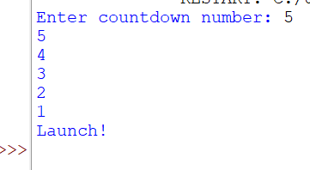
1(B).AIM: Banks calculate the growth of an investment using compound interest. The formula requires calculating powers, which can be implemented recursively. Write a recursive program to calculate pⁿ (power) where:
- p = principal growth factor
- n = number of years
CODE:
def power(p, n):
if n == 0:
return 1
else:
return p * power(p, n - 1)
p = int(input("Enter p: "))
n = int(input("Enter n: "))
result = power(p, n)

print("Answer =", result)
OUTPUT:
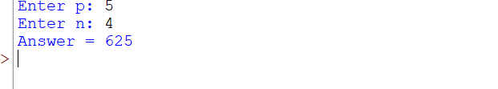
1(C).AIM: An HR department stores employee IDs in a list. Develop a recursive program to search for a given employee ID. Write a recursive function to search for an employee ID in a list.
PROGRAM:
def search(arr, key, index):
if index == len(arr):
return False
if arr[index] == key:
return True
return search(arr, key, index + 1)
ids = [101, 102, 103, 104, 105]
key = int(input("Enter employee ID to search: "))
if search(ids, key, 0):
print("Employee ID found")
else:
print("Employee ID not found")
OUTPUT:
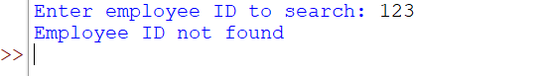
1(D).AIM: In a logistics company, the number of possible ways to arrange n different parcels are calculated using the factorial formula (n!). Develop a recursive program to calculate the factorial of a given number.
PROGRAM:
def factorial(n):
if n == 0 or n == 1:
return 1
else:
return n * factorial(n - 1)
n = int(input("Enter a number: "))
print("Factorial =", factorial(n))
OUTPUT:
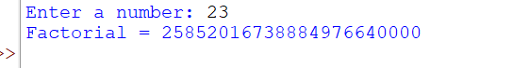
1(E).AIM: Write a recursive Python program to print the first n terms of Fibonacci series. PROGRAM:
def fibonacci(a, b, n):
if n == 0:
return
print(a, end=" ")
fibonacci(b, a + b, n - 1)
n = int(input("Enter number of terms: "))
fibonacci(0, 1, n)
OUTPUT:
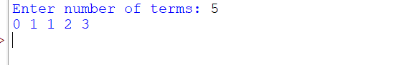
WEEK 2
2(A).AIM: Write a python program to implement linear search.
PROGRAM:
arr = list(map(int, input("Enter array elements separated by spaces: ").split()))

key = int(input("Enter element to search: "))

found = False

for i in range(len(arr)):
if arr[i] == key:
print("Element found at position", i + 1)
found = True
break

if not found:
print("Element not found")
OUTPUT:
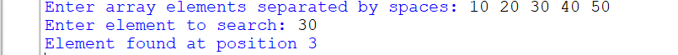
2(B).AIM: Write a python program to implement binary search with and without sorted array as an input.
PROGRAM:
(i): Binary Search on a Sorted Array
arr = list(map(int, input("Enter sorted array elements: ").split()))

key = int(input("Enter element to search: "))

low = 0
high = len(arr) - 1

found = False

while low <= high:
mid = (low + high) // 2

if arr[mid] == key:
print("Element found at position", mid + 1)
found = True
break

elif key < arr[mid]:
high = mid - 1

else:
low = mid + 1

if not found:
print("Element not found")
OUTPUT:
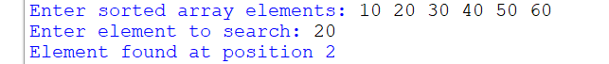
ii): Binary Search on an Unsorted Array
arr = list(map(int, input("Enter array elements separated by spaces: ").split()))

arr.sort()

print("Sorted array:", arr)

key = int(input("Enter element to search: "))

low = 0
high = len(arr) - 1

found = False

while low <= high:
mid = (low + high) // 2

if arr[mid] == key:
print("Element found at position", mid + 1, "in the sorted array")
found = True
break

elif key < arr[mid]:
high = mid - 1

else:
low = mid + 1

if not found:
print("Element not found")
OUTPUT:
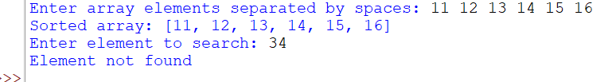
WEEK 3
3(A).AIM:Write a python program to implement bubble sort where the input elements are taken from the user
PROGRAM:
def bubble_sort(arr):
n = len(arr)

for i in range(n - 1):
for j in range(n - i - 1):
if arr[j] > arr[j + 1]:
arr[j], arr[j + 1] = arr[j + 1], arr[j]

return arr

n = int(input("Enter number of elements: "))

arr = []

for i in range(n):
arr.append(int(input("Enter element: ")))

bubble_sort(arr)

print("Sorted array:", arr)
OUTPUT:
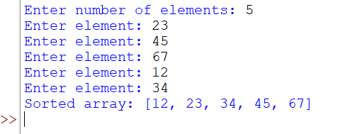
3(B).AIM:Write a python program to implement insertion sort where the input elements are taken from the user
def insertion_sort(arr):
for i in range(1, len(arr)):
key = arr[i]
j = i - 1

while j >= 0 and arr[j] > key:
arr[j + 1] = arr[j]
j -= 1

arr[j + 1] = key

return arr

n = int(input("Enter number of elements: "))

arr = []

for i in range(n):
arr.append(int(input("Enter element: ")))

insertion_sort(arr)

print("Sorted array:", arr)
OUTPUT:
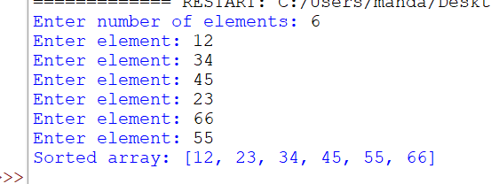

3(C).AIM:Write a python program to implement selection sort where the input elements are taken from the user
PROGRAM:
def selection_sort(arr):
n = len(arr)

for i in range(n - 1):
min_index = i

for j in range(i + 1, n):
if arr[j] < arr[min_index]:
min_index = j

arr[i], arr[min_index] = arr[min_index], arr[i]

return arr

n = int(input("Enter number of elements: "))

arr = []

for i in range(n):
arr.append(int(input("Enter element: ")))

selection_sort(arr)

print("Sorted array:", arr)
OUTPUT:
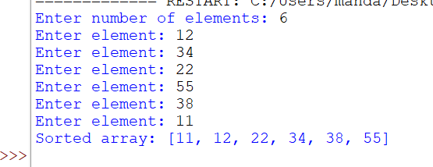
WEEK4
4(A).AIM: Write a python program to implement quick sort.
PROGRAM:
def quicksort(a, low, high):
if low < high:
pivot = a[low]
i = low + 1
j = high

while True:
while i <= high and a[i] <= pivot:
i += 1

while a[j] > pivot:
j -= 1

if i >= j:
break

a[i], a[j] = a[j], a[i]

a[low], a[j] = a[j], a[low]

quicksort(a, low, j - 1)
quicksort(a, j + 1, high)

arr = list(map(int, input("Enter numbers to sort: ").split()))

quicksort(arr, 0, len(arr) - 1)

print("Sorted array:", arr)
OUTPUT:
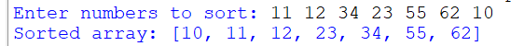
4(B).AIM:Write a python program to implement merge sort where the input elements are taken from the user
PROGRAM:
def merge_sort(arr):
if len(arr) <= 1:
return arr

mid = len(arr) // 2

left = merge_sort(arr[:mid])
right = merge_sort(arr[mid:])

merged = []

i = j = 0

while i < len(left) and j < len(right):
if left[i] <= right[j]:
merged.append(left[i])
i += 1
else:
merged.append(right[j])
j += 1

merged.extend(left[i:])
merged.extend(right[j:])

return merged

arr = list(map(int, input("Enter elements separated by spaces: ").split()))

print("Sorted array:", merge_sort(arr))
OUTPUT:
WEEK 5
5(A).AIM: Write a python program to implement a Singly Linked List with the below operations.
- Create Linked List
- Insert Beginning
- Insert End
- Insert at Index
- Delete by Value
- Delete First Node
- Delete Last Node
- Count number of nodes
- Sort the data of SLL
- Search data in SLL
- Display or Traverse
- Exit
PROGRAM:

class Node:
def __init__(self, data):
self.data = data
self.next = None

class SinglyLinkedList:
def __init__(self):
self.head = None

# 1. Create Linked List
def create(self):
n = int(input("Enter number of nodes: "))
for i in range(n):
data = int(input("Enter data: "))
self.insert_end(data)
print("Linked List created successfully.")

# 2. Insert at Beginning
def insert_beginning(self, data):
new_node = Node(data)
new_node.next = self.head
self.head = new_node
print("Node inserted at beginning.")

# 3. Insert at End
def insert_end(self, data):
new_node = Node(data)

if self.head is None:
self.head = new_node
return

temp = self.head
while temp.next is not None:
temp = temp.next
temp.next = new_node
# 4. Insert at Index (0-based)
def insert_index(self, data, index):
if index < 0:
print("Invalid index.")
return
if index == 0:
self.insert_beginning(data)
return

temp = self.head
for i in range(index - 1):
if temp is None:
print("Invalid index.")
return
temp = temp.next

if temp is None:
print("Invalid index.")
return

new_node = Node(data)
new_node.next = temp.next
temp.next = new_node
print("Node inserted at index", index)

# 5. Delete by Value
def delete_value(self, value):
temp = self.head

if temp is not None and temp.data == value:
self.head = temp.next
print("Node deleted.")
return

prev = None
while temp is not None and temp.data != value:
prev = temp
temp = temp.next

if temp is None:
print("Value not found.")
return

prev.next = temp.next
print("Node deleted.")

# 6. Delete First Node
def delete_first(self):
if self.head is None:
print("List is empty.")
return

self.head = self.head.next
print("First node deleted.")

# 7. Delete Last Node
def delete_last(self):
if self.head is None:
print("List is empty.")
return

if self.head.next is None:
self.head = None
print("Last node deleted.")
return

temp = self.head
while temp.next.next is not None:
temp = temp.next

temp.next = None
print("Last node deleted.")

# 8. Count Nodes
def count(self):
count = 0
temp = self.head

while temp is not None:
count += 1
temp = temp.next

print("Number of nodes:", count)

# 9. Sort Linked List
def sort(self):
if self.head is None:
print("List is empty.")
return

current = self.head
while current is not None:
index = current.next
while index is not None:
if current.data > index.data:
current.data, index.data = index.data, current.data
index = index.next
current = current.next

print("Linked List sorted.")

# 10. Search Data
def search(self, value):
temp = self.head
index = 0

while temp is not None:
if temp.data == value:
print("Value found at index", index)
return
temp = temp.next
index += 1

print("Value not found.")

# 11. Display / Traverse
def display(self):
if self.head is None:
print("List is empty.")
return

temp = self.head
while temp is not None:
print(temp.data, end=" -> ")
temp = temp.next

print("None")

# Main Menu
sll = SinglyLinkedList()

while True:
print("\n--- SINGLY LINKED LIST MENU ---")
print("1. Create Linked List")
print("2. Insert Beginning")
print("3. Insert End")
print("4. Insert at Index")
print("5. Delete by Value")
print("6. Delete First Node")
print("7. Delete Last Node")
print("8. Count Number of Nodes")
print("9. Sort the Linked List")
print("10. Search Data")
print("11. Display / Traverse")
print("12. Exit")

choice = int(input("Enter your choice: "))

if choice == 1:
sll.create()
elif choice == 2:
data = int(input("Enter data: "))
sll.insert_beginning(data)

elif choice == 3:
data = int(input("Enter data: "))
sll.insert_end(data)
print("Node inserted at end.")

elif choice == 4:
data = int(input("Enter data: "))
index = int(input("Enter index (starting from 0): "))
sll.insert_index(data, index)

elif choice == 5:
value = int(input("Enter value to delete: "))
sll.delete_value(value)

elif choice == 6:
sll.delete_first()

elif choice == 7:
sll.delete_last()

elif choice == 8:
sll.count()

elif choice == 9:
sll.sort()

elif choice == 10:
value = int(input("Enter value to search: "))
sll.search(value)

elif choice == 11:
sll.display()

elif choice == 12:
print("Exiting program.")
break

else:
print("Invalid choice. Please try again.")
OUTPUT:
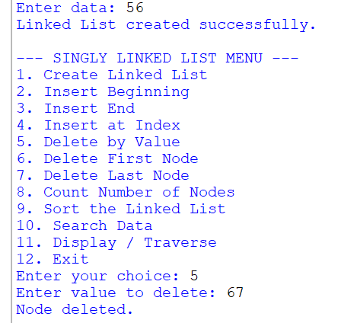
WEEK 6
AIM: Write a python program to implement a Double Linked List with the below operations.
- Create Linked List
- Insert Beginning
- Insert End
- Insert at Index
- Delete by Value
- Delete First Node
- Delete Last Node
- Count number of nodes
- Display or Traverse
10)Exit
PROGRAM:
class Node:
def __init__(self, data):
self.data = data
self.prev = None
self.next = None

class DoublyLinkedList:
def __init__(self):
self.head = None

# 1. Create Linked List
def create(self):
n = int(input("Enter number of nodes: "))
for i in range(n):
data = int(input("Enter data: "))
self.insert_end(data)
print("Linked List created successfully.")

# 2. Insert at Beginning
def insert_beginning(self, data):
new_node = Node(data)

if self.head is not None:
new_node.next = self.head
self.head.prev = new_node

self.head = new_node
print("Node inserted at beginning.")

# 3. Insert at End
def insert_end(self, data):
new_node = Node(data)

if self.head is None:
self.head = new_node
return

temp = self.head
while temp.next is not None:
temp = temp.next

temp.next = new_node
new_node.prev = temp

# 4. Insert at Index (0-based)
def insert_index(self, data, index):
if index < 0:
print("Invalid index.")
return

if index == 0:
self.insert_beginning(data)
return

temp = self.head
for i in range(index - 1):
if temp is None:
print("Invalid index.")
return
temp = temp.next

if temp is None:
print("Invalid index.")
return

new_node = Node(data)
new_node.next = temp.next
new_node.prev = temp

if temp.next is not None:
temp.next.prev = new_node

temp.next = new_node
print("Node inserted at index", index)

# 5. Delete by Value
def delete_value(self, value):
temp = self.head

while temp is not None and temp.data != value:
temp = temp.next

if temp is None:
print("Value not found.")
return

if temp.prev is not None:
temp.prev.next = temp.next
else:
self.head = temp.next

if temp.next is not None:
temp.next.prev = temp.prev

print("Node deleted.")

# 6. Delete First Node
def delete_first(self):
if self.head is None:
print("List is empty.")
return

self.head = self.head.next

if self.head is not None:
self.head.prev = None

print("First node deleted.")

# 7. Delete Last Node
def delete_last(self):
if self.head is None:
print("List is empty.")
return

temp = self.head

if temp.next is None:
self.head = None
print("Last node deleted.")
return

while temp.next is not None:
temp = temp.next

temp.prev.next = None
print("Last node deleted.")

# 8. Count Number of Nodes
def count(self):
count = 0
temp = self.head

while temp is not None:
count += 1
temp = temp.next

print("Number of nodes:", count)

# 9. Display / Traverse
def display(self):
if self.head is None:
print("List is empty.")
return

temp = self.head
print("None", end=" <-> ")

while temp is not None:
print(temp.data, end=" <-> ")
temp = temp.next

print("None")

# Main Menu
dll = DoublyLinkedList()

while True:
print("\n--- DOUBLY LINKED LIST MENU ---")
print("1. Create Linked List")
print("2. Insert Beginning")
print("3. Insert End")
print("4. Insert at Index")
print("5. Delete by Value")
print("6. Delete First Node")
print("7. Delete Last Node")
print("8. Count Number of Nodes")
print("9. Display / Traverse")
print("10. Exit")

choice = int(input("Enter your choice: "))

if choice == 1:
dll.create()

elif choice == 2:
data = int(input("Enter data: "))
dll.insert_beginning(data)

elif choice == 3:
data = int(input("Enter data: "))
dll.insert_end(data)
print("Node inserted at end.")

elif choice == 4:
data = int(input("Enter data: "))
index = int(input("Enter index (starting from 0): "))
dll.insert_index(data, index)

elif choice == 5:
value = int(input("Enter value to delete: "))
dll.delete_value(value)

elif choice == 6:
dll.delete_first()

elif choice == 7:
dll.delete_last()

elif choice == 8:
dll.count()

elif choice == 9:
dll.display()

elif choice == 10:
print("Exiting program.")
break

else:
print("Invalid choice. Please try again.")
OUTPUT:
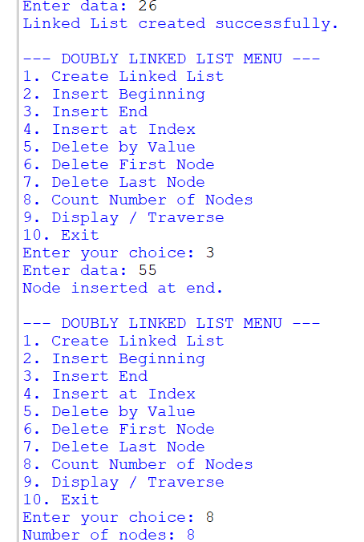
WEEK7

7(A).AIM: Write a python program to implement stack operations such as push, pop, peek, display using arrays
PROGRAM:
class Stack:
def __init__(self, size):
self.size = size
self.stack = [None] * size
self.top = -1

def push(self, data):
if self.top == self.size - 1:
print("Stack Overflow")
else:
self.top += 1
self.stack[self.top] = data

def pop(self):
if self.top == -1:
print("Stack Underflow")
else:
print("Deleted value =", self.stack[self.top])
self.top -= 1

def peek(self):
if self.top == -1:
print("Stack Underflow")
else:
print("Top element =", self.stack[self.top])

def display(self):
if self.top == -1:
print("Stack is empty")
else:
for i in range(self.top, -1, -1):
print(self.stack[i], end=" ")
print()

size = int(input("Enter size of stack: "))

s = Stack(size)

while True:
print("\n1.Push 2.Pop 3.Peek 4.Display 5.Exit")

choice = int(input("Enter choice: "))

if choice == 1:
s.push(int(input("Enter value: ")))

elif choice == 2:
s.pop()

elif choice == 3:
s.peek()

elif choice == 4:
s.display()

elif choice == 5:
break

else:
print("Invalid choice")
OUTPUT:
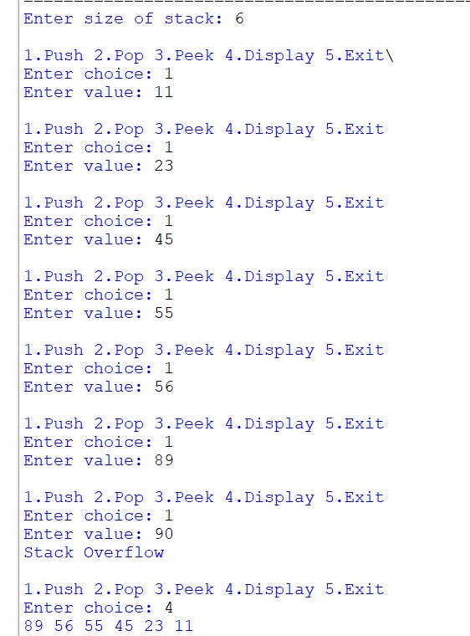
7(B).AIM.Write a python program to implement stack operations such as push, pop, peek, display using linked lists.
PROGRAM:
class Node:
def __init__(self, data):
self.data = data
self.next = None

class Stack:
def __init__(self):
self.top = None

def push(self, data):
new = Node(data)
new.next = self.top
self.top = new

def pop(self):
if self.top is None:
print("Stack Underflow")
else:
print("Deleted value =", self.top.data)
self.top = self.top.next

def peek(self):
if self.top is None:
print("Stack Underflow")
else:
print("Top element =", self.top.data)

def display(self):
if self.top is None:
print("Stack is empty")
return

temp = self.top

while temp:
print(temp.data, end=" ")
temp = temp.next

print()

s = Stack()

while True:
print("\n1.Push 2.Pop 3.Peek 4.Display 5.Exit")

choice = int(input("Enter choice: "))

if choice == 1:
s.push(int(input("Enter value: ")))

elif choice == 2:
s.pop()

elif choice == 3:
s.peek()

elif choice == 4:
s.display()

elif choice == 5:
break

else:
print("Invalid choice")
OUTPUT:
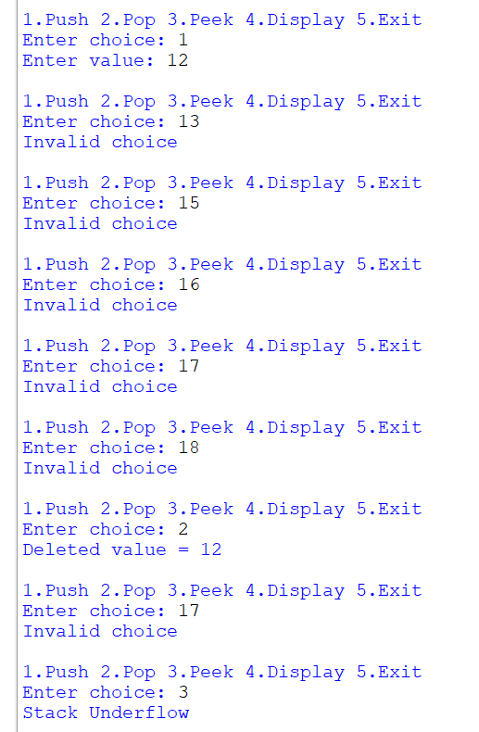
WEEK 8
8(A). AIM: Write a python program to implement Queue and its operations such as enqueue, dequeue, peek, display with a menu driven approach. Implement using array, and linked list data structures.
PROGRAM:
I): Queue Using Array
class Queue:
def __init__(self, size):
self.size = size
self.queue = [0] * size
self.front = -1
self.rear = -1

def enqueue(self, data):
if self.rear == self.size - 1:
print("Queue Overflow")
return

if self.front == -1:
self.front = 0

self.rear += 1
self.queue[self.rear] = data
print(data, "inserted")

def dequeue(self):
if self.front == -1 or self.front > self.rear:
print("Queue Underflow")
else:
print(self.queue[self.front], "deleted")
self.front += 1

if self.front > self.rear:
self.front = self.rear = -1

def peek(self):
if self.front == -1:
print("Queue is empty")
else:
print("Front element:", self.queue[self.front])

def display(self):
if self.front == -1:
print("Queue is empty")
else:
print(*self.queue[self.front:self.rear + 1])

size = int(input("Enter queue size: "))

q = Queue(size)

while True:
print("\n1.Enqueue 2.Dequeue 3.Peek 4.Display 5.Exit")

choice = int(input("Enter choice: "))

if choice == 1:
q.enqueue(int(input("Enter element: ")))

elif choice == 2:
q.dequeue()

elif choice == 3:
q.peek()

elif choice == 4:
q.display()

elif choice == 5:
break

else:
print("Invalid choice")
OUTPUT:
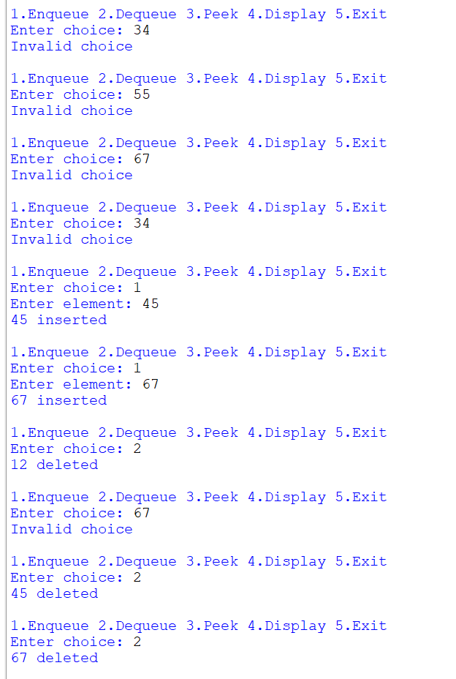
II): Queue Using Linked List
class Node:
def __init__(self, data):
self.data = data
self.next = None

class Queue:
def __init__(self):
self.front = None
self.rear = None

def enqueue(self, data):
new = Node(data)

if self.rear is None:
self.front = self.rear = new
else:
self.rear.next = new
self.rear = new

print(data, "inserted")

def dequeue(self):
if self.front is None:
print("Queue Underflow")
return

print(self.front.data, "deleted")
self.front = self.front.next

if self.front is None:
self.rear = None

def peek(self):
if self.front is None:
print("Queue is empty")
else:
print("Front element:", self.front.data)

def display(self):
if self.front is None:
print("Queue is empty")
return

temp = self.front

while temp:
print(temp.data, end=" ")
temp = temp.next

print()

q = Queue()

while True:
print("\n1.Enqueue 2.Dequeue 3.Peek 4.Display 5.Exit")

choice = int(input("Enter choice: "))

if choice == 1:
q.enqueue(int(input("Enter element: ")))

elif choice == 2:
q.dequeue()

elif choice == 3:
q.peek()

elif choice == 4:
q.display()

elif choice == 5:
break

else:
print("Invalid choice")
OUTPUT:
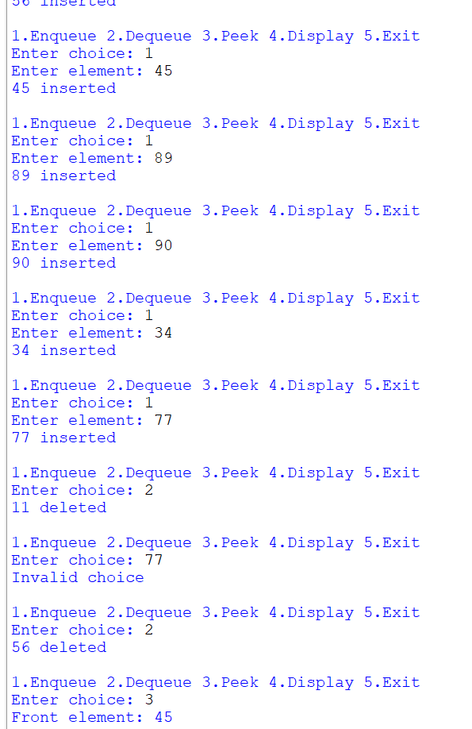
8(B). AIM: Write a python program to implement Circular Queue and its operations such as enqueue, dequeue, peek, display with a menu driven approach. Implement using array, and linked list data structures.
PROGRAM:
I): Circular Queue Using Array
class CircularQueue:
def __init__(self, size):
self.size = size
self.queue = [0] * size
self.front = -1
self.rear = -1

def enqueue(self, data):
if (self.rear + 1) % self.size == self.front:
print("Queue Overflow")
return

if self.front == -1:
self.front = self.rear = 0
else:
self.rear = (self.rear + 1) % self.size

self.queue[self.rear] = data
print(data, "inserted")

def dequeue(self):
if self.front == -1:
print("Queue Underflow")
return

print(self.queue[self.front], "deleted")

if self.front == self.rear:
self.front = self.rear = -1
else:
self.front = (self.front + 1) % self.size

def peek(self):
if self.front == -1:
print("Queue is empty")
else:
print("Front element:", self.queue[self.front])

def display(self):
if self.front == -1:
print("Queue is empty")
return

i = self.front

while True:
print(self.queue[i], end=" ")

if i == self.rear:
break

i = (i + 1) % self.size

print()

size = int(input("Enter queue size: "))

q = CircularQueue(size)

while True:
print("\n1.Enqueue 2.Dequeue 3.Peek 4.Display 5.Exit")

choice = int(input("Enter choice: "))

if choice == 1:
q.enqueue(int(input("Enter element: ")))

elif choice == 2:
q.dequeue()

elif choice == 3:
q.peek()

elif choice == 4:
q.display()

elif choice == 5:
break

else:
print("Invalid choice")
OUTPUT:
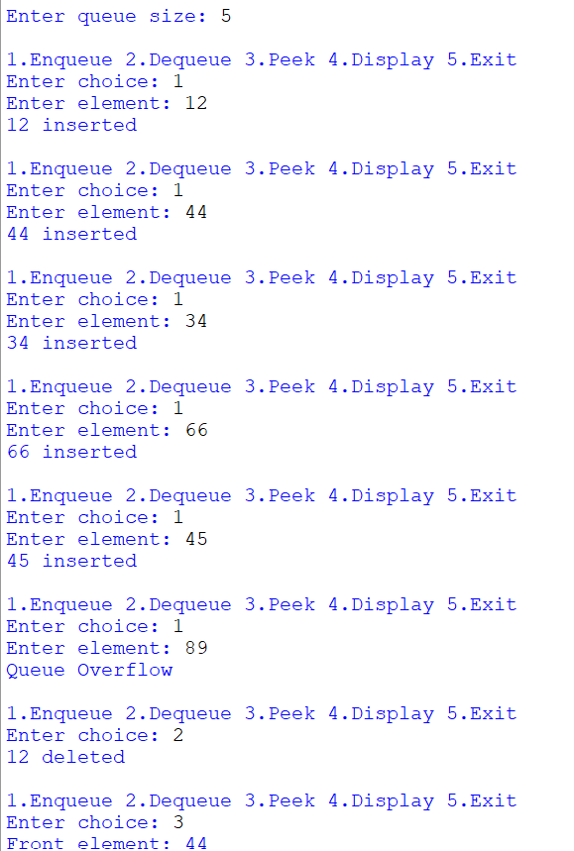
II): Circular Queue Using Linked List
class Node:
def __init__(self, data):
self.data = data
self.next = None

class CircularQueue:
def __init__(self):
self.front = None
self.rear = None

def enqueue(self, data):
new = Node(data)

if self.front is None:
self.front = self.rear = new
new.next = new
else:
new.next = self.front
self.rear.next = new
self.rear = new

print(data, "inserted")

def dequeue(self):
if self.front is None:
print("Queue Underflow")
return

print(self.front.data, "deleted")

if self.front == self.rear:
self.front = self.rear = None
else:
self.front = self.front.next
self.rear.next = self.front

def peek(self):
if self.front is None:
print("Queue is empty")
else:
print("Front element:", self.front.data)

def display(self):
if self.front is None:
print("Queue is empty")
return

temp = self.front

while True:
print(temp.data, end=" ")
temp = temp.next

if temp == self.front:
break

print()

q = CircularQueue()

while True:
print("\n1.Enqueue 2.Dequeue 3.Peek 4.Display 5.Exit")

choice = int(input("Enter choice: "))

if choice == 1:
q.enqueue(int(input("Enter element: ")))

elif choice == 2:
q.dequeue()

elif choice == 3:
q.peek()

elif choice == 4:
q.display()

elif choice == 5:
break

else:
print("Invalid choice")
OUTPUT:
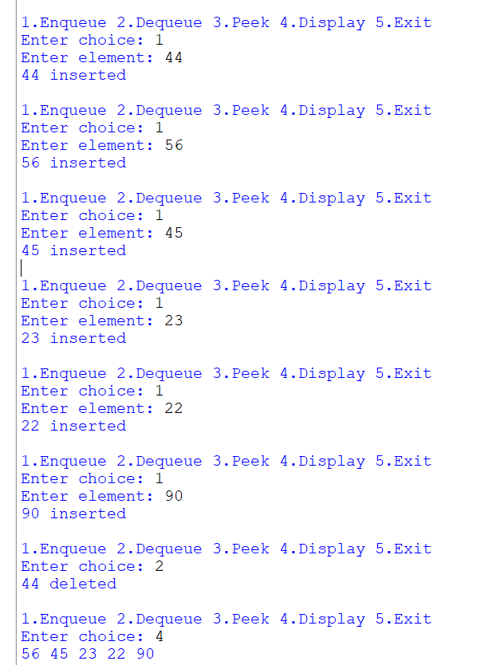
WEEK 9
AIM: Write a python program to implement a Binary Search Tree (BST) and perform the following operations.
1. Insertion
2. Deletion
3. Tree Traversals – in-order, pre-order and post-order
4. Count Leaf Nodes
5. Count Internal Nodes
6. Height of the Tree
PROGRAM:
class Node:
def __init__(self, data):
self.data = data
self.left = None
self.right = None

def insert(root, x):
if root is None:
return Node(x)
if x < root.data:
root.left = insert(root.left, x)
elif x > root.data:
root.right = insert(root.right, x)
else:
print("Duplicate value is not allowed.")
return root

def inorder(root):
if root is None:
return
inorder(root.left)
print(root.data, end=" ")
inorder(root.right)

def preorder(root):
if root is None:
return
print(root.data, end=" ")
preorder(root.left)
preorder(root.right)

def postorder(root):
if root is None:
return
postorder(root.left)
postorder(root.right)
print(root.data, end=" ")

def count_leaves(root):
if root is None:
return 0
if root.left is None and root.right is None:
return 1
return count_leaves(root.left) + count_leaves(root.right)

def count_internal(root):
if root is None:
return 0
if root.left is None and root.right is None:
return 0
return count_internal(root.left) + count_internal(root.right) + 1

def height(root):
if root is None:
return -1
left_height = height(root.left)
right_height = height(root.right)
return max(left_height, right_height) + 1

def delete(root, x):
if root is None:
print("Element not found.")
return None
if x < root.data:
root.left = delete(root.left, x)
elif x > root.data:
root.right = delete(root.right, x)
else:
# Case 1: Node has no children
if root.left is None and root.right is None:
root = None
# Case 2: Node has only right child
elif root.left is None:
root = root.right
# Case 3: Node has only left child
elif root.right is None:
root = root.left
# Case 4: Node has two children
else:
successor = find_min(root.right)
root.data = successor.data
root.right = delete(root.right, successor.data)
return root

# =====================================================
# MAIN PROGRAM
# =====================================================

root = None
while True:
print("\n\n******** BINARY SEARCH TREE ********")
print("1. INSERT")
print("2. PREORDER TRAVERSAL")
print("3. INORDER TRAVERSAL")
print("4. POSTORDER TRAVERSAL")
print("5. DELETE")
print("6. COUNT LEAVES")
print("7. COUNT INTERNAL NODES")
print("8. HEIGHT")
print("9. EXIT")

choice = int(input("Enter your choice: "))
if choice == 1:
data = int(input("Enter the data to be inserted: "))
root = insert(root, data)
print("Element inserted successfully.")
elif choice == 2:
print("Preorder Traversal:", end=" ")
if root is None:
print("Tree is empty.")
else:
preorder(root)
print()
elif choice == 3:
print("Inorder Traversal:", end=" ")
if root is None:
print("Tree is empty.")
else:
inorder(root)
print()
elif choice == 4:
print("Postorder Traversal:", end=" ")
if root is None:
print("Tree is empty.")
else:
postorder(root)
print()

elif choice == 5:
data = int(input("Enter the data to be deleted: "))
root = delete(root, data)
elif choice == 6:
print("Number of leaf nodes:", count_leaves(root))
elif choice == 7:
print("Number of internal nodes:", count_internal(root))
elif choice == 8:
print("Height of BST:", height(root))
elif choice == 9:
print("Program terminated.")
break
else:
print("Invalid choice. Please try again.")
OUTPUT:
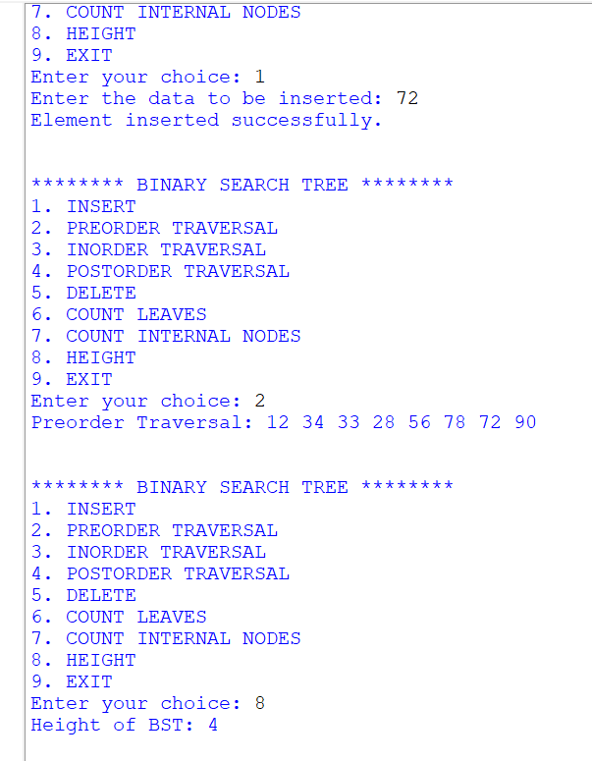

WEEK-10:
AIM: Write a menu driven python program to implement an AVL Tree and perform the following operations.
1. Insertion
2. Deletion
3. Tree Traversals
4. Count Leaf Nodes
5. Count Internal Nodes
6. Height of the Tree
PROGRAM:
class Node:
def __init__(self, x):
self.left = None
self.data = x
self.right = None
self.h = 0

#AVL TREE Program
def height(root):
if root is None:
return -1
else:
return root.h

# LL Rotation
def LL(x):
y = x.left
x.left = y.right
y.right = x
x.h = max(height(x.left), height(x.right)) + 1
y.h = max(height(y.left), height(y.right)) + 1
return y

# RR Rotation
def RR(x):
y = x.right
x.right = y.left
y.left = x
x.h = max(height(x.left), height(x.right)) + 1
y.h = max(height(y.left), height(y.right)) + 1
return y

# LR Rotation
def LR(k3):
k3.left = RR(k3.left)
return LL(k3)

# RL Rotation
def RL(k3):
k3.right = LL(k3.right)
return RR(k3)

# Inorder Traversal
def inorder(root):
if root is not None:
inorder(root.left)
print(root.data, end=" ")
inorder(root.right)

# Preorder Traversal
def preorder(root):
if root is not None:
print(root.data, end=" ")
preorder(root.left)
preorder(root.right)

# Postorder Traversal
def postorder(root):
if root is not None:
postorder(root.left)
postorder(root.right)
print(root.data, end=" ")

# Insert a node into AVL Tree
def insert(root, x):
if root is None:
return Node(x)

if x < root.data:
root.left = insert(root.left, x)
if height(root.left) - height(root.right) == 2:
if x < root.left.data:
root = LL(root)
else:
root = LR(root)

elif x > root.data:
root.right = insert(root.right, x)
if height(root.right) - height(root.left) == 2:
if x > root.right.data:
root = RR(root)
else:
root = RL(root)
else:
print("Duplicates not allowed")
root.h = max(height(root.left),height(root.right)) + 1
return root

# Delete a node from AVL Tree
def delete(root, x):
# Element not found
if root is None:
return None

# Search in left subtree
if x < root.data:
root.left = delete(root.left, x)
if height(root.left) - height(root.right) == 2:
if x < root.left.data:
root = LL(root)
else:
root = LR(root)

# Search in right subtree
elif x > root.data:
root.right = delete(root.right, x)
if height(root.right) - height(root.left) == 2:
if x > root.right.data:
root = RR(root)
else:
root = RL(root)

# When target found
else:
if root.left is None and root.right is None:
root = None
elif root.right is None:
root = root.left
elif root.left is None:
root = root.right
else:
successor = root.right # Find inorder successor
while successor.left is not None:
successor = successor.left
root.data = successor.data #Copy successor data
root.right = delete(root.right, successor.data) # Delete the inorder successor

root.h = max(height(root.left), height(root.right)) + 1
return root

# -------------------------------
# Main Program
# -------------------------------

root = None
while True:
print("\n***** AVL TREE MENU *****")
print("1. INSERT")
print("2. PREORDER TRAVERSAL")
print("3. INORDER TRAVERSAL")
print("4. POSTORDER TRAVERSAL")
print("5. DELETE")
print("6. EXIT")

choice = int(input("Enter your choice: "))
if choice == 1:
data = int(input("Enter the data to be inserted: "))
root = insert(root, data)
elif choice == 2:
print("Preorder Traversal:")
preorder(root)
print()
elif choice == 3:
print("Inorder Traversal:")
inorder(root)
print()
elif choice == 4:
print("Postorder Traversal:")
postorder(root)
print()
elif choice == 5:
data = int(input("Enter the data to be deleted: "))
root = delete(root, data)
elif choice == 6:
print("Program terminated.")
break
else:
print("Invalid choice!")
OUTPUT:
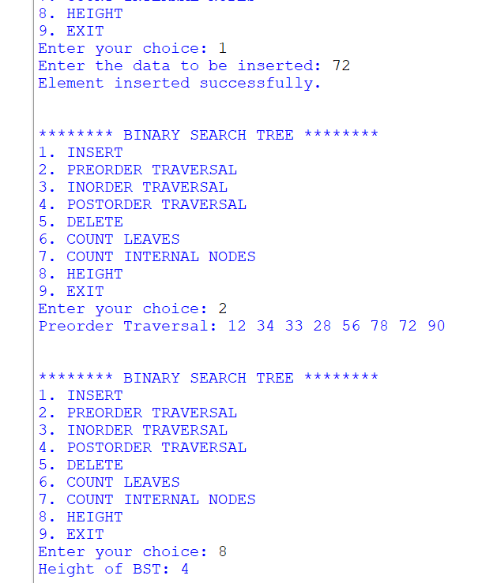
WEEK-11:
AIM: Write a menu-driven Python program to implement a Binary Heap (Max Heap and Min Heap) and perform the following operations:
- Insertion of an element into the Heap.
- Deletion of the root element from the Heap.
- Display the array representation of the Heap.
Exit the program
PROGRAM:

def insert(heap, value, heap_type):
heap.append(value)
i = len(heap) - 1

while i > 0:
parent = (i - 1) // 2

if heap_type == "max" and heap[i] > heap[parent]:
heap[i], heap[parent] = heap[parent], heap[i]
i = parent
elif heap_type == "min" and heap[i] < heap[parent]:
heap[i], heap[parent] = heap[parent], heap[i]
i = parent
else:
break

print("Element inserted successfully.")

def delete_root(heap, heap_type):
if len(heap) == 0:
print("Heap is empty.")
return

print("Deleted root element:", heap[0])

heap[0] = heap[-1]
heap.pop()

n = len(heap)
i = 0

while True:
target = i
left = 2 * i + 1
right = 2 * i + 2

if heap_type == "max":
if left < n and heap[left] > heap[target]:
target = left
if right < n and heap[right] > heap[target]:
target = right
else:
if left < n and heap[left] < heap[target]:
target = left
if right < n and heap[right] < heap[target]:
target = right

if target != i:
heap[i], heap[target] = heap[target], heap[i]
i = target
else:
break

def display(heap):
if len(heap) == 0:
print("Heap is empty.")
else:
print("Heap array representation:", heap)

# Main Program
heap = []
heap_type = ""

while True:
print("\n--- BINARY HEAP MENU ---")
print("1. Select Max Heap")
print("2. Select Min Heap")
print("3. Insert Element")
print("4. Delete Root Element")
print("5. Display Heap")
print("6. Exit")

choice = int(input("Enter your choice: "))

if choice == 1:
heap_type = "max"
heap = []
print("Max Heap selected.")

elif choice == 2:
heap_type = "min"
heap = []
print("Min Heap selected.")

elif choice == 3:
if heap_type == "":
print("Please select Max Heap or Min Heap first.")
else:
value = int(input("Enter value to insert: "))
insert(heap, value, heap_type)

elif choice == 4:
if heap_type == "":
print("Please select Max Heap or Min Heap first.")
else:
delete_root(heap, heap_type)

elif choice == 5:
display(heap)

elif choice == 6:
print("Exiting program.")
break

else:
print("Invalid choice. Please try again.")
output:
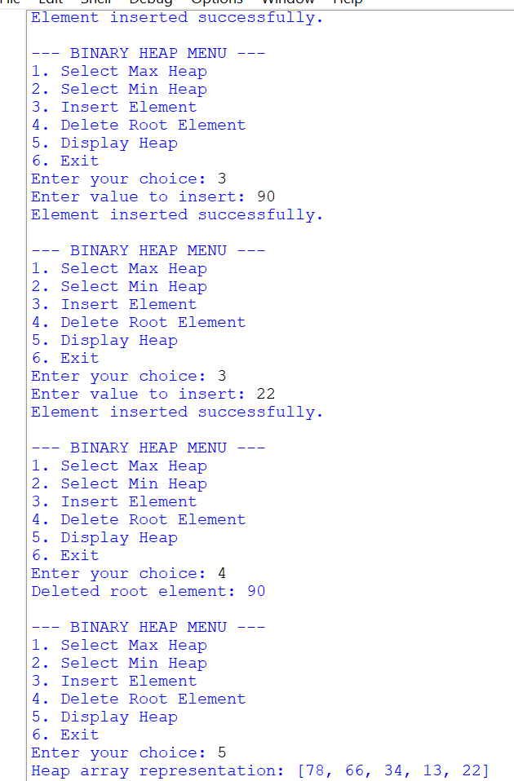
WEEK-12:
AIM: Write a program to implement the following three collision resolution techniques in a Hash Table:
- Separate Chaining
- Linear Probing
- Quadratic Probing
PROGRAM:

# Separate Chaining
def separate_chaining():
size = int(input("Enter hash table size: "))
table = [[] for i in range(size)]

n = int(input("Enter number of elements: "))

for i in range(n):
key = int(input("Enter key: "))
index = key % size
table[index].append(key)

print("Hash Table using Separate Chaining:")
for i in range(size):
print(i, ":", table[i])

# Linear Probing
def linear_probing():
size = int(input("Enter hash table size: "))
table = [None] * size

n = int(input("Enter number of elements: "))

for i in range(n):
key = int(input("Enter key: "))
index = key % size
count = 0

while table[index] is not None and count < size:
index = (index + 1) % size
count += 1

if count == size:
print("Hash Table is full. Cannot insert", key)
else:
table[index] = key

print("Hash Table using Linear Probing:")
for i in range(size):
print(i, ":", table[i])

# Quadratic Probing
def quadratic_probing():
size = int(input("Enter hash table size: "))
table = [None] * size

n = int(input("Enter number of elements: "))

for i in range(n):
key = int(input("Enter key: "))
index = key % size
j = 0

while j < size:
new_index = (index + j * j) % size

if table[new_index] is None:
table[new_index] = key
break

j += 1

if j == size:
print("Cannot insert", key, "- no empty slot found")

print("Hash Table using Quadratic Probing:")
for i in range(size):
print(i, ":", table[i])

# Main Menu
while True:
print("\n--- HASH TABLE MENU ---")
print("1. Separate Chaining")
print("2. Linear Probing")
print("3. Quadratic Probing")
print("4. Exit")

choice = int(input("Enter your choice: "))

if choice == 1:
separate_chaining()

elif choice == 2:
linear_probing()

elif choice == 3:
quadratic_probing()

elif choice == 4:
print("Exiting program.")
break

else:
print("Invalid choice.")
OUTPUT:


