Instructions

Setup.
For setup you need Apache webserver, mysql and Php. You can use wamp that combines all three.
You also need to run the sql script in the DBSchema folder. The script contains also some examples. If you want a clean setup then remove the Insert statements and enter a User in the Users table. Keep the data however if you want to see how our examples work.
You will also need a database management program such as phpmyAdmin.
The folders build, media and src are the source code from the media element open source HTML 5 video player.
http://mediaelementjs.com/

Running the app.

First you need to store videos in the database with the
/setup-videos/createvideo.php.
You need to give a video title and a URL from you tube

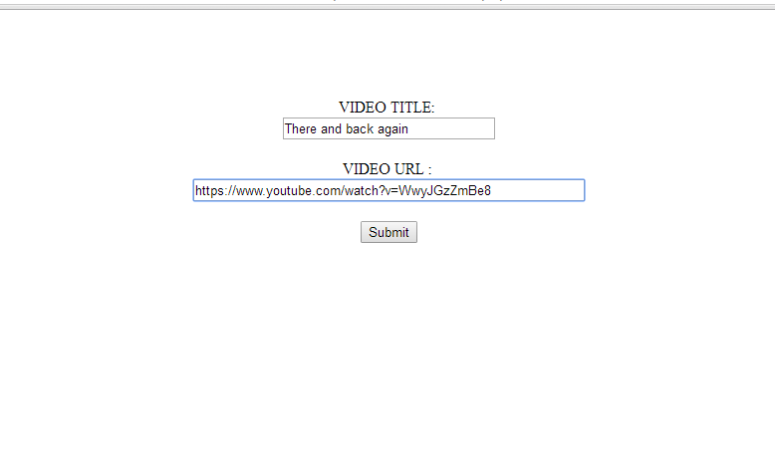
Fig. 1- Create Video

Then you are transferred to /setup-videos/previewvideo.php

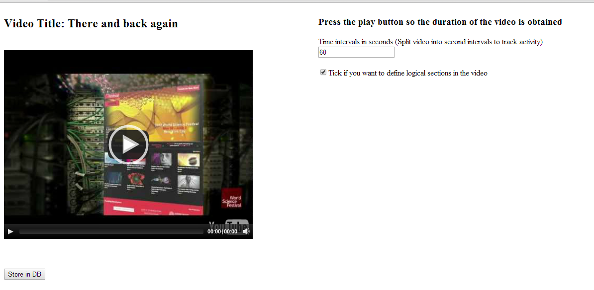
Fig. 2- preview video and define details

There you define the time interval sections (e.g 60 or 120 seconds). This are used for analytics purposes and act as marker points. When there is a change in the interval (while viewing the video) then an entry in the database will be stored.

If you are going to define logical sections (that will also show with a table of contents to aid navigation) then tick the box.

Press Play so the video starts playing. The duration will be acquired in this way.

By pressing the Button Store in DB the video details (title, Url, Duration) will be stored in the database.
(When storing in the Database use phpAdmin to check whether everything went OK).

Then you get to the choose /setup-videos/chooselements.php

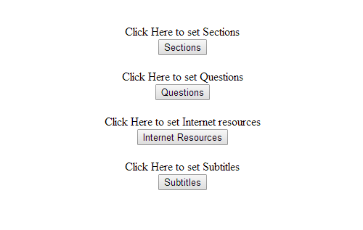
Fig. 3- Setting up elements

There you can define
a)logical sections for your video (that will show up also as a table of contents if you decide so,
b)Questions (multiple choice and open response)
c) Internet resources (web pages that will show up either as links that the user has to follow or as embedded webpages next to the video)
d) subtitles.

Sections

If you press the Sections button you will be transferred to the setup-videos/createsections.php script in order to define sections.

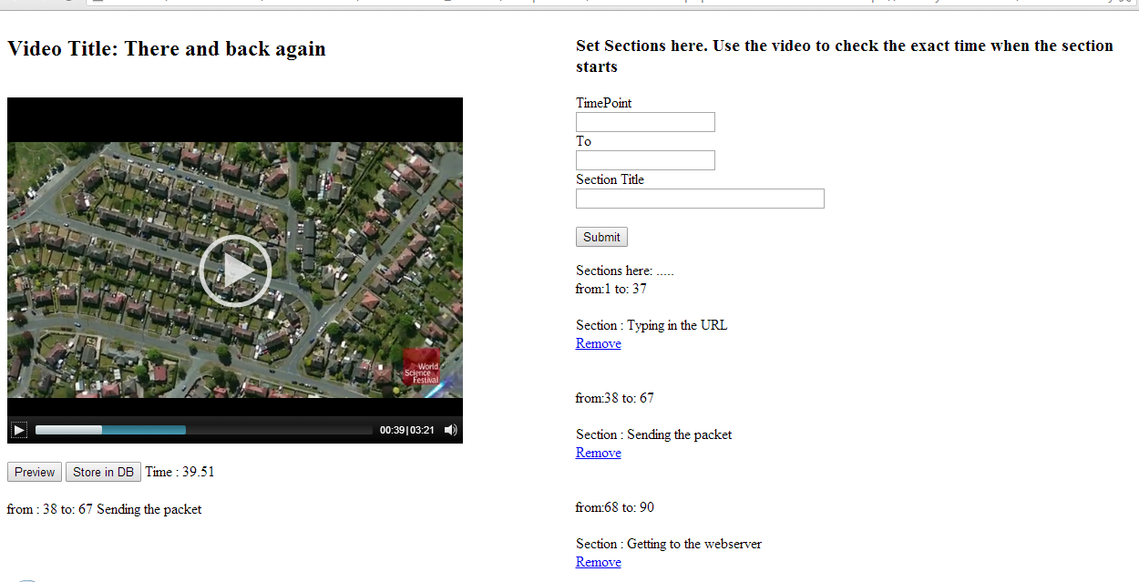
Fig. 4-Setting up logical sections

To define a section you give the Interval (From, to without decimal digits) and the section title.
You can look at the video time when the video is playing either on the player or at a label that shows when the video is playing.
Make sure you cover the video length with the defined intervals.
After you define the sections then you can Preview the outcome by pressing preview.
The section titles will show under the video at the intervals that you have defined.
If you are happy with the outcome then store in database.

send_sections.php script is used for storing in the database.

At this point there are no update functions (or delete functions) once things are stored in the database. You will have to use phpMyAdmin to do this.

Some short videos cannot probably divided in logical sections. In this case skip this step.

Press the return to choose other elements button to continue with setting up other elements.

Questions
If you press the Questions button you will be transferred to the setup-videos/ createquizquestions.php script in order to define Questions.

Questions work in the same way. You define the intervals (from, to in seconds).
It is best to choose the same value for both boxes.
You can define up to 5 answers for the multiple choice questions.
If no answers are written then it is assumed that it is an open response.
Once you define all the questions press preview to see the outcome.
Then store the quiz elements in the database by pressing Store in DB
The storing is done with the send_quiz_questions.php script

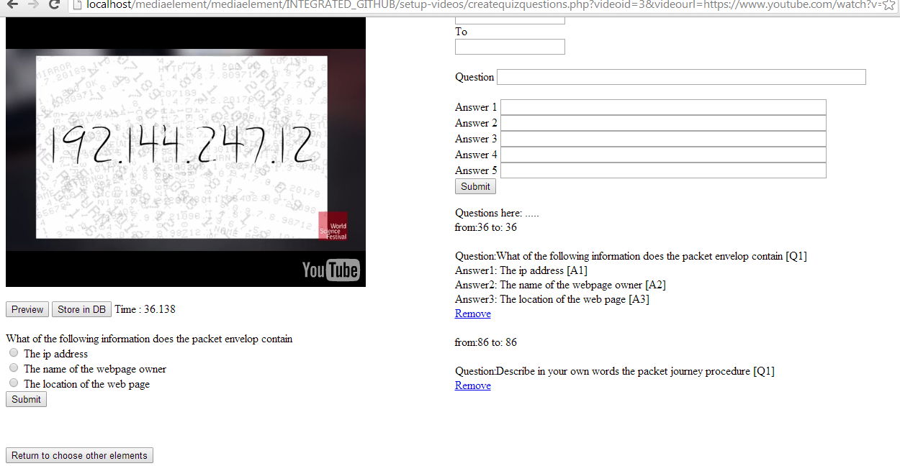
Fig. 5-Setting up Quiz Questions (Multiple choice & Open Response)

Internet Resources
If you press the Internet Resources button you will be transferred to the setup-videos/ createurls.php script in order to define Web Resources.

Here you can set any open internet recourses that you will like to show up next to your video at specific time points. If you just type in a URL then a url will show up at the appropriate time point. If you type in an embed code (<iframe src= ….></iframe> and tick the embed code check box then the webpage will be embedded next to your video.
The resources can be anything e.g webpages, google maps location, slideshare slides, google forms questionnaire etc.
The webpages can be also accommodated on your webserver. We used this option in order to incorporate activities created with hotpotatoes. In the display-videos folder we have one example.
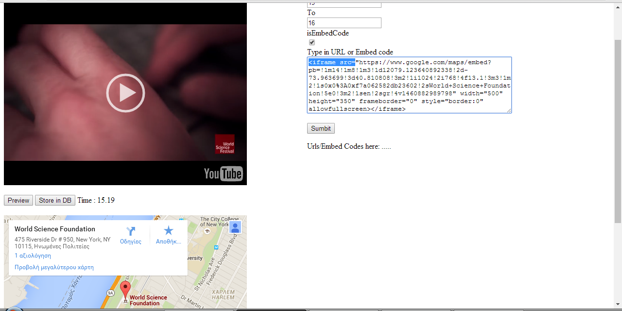
Fig. 6- Defining Internet Resources (e.g Google Map)

You can again Preview the Web Elements and store them in the database by pressing the right buttons.
The sendurls.php is used for storing the resources

Subtitles
Finally you can set subtitles using the same procedure.
By Pressing the Subtitles button you will be transferred to the setup-videos/ createsubtitles.php script in order to define Subtitles.

The storing is done with the sendsubtitles.php script

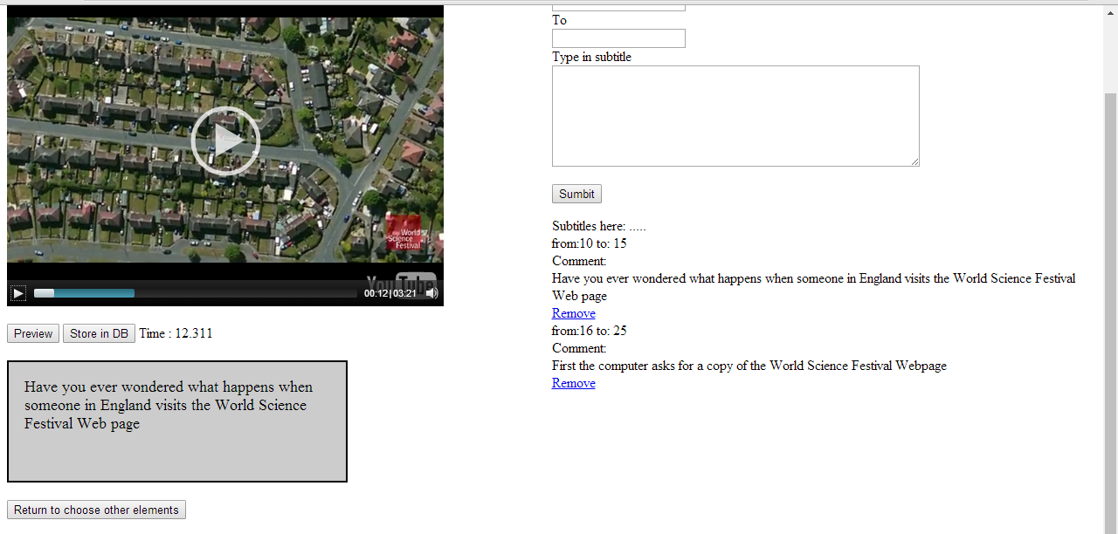
Fig. 7- Defining subtitles and subtitle intervals, Previewing and Storing in DB

Display Videos examples

In the folder Display Videos there are examples of scripts that are used to show elements next to videos.
If you go to the display-videos/start.php you will be directed to a webpage where you will have to follow a login procedure in order to access the videos.
Remember than in our settings this is necessary since we also track analytics abour the viewing and activity behavour.

You can create your own database users using the phpmyAdmin.
Otherwise use Alex as username and 123 as password

Then you will be redirected to a webpage containing examples.
If you kept the entries in the database at database setup then you will see our examples.

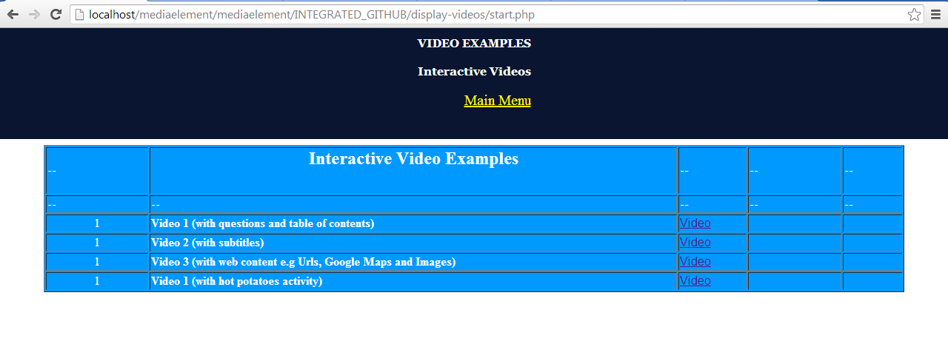

If you press Video 1 (display_video_questions_table_of_contents.php)

You will see the sections defined for video 1 (table of contents) as well as the questions defined for this video.

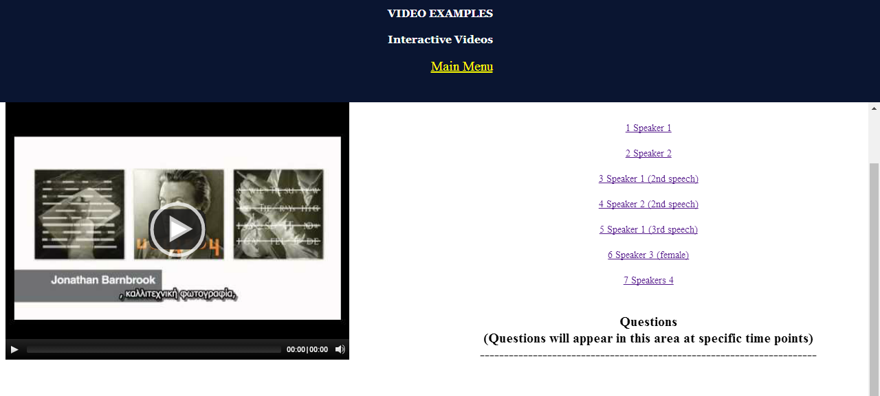

All the viewing and interaction activity is stored in the session_events table of the database.

By looking at the script you will notice that some things are hardcoded
(e.g events CONST_LOADSTART=1; CONST_SECTION_ENTER=2, CONST_PLAY=3) and are not included for the time being in a database table.

There are also examples with Subtitles, Open Internet Resources and Hotpotatoes.

We will also provide examples where other APIs are called (e.g wikipedia, slideshare etc) or where other apps are incorporated (e.g etherpad), in the near future.

My contact mail is
Kleftodimos@gmail.com

