References:

[Intellectual Property Management Office](https://www.pup.edu.ph/research/ipmo/?fbclid=IwAR3QKd1HIY91vzJeJATcoI3LJZqCtkV8AjeJf-ULB9xbyCwW4cvwO9qWzog) [Document Templates](https://drive.google.com/drive/folders/1y-Je3oiGH0kkU9BVgPoevpZKtu7UH47M?usp=sharing) [Manuscript Folder from Ma’am Dastas](https://drive.google.com/drive/folders/1WChzW9XMeY-3m5i9kw-6PWwrzn3pRFoE?usp=sharing)

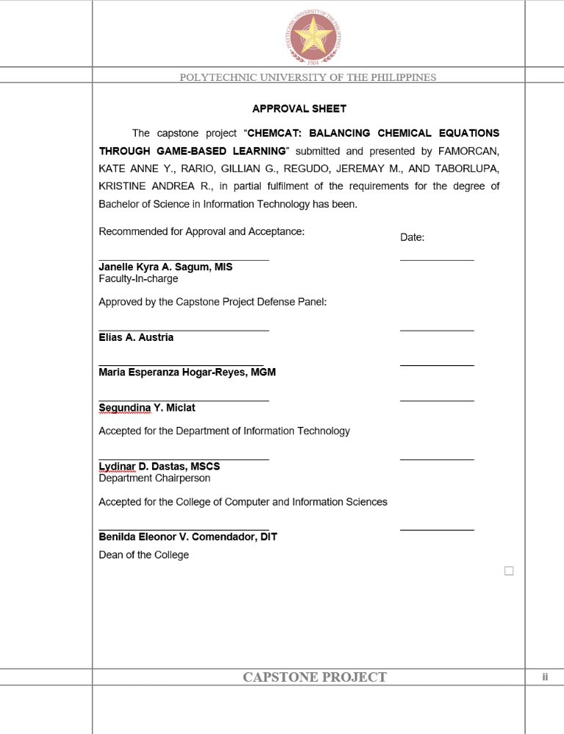

# Turnitin results should be 15% or below.

* Add the result to the Appendices.

# Signing of Approval Sheets

1. Print 7 copies of approval sheet:

* 1 - College
* 3 - Panelists
* 1 - Adviser
* 1 - IPMO
* 1 - Hardbound manuscript

1. All 7 copies should be signed by the Panelists,   
   Department Chairperson, Dean of the College

# Final Proofreading by Grammarian

* Get a Proofreader's Certificate
* Edit the Final Manuscript following the   
  [University Thesis Manual](https://drive.google.com/file/d/15G83blxMLln6JMf5zgyoiP0dEDwwijts/view?usp=sharing) **but retain the borders.**

# Copyright Application

1. Requirement Preparation ([Document Templates](https://drive.google.com/drive/folders/1y-Je3oiGH0kkU9BVgPoevpZKtu7UH47M?usp=sharing))

* Fill-out all the Copyright Application forms and Affidavit of Co-ownership in triplicate copy (3) duly signed by the author/s and have it notarized.
* Fill-out the recordal slip and acknowledgement receipt.
* Pay the amount of Three Hundred Pesos (PHP 300.00) at the Cashiers’ Window 1. Secure the Receipt. (Refer to picture below for full amount)
* No description available.
* Prepare the following documents: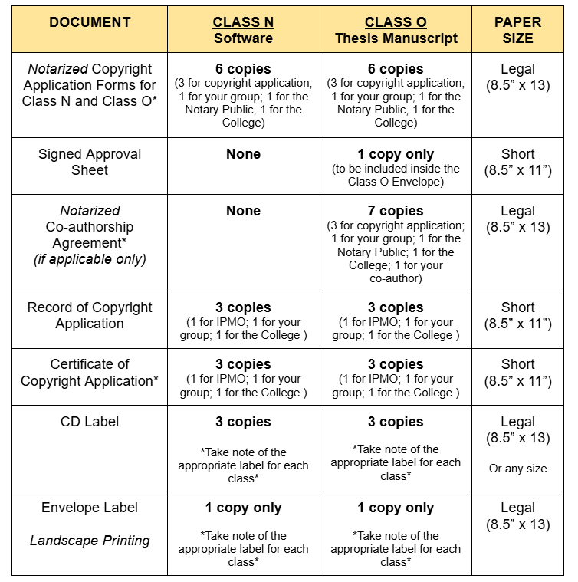

1. Requirements for Submission

* In your college color coding envelope with a label at the back of the envelope. (College, Program, Title, Author/s, Adviser)
* Triplicate (3) copy of Copyright Application forms and Affidavit of Co-ownership with signature/s of author/s and duly notarized.
* Recordal slip and acknowledgement receipt.
* 1 copy of Approval Sheet with complete signature/s.
* Original receipt of payment
* 3 copies of manuscript/thesis/dissertation in Whole Manuscript and Journal Publication Format in CD form with CD case and label.

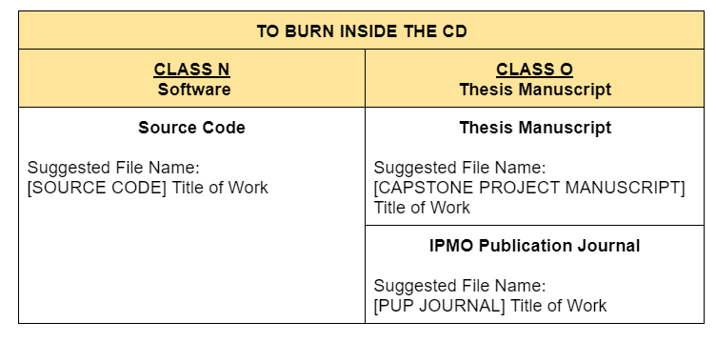

* For the CD Cover, follow this template CD Cover Template
* Submit the envelope containing all the requirements to IPMO-ITSO-CTTED Office

# Submission of Manuscript

* 1 Hardbound manuscript for CCIS