INSY 8311 - Database Development with PL/SQL
Individual Assignment I: SQL JOINs & Window Functions Project
Student ID: 27226 | Name: LENDZONDZO KLEIN CHRIST
Date: 08 FEBRUARY 2026

STEP 1 : Problem definition
STEP 1: Problem Definition
1. Business Context
The CIRMF is a high-level research center based in Franceville, Gabon, since 1979. Its main specialty is infectious diseases. It is also the national reference center for diagnosing serious viruses such as Ebola. Because of their unique expertise, they receive a large number of patients from different regions for highly specific tests that are not available elsewhere.
Type of structure: Franceville International Center for Medical Research (CIRMF), a level 1 research center of excellence located in Franceville, Gabon.
Department: Scientific Directorate / Epidemiology and Diagnostic Unit.
Sector of activity: Public health / Medical research / Virology.
2.Data Challenge
Currently, the organization is in a bit of a mess: patient information, staff schedules, and care histories are scattered across several different systems. This fragmentation poses a real problem for management. Specifically, it's impossible for them to properly analyze treatment effectiveness by region, manage doctors' workloads, or accurately track the costs of various illnesses.
- Expected Outcome
The idea is to install a centralized relational database to bring everything together. By using window functions, we can finally analyze the data properly. This will allow us to target the highest-risk geographic areas, better allocate staff where they are truly needed, and precisely track the evolution of costs for each disease. It's the missing tool for managing the center intelligently.
Step 2: Database Schema Design
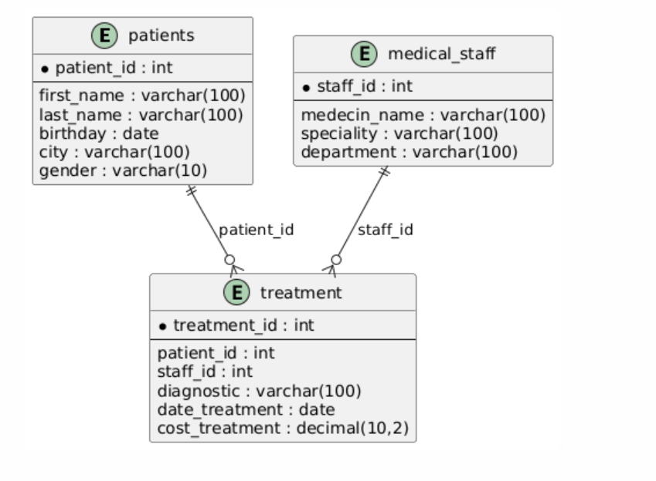
Step 3: Success Criteria
- The analysis will be considered successful if we can answer the following questions using the window functions:
1. Ranking of costly diseases: Identify the 3 most expensive treatments per medical department (RANK()).
2. Cumulative financial tracking: Calculate the total cumulative revenue generated by consultations month by month (SUM() OVER()).
3. Time comparison: Analyze the evolution of a patient's treatment costs compared to their previous visit (LAG()).
4. Patient segmentation: Classify patients into 4 groups based on their visit frequency to target medical follow-up (NTILE(4)).
Moving average of cases: Calculate the 3-month moving average of treatment costs to smooth out seasonal variations (AVG() OVER()).

Step 4 : Implémentation des JOINs SQL
Part A: SQL JOINs
1. INNER JOIN
Objective: List all treatments with associated patients and physicians.
2. LEFT JOIN
Objective: Identify patients with no recorded treatments.
3. RIGHT JOIN
Objective: Detect inactive physicians (no treatments administered).
4. FULL OUTER JOIN
Objective: Complete patient/physician view including unmatched records.
5. SELF JOIN
Objective: Compare patients from the same city of origin.
See screenshots in the folder screenshots
4. Distribution Functions
- NTILE(4): Segmentation into cost quartiles
- CUME_DIST(): Cumulative distribution
Step 5 : Implémentation des Fonctions de Fenêtre
Part B: Window Functions
1. Ranking Functions
- ROW_NUMBER(): Sequential numbering of treatments
- RANK(): Ranking of treatments by cost
- DENSE_RANK(): Dense ranking by department
2. Aggregate Window Functions
- SUM() OVER(): Cumulative totals per patient
- AVG() OVER(): Moving average of costs
3. Navigation Functions
- LAG(): Comparison of previous treatment
- LEAD(): Prediction of next treatment
Step 6: Analyse
- Descriptive analysis
This query was designed to rank treatments based on their cost, segmented by medical specialty.
In our current data, each specialty has only one entry, which explains why all results are assigned the first rank. However, the strength of this function lies in its ability to make relative comparisons: with a larger dataset, it would generate a hierarchical ranking (1, 2, 3, etc.) allowing for the instant identification of the most expensive treatments within a given discipline.
- Diagnostic analysis
Here, I calculated the cumulative total of treatment costs over time. The result shows a steady progression: 150,000 to 350,000 to 400,000 to 650,000. This illustrates how medical expenses accumulate chronologically. This approach is useful for tracking overall financial trends and identifying periods of high or stable spending.

- Prescriptive Analysis
The query using LAG() was supposed to compare the current cost of a treatment with the cost of the previous one for each patient. In my results, the previous_cost and cost_variation columns are both NULL because each patient only has one treatment recorded. This shows that the function is correctly configured. With multiple treatments per patient, you would see positive or negative differences, revealing individual trends.

Step 8: References
1. MySQL Documentation. (2025). *Window Functions*. Oracle Corporation.
https://dev.mysql.com/doc/refman/8.0/en/window-functions.html
2. Ben-Gan, I. (2022). *T-SQL Window Functions: For Data Analysis and Beyond*.
Microsoft Press.
3. CIRMF (2024). *Annual activity report*. Franceville, Gabon.
4. Beaulieu, A. (2020). *Learning SQL: Generate, Manipulate, and Retrieve Data*.
O’Reilly Media.

Final Checklist
- Repository is public and accessible ☒
- SQL runs without errors ☒
- Screenshots included ☒
- README is clear and professional ☒
- JOINs and Window Functions completed ☒
- References and integrity statement included ☒

