PERFORMANCE TASK #2
Evaluator: Klein Timothy A. Magallano
Recipient: Ben Jay Lozada
Date: April 15, 2026
Subject: ITE-16
Section: JK1

Evaluation:

i. The diagram can mostly perform database operations without any critical issues. However an anomaly is identified in the “Customer” entity, that is an insertion anomaly. If a new customer is added to the database, one must manually input their first, middle, and last names as well as their contact number (e.g. mobile_number, work_phone, emergency_contact, etc.). If we do not know each of these, it could compromise data integrity. Other than this, no apparent anomalies are identified in the diagram.

ii. 2NF Normalization is violated in the “Customer” entity. This is due to multi-valued attributes such as mobile_number and work_phone. “Customer” may have many mobile numbers and thus 1NF is violated. Since a requirement of a 2NF normalization specifies that the table must be 1NF, it also violated 2NF. Consequently, a separate table is necessary to facilitate and resolve this in order to bring the table to 2NF.

Iii. The diagram’s issues can be mitigated by creating a new table called “Contact Method”. Through this, the attributes listed above can be removed from the “Customer” entity and is handled by the “Contact Method” entity. “Customer” has a optional many relationship with “Customer Method” and “Customer Method” has a mandatory one relationship with “Customer”. It shall have a identifying relationship with “Customer Method” being the weak entity to satisfy the condition that if a customer has to be deleted, their contact methods shall be as well.

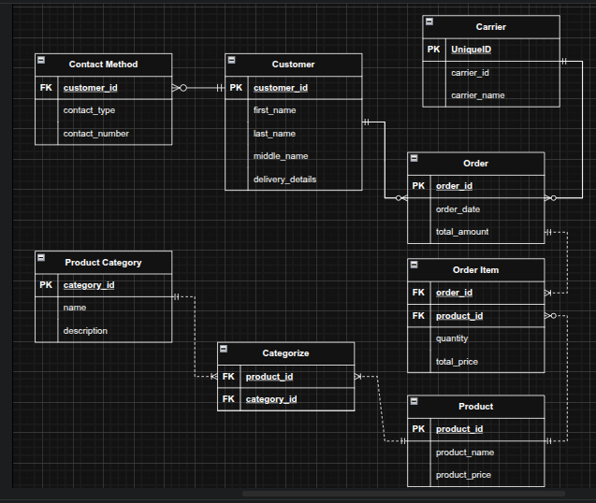

Conclusion:
Overall, the diagram is adequate and mostly passes the criteria of the activity. However due to a minor blunder, unfortunately, the owner of this diagram has to get lesser points. Despite that, other entities in the ERD reflects the owner’s understanding of the fundamentals of ERD design. The diagram can handle M:M relationships through Associative Entities. Furthermore, it displays logical organization and clarity and accurate usage of cardinality symbols.

Scoring:
Critique & 2NF – 3NF Analysis 16pts
Diagram Clarity & Standards 10pts
M:M Resolution 10pts
Cardinality Accuracy 5pts
Relational Integrity 5pts

Total 46pts

Reference:
https://drive.google.com/file/d/1biQ2Igf2zd_AEhZaSGJU4JIeHitUCkKD/view?usp=sharing

