Job Details
Job Name | TerminateRun
Job Function | Sends WPS request to terminate agreements of cus/syscaned outlets
Control-M Setup | Script Name – sbbmcr070_terminate.ksh  Script Path location –  SBWPTQMPRD  /apps/PRD/batch/batch_env/src/java/TerminateRun/  Owner/User – esbbtprd  Input Parameters to pass to script– n/a
Input Requirements | None
Output  Produced | None
Database(s) Accessed | SCSAP1P (SB Prod CSC), SCHAP1P (SB Prod CHD)
Audit Considerations  (PCI/SAO/DP) | n/a
Business Owner of Service | esbbtprd
NFT – Sign-off required | n/a

SCHEDULING & RECOVERY
Predecessor Jobs | SBPD-VIRTUAL-MIDNIGHT-SKYBUS
Successor Jobs | None
Scheduling | Nightly after SBPD-VIRTUAL-MIDNIGHT-SKYBUS  With first run to be scheduled from 2nd of December 2015  *NOTE* if this date changes we will contact production control to advise.
Business Impact of Failure | Accounts will not be terminated
Recovery Action – Operations | An incident should be raised and assigned to Sky Business WPS Support who can investigate in the morning. No Callout is required.
Recovery Action – Support Team | n/a
Disaster Recovery | Can be run on contingent host.
Outages / Failovers – | n/a
Callout | No Callout is required upon failure – an incident should be raised instead and assigned to Sky Business WPS Support who can investigate.

Additional Information

Introduction –  Description of the process and overview of the functions. | Job will extract independent accounts that are sys or cus canceled and will terminate any active agreements.  Job follows standard Osprey Batch logging process by updating sbreport.runsummary table with run times, processing volumes and outcomes.
Reference To other Documents -  Links to Share-point sites or shared drives if required | n/a
Normal Availability –  Database or/and server requirements. | n/a
Configuration / Inventory Details –  This can be Database logons, FTP configuration, Oracle Batch processes, | n/a
Any other Relevant Information –

Exit Codes –  This is for exit codes and recovery actions required. | Ctrl-M Exitcode =0  The Exit code being returned from the java program is 0 then the .sh will proceed to completion.  Ctrl-M ExitCode =99  Abnormal ending of the java program(exit code -1)  Job to be Set as ‘FAIL’, Trouble Ticket raised.  To be reported in the daily batch report

Operational Flowchart
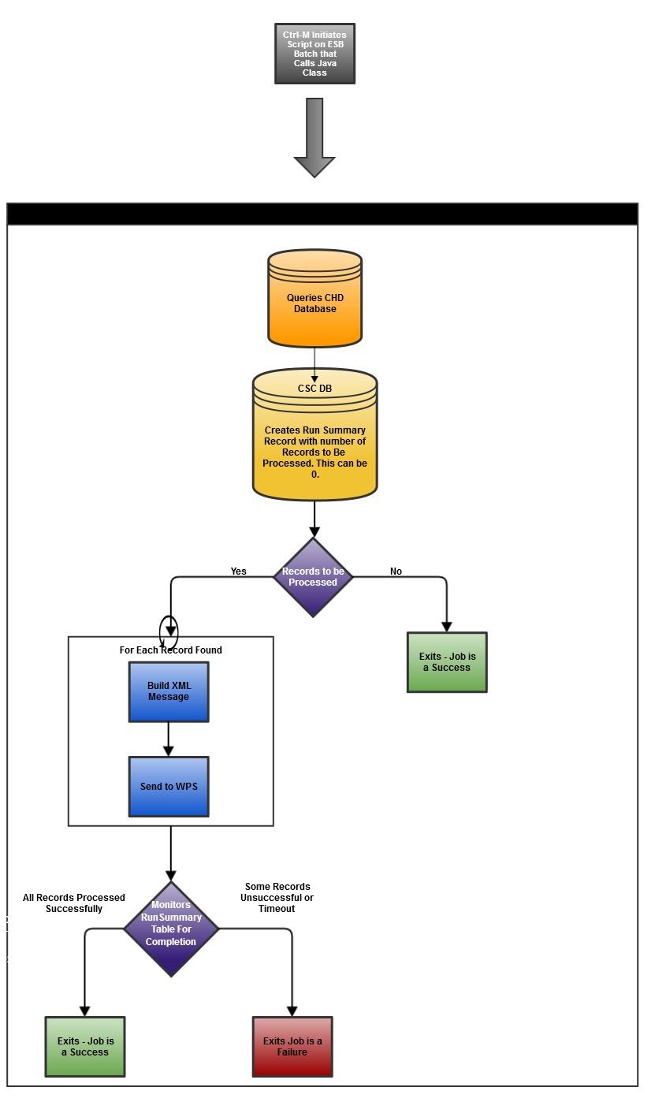

Network Infrastructure
n/a

