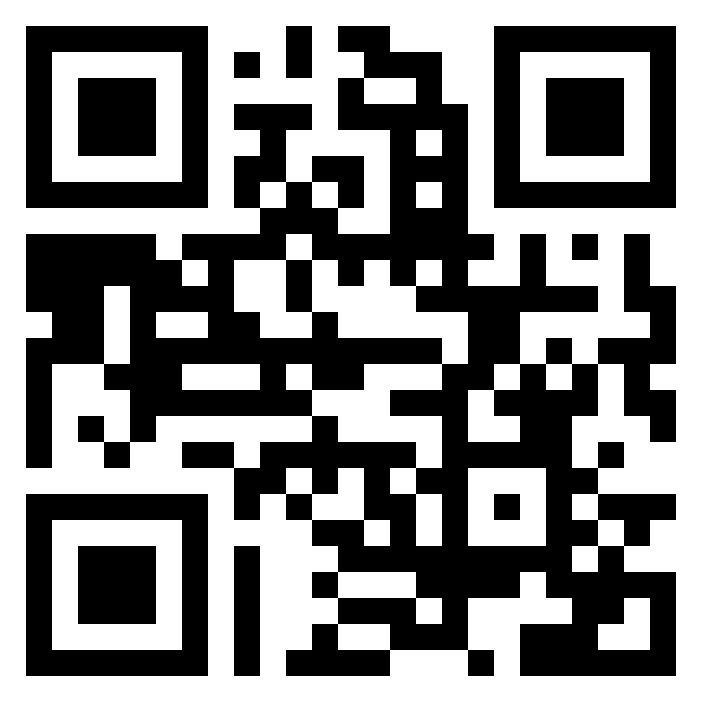

REZULTATI / RESULTS

https://cerknocup.updog.co/

