Aufgabe 1
1.1
Code
SELECT last_name, hire_date
FROM employees
WHERE hire_date >= TO_DATE('01.01.1999', 'DD.MM.YYYY')
AND hire_date < TO_DATE('01.01.2000','DD.MM.YYYY');
Ausgabe
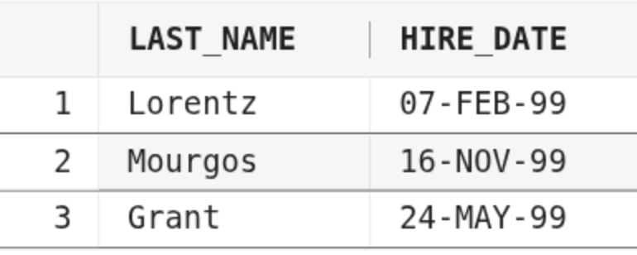
1.2
Code
SELECT last_name, salary, commission_pct,
ADD_MONTHS(TRUNC(hire_date, 'MM'), 24)
FROM employees
WHERE commission_pct IS NOT NULL;
Ausgabe
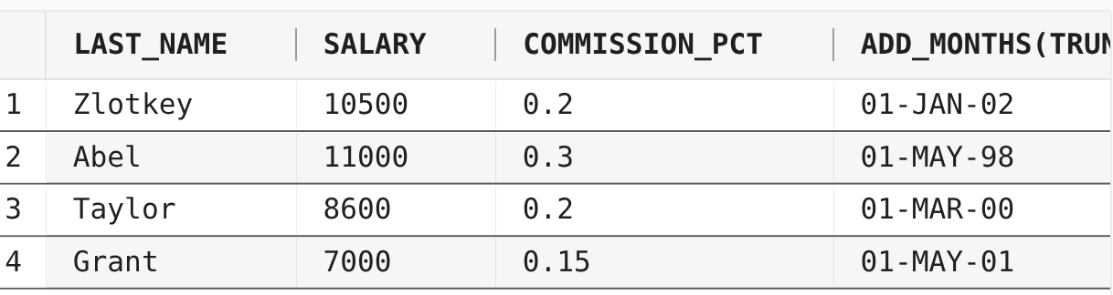
1.3
Code
SELECT last_name, hire_date,
TRUNC(MONTHS_BETWEEN(hire_date, (
SELECT hire_date
FROM employees
WHERE last_name = 'King')) / 12)
AS Jahresunterschied
FROM employees
WHERE department_id = 20 OR department_id = 50
ORDER BY Jahresunterschied DESC;
Ausgabe
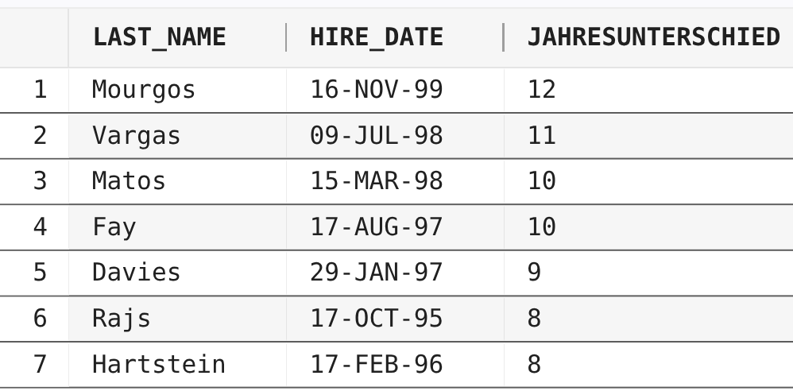

1.4
Code
SELECT first_name, last_name, hire_date
FROM employees
WHERE hire_date > (SELECT hire_date
FROM employees
WHERE last_name = 'Davies');
Ausgabe
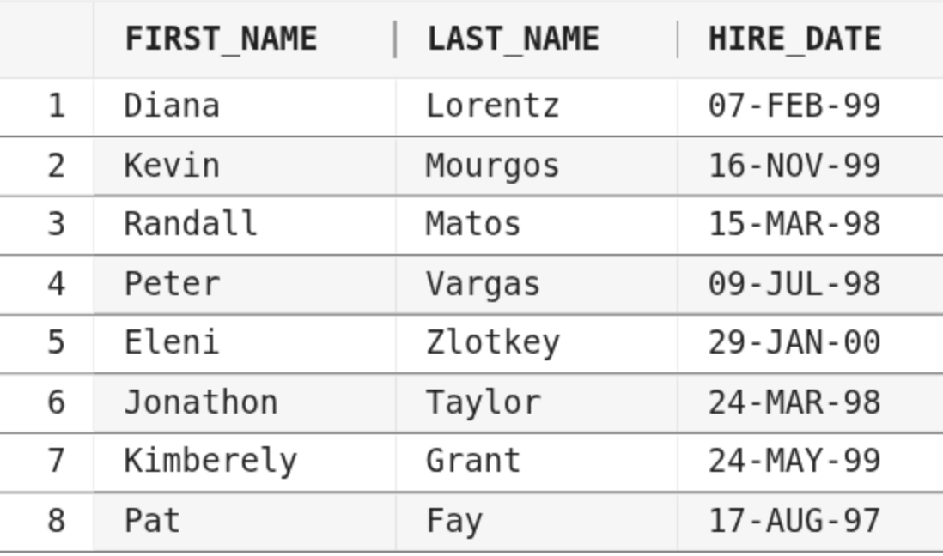

1.5
Code
SELECT e.first_name, e.last_name, e.salary
FROM employees e
JOIN employees m ON e.manager_id = m.employee_id
WHERE e.salary > m.salary AND e.hire_date < m.hire_date;
Ausgabe
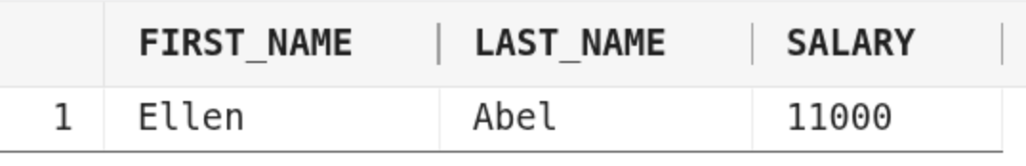

Aufgabe 2

2.1
Code
SELECT last_name
FROM employees
WHERE last_name LIKE '%e_';
Ausgabe
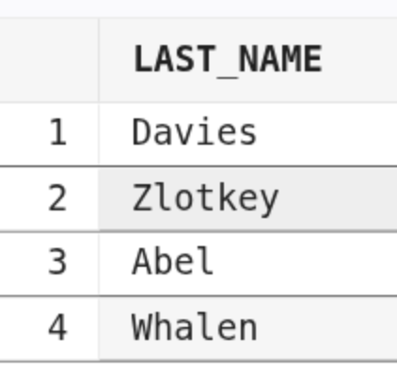

2.2
Code
SELECT last_name
FROM employees
WHERE REGEXP_LIKE(last_name, '^.e.*');
Ausgabe
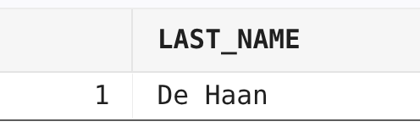

2.3
Code
SELECT last_name
FROM employees
WHERE REGEXP_LIKE(last_name, 'a.*a');
Ausgabe
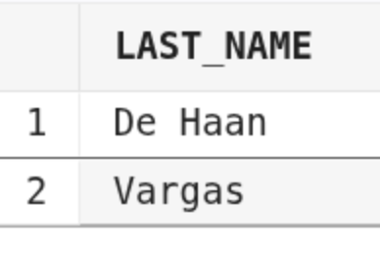

2.4

Code
SELECT employee_id, first_name, last_name,
UTL_MATCH.JARO_WINKLER_SIMILARITY(UPPER('Margos'), UPPER(last_name)) AS similarity
FROM employees
ORDER BY similarity DESC;
Ausgabe
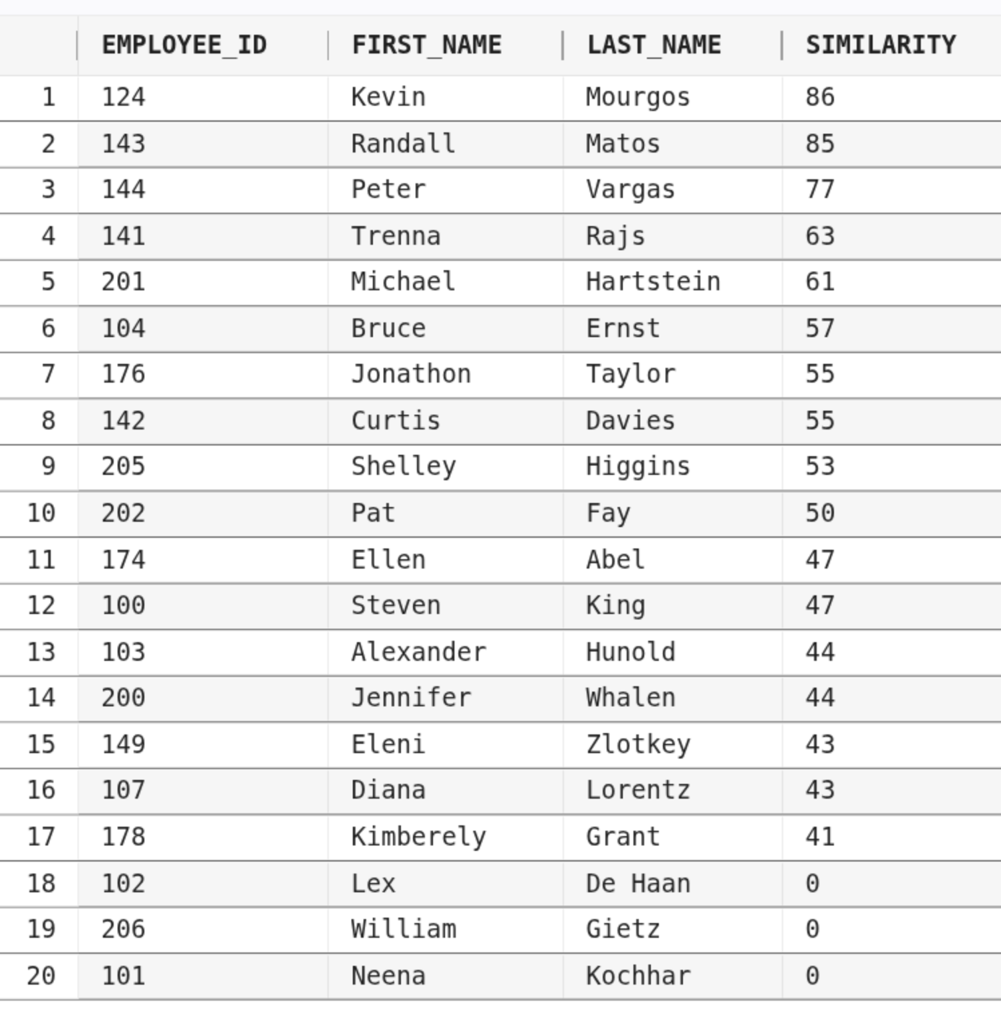

2.5
Code
SELECT employee_id, first_name, last_name,
UTL_MATCH.JARO_WINKLER_SIMILARITY(UPPER('Irena Mays'),
UPPER(first_name || ' ' || last_name)) AS similarity
FROM employees
ORDER BY similarity DESC;
Ausgabe
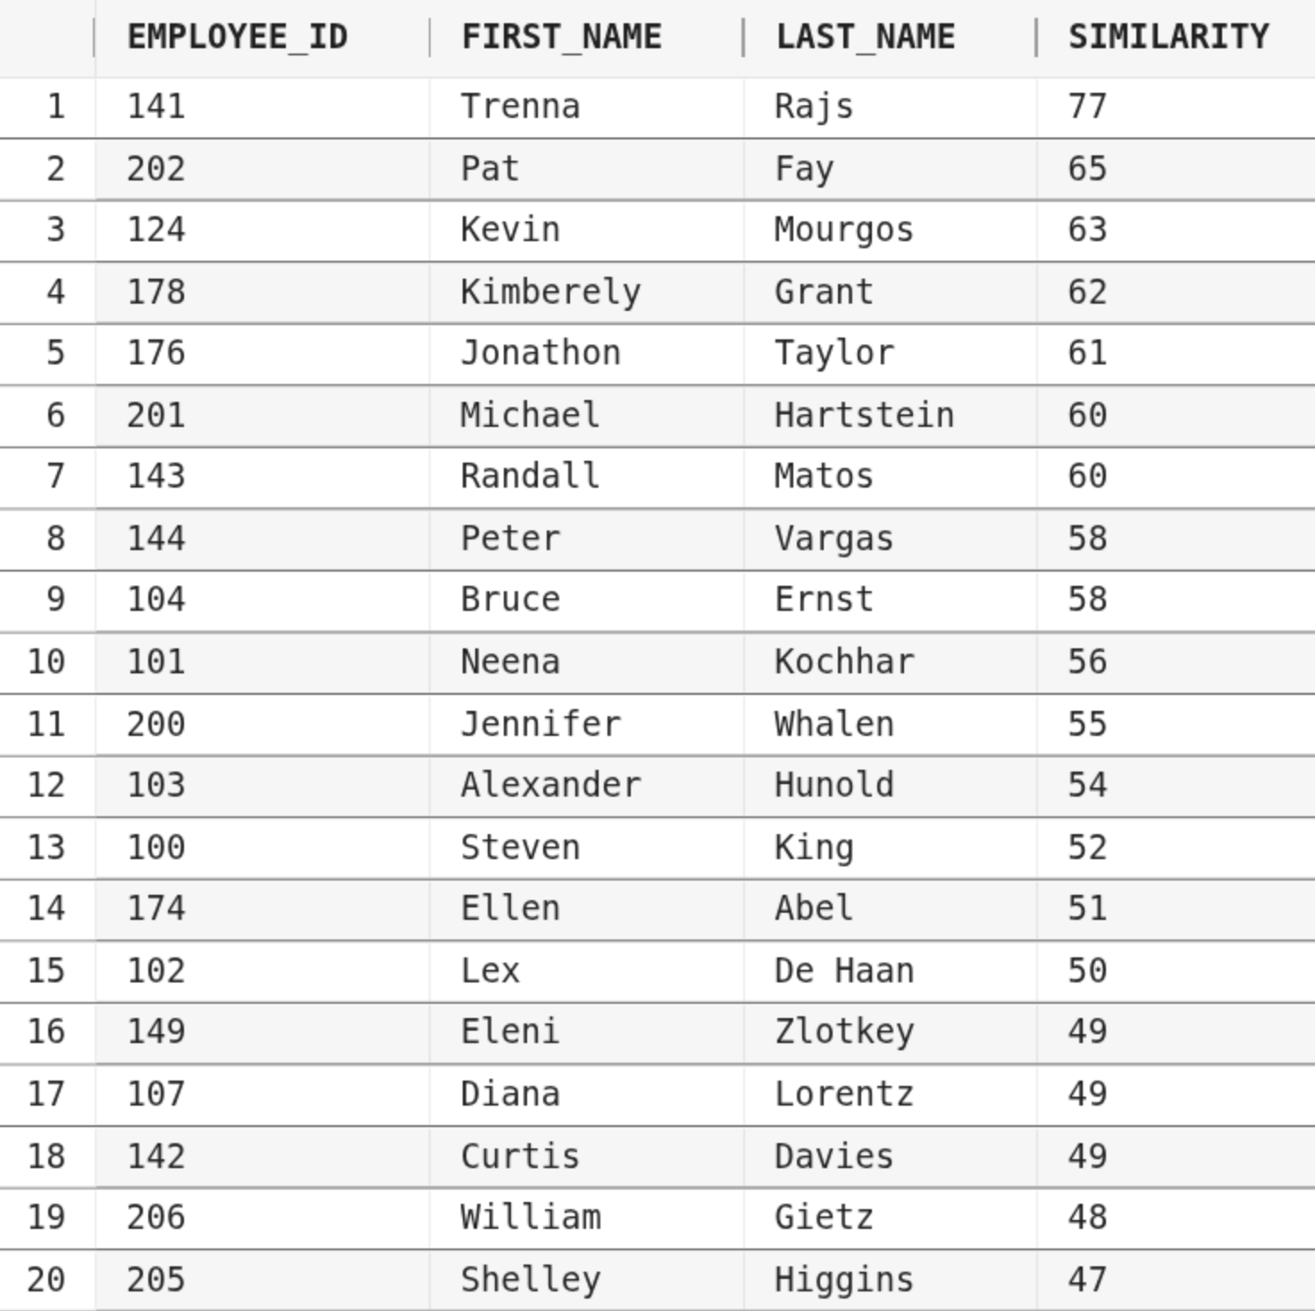

Aufgabe 3

3.1
Code
SELECT country_id, COUNT(*)
FROM employees
JOIN departments USING(department_id)
JOIN locations USING(location_id)
WHERE salary NOT BETWEEN 5000 AND 12000
GROUP BY country_id;
Ausgabe
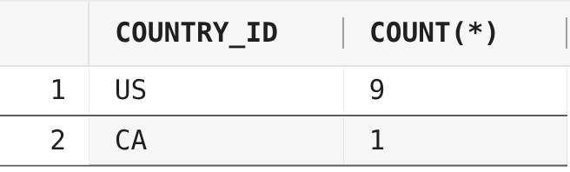

3.2
Code
SELECT last_name, job_id, salary
FROM employees
WHERE job_id IN ('SA_REP', 'ST_CLERK')
AND salary NOT IN (2500, 3500, 7000);
Ausgabe
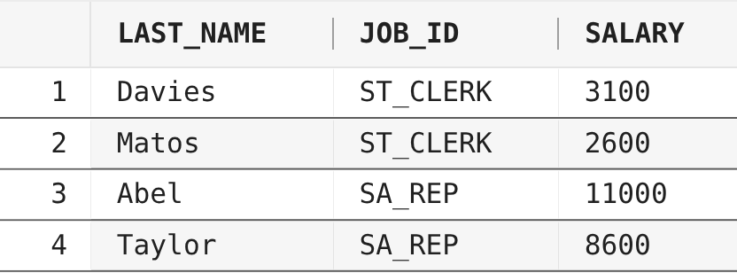

3.3
Code
SELECT jg.grade_level AS Gehaltsstufe,
department_name AS Departmentname,
COUNT(employee_id) AS Mitarbeiteranzahl
FROM employees
JOIN departments USING(department_id)
JOIN job_grades jg
ON salary BETWEEN jg.lowest_sal AND jg.highest_sal
GROUP BY jg.grade_level, department_id, department_name;
Ausgabe
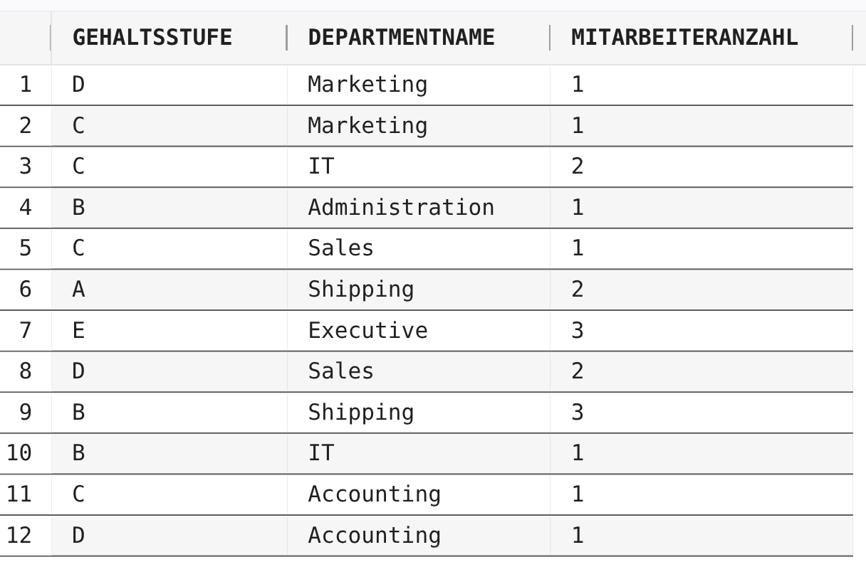

3.4
Code
SELECT department_name, COUNT(employee_id)
FROM employees
RIGHT JOIN departments USING(department_id)
-- durch den right-join bleibt die rechte
-- Tabelle vollständig erhalten
-- NULL-Werte in employee_id
-- werden von COUNT nicht berücksichtigt
-- daher ist COUNT dann 0
GROUP BY department_id, department_name
HAVING COUNT(employee_id) < 3;
Ausgabe
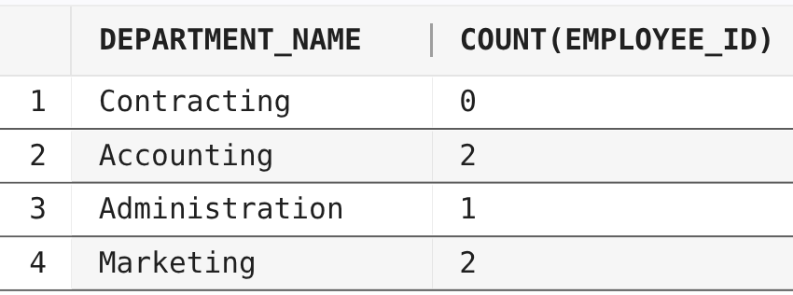

3.5
Code
SELECT department_name
FROM employees
RIGHT JOIN departments USING(department_id)
GROUP BY department_id, department_name
HAVING COUNT(employee_id) = (
SELECT MAX(COUNT(employee_id))
FROM employees
GROUP BY department_id
);
Ausgabe
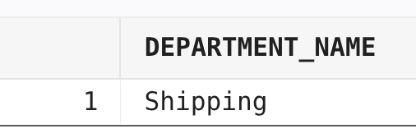

3.6
Code
SELECT dep.department_name,
COALESCE(m.last_name, 'position vacant')
FROM departments dep
LEFT JOIN employees m -- manager_id kann null sein
ON dep.manager_id = m.employee_id;
Ausgabe
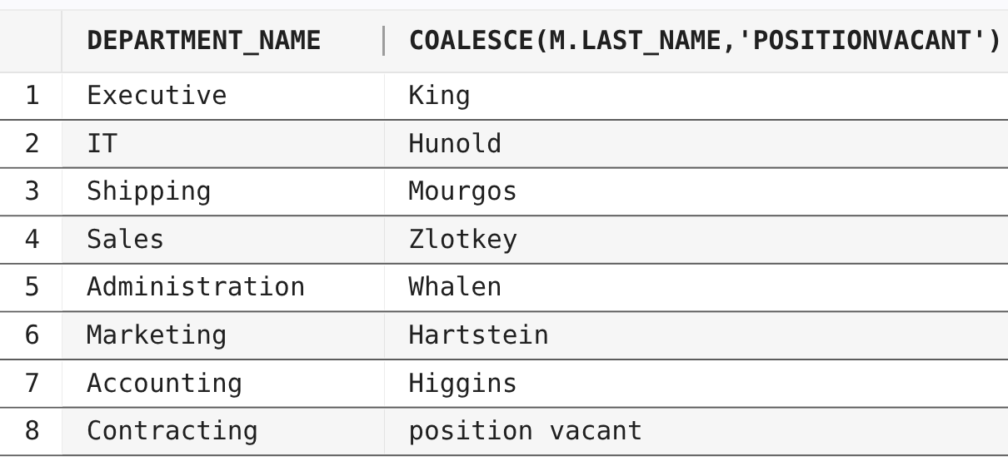

3.7
Code
SELECT emp.last_name, emp.salary, emp.job_id
FROM employees emp
WHERE salary < 5000
OR salary < (
SELECT AVG(salary)
FROM employees emp_sal
WHERE emp.job_id = emp_sal.job_id
);
Ausgabe
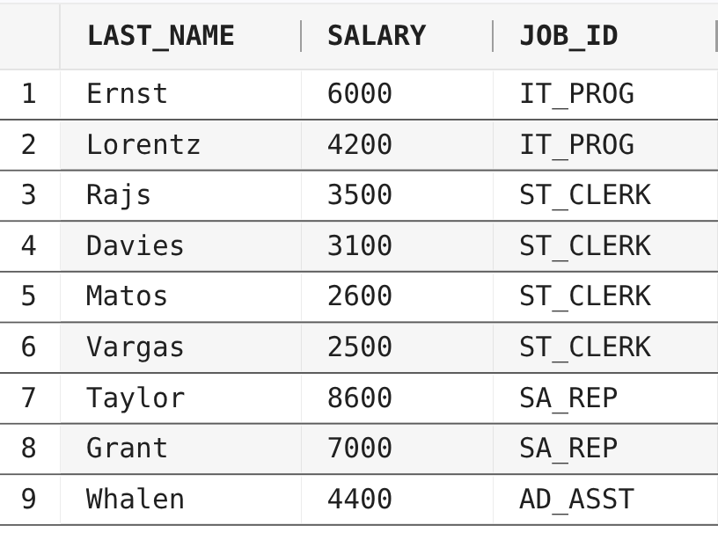

3.8
Code
SELECT department_id, department_name, location_id
FROM departments
WHERE department_id NOT IN (
SELECT department_id
FROM employees
WHERE job_id = 'SA_REP'
AND department_id IS NOT NULL
-- wichtig weil sonst könnte der Ausdruck unknown sein
);
Ausgabe
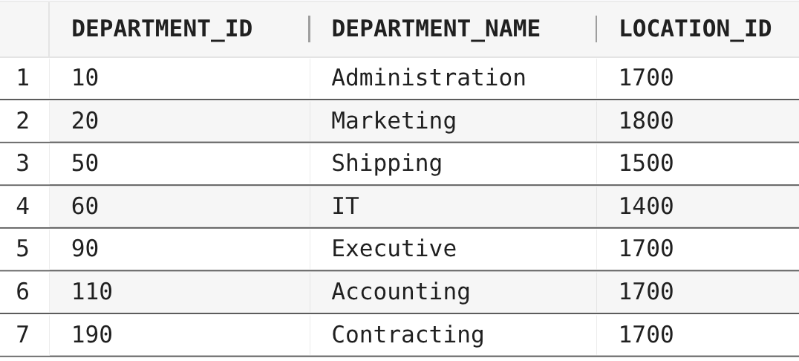

3.9
Code
SELECT department_id
FROM employees
JOIN departments USING(department_id)
WHERE department_id IS NOT NULL
GROUP BY department_id
HAVING COUNT(DISTINCT job_id) = 1;
Ausgabe
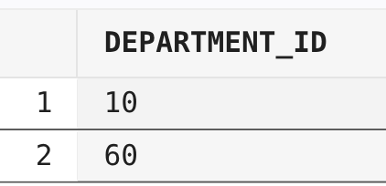

3.10
Code
SELECT last_name, job_id, department_id
FROM employees
WHERE (job_id, department_id) IN (
SELECT job_id, department_id
FROM employees
WHERE employee_id IN (103, 142)
) AND employee_id NOT IN (103, 142);
Ausgabe
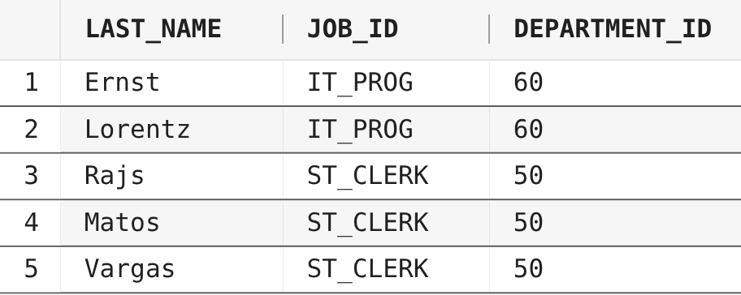

3.11
Code
SELECT last_name || ', ' || job_id AS EmployeeAndJob
FROM employees e1
ORDER BY (
-- Durchschnittsgehalt der Abeilung
SELECT AVG(salary)
FROM employees e2
WHERE e2.department_id = e1.department_id
) DESC NULLS LAST;
Ausgabe
