Aufgabe 1

1.1
Code
SELECT MAX(salary) AS Maximum,
MIN(salary) AS Minimum,
SUM(salary) AS Summe,
AVG(salary) AS Durchschnitt
FROM employees
WHERE job_id = 'SA_REP';
Ausgabe

1.2
Code
SELECT job_id,
ROUND(MAX(salary), -3) AS Maximum,
ROUND(MIN(salary), -3) AS Minimum,
ROUND(SUM(salary), -3) AS Summe,
ROUND(AVG(salary), -3) AS Durchschnitt
FROM employees
GROUP BY job_id;
Ausgabe
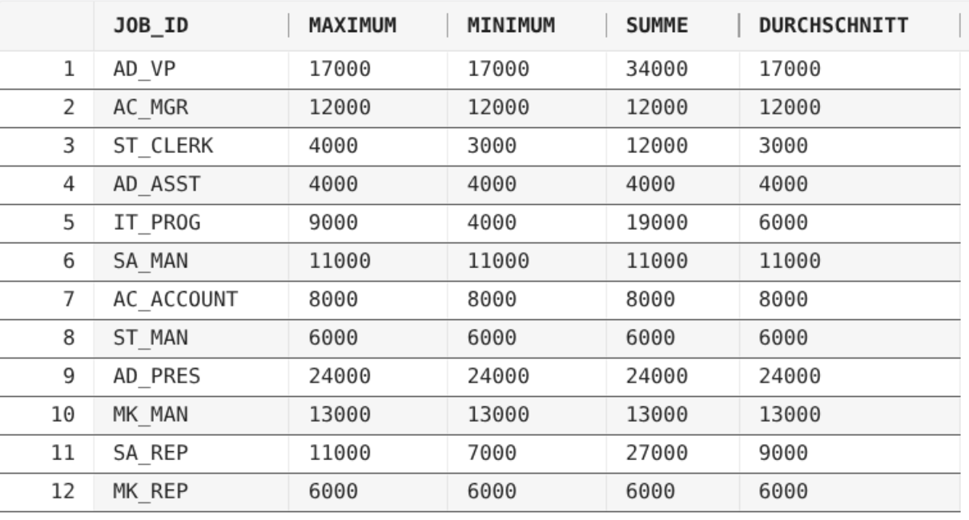

1.3
Code
SELECT COUNT(DISTINCT job_id) AS Jobanzahl
FROM employees;
Ausgabe


1.4
Code
SELECT country_id
FROM locations
GROUP BY country_id
HAVING COUNT(location_id) > 1;
Ausgabe


1.5
Code
SELECT department_id,
department_name,
AVG(salary)
FROM employees JOIN departments USING(department_id)
GROUP BY department_id, department_name
ORDER BY AVG(salary) ASC;
Ausgabe
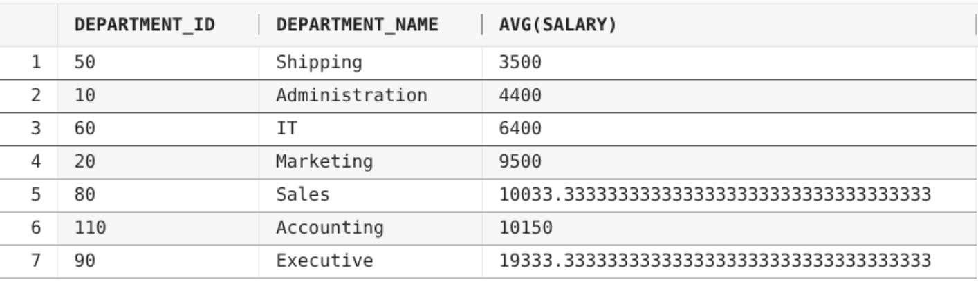

1.1
Code
Ausgabe

1.1
Code
Ausgabe

1.1
Code
Ausgabe

1.1
Code
Ausgabe

1.1
Code
Ausgabe

1.1
Code
Ausgabe

