

Functional Safety Concept Lane Assistance

**Document Version: [Version]**



# Document history

|  |  |  |  |
| --- | --- | --- | --- |
| Date | Version | Editor | Description |
| 02.09.2017 | 1.0 | Klemens Esterle | Initial Version |
|  |  |  |  |
|  |  |  |  |
|  |  |  |  |
|  |  |  |  |

# Table of Contents

**[Instructions: We have provided a table of contents. If you change the document structure, please update the table of contents accordingly. The table of contents should show each section of the document and page numbers or links. Most word processors can do this for you. In** [**Google Docs**](https://support.google.com/docs/answer/116338?co=GENIE.Platform%3DDesktop&hl=en)**, you can use headings for each section and then go to Insert > Table of Contents.** [**Microsoft Word**](https://support.microsoft.com/en-us/help/285059/how-to-create-a-table-of-contents-by-marking-text-in-word) **has similar capabilities]**

Document history

Table of Contents

Purpose of the Functional Safety Concept

Inputs to the Functional Safety Analysis

Safety goals from the Hazard Analysis and Risk Assessment

Preliminary Architecture

Description of architecture elements

Functional Safety Concept

Functional Safety Analysis

Functional Safety Requirements

Refinement of the System Architecture

Allocation of Functional Safety Requirements to Architecture Elements

Warning and Degradation Concept

# Purpose of the Functional Safety Concept

**[Instructions: Answer what is the purpose of a functional safety concept?]**

The functional safety concept is used to defive functional safety requirements looking at the general functionality of the item.

# Inputs to the Functional Safety Concept

## Safety goals from the Hazard Analysis and Risk Assessment

**[Instructions:**

**REQUIRED:**

**Provide the lane departure warning and lane keeping assistance safety goals as discussed in the lessons and derived in the hazard analysis and risk assessment.**

**OPTIONAL:**

**If you expanded the hazard analysis and risk assessment to include other safety goals, include them here.**

**]**

|  |  |
| --- | --- |
| **ID** | **Safety Goal** |
| Safety_Goal_01 | The osciallating steering torque from the lane departure warning function shall be limited. |
| Safety_Goal_02 | The lane keeping assistance function shall be time limited and the additional steering torque shall end after a given time interval so that the driver cannot misuse the system for autonomous driving. |

## Preliminary Architecture

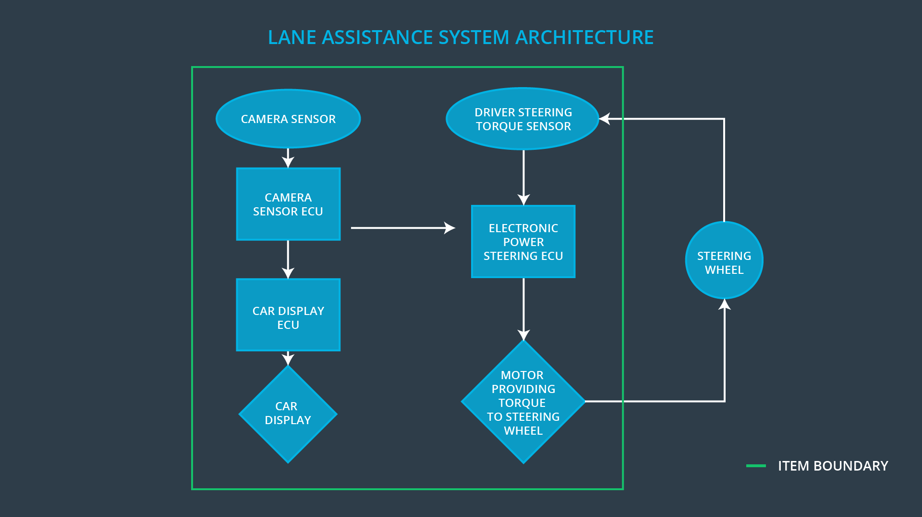

### Description of architecture elements

|  |  |
| --- | --- |
| **Element** | **Description** |
| Camera Sensor | Front camer sensor to film lane in front |
| Camera Sensor ECU | ECU using algorithms to extract lane information from camera video stream |
| Car Display | Interface to human showing current status of functionality (on, off) |
| Car Display ECU | ECU to process input from driver (swtich off) and also process any system status for visualization to driver |
| Driver Steering Torque Sensor | Sensor to measure applied steering torque by driver to steering wheel |
| Electronic Power Steering ECU | ECU to process request for returning to lane and sending necessary torque signal to motor |
| Motor | Actuator applying torque to steering wheel |

# Functional Safety Concept

The functional safety concept consists of:

* Functional safety analysis
* Functional safety requirements
* Functional safety architecture
* Warning and degradation concept

## Functional Safety Analysis

|  |  |  |  |
| --- | --- | --- | --- |
| **Malfunction ID** | **Main Function of the Item Related to Safety Goal Violations** | **Guidewords (NO, WRONG, EARLY, LATE, MORE, LESS)** | **Resulting Malfunction** |
| Malfunction_01 | Lane Departure Warning (LDW) function shall apply an oscillating steering torque to provide the driver a haptic feedback | MORE | The lane departure warning function applies an oscillating torque with very high torque amplitude (above limit) |
| Malfunction_02 | Lane Departure Warning (LDW) function shall apply an oscillating steering torque to provide the driver a haptic feedback | MORE | The lane departure warning function applies an oscillating torque with very high torque frequency (above limit) |
| Malfunction_03 | Lane Keeping Assistance (LKA) function shall apply the steering torque when active in order to stay in ego lane | NO | The lane keeping assistance function is not limited in time duration which leads to misuse as an autonomous driving function. |
| Malfunction_04 | Lane Keeping Assistance (LKA) function shall apply the steering torque when active in order to stay in ego lane | WRONG | The lane keeping assistance function is active, but there is high uncertainty about the lane detection result, leading to a wrong stabilization actuation. |

## Functional Safety Requirements

Lane Departure Warning (LDW) Requirements:

|  |  |  |  |  |
| --- | --- | --- | --- | --- |
| **ID** | **Functional Safety Requirement** | **ASIL** | **Fault Tolerant Time Interval** | **Safe State** |
| Functional  Safety  Requirement  01-01 | The electronic power steering ECU shall ensure that the lane departure warning oscilatting torque amplitude is below Max_Torque_Amplitude | C | 50ms | System turned off |
| Functional  Safety  Requirement  01-02 | The electronic power steering ECU shall ensure that the lane departure warning oscilatting torque frequency is below Max_Torque_Frequency | C | 50ms | System turned off |

Lane Departure Warning (LDW) Verification and Validation Acceptance Criteria:

|  |  |  |
| --- | --- | --- |
| **ID** | **Validation Acceptance**  **Criteria and Method** | **Verification Acceptance**  **Criteria and Method** |
| Functional  Safety  Requirement  01-01 | test how drivers react to different torque amplitudes | Software-In-The-Loop tests with fault insertion: desired torque amplitude signal is above limit -🡪 does Motor ECU limits torque to specified value? |
| Functional  Safety  Requirement  01-02 | test how drivers react to different torque frequencies | Software-In-The-Loop tests with fault insertion: desired torque frequency signal is above limit-🡪 does Motor ECU limits torque to specified value? |

Lane Keeping Assistance (LKA) Requirements:

|  |  |  |  |  |
| --- | --- | --- | --- | --- |
| **ID** | **Functional Safety Requirement** | **ASIL** | **Fault Tolerant Time Interval** | **Safe State** |
| Functional  Safety  Requirement  02-01 | The electronic power steering ECU shall ensure that the lane keeping assistance torque is applied for only Max_Duration | B | 500ms | System turned off |
| Functional  Safety  Requirement  02-02 | The camera sensor ECU shall ensure that the system is switched off if the detection uncertainty is below Min_Detection_Certainty | B | 50ms | System turned off |

Lane Keeping Assistance (LKA) Verification and Validation Acceptance Criteria:

|  |  |  |
| --- | --- | --- |
| **ID** | **Validation Acceptance**  **Criteria and Method** | **Verification Acceptance**  **Criteria and Method** |
| Functional  Safety  Requirement  02-01 | test and validate that the max_duration chosen really did dissuade drivers from taking their hands off the wheel | Software-In-The-Loop tests with fault insertion: no torque applied by human for more than 500ms |
| Functional  Safety  Requirement  02-02 | Test wether degradation method will result in robust state | Software-In-The-Loop tests with fault insertion: detection certainty below Min_Detection_Certainty 🡪 is return safe for various scenarios with typical driver behavior? |

## Refinement of the System Architecture

**[Instructions: Include the refined system architecture. Hint: The refined system architecture should include the system architecture from the end of the functional safety lesson including all of the ASIL labels.]**

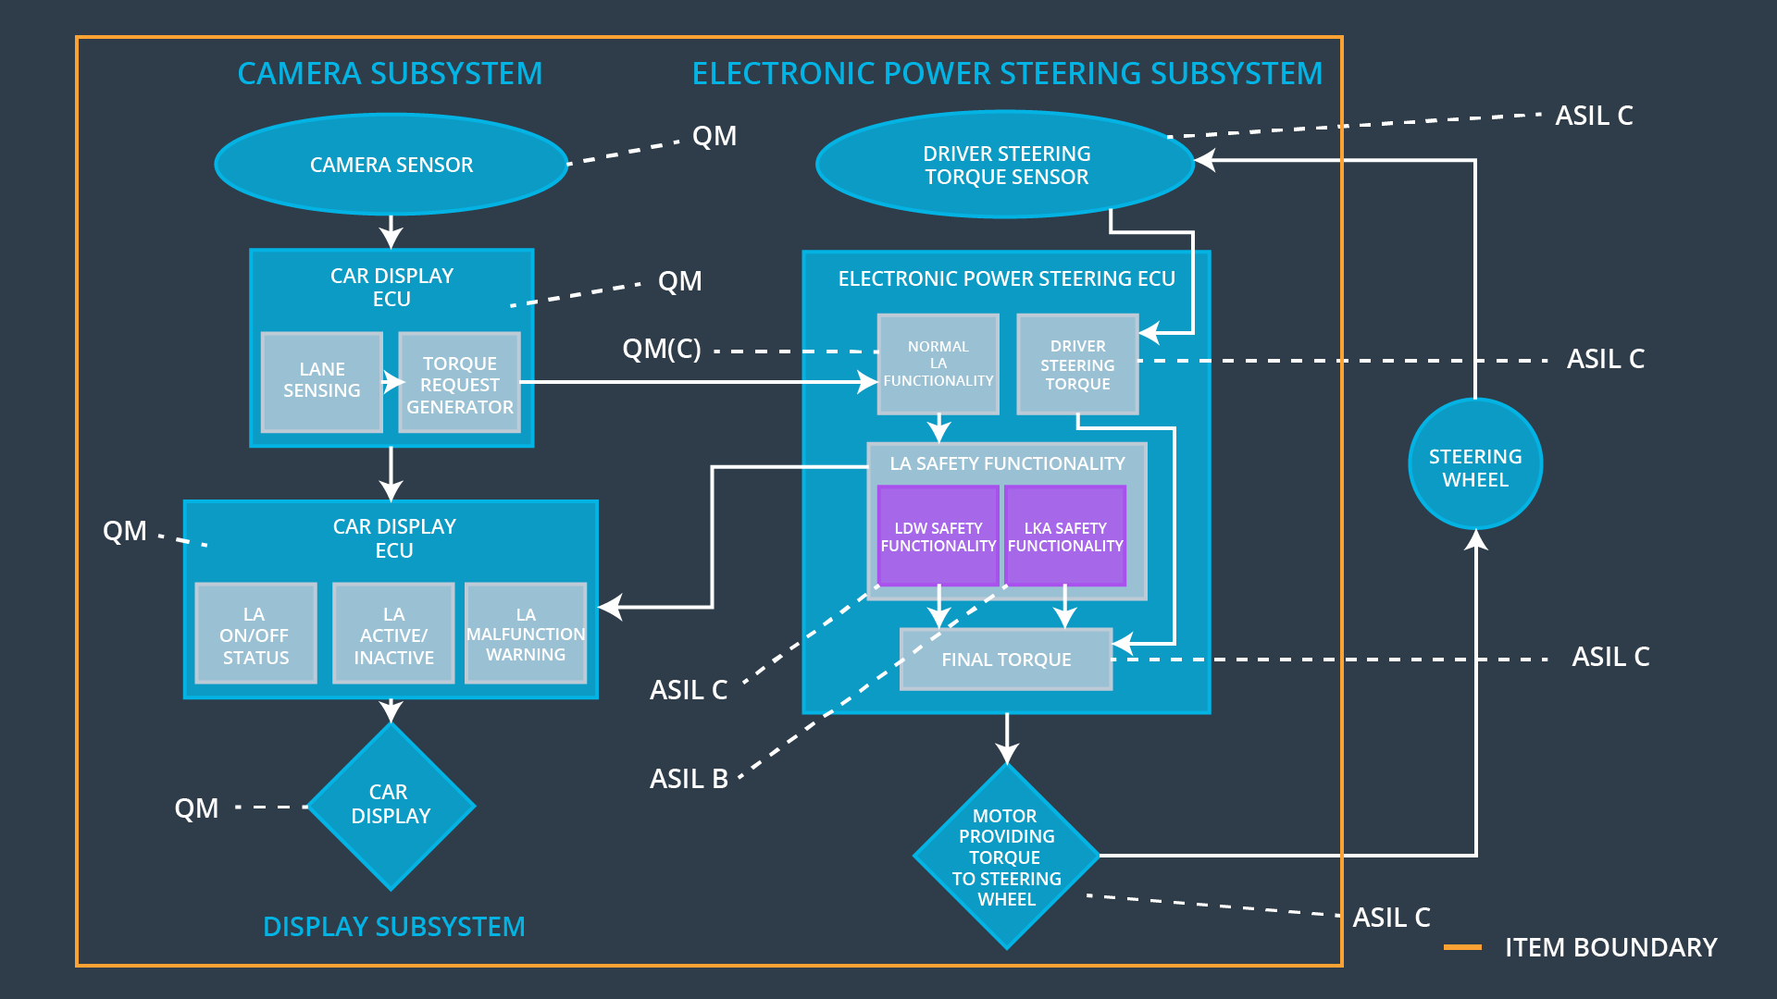

## Allocation of Functional Safety Requirements to Architecture Elements

**[Instructions: Mark which element or elements are responsible for meeting the functional safety requirement. Hint: Only one ECU is responsible for meeting all of the requirements.]**

|  |  |  |  |  |
| --- | --- | --- | --- | --- |
| **ID** | **Functional Safety Requirement** | **Electronic Power Steering ECU** | **Camera ECU** | **Car Display ECU** |
| Functional  Safety  Requirement  01-01 | The electronic power steering ECU shall ensure that the lane departure warning oscilatting torque amplitude is below Max_Torque_Amplitude | **x** |  |  |
| Functional  Safety  Requirement  01-02 | The electronic power steering ECU shall ensure that the lane departure warning oscilatting torque frequency is below Max_Torque_Frequency | **x** |  |  |
| Functional  Safety  Requirement  02-01 | The electronic power steering ECU shall ensure that the lane keeping assistance torque is applied for only Max_Duration | **x** |  |  |
| Functional  Safety  Requirement  02-02 | The camera sensor ECU shall ensure that the system is switched off if the detection uncertainty is below Min_Detection_Certainty | **x** | **x** | **x** |

## Warning and Degradation Concept

|  |  |  |  |  |
| --- | --- | --- | --- | --- |
| **ID** | **Degradation Mode** | **Trigger for Degradation Mode** | **Safe State invoked?** | **Driver Warning** |
| WDC-01 | Turn off functionality | Malfunction_01, Malfunction_02 | yes | warning light on the dashboard |
| WDC-02 | Turn off functionality | Malfunction_03 | yes | warning light on the dashboard, acoustic signal |
| WDC-03 | Gradual degredation | Malfunction_04 | yes | warning light on the dashboard, acoustic signal |