

Technical Safety Concept Lane Assistance

**Document Version: [Version]**

**Template Version 1.0, Released on 2017-06-21**



# Document history

|  |  |  |  |
| --- | --- | --- | --- |
| Date | Version | Editor | Description |
| 02.09.17 | 1.0 | Klemens Esterle | Initial Version |
|  |  |  |  |
|  |  |  |  |
|  |  |  |  |
|  |  |  |  |

# 

# Table of Contents

Document history

Table of Contents

Purpose of the Technical Safety Concept

Inputs to the Technical Safety Concept

Functional Safety Requirements

Refined System Architecture from Functional Safety Concept

Functional overview of architecture elements

Technical Safety Concept

Technical Safety Requirements

Refinement of the System Architecture

Allocation of Technical Safety Requirements to Architecture Elements

Warning and Degradation Concept

# Purpose of the Technical Safety Concept

The purpose of the technical safety concept is to derive technical requirements from functional requirements.

# Inputs to the Technical Safety Concept

## Functional Safety Requirements

|  |  |  |  |  |
| --- | --- | --- | --- | --- |
| **ID** | **Functional Safety Requirement** | **ASIL** | **Fault Tolerant Time Interval** | **Safe State** |
| Functional  Safety  Requirement  01-01 | The electronic power steering ECU shall ensure that the lane departure warning oscilatting torque amplitude is below Max_Torque_Amplitude | C | 50ms | System turned off |
| Functional  Safety  Requirement  01-02 | The electronic power steering ECU shall ensure that the lane departure warning oscilatting torque frequency is below Max_Torque_Frequency | C | 50ms | System turned off |
| Functional  Safety  Requirement  02-01 | The electronic power steering ECU shall ensure that the lane keeping assistance torque is applied for only Max_Duration | B | 500ms | System turned off |
| Functional  Safety  Requirement  02-02 | The camera sensor ECU shall ensure that the system is switched off if the detection uncertainty is below Min_Detection_Certainty | B | 50ms | System turned off |

## Refined System Architecture from Functional Safety Concept

**[Instructions: Provide the refined system architecture from the functional safety concept]**

### 

### Functional overview of architecture elements

**[Instructions: Provide a description for each functional safety element; what is each element's purpose in the lane assistance item? ]**

|  |  |
| --- | --- |
| **Element** | **Description** |
| Camera Sensor | Front camera sensor to film lane in front |
| Camera Sensor ECU - Lane Sensing | ECU using algorithms to extract lane information from camera video stream |
| Camera Sensor ECU - Torque request generator | ECU generating torque request and forwarding it to EPS ECU |
| Car Display | Interface to human showing current status of functionality (on, off) |
| Car Display ECU - Lane Assistance On/Off Status | ECU to process input from driver (switch on/off) |
| Car Display ECU - Lane Assistant Active/Inactive | ECU processing any system status for visualization to driver |
| Car Display ECU - Lane Assistance malfunction warning | ECU processing malfunction warning |
| Driver Steering Torque Sensor | Sensor to measure applied steering torque by driver to steering wheel |
| Electronic Power Steering (EPS) ECU - Driver Steering Torque | and sending necessary torque signal to motor |
| EPS ECU - Normal Lane Assistance Functionality | ECU forwarding torque request to safety lane assistance functionality |
| EPS ECU - Lane Departure Warning Safety Functionality | ECU generating lane departure warning and sending it to CAR Display ECU |
| EPS ECU - Lane Keeping Assistant Safety Functionality | ECU performing LDW safety check |
| EPS ECU - Final Torque | ECU to process request for returning to lane |
| Motor | Actuator applying torque to steering wheel |

# Technical Safety Concept

## Technical Safety Requirements

**Lane Departure Warning (LDW) Requirements:**

Functional Safety Requirement 01-01 with its associated system elements

(derived in the functional safety concept)

|  |  |  |  |  |
| --- | --- | --- | --- | --- |
| **ID** | **Functional Safety Requirement** | **Electronic Power Steering ECU** | **Camera ECU** | **Car Display ECU** |
| Functional  Safety  Requirement  01-01 | The lane keeping item shall ensure that the lane departure oscillating torque amplitude is below Max_Torque_Amplitude | X |  |  |

Technical Safety Requirements related to Functional Safety Requirement 01-01 are:

|  |  |  |  |  |  |
| --- | --- | --- | --- | --- | --- |
| **ID** | **Technical Safety Requirement** | **ASIL** | **Fault Tolerant Time Interval** | **Architecture Allocation** | **Safe State** |
| Technical  Safety  Requirement  01 | The LDW safety component shall ensure that the amplitude of the ‘LDW_Torque_Request’ sent to the ‘Final electronic power steering Torque’ component is below ‘Max_Torque_Amplitude’ | C | 50ms | LDW safety element | LDW torque request amplitude shall be set to zero |
| Technical  Safety  Requirement  02 | The validity and integrity of the data transmission for ‘LDW_Torque_Request’ signal shall be ensured | C | 50ms | Data transmission ingegrity check item | LDW torque output is set to zero |
| Technical  Safety  Requirement  03 | As soon as a failure is detected by the LDW function, it shall deactivate the LDW feature and the ‘LDW_Torque_Request’ shall be set to zero | C | 50ms | LDW safety element | LDW torque output is set to zero |
| Technical  Safety  Requirement  04 | As soon as the LDW function deactivates the LDW feature, the ‘LDW Safety’ software block shall send a signal to the car display ECU to turn on a warning light | C | 50ms | LDW safety element | LDW torque output is set to zero |
| Technical  Safety  Requirement  05 | Memory test shall be conducted at start of the EPS ECU to check for any faults in memory | A | Length of vehicle ignition cycle | Memory test item | LDW torque output is set to zero |

Functional Safety Requirement 01-2 with its associated system elements

(derived in the functional safety concept)

|  |  |  |  |  |
| --- | --- | --- | --- | --- |
| **ID** | **Functional Safety Requirement** | **Electronic Power Steering ECU** | **Camera ECU** | **Car Display ECU** |
| Functional  Safety  Requirement  01-02 | The lane keeping item shall ensure that the lane departure oscillating torque frequency is below Max_Torque_Frequency | X |  |  |

Technical Safety Requirements related to Functional Safety Requirement 01-02 are:

|  |  |  |  |  |  |
| --- | --- | --- | --- | --- | --- |
| **ID** | **Technical Safety Requirement** | **ASIL** | **Fault Tolerant Time Interval** | **Architecture Allocation** | **Safe State** |
| Technical  Safety  Requirement  01 | The LDW safety component shall ensure that the frequency of the ‘LDW_Torque_Request’ sent to the ‘Final electronic power steering Torque’ component is below ‘Max_Torque_Frequency’ | C | 50ms | LDW safety element | LDW torque request amplitude shall be set to zero |
| Technical  Safety  Requirement  02 | The validity and integrity of the data transmission for ‘LDW_Torque_Request’ signal shall be ensured | C | 50ms | Data transmission ingegrity check item | LDW torque output is set to zero |
| Technical  Safety  Requirement  03 | As soon as a failure is detected by the LDW function, it shall deactivate the LDW feature and the ‘LDW_Torque_Request’ shall be set to zero | C | 50ms | LDW safety element | LDW torque output is set to zero |
| Technical  Safety  Requirement  04 | As soon as the LDW function deactivates the LDW feature, the ‘LDW Safety’ software block shall send a signal to the car display ECU to turn on a warning light | C | 50ms | LDW safety element | LDW torque output is set to zero |
| Technical  Safety  Requirement  05 | Memory test shall be conducted at start of the EPS ECU to check for any faults in memory | A | Length of vehicle ignition cycle | Memory test item | LDW torque output is set to zero |

**Lane Departure Warning (LDW) Verification and Validation Acceptance Criteria:**

**[OPTIONAL: For each technical safety requirement, identify both the verification and validation acceptance criteria. “Validation” asks whether or not you chose the appropriate parameters. “Verification” involves testing to make sure the vehicle behaves as expected when the parameter value is crossed. There is not necessarily one right answer. Look at your verification and validation acceptance criteria from the functional safety concept for inspiration.]**

**Lane Keeping Assistance (LKA) Requirements:**

Functional Safety Requirement 02-1 with its associated system elements

(derived in the functional safety concept)

|  |  |  |  |  |
| --- | --- | --- | --- | --- |
| **ID** | **Functional Safety Requirement** | **Electronic Power Steering ECU** | **Camera ECU** | **Car Display ECU** |
| Functional  Safety  Requirement  02-01 | The lane keeping item shall ensure that the lane keeping assistance torque is applied for only Max_Duration | X |  |  |

Technical Safety Requirements related to Functional Safety Requirement 02-01 are:

|  |  |  |  |  |  |
| --- | --- | --- | --- | --- | --- |
| **ID** | **Technical Safety Requirement** | **ASIL** | **Fault Tolerant Time Interval** | **Allocation to Architecture** | **Safe State** |
| Technical  Safety  Requirement  01 | The LKA safety component shall ensure that the duration of the ‘LKA_Torque_Request’ sent to the ‘Final electronic power steering Torque’ component is below ‘Max_Duration’ | B | 500ms | LKA safety element | LKA torque request amplitude shall be set to zero |
| Technical  Safety  Requirement  02 | The validity and integrity of the data transmission for ‘LKA_Torque_Request’ signal shall be ensured | B | 500ms | Data transmission ingegrity check item | N/A |
| Technical  Safety  Requirement  03 | As soon as a failure is detected by the LKA function, it shall deactivate the LDW feature and the ‘LKA_Torque_Request’ shall be set to zero | B | 500ms | LKA safety element | LKA torque output is set to zero |
| Technical  Safety  Requirement  04 | As soon as the LKA function deactivates the LKA feature, the ‘LKA Safety’ software block shall send a signal to the car display ECU to turn on a warning light | B | 500ms | LKA safety element | LKA torque output is set to zero |
| Technical  Safety  Requirement  05 | Memory test shall be conducted at start of the EPS ECU to check for any faults in memory | A | Length of vehicle ignition cycle | Memory test item | LKA torque output is set to zero |

Functional Safety Requirement 02-2 with its associated system elements

(derived in the functional safety concept)

|  |  |  |  |  |
| --- | --- | --- | --- | --- |
| **ID** | **Functional Safety Requirement** | **Electronic Power Steering ECU** | **Camera ECU** | **Car Display ECU** |
| Functional  Safety  Requirement  02-02 | The camera sensor ECU shall ensure that the system is switched off if the detection uncertainty is below Min_Detection_Certainty | X | X | X |

Technical Safety Requirements related to Functional Safety Requirement 02-01 are:

|  |  |  |  |  |  |
| --- | --- | --- | --- | --- | --- |
| **ID** | **Technical Safety Requirement** | **ASIL** | **Fault Tolerant Time Interval** | **Allocation to Architecture** | **Safe State** |
| Technical  Safety  Requirement  01 | The LKA safety component shall ensure that the value of the ‘LKA_Lane_Detection_Certainty’ sent to the ‘Final electronic power steering Torque’ component is below ‘Min_Detection_Certainty’ | B | 50ms | LKA safety element | LKA torque request amplitude shall be set to zero |
| Technical  Safety  Requirement  02 | The validity and integrity of the data transmission for ‘LKA_Lane_Detection_Certainty’’ signal shall be ensured | B | 50ms | Data transmission ingegrity check item | N/A |
| Technical  Safety  Requirement  03 | As soon as a failure is detected by the LKA function, it shall deactivate the LDW feature and the ‘LKA_Torque_Request’ shall be set to zero | B | 50ms | LKA safety element | LKA torque output is set to zero |
| Technical  Safety  Requirement  04 | As soon as the LKA function deactivates the LKA feature, the ‘LKA Safety’ software block shall send a signal to the car display ECU to turn on a warning light | B | 50ms | LKA safety element | LKA torque output is set to zero |
| Technical  Safety  Requirement  05 | Memory test shall be conducted at start of the EPS ECU to check for any faults in memory | A | Length of vehicle ignition cycle | Memory test item | LKA torque output is set to zero |

**Lane Keeping Assistance (LKA) Verification and Validation Acceptance Criteria:**

**[OPTIONAL: For each technical safety requirement, identify both the verification and validation acceptance criteria. “Validation” asks whether or not you chose the appropriate parameters. “Verification” involves testing to make sure the vehicle behaves as expected when the parameter value is crossed. There is not necessarily one right answer. Look at your verification and validation acceptance criteria from the functional safety concept for inspiration.]**

## Refinement of the System Architecture

**[Instructions: Include the refined system architecture. Hint: The refined system architecture should include the system architecture from the end of the technical safety lesson, including all of the ASIL labels.]**

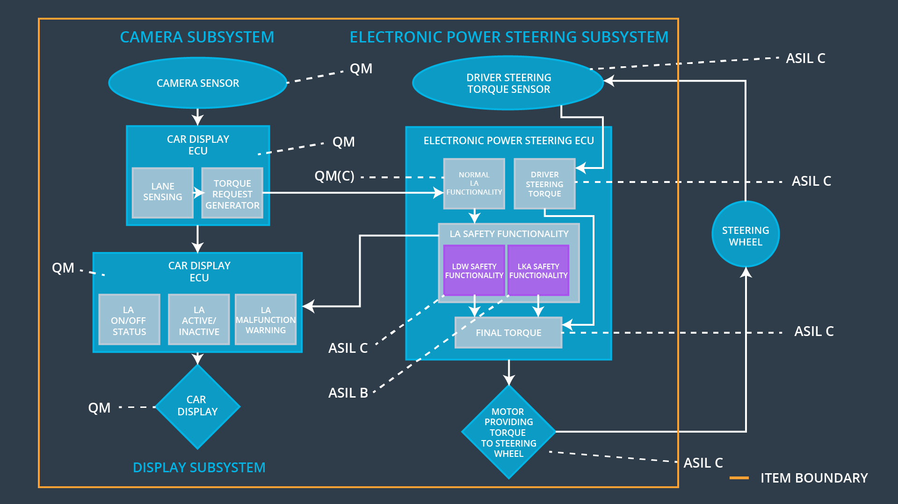

## Allocation of Technical Safety Requirements to Architecture Elements

**[Instructions: We already included the allocation as part of the technical requirement tables. Here you can state that for this particular item, all technical safety requirements are allocated to the Electronic Power Steering ECU]**

## Warning and Degradation Concept

**[Instructions: We've already identified that for any system malfunction, the lane assistance functions will be turned off and the driver will receive a warning light indication. The technical safety requirements have not changed how functionality will be degraded or what the warning will be.**

**So in this case, the warning and degradation concept is the same for the technical safety requirements as for the functional safety requirements. You can copy the functional safety warning and degradation concept here.**

**Oftentimes, a technical safety analysis will lead to a more detailed warning and degradation concept. ]**

|  |  |  |  |  |
| --- | --- | --- | --- | --- |
| **ID** | **Degradation Mode** | **Trigger for Degradation Mode** | **Safe State invoked?** | **Driver Warning** |
| WDC-01 | Turn off functionality | Malfunction_01, Malfunction_02 | yes | warning light on the dashboard |
| WDC-02 | Turn off functionality | Malfunction_03 | yes | warning light on the dashboard, acoustic signal |
| WDC-03 | Gradual degredation | Malfunction_04 | yes | warning light on the dashboard, acoustic signal |