SQL Injection Detection Report

1. Overview
This report documents the implementation and evaluation of multiple machine learning models for SQL injection detection. The models explored include:
• Fine-tuned CodeBERT.
• Dense Neural Network (DNN) with BERT embeddings.
• XGBoost with BERT embeddings.
The focus is on binary classification (safe vs. injection), using metrics such as accuracy, precision, recall, F1-score, and confusion matrix analysis.

Models and Tokenizers
BERT (Bidirectional Encoder Representations from Transformers) is a transformer-based model designed to understand the context of words in a sentence by considering the words that come before and after.
BERT Tokenizer is a tokenizer specific to BERT, responsible for converting text into input tokens the BERT model can process.
RoBERTa is a robustly optimized BERT.
Roberta Tokenizer also uses Byte-Pair Encoding (BPE) but without the next sentence prediction task-specific tokens.
RobertaForSequenceClassification is a pre-trained RoBERTa model tailored for sequence classification tasks.

2. Workflow
The pipeline consists of the following steps:
1. Install and import necessary libraries.
2. Load and preprocess the dataset.
3. Tokenize SQL queries using the CodeBERT tokenizer.
4. Fine-tune CodeBERT for binary classification.
5. Train additional models DNN and XGBoost using BERT embeddings.
6. Evaluate and compare the performance of the models.

3. Requirements

To set up and run this project, ensure you have Python 3.9.6 installed. Below are the necessary Python libraries required. Install them by running the following command in your terminal:
pip install torch torchvision torchaudio --index-url https://download.pytorch.org/whl/cpu \
transformers==4.33.0 \
datasets==2.14.4 \
xgboost==1.7.6 \
scikit-learn==1.3.0 \
tf-keras==2.13.1 \
tensorflow==2.13.0 \
tqdm==4.66.1 \
numpy==1.23.5 \
pandas==1.5.3 \
matplotlib==3.6.2

3. Data Preprocessing
The dataset can be found at https://www.kaggle.com/datasets/sajid576/sql-injection-dataset/data
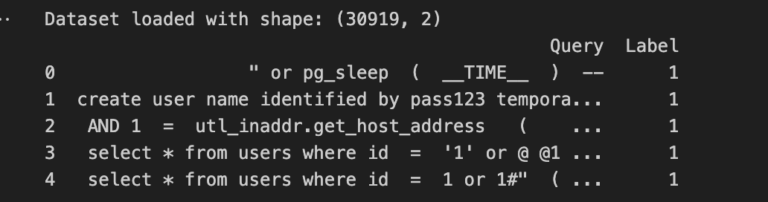

- `Query`: The SQL query.
- `Label`: The target class (0 = Safe, 1 = SQL Injection).
The dataset was divided into training (80%) and testing (20%) sets. The Hugging Face Dataset library was used for efficient tokenization and preprocessing.

4. Fine-Tuning CodeBERT
The CodeBERT model (microsoft/codebert-base) was fine-tuned using the Hugging Face Transformers framework. Key details are as follows:
- Learning Rate: 2e-5. It ensures gradual and stable updates to the model weights.
- Batch Size: 32. It’s a commonly used size that allows effective gradient updates without overwhelming system resources.
- Epochs: 3. Pre-trained models require fewer epochs since they already understand general patterns and need less training to adapt to the task-specific data.
- Weight Decay: 0.01. Weight decay (L2 regularization) prevents overfitting by penalizing large weights in the model.

The fine-tuned CodeBERT (microsoft/codebert-base) model is a transformer-based language model originally pre-trained on code and natural language. In this specific case, the model was fine-tuned to classify SQL queries as either safe (0) or SQL injection attacks (1). The model analyzes the structure and patterns in SQL queries to detect potentially malicious content, such as SQL injection payloads.

5. Dense Neural Network (DNN):
- Architecture: Dense layer (128 neurons, ReLU activation), Dropout layer (20%), and Sigmoid output layer. This is a reasonable size to capture meaningful patterns without over-complicating the model.
The Rectified Linear Unit (ReLU) activation introduces non-linearity, enabling the model to learn non-linear decision boundaries, which are critical for complex tasks like SQL injection detection. Randomly “drops out” 20% of the neurons during training to prevent overfitting.
This is a commonly used dropout rate that provides regularization without losing too much information. The sigmoid activation squashes the output to a value between 0 and 1, representing the probability of a query being malicious.

- Optimizer: Adam. The Adam optimizer adjusts the model’s learning rate dynamically during training, combining the benefits of two popular optimizers: SGD (momentum) and RMSprop (adaptive learning rates).
- Loss Function: Binary Crossentropy. Measures the difference between the predicted probabilities and the actual binary labels.

The Dense Neural Network (DNN) is designed to classify SQL queries as either safe (0) or malicious (1). It takes precomputed embeddings (e.g., from CodeBERT or another model) as input and uses fully connected layers to perform the classification. The dense layer connects every input feature to every neuron in the layer. This allows the network to learn complex patterns in the embeddings.

6. XGBoost Classifier:
- Trained with default hyperparameters using BERT embeddings.
XGBoost (Extreme Gradient Boosting) is a highly efficient and scalable implementation of gradient boosting. It builds an ensemble of decision trees in a sequential manner to optimize model performance. When combined with BERT embeddings, it becomes a powerful tool for tasks like SQL injection detection.

6. Confusion Matrix Analysis
A table showing true positives, true negatives, false positives, and false negatives for predictions.

- RoBERTa:
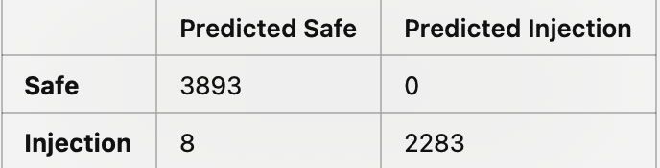

- DNN:
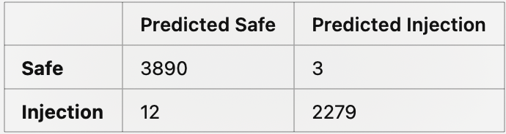

- XGBoost:
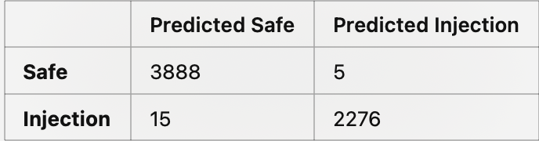

7. Metrics and Results
The models were evaluated on the following metrics:
1. Accuracy. The proportion of correctly predicted samples out of the total samples.
2. Precision. The proportion of correctly predicted positive samples out of all predicted positives.
3. Recall. The proportion of actual positive samples that were correctly predicted.
4. F1-Score. The harmonic mean of precision and recall, balancing their trade-offs.
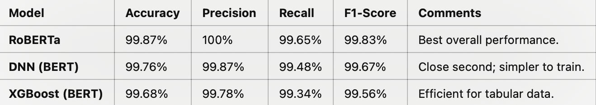

8. Conclusion
This report demonstrates the effectiveness of fine-tuning CodeBERT and using additional machine learning models (DNN and XGBoost) for SQL injection detection. The results show that RoBERTa delivers the best performance in terms of precision, recall, and overall accuracy, making it a suitable choice for cybersecurity applications. However further tests need to be done in modifying parameters to check if the RoBERTa is overfitting the model to the training data.

