1. Done
2. CPU:

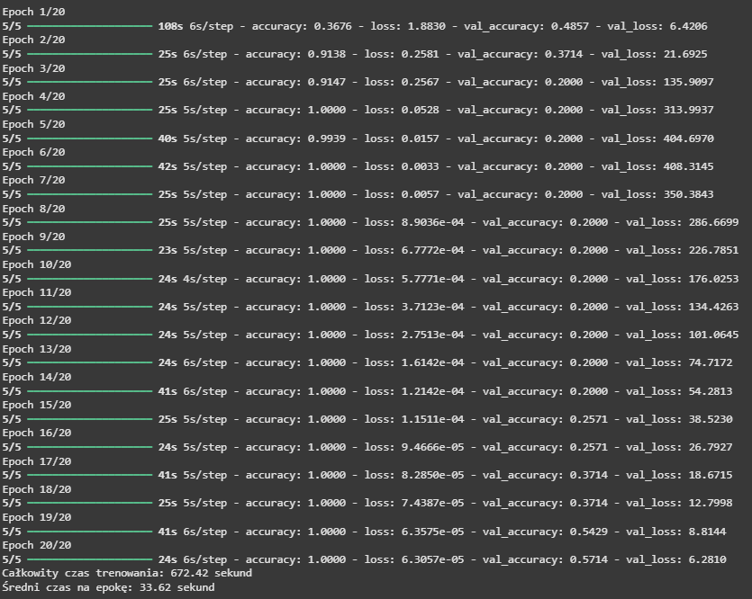

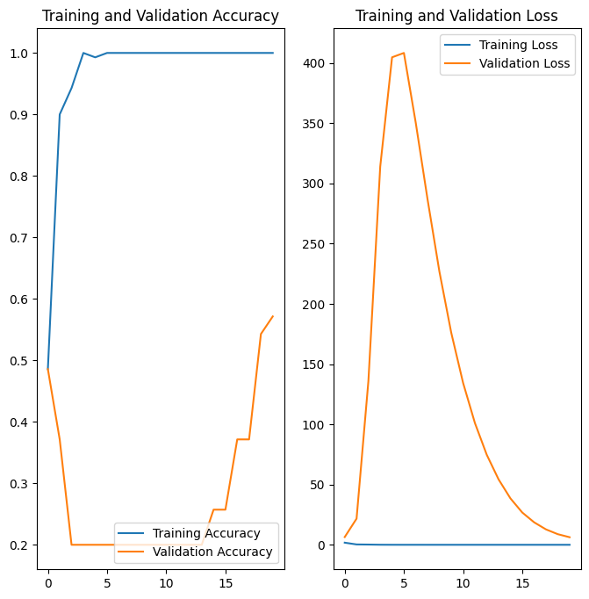

precision recall f1-score support

bio 0.33 0.33 0.33 3

papier 0.50 0.57 0.53 7

plastik 1.00 0.89 0.94 9

szkło 0.86 0.67 0.75 9

zmieszane 0.33 0.43 0.38 7

accuracy 0.63 35

macro avg 0.60 0.58 0.59 35

weighted avg 0.67 0.63 0.65 35

[[1 0 0 0 2]

[0 4 0 0 3]

[0 0 8 0 1]

[1 2 0 6 0]

[1 2 0 1 3]]

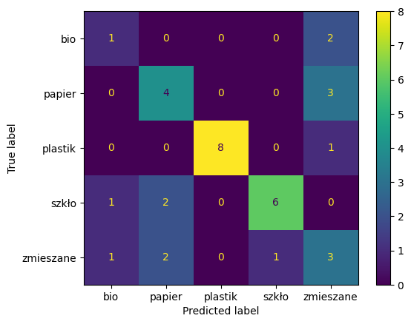

* 1. GPU same i porównanie

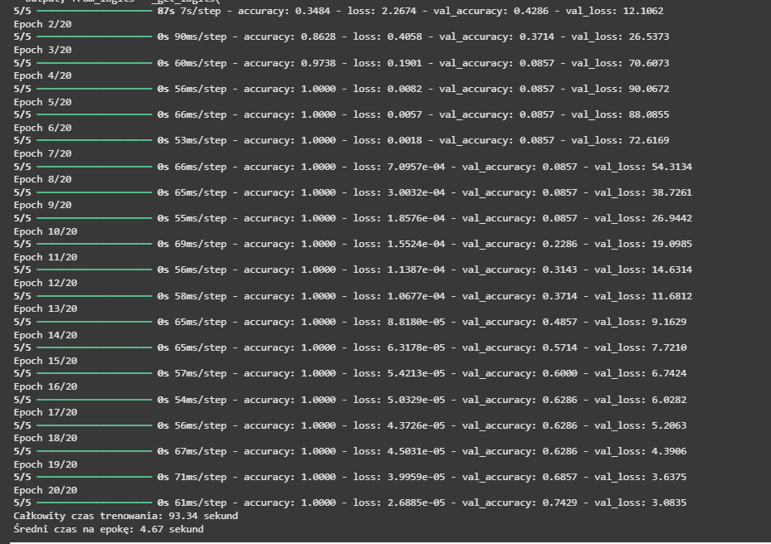

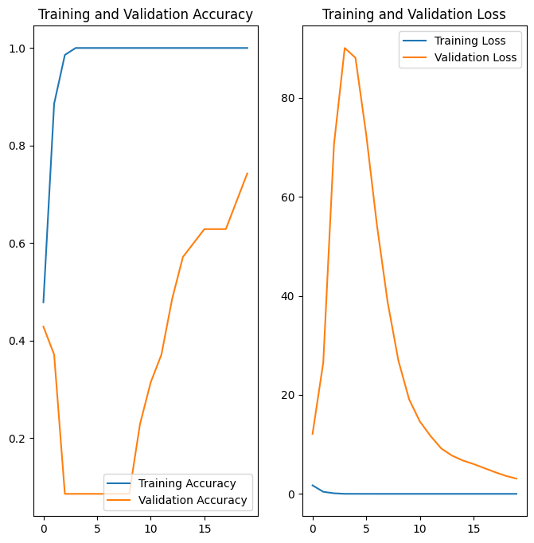

precision recall f1-score support

bio 0.50 0.67 0.57 3

papier 0.62 0.71 0.67 7

plastik 1.00 0.56 0.71 9

szkło 1.00 0.78 0.88 9

zmieszane 0.64 1.00 0.78 7

accuracy 0.74 35

macro avg 0.75 0.74 0.72 35

weighted avg 0.81 0.74 0.75 35

[[2 0 0 0 1]

[0 5 0 0 2]

[1 3 5 0 0]

[1 0 0 7 1]

[0 0 0 0 7]]

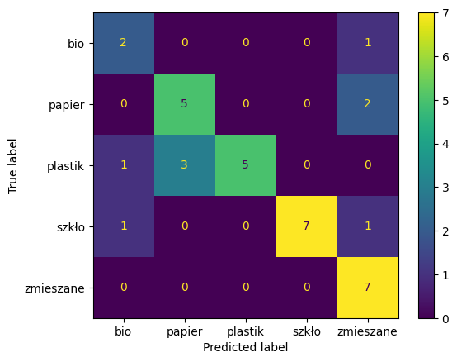

* 1. Transfer lerning:

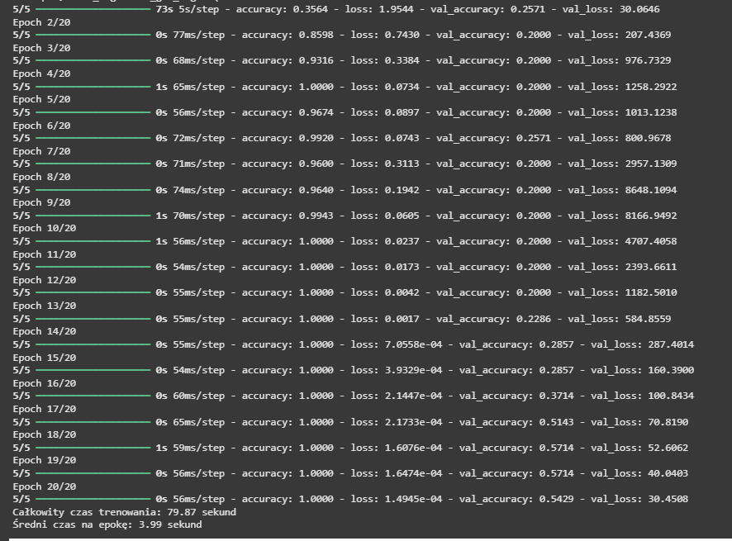

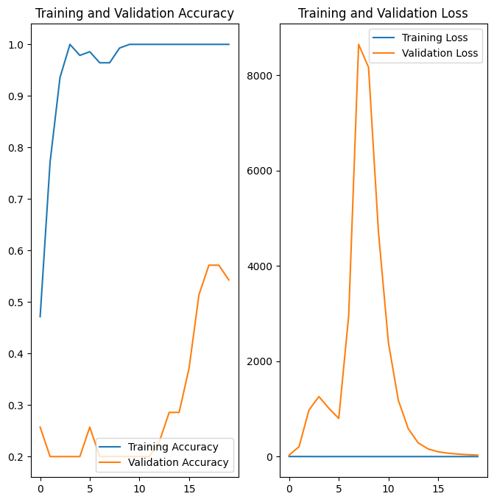

precision recall f1-score support

bio 1.00 0.67 0.80 3

papier 0.32 1.00 0.48 7

plastik 1.00 0.11 0.20 9

szkło 1.00 0.67 0.80 9

zmieszane 0.75 0.43 0.55 7

accuracy 0.54 35

macro avg 0.81 0.57 0.57 35

weighted avg 0.81 0.54 0.53 35

[[2 1 0 0 0]

[0 7 0 0 0]

[0 8 1 0 0]

[0 2 0 6 1]

[0 4 0 0 3]]

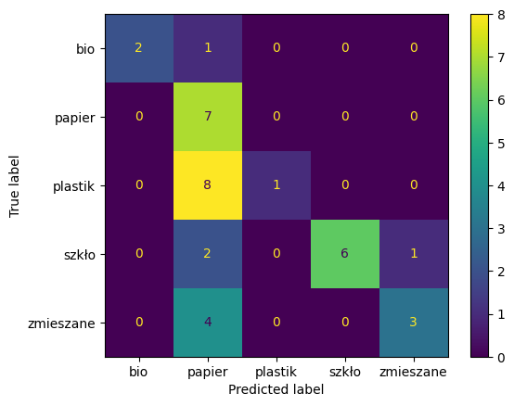

* 1. normalizacja:

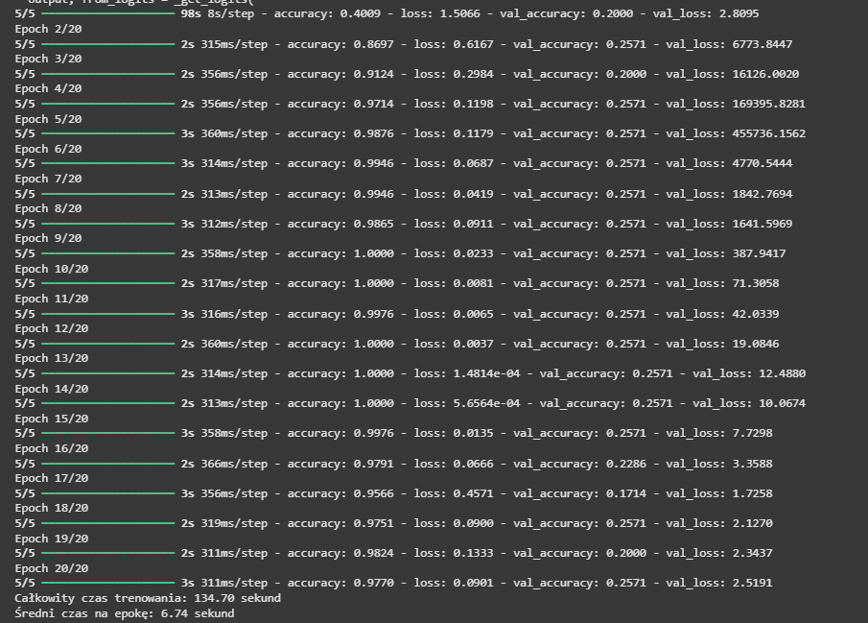

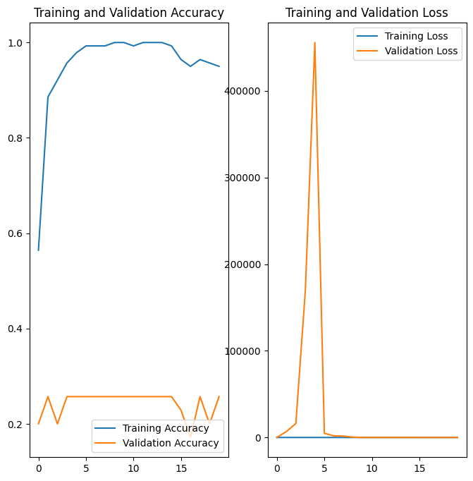

precision recall f1-score support

bio 0.00 0.00 0.00 3

papier 0.00 0.00 0.00 7

plastik 0.00 0.00 0.00 9

szkło 0.26 1.00 0.41 9

zmieszane 0.00 0.00 0.00 7

accuracy 0.26 35

macro avg 0.05 0.20 0.08 35

weighted avg 0.07 0.26 0.11 35

[[0 0 0 3 0]

[0 0 0 7 0]

[0 0 0 9 0]

[0 0 0 9 0]

[0 0 0 7 0]]

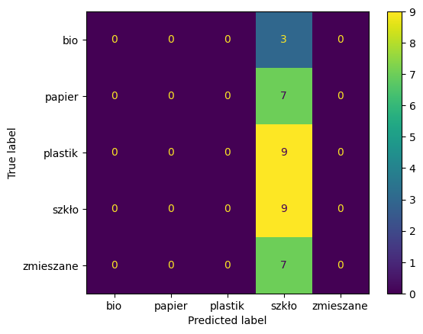

* 1. argumentacja danych:

1. x = layers.RandomFlip("horizontal")(inputs)
2. x = layers.RandomRotation(0.1)(x)
3. x = layers.RandomZoom(0.1)(x)
4. x = layers.RandomTranslation(0.1, 0.1)(x)
6. x = base_model(x)
7. x = layers.GlobalAveragePooling2D()(x)

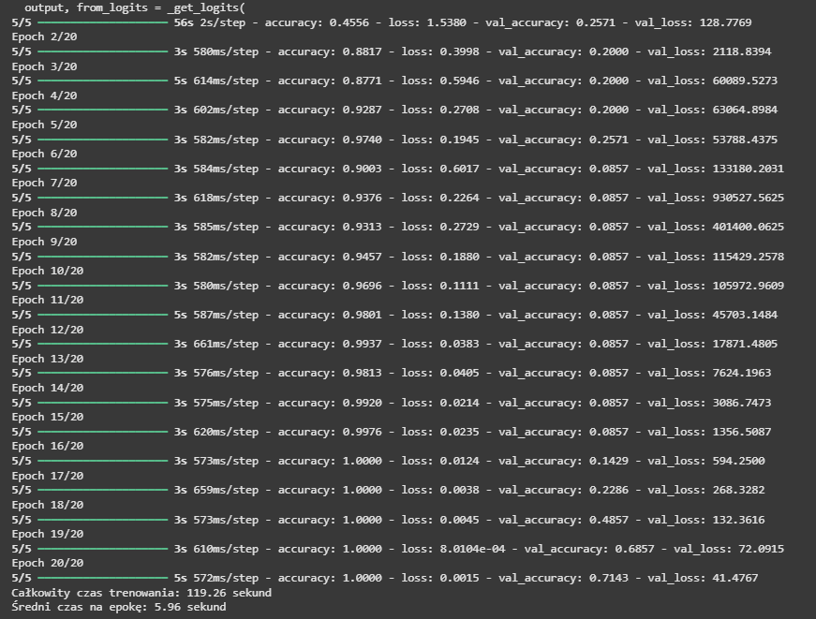

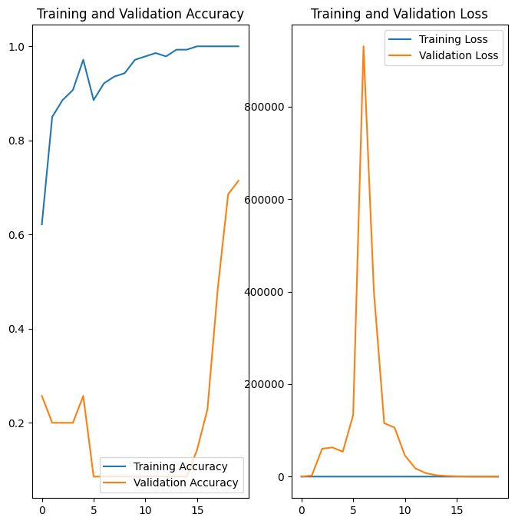

precision recall f1-score support

bio 0.27 1.00 0.43 3

papier 1.00 0.57 0.73 7

plastik 0.75 0.33 0.46 9

szkło 1.00 1.00 1.00 9

zmieszane 0.86 0.86 0.86 7

accuracy 0.71 35

macro avg 0.78 0.75 0.69 35

weighted avg 0.84 0.71 0.73 35

[[3 0 0 0 0]

[2 4 0 0 1]

[6 0 3 0 0]

[0 0 0 9 0]

[0 0 1 0 6]]

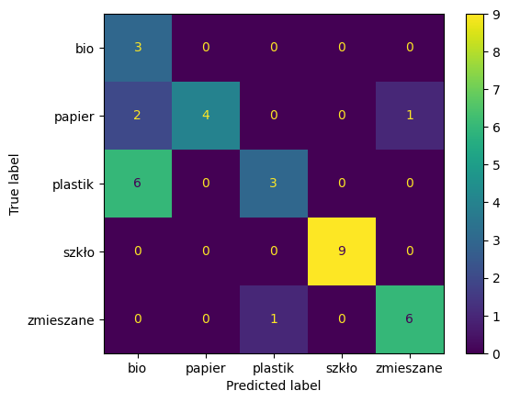

1. Dropout

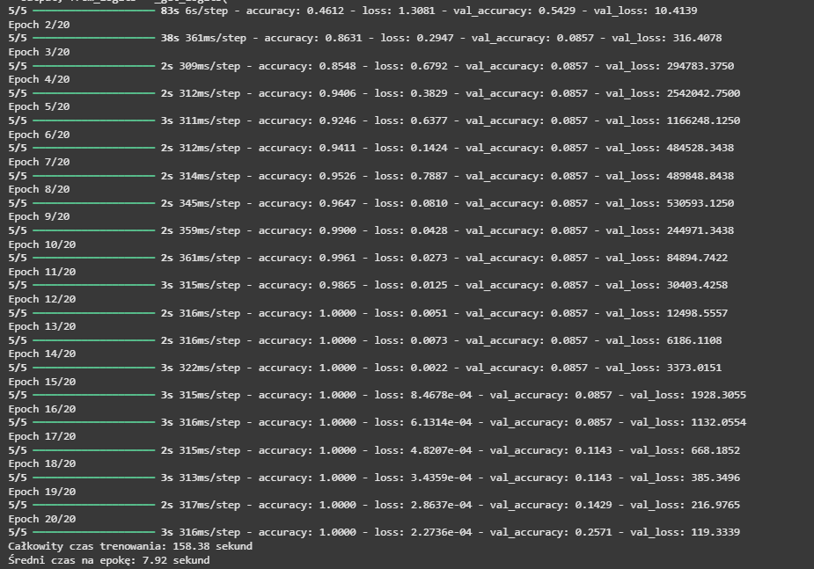



precision recall f1-score support

bio 0.27 1.00 0.43 3

papier 1.00 0.57 0.73 7

plastik 0.75 0.33 0.46 9

szkło 1.00 1.00 1.00 9

zmieszane 0.86 0.86 0.86 7

accuracy 0.71 35

macro avg 0.78 0.75 0.69 35

weighted avg 0.84 0.71 0.73 35

[[3 0 0 0 0]

[2 4 0 0 1]

[6 0 3 0 0]

[0 0 0 9 0]

[0 0 1 0 6]]



1. dokładnie danych

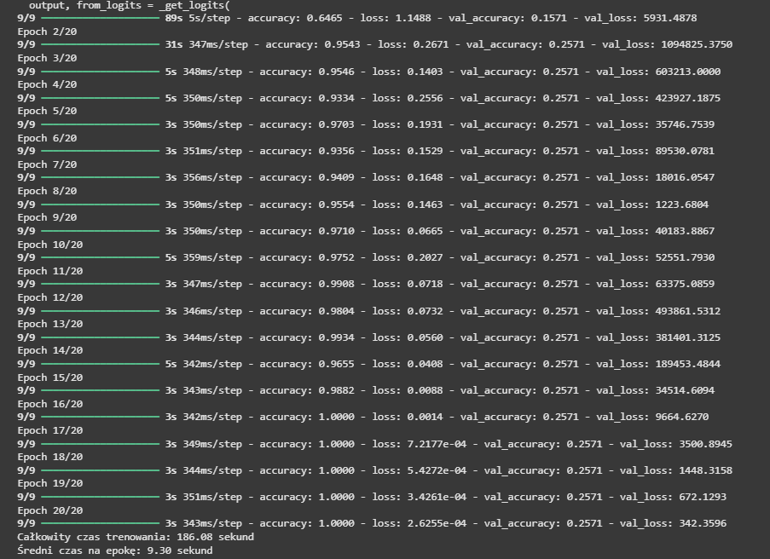

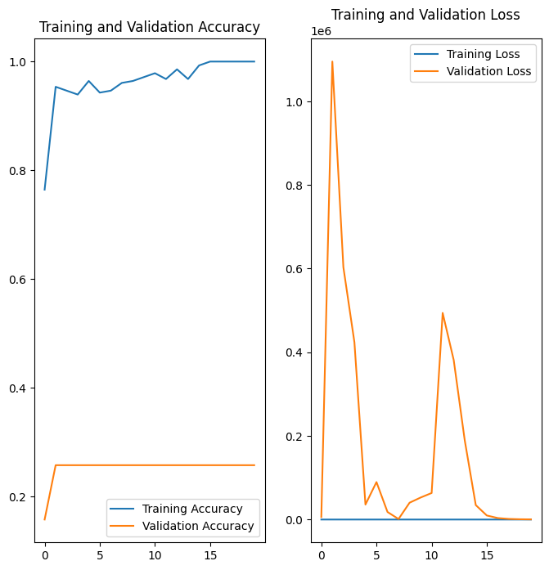

precision recall f1-score support

bio 0.00 0.00 0.00 16

papier 0.26 1.00 0.41 18

plastik 0.00 0.00 0.00 11

szkło 0.00 0.00 0.00 13

zmieszane 0.00 0.00 0.00 12

accuracy 0.26 70

macro avg 0.05 0.20 0.08 70

weighted avg 0.07 0.26 0.11 70

[[ 0 15 1 0 0]

[ 0 18 0 0 0]

[ 0 11 0 0 0]

[ 0 13 0 0 0]

[ 0 12 0 0 0]]

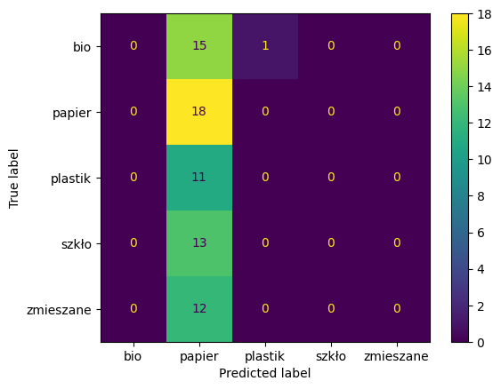

* 1. Różnie rozmiary wejściowe

96x96:

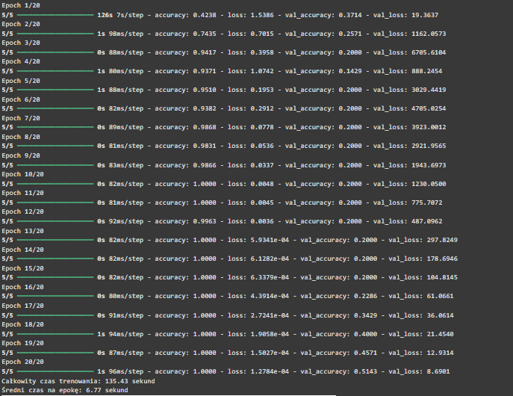

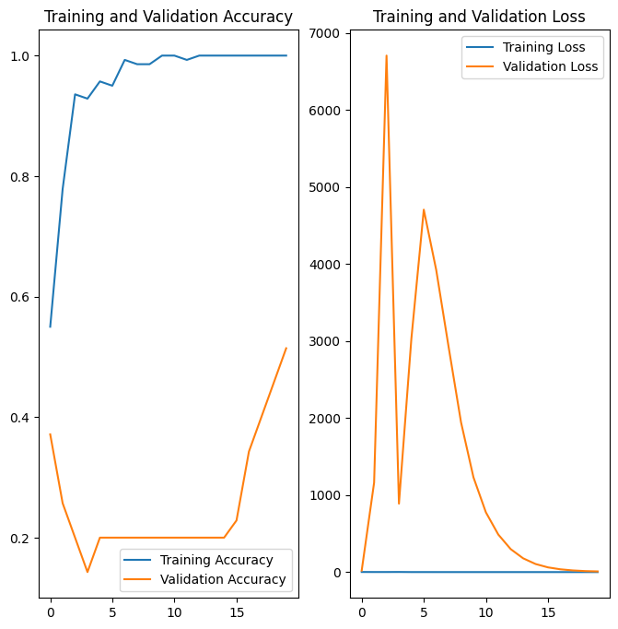

bio 0.00 0.00 0.00 3

papier 0.35 1.00 0.52 7

plastik 0.40 0.22 0.29 9

szkło 0.89 0.89 0.89 9

zmieszane 1.00 0.14 0.25 7

accuracy 0.51 35

macro avg 0.53 0.45 0.39 35

weighted avg 0.60 0.51 0.46 35

[[0 0 3 0 0]

[0 7 0 0 0]

[0 7 2 0 0]

[0 1 0 8 0]

[0 5 0 1 1]]

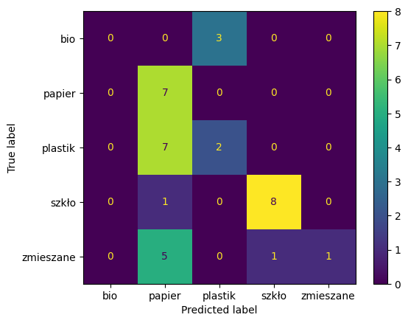

160x160:

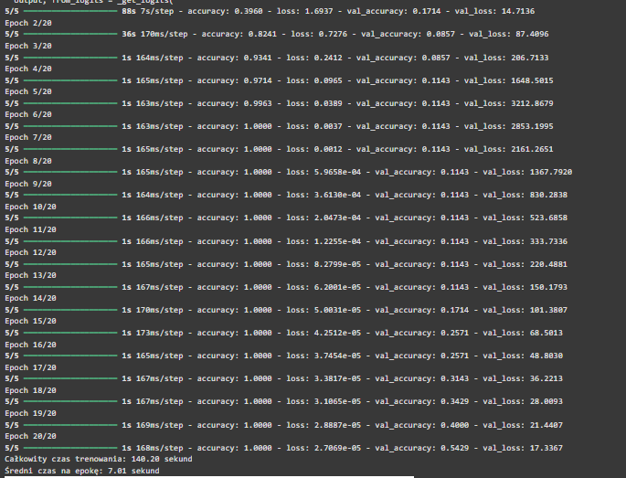

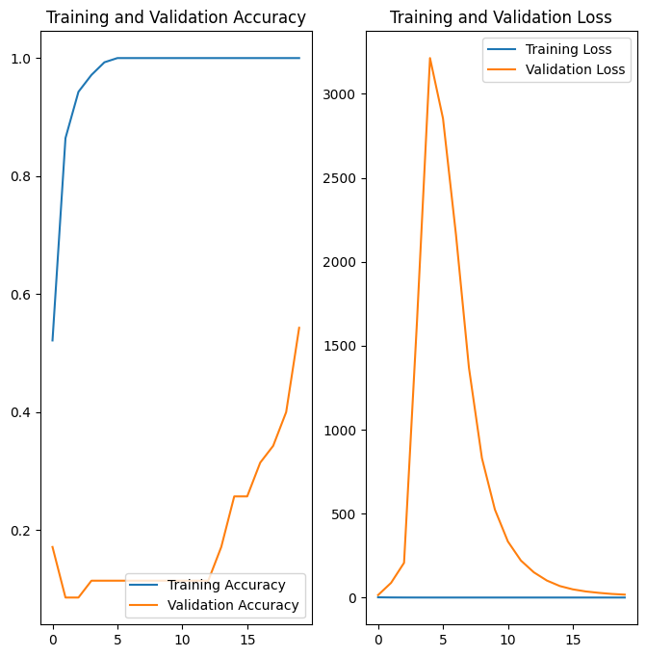

precision recall f1-score support

bio 0.67 0.67 0.67 3

papier 0.33 1.00 0.50 7

plastik 0.80 0.44 0.57 9

szkło 1.00 0.33 0.50 9

zmieszane 1.00 0.43 0.60 7

accuracy 0.54 35

macro avg 0.76 0.57 0.57 35

weighted avg 0.79 0.54 0.55 35

[[2 0 1 0 0]

[0 7 0 0 0]

[0 5 4 0 0]

[0 6 0 3 0]

[1 3 0 0 3]]

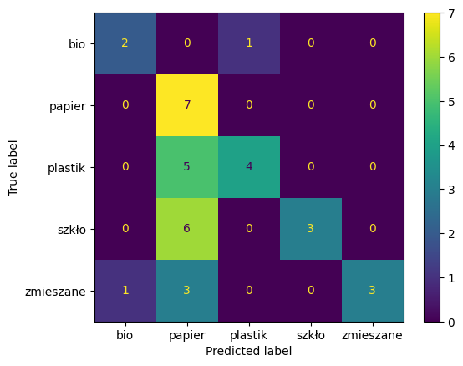

224x224:

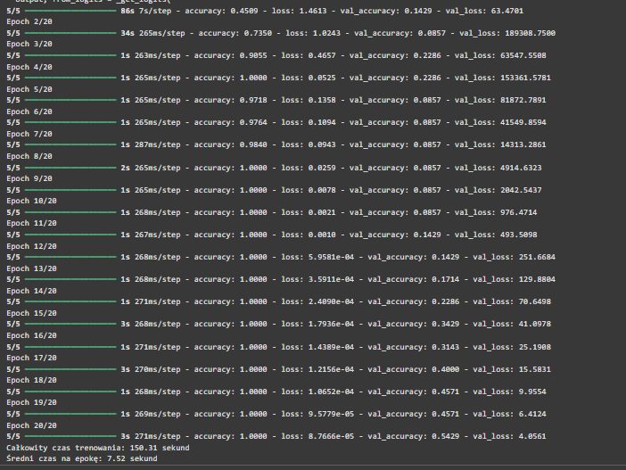

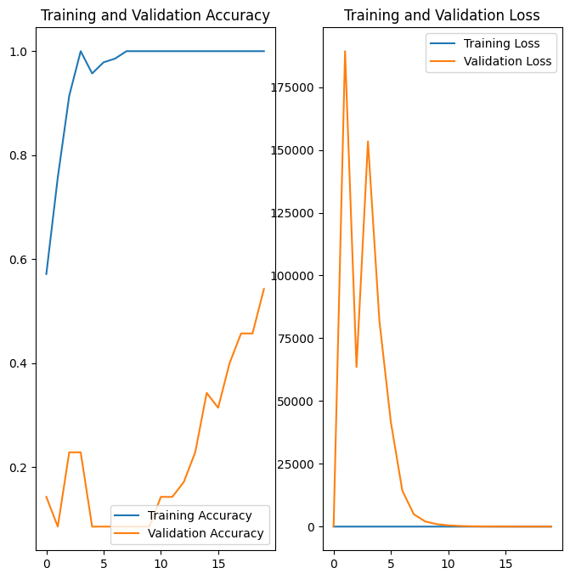

precision recall f1-score support

bio 0.25 1.00 0.40 3

papier 1.00 0.57 0.73 7

plastik 0.50 0.11 0.18 9

szkło 0.60 1.00 0.75 9

zmieszane 1.00 0.29 0.44 7

accuracy 0.54 35

macro avg 0.67 0.59 0.50 35

weighted avg 0.70 0.54 0.51 35

[[3 0 0 0 0]

[1 4 1 1 0]

[8 0 1 0 0]

[0 0 0 9 0]

[0 0 0 5 2]]

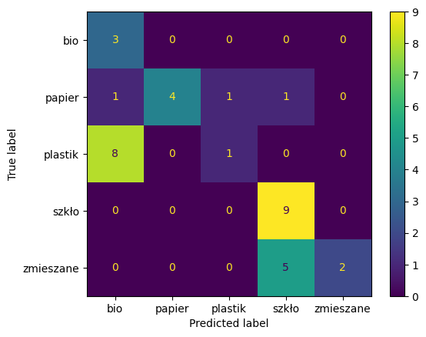

* 1. Batch size 32: 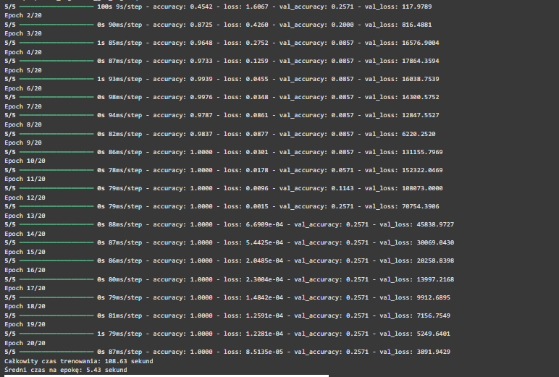

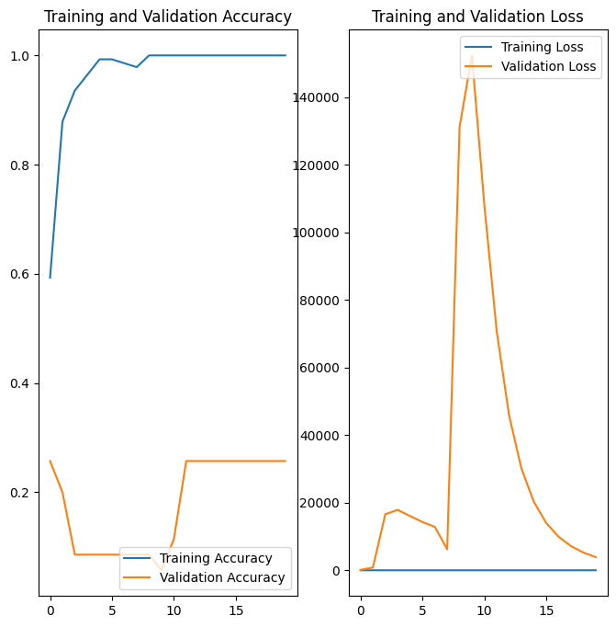

precision recall f1-score support

bio 0.00 0.00 0.00 3

papier 0.00 0.00 0.00 7

plastik 0.26 1.00 0.41 9

szkło 0.00 0.00 0.00 9

zmieszane 0.00 0.00 0.00 7

accuracy 0.26 35

macro avg 0.05 0.20 0.08 35

weighted avg 0.07 0.26 0.11 35

[[0 0 3 0 0]

[0 0 7 0 0]

[0 0 9 0 0]

[0 0 9 0 0]

[0 0 7 0 0]]

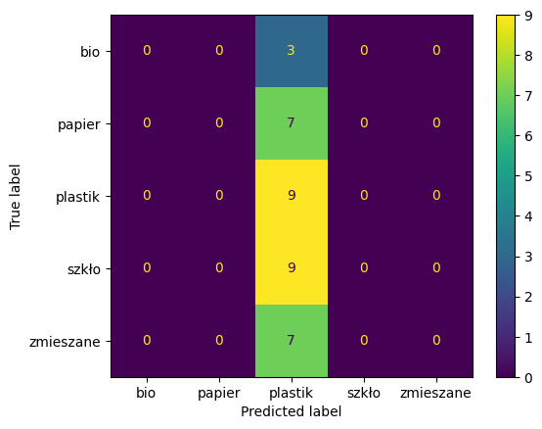

64:

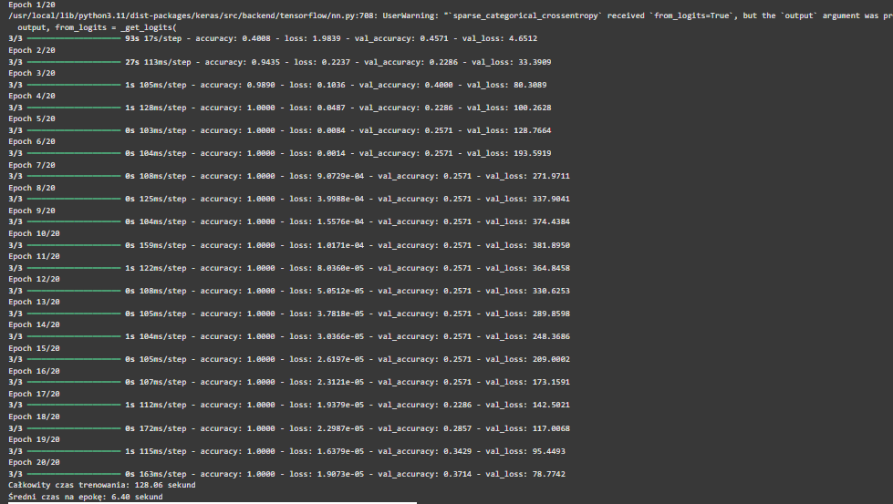

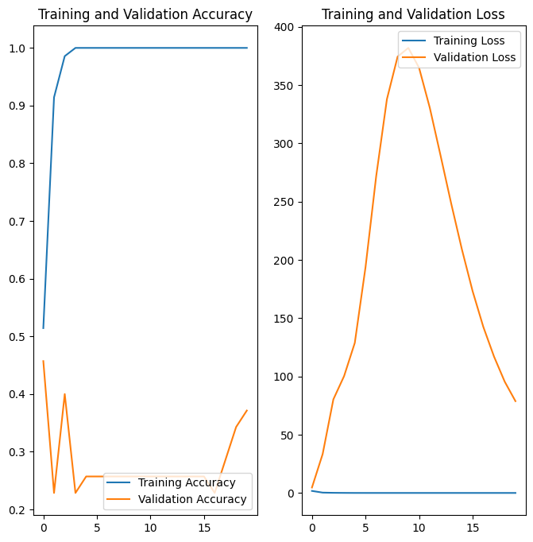

precision recall f1-score support

bio 1.00 0.67 0.80 3

papier 0.28 1.00 0.44 7

plastik 0.00 0.00 0.00 9

szkło 0.00 0.00 0.00 9

zmieszane 1.00 0.57 0.73 7

accuracy 0.37 35

macro avg 0.46 0.45 0.39 35

weighted avg 0.34 0.37 0.30 35

[[2 0 1 0 0]

[0 7 0 0 0]

[0 9 0 0 0]

[0 6 3 0 0]

[0 3 0 0 4]]

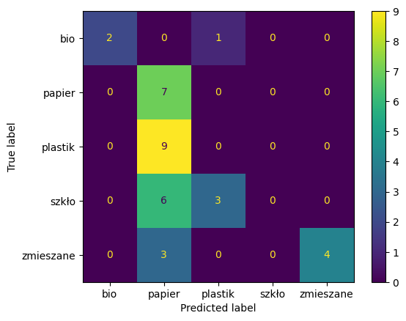  
128:

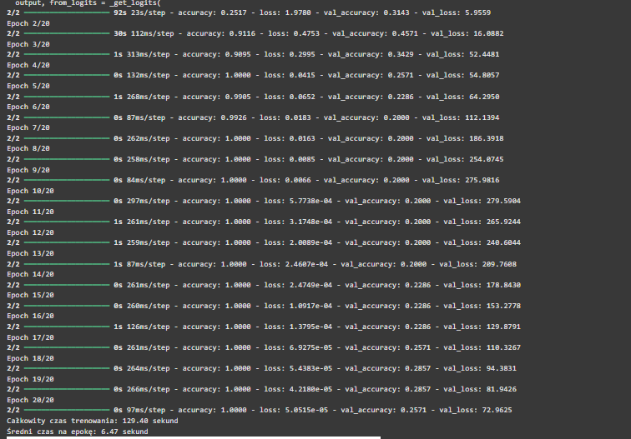

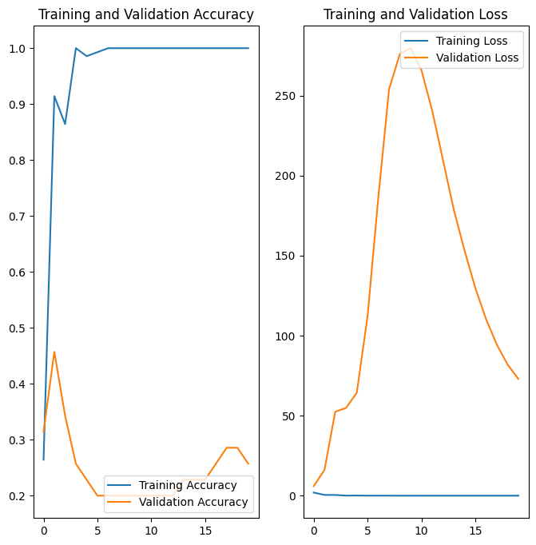

precision recall f1-score support

bio 0.00 0.00 0.00 3

papier 0.23 0.86 0.36 7

plastik 0.25 0.22 0.24 9

szkło 1.00 0.11 0.20 9

zmieszane 0.00 0.00 0.00 7

accuracy 0.26 35

macro avg 0.30 0.24 0.16 35

weighted avg 0.37 0.26 0.18 35

[[0 1 2 0 0]

[0 6 1 0 0]

[0 7 2 0 0]

[0 5 3 1 0]

[0 7 0 0 0]]

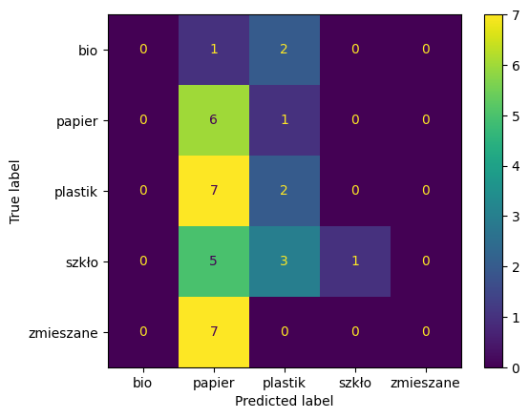

* 1. Różne struktury sieci

ResNet101: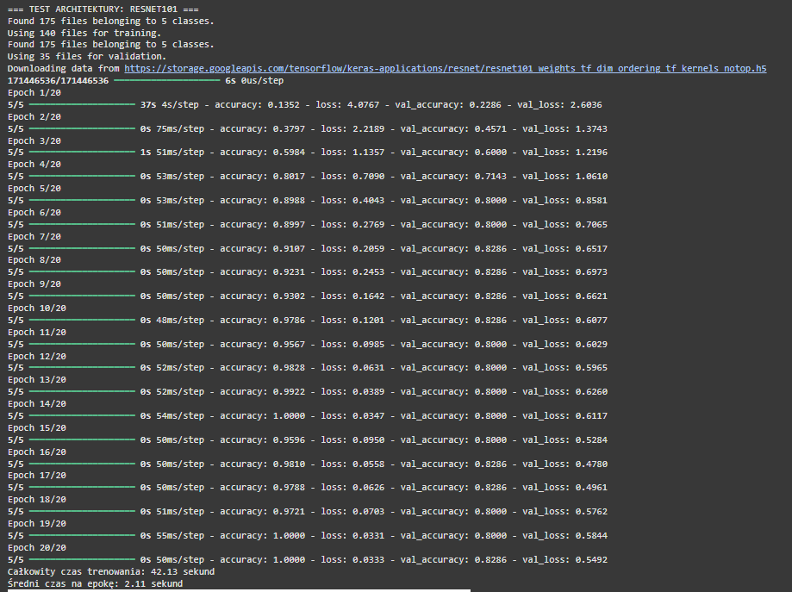

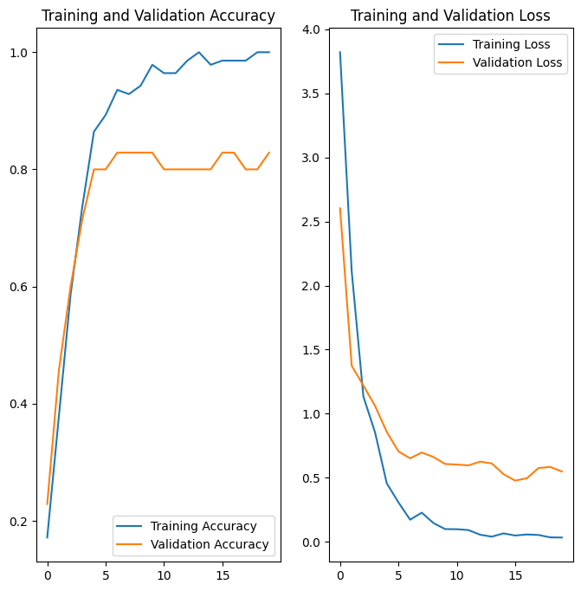

precision recall f1-score support

bio 1.00 1.00 1.00 3

papier 0.75 0.86 0.80 7

plastik 0.89 0.89 0.89 9

szkło 1.00 0.56 0.71 9

zmieszane 0.70 1.00 0.82 7

accuracy 0.83 35

macro avg 0.87 0.86 0.85 35

weighted avg 0.86 0.83 0.82 35

[[3 0 0 0 0]

[0 6 0 0 1]

[0 0 8 0 1]

[0 2 1 5 1]

[0 0 0 0 7]]

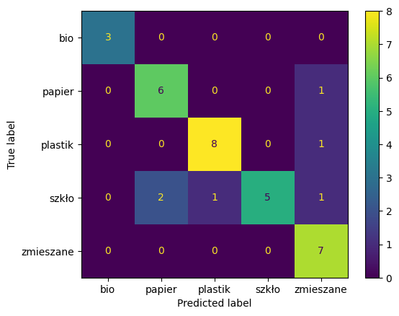

VGG16:

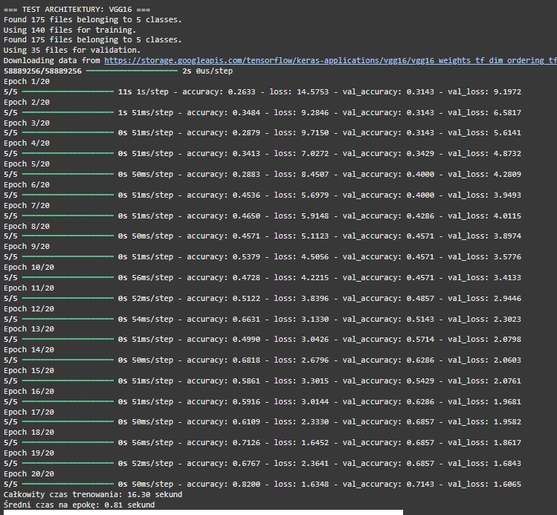

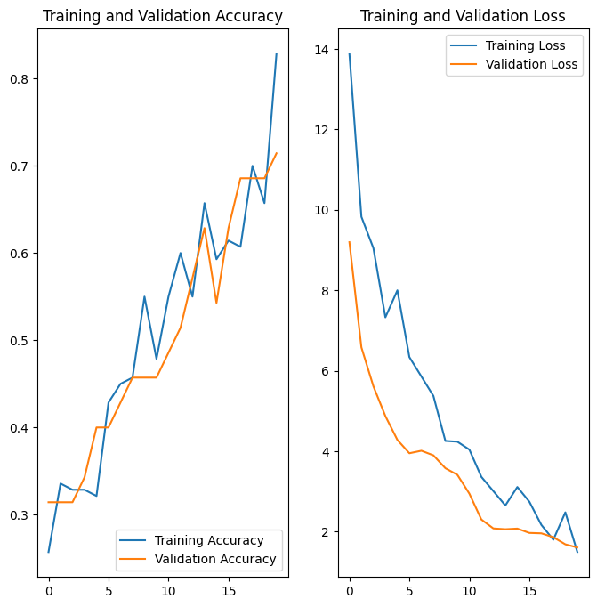 precision recall f1-score support

bio 0.50 1.00 0.67 3

papier 0.62 0.71 0.67 7

plastik 1.00 0.89 0.94 9

szkło 0.71 0.56 0.62 9

zmieszane 0.67 0.57 0.62 7

accuracy 0.71 35

macro avg 0.70 0.75 0.70 35

weighted avg 0.74 0.71 0.72 35

[[3 0 0 0 0]

[0 5 0 1 1]

[0 0 8 0 1]

[1 3 0 5 0]

[2 0 0 1 4]]

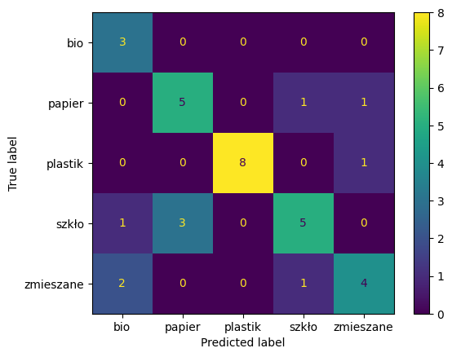

InceptionV3:

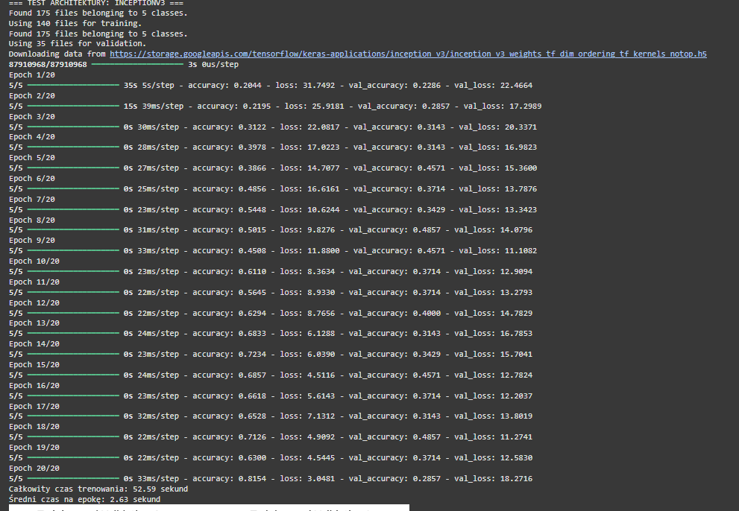

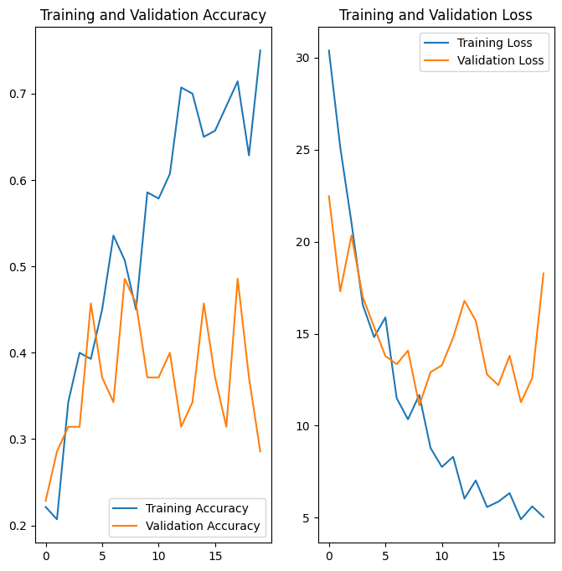

precision recall f1-score support

bio 0.18 1.00 0.30 3

papier 0.25 0.14 0.18 7

plastik 0.50 0.44 0.47 9

szkło 1.00 0.11 0.20 9

zmieszane 0.20 0.14 0.17 7

accuracy 0.29 35

macro avg 0.43 0.37 0.26 35

weighted avg 0.49 0.29 0.27 35

[[3 0 0 0 0]

[3 1 3 0 0]

[3 0 4 0 2]

[5 1 0 1 2]

[3 2 1 0 1]]

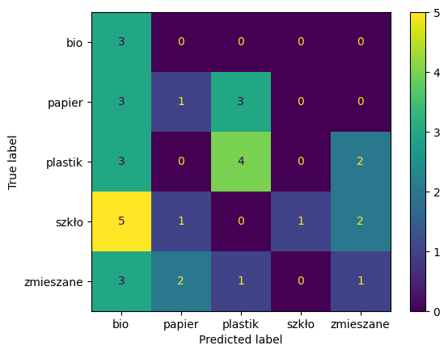

MobileNet:  
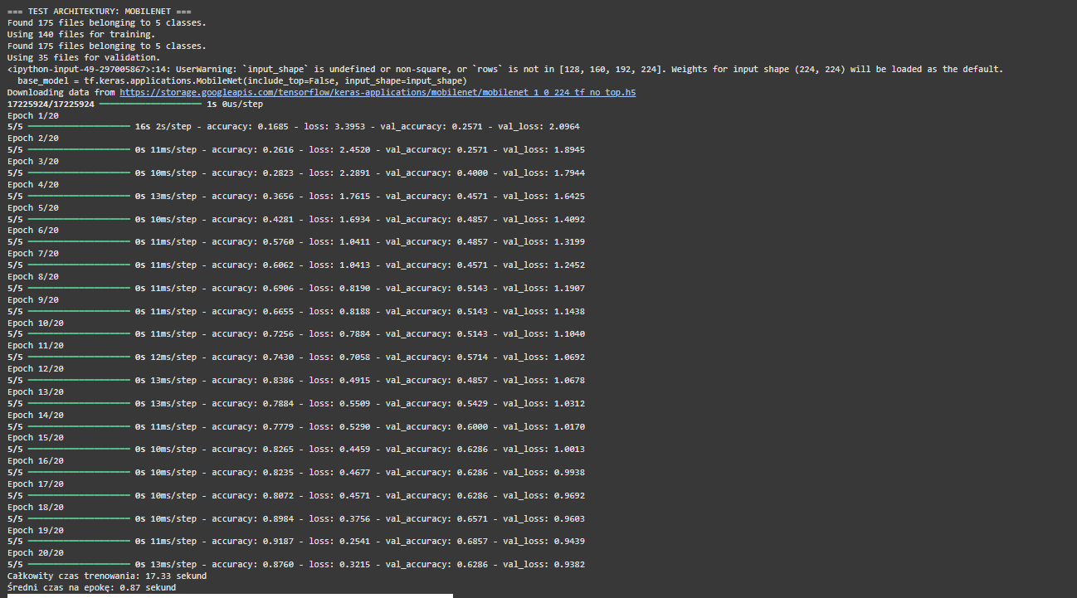

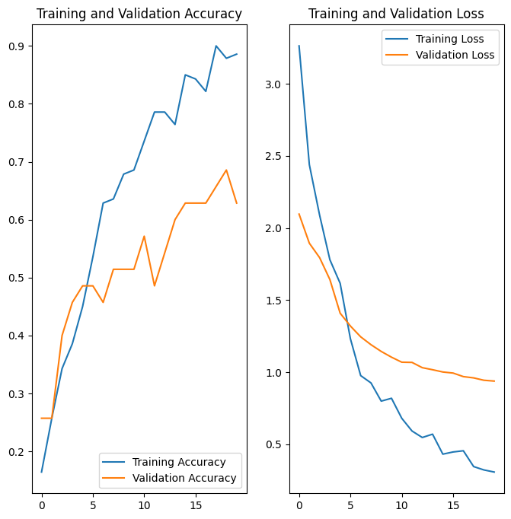

precision recall f1-score support

bio 0.67 0.67 0.67 3

papier 0.50 0.71 0.59 7

plastik 0.67 0.44 0.53 9

szkło 0.67 0.67 0.67 9

zmieszane 0.71 0.71 0.71 7

accuracy 0.63 35

macro avg 0.64 0.64 0.63 35

weighted avg 0.64 0.63 0.63 35

[[2 0 1 0 0]

[0 5 0 1 1]

[0 2 4 2 1]

[0 2 1 6 0]

[1 1 0 0 5]]

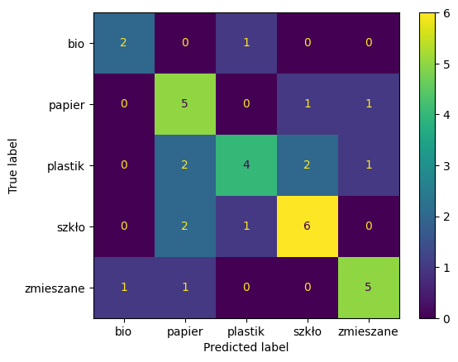

|  |  |
| --- | --- |
| CPU | GPU |
| Time: 652 sec  Time for epoch: 33,6  Accuracy: 0.63 | Time: 93,3 sec  Time for epoch: 4,6  Accuracy: 0.74 |

|  |  |
| --- | --- |
| Transfer Learning | Bazowe GPU |
| Time: 79,87 sec  Time for epoch: 3,99  Accuracy: 0.54 | Time: 93,3 sec  Time for epoch: 4,6  Accuracy: 0.74 |

|  |  |
| --- | --- |
| Normalizacja | Bazowe GPU |
| Time: 134,7 sec  Time for epoch: 6,74  Accuracy: 0.26 | Time: 93,3 sec  Time for epoch: 4,6  Accuracy: 0.74 |

|  |  |
| --- | --- |
| Augumentacja Danych | Bazowe GPU |
| Time: 119,26 sec  Time for epoch: 5,96  Accuracy: 0.71 | Time: 93,3 sec  Time for epoch: 4,6  Accuracy: 0.74 |

|  |  |
| --- | --- |
| Dropout | Bazowe GPU |
| Time: 158,38 sec  Time for epoch: 7,92  Accuracy: 0.71 | Time: 93,3 sec  Time for epoch: 4,6  Accuracy: 0.74 |

|  |  |
| --- | --- |
| Dokładnie danych | Bazowe GPU |
| Time: 186,08 sec  Time for epoch: 9,3  Accuracy: 0.26 | Time: 93,3 sec  Time for epoch: 4,6  Accuracy: 0.74 |

|  |  |
| --- | --- |
| Rozmiar obrazu: |  |
| 96 | Time: 135,43 sec  Time for epoch: 6,77  Accuracy: 0.51 |
| 160 | Time: 140,2 sec  Time for epoch: 7,01  Accuracy: 0.54 |
| 224 | Time: 150,31 sec  Time for epoch: 7,52  Accuracy: 0.54 |

|  |  |
| --- | --- |
| Batch size: |  |
| 32 | Time: 108,63 sekund  Time for epoch: 5,43  Accuracy: 0.26 |
| 64 | Time: 128,06 sekund  Time for epoch: 6,4  Accuracy: 0.37 |
| 128 | Time: 129,40 sekund  Time for epoch: 6,47  Accuracy: 0.26 |

|  |  |
| --- | --- |
| ResNet50 | Time: 93,3 sec  Time for epoch: 4,6  Accuracy: 0.74 |
| VGG16, | Time: 16,30 sekund  Time for epoch: 0,81  Accuracy: 0.71 |
| ResNet101 | Time: 42,13 sekund  Time for epoch: 2,11  Accuracy: 0.83 |
| InceptionV3 | Time: 52,59 sekund  Time for epoch: 2,63  Accuracy: 0.29 |
| MobileNet | Time: 17,33 sekund  Time for epoch: 0,87  Accuracy: 0.63 |